TECHNICAL INFORMATION FOR NSM-PHONOGRAPH

mmmm

FW£ ©MIIOTW
It w-ea tcchnoum*
1 TECHNICAL
INSTRUCTIONS
2 | OPERATING  INSTRUCTIONS
3 | SERVICE
 | PROGRAMS
A- | CONTROL
 | UNIT
S | DISPLAY/
t | KEY BOARD
© | CENTRAL
 | UNIT
~7 | OUTPUT
 | STAGE
Q | CD-CHANGER
3 | TITLE
 | INDICATION
1 O COIN and BILL
 | ACCEPTOR
1 1 | REMOTE
 | CONTROL
1 2
1 3 OUTPUT
 | TRANSFORMER
1 A- TROUBLE
 | SHOOTING
1 S ACCESSORIES

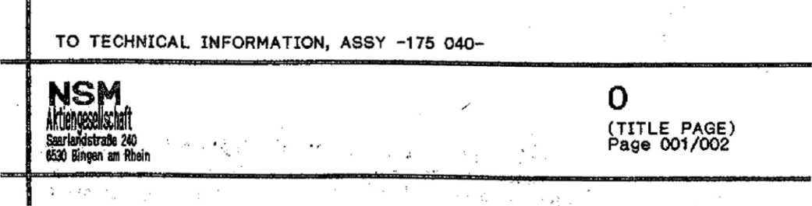

GENERAL
r?'
The modern technology of this new NSM phonograph *FIREBIRD/COUNTRY* with CD changer assures the highest functional reliability. A practical diagnostic system is available for maintenance and service.
In order to assure satisfactory operation at all times we recommend reading the technical descriptions carefully so that you are familiar with ail service operations.
The following technical documents include:

- The “TECHNICAL INSTRUCTIONS” with important Information regarding set-up of the phonograph, technical data, location of the components, the "cabinet" parts list as well as the electrical plan and various wiring diagrams.
- The "OPERATING INSTRUCTIONS" with explanations regarding play and settings as well as short Instructions for statistics and service programs
- The "STATISTICS AND SERVICE PROGRAMS" as well as test programs
- and error displays. The convenient service programs help the user In maintenance and control and permit the transfer of bookkeeping and technical data Into the new NSM recording device and the printer “DATAPRINT”.The Operating

4-13 The "UNIT DESCRIPTIONS⁻ Tor control unit, display/keyboard, central unit, output stage, CD changer, title display, electronic coin mechanism and bill validator, remote control and output transformer with their functions and, where applicable, wiring diagram and parts list.
- "TROUBLE-SHOOTING CHART", a description of errors, error displays as well as flow chart to determine errors.
- "ACCESSORIES", information on genuine NSM accessories with Instructions for installation and exercising options.
The information and Illustrations contained in these technical documents are up to date at the time of publication.
SUBJECT TO TECHNICAL MODIFICATION WITHOUT OBLIGATION TO MODIFY EQUIPMENT ALREADY DELIVERED!

Copyright by
NSM Aktiengesellschaft, D6530 Bingen/Rhein 1, Germany
No reprint-in full or part unless approved.
"Caution: Replace With Same Type Fuses”
m. a
"Attention: Ulitiser Un Fusible De Rechange de M6me Typ"
The CD-Player with Laser pick-up used in this phonograph is In compliance with the regulations of the F.D.A. Accession number 8 320 425
Note: This equipment has been tested and found to comply with the limits for a Class A digital device, pursuant to Part 15 of the FCC Rules. These limits .are designed to provide reasonable protection against harmful interference when the equipment is operated in a commercial environment. This equipment generates, uses, and can radiate radio frequency energy and, if not Installed and used in accordance with the Instruction manual, may cause harmful interference to radio communications. Operation of this equipment in a residential area is likely to cause harmful interference In which case the user will be required to correct the interference at his own expense.
TECHNICAL INSTRUCTIONS FOR NSM-PHONOGRAPHS
flU ©MM5E1'
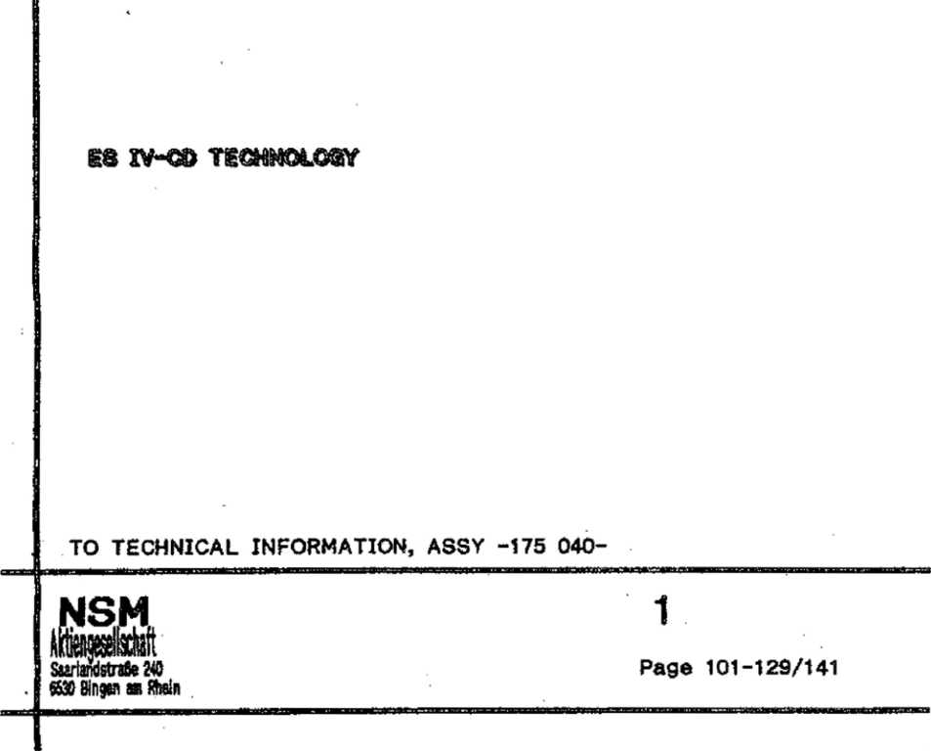
- PLEASE READ INSTRUCTIONS
  - Transport damages
  - Keys
  - Use NSM mounting bracket
  - Observe when using an upright stand
  - Transport devices
  - Power connection
  - Title strips and CD’s
- LAYOUT OF UNITS
  - Display / Keyboard
- SPECIFICATIONS
  - Electrical data
  - Music power
  - Fuses
  - Lighting
  - Credit / Cash Input
  - Keyboard
  - Displays
  - CD changer
  - Loudspeakers
  - Special features
  - Dimensions
- LOUDSPEAKER CONNECTION
- SPARE PARTS LIST "CABINET"
- OPERATING SCHEME
- PLEASE READ INSTRUCTIONS Storage and operation of this device is allowed in dry rooms only.
  - Transport Damages
If external damage due to transport is noticed, this should at once be recorded on the delivery slip and endorsed by the person making the delivery.
The manufacturer is not liable for damages during transport!
1.2 Keys
One cabinet key is taped to the front glass. The other keys are in the cash box. '
To open the cabinet unlock on the right side and open the door.
1.3 Use NSM Mounting Bracket (Part-No. 040 739)
So that the coin mechanism can function correctly, mount the phonograph horizontally and vertically correct. Therefore, we recommend the practical NSM mounting bracket.
Take care to mount the bracket untwisted since the rear of the cabinet can otherwise be twisted.
To secure the phonograph to the bracket, hexagonal screw M 10x12 -from the accessory bag- is to be used.
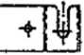
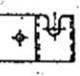
Plug In connection cable before mounting (see 1.6 "Power Connection").
i | ■f 4* 4- | ’+ *
TECHNICAL INSTRUCTIONS! |  | 4-
for Mounting of the machine on the wall
Secure mounting of the machine is very important since besides the danger of severely damaging the machine, the operator Is responsible for all damages caused by an Incorrectly mounted wallbox; when choosing the fastening material, take into account the machine’s weight of 83 kg.  We recommend dowel pins in sufficient quantities. |  | T  4  't>
The screws should be at least 6 mm | in diameter! | 4-
 |  | 4■
e | ♦ ^ | ⁹ f * •

♦
4~
4- 4-
- 03

Instance: Plastic - Wall plug
First a few tips:
- The maximum bearing capacity of nylon expansion plugs may only be achieved with the greatest possible screw diameters and with screws exceeding the plug point by the screw diameter again.
- Please ensure that with fixings in hollow brick and hollow blocks that the expansion zone of the plug is completely anchored In at least one stone web.
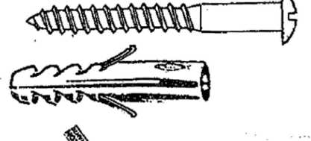
- Determination of minimum screw length
1xd (d=nominal diameter of screw)
+ Plug length
+ Thickness of plaster and/or insulating material
+ Thickness of mounting bracket 3 mm
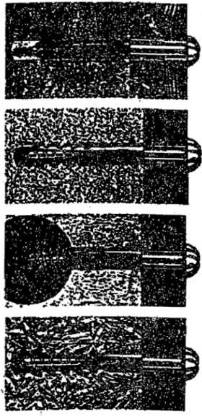
= Min. screw length
' Wlchtlg:
mind. 1 x | $chrauben-$  ^ ^
 | ty&'/WA
/fb
 | Win nn& urn m m
 | zX r\ r\ rs P—^ »
y \Z. | >t/2V^7/A
X

Light building boards
Concrete
Aerated
concrete
Hollow blocks
If you observe these tips you will have created the prerequisite for secure fixings.
Pull-out values in kN*. Determined in each case with the largest screw diameter (steel screw) and with flush fixing of the plug in the load-bearing anchorage base.
Allowance must be made for an appropriate safety factor.
Pull-out values (kN)
Type-Wall plug S5 S6 | SB | S10
Wood screws dia in mm | 6
Concrete B25 | 4,5
Aerated concrete GB 3,3 | 1,2
Aerated concrete G 4 | 1,3
Solid brick Mz20 | 4,1
Perforated brick Hlz20 | 3,0

The following points must be observed when drilling, irrespective of the material:
- Drill hole geometry
The exact drill hole geometry dictates the load-bearing capacity of a plug. Therefore always drill at right-angles and do not change direction during drilling. This is especially to be observed in the case of soft materials.
- Drill process
The following drilling methods are possible depending on the type of drilling machine: '
- Rotary - without impact
- Impact drill-many impacts with a low amount of impacts with a low amount of impact, energy. Fast rotation
- Hammer drill - few Impacts with a high amount of impact energy. Slow rotation.
The material determines the drill process:
- Solid materials of dense structure: Impact and hammer drilling.
- Hollow brick, materials of low strength and aerated concrete: Only rotary so that the hole does, not become too big and in hollow brick the webs do not break out.
Never forget to remove the dust from the drill hole after drilling. Only then is the plug secure.
Pull - Out Values - Safety Factors:
The pull-out values (breaking loads) given in this catalog are mean failure loads determined in at least 5 tests in uncracked building material. Failure criteria may be: failure of building material, breaking of bolt, loosening of anchor, breaking of anchor.
The maximum working load is calculated by dividing the pull-out value (breaking load) by the safety factor.
As a safety factor we recommend: for nylon wall plugs y" > 7.
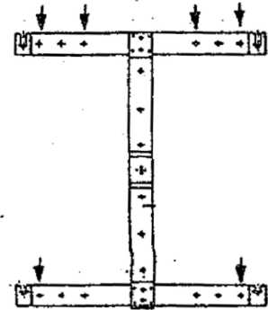
Example: In aerated concrete GB 3,3 the pull-out value for 8 plugs with 6 diameter screws Is 1,2 KN. Divided by safety factor 7 equals 0,17 KN = 17 Kp for 1 screw.
The weight of the machine Is 83 kg; therefore, at least 83 kg / 17 Kp = 5 screws are necessary. For safety and symmetry reasons 6 screws are to be used (see sketch).
When fixing the machine to the wait, make sure the vent is not hindered, in its function. When using the mounting bracket, there is normally enough distance between cabinet and wall for air circulation. Plush wall hangings decrease this distance; In that case the bracket has to be fastened to a flat board. Do not mount machine above heaters!
1-4 Observe When Using an Upright Stand
If the machine is mounted on a stand, it must be made sure that is cannot fall over. Therefore, It Is recommended to use sandbags to weigh down the stand. With approx. 15* angle the open machine should not tip over!
1-5 Transport Devices
Before operating the phonograph all devices for safety and protection during transport have to be removed.
Prior to any further transit the safety and protection devices have to be replaced.
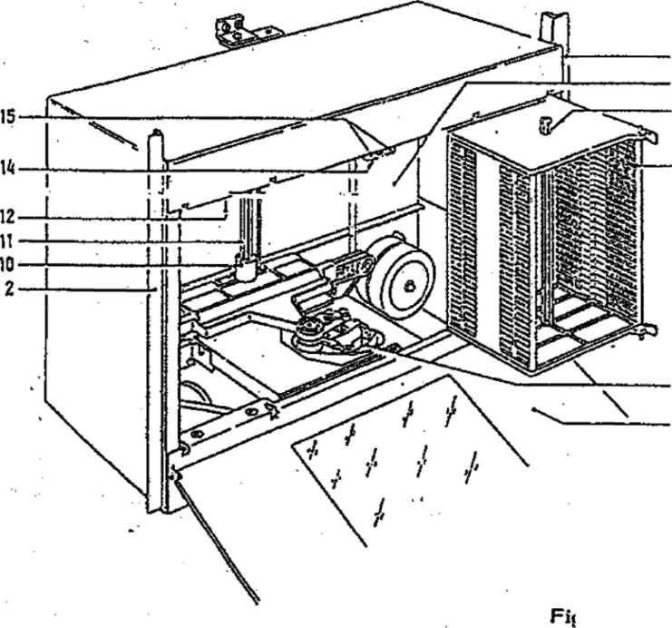

- Take off securing screws and holding bracket.
If the PCB holding plate (12) is to be flipped down, the fastening screw Is to be removed.
- Push the bar locker (15) to the center and swing out left and right magazine (5).
- Remove slotted plastic pipe from the lift axle (11), grip the lift closed to lift axle (10) and pull up.
- Remove cover from playing mechanism. Remove foam padding (A) or rubber ring (B),
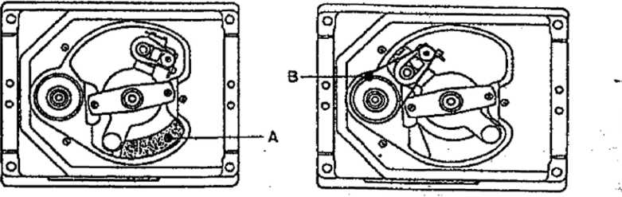
If applicable, which protect the radial motor.
Do not insert foam padding on the cable side if safety devices have to be installed for further transport.
- Loosen CD changer by turning the four nuts (8) so far back from the bottom plate (9) that the changer moves freely.
Keep transport devices in a suitable location in cabinet for later transport!
Information for transport of CD changer:
When exchanging the changer, it may only be transported in the original packaging!
- Remove magazine, push the proper button (15) outwards and remove the unit.
Inserted CD’s can be kept from falling out when the plastic pipe from the lift axle as well as a second one from the enclosed package is put through the opening (4) and all CD’s of the magazines.
- Remove design parts: Take out front glass (7).
- Put in safety and protection devices in proper sequence.
- - © Power Connection
The label on the power cord shows the voltage setting by the factory.
For other voltages set voltage required on transformers.
Put in power line into 3-pole socket on rear of cabinet.
Green-yellow of the three-wire power cord must be connected to the ground according to the International safety code.
Check main voltage before connecting!
After plugging in the phonograph turn on the switch -located under right side of cabinet- fluorescent lights should now light up.
PLEASE OBSERVE*
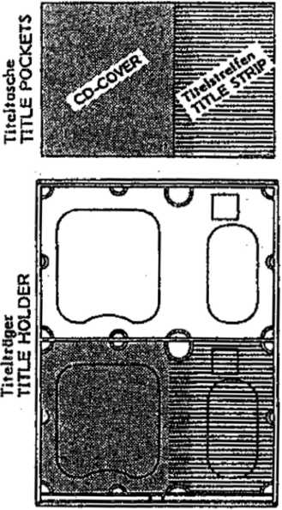
Equipping of black title holders should be done as follows:
•
Remove title pockets from accessory pack, insert CD covers on the left side and written title strips on the right side in the title pocket - thicker foil side of title pocket to the outside - and insert then in black title holder. If the covers are bigger than 120x120 mm, they need to cut to size - please use only title cover.
The title program displays are moved by pressing the ← key or the → key on the outside of the machine or the “TL" or “TR" key on the title display PCB.
TITLE STRIP Part-No. 219 185
TITLE COVER Part-No. 212 509
In case of dislocation of title holders due to rough Transportation, please refer to section 9, paragraph 1.4 "Jammed or dislocated title holders".
CD-Changer (Fig. 1): in order to avoid movement of the lift (Attract mode) the cabinet switch has to be pulled out. Now the device is in service mode. in addition, the CD will be returned when It remains on the player after the last track (see also: CD-Changer "Return Holder").
Push button (15) to the center, swing out the magazine, pull out tray and load with CD’s. Observe the sequence of the magazine and title strip numbers.
Take care to push in the CD trays until they rest in center and do not hinder the lift.
Note: To take out the magazines push the button (15) to the outside; take out magazines one after the other!
The CD's can be protected against falling out, when transporting loaded magazines, by putting the plastic pipes (4) through the magazines and all loaded CD’s.
1 08
ITS WO

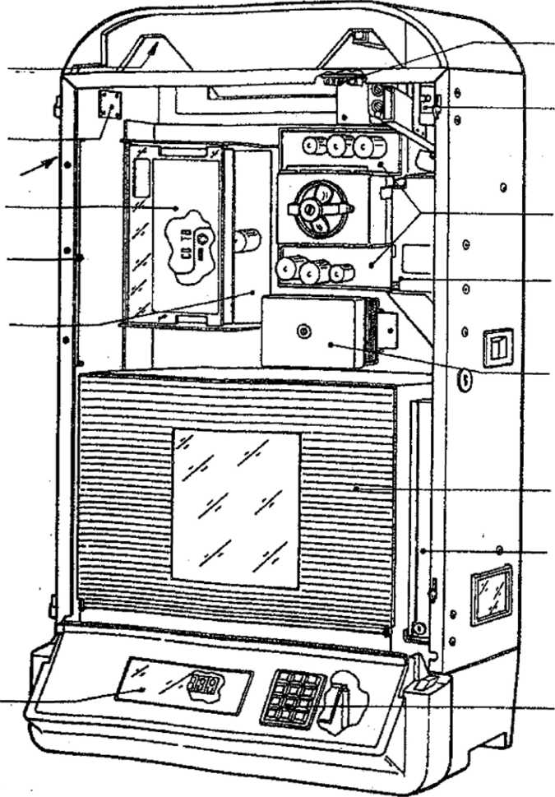
CONTROL LOUDSPEAKER
WALLBOX CONNECTION
KEY SWITCH
CONTROL UNIT CD
HOLDER FOR CD-TITLE INDICATION II
CD-CENTRAL UNIT
DISPLAY
AUDIO
CONNECTION CABINET SWITCi
OUTPUT STAGE
COIN MECHANISM
OUTPUT
TRANSFORMER
CD-CHANGER
- CASH BOX
KEYBOARD
2.1 SELECTOR and DISPLAY RANEL
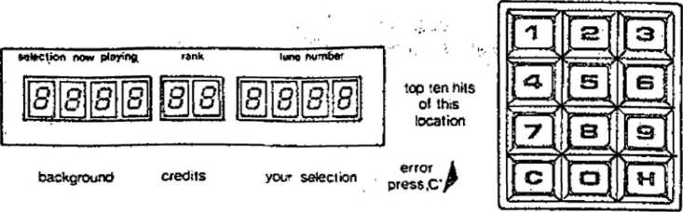
Display panel with displays 1, 2 and 3 os well cs 12 button selector
1 03

3 SPECIFICATIONS 3-1 Electrical Data
Main voltage: 100-260 V (variable), 50/60 Hz
Power consumption at stand by 170 W at play 450 W
- Music Power⁻ 2 x 200 watts music power at 2 ohms
- Fuses
Replace fuses only with those of same value! 3--4- Lighting
 |  | Firebird | Country
Fluorescent lamps = | 4 W | A. | 2
Fluorescent lamps = | 8 W | 2 | 2
Fluorescent lamps = | 13 W | 2 | 1
Lamps = 12 V / 2 W

  - Credit / CasH Input
Maximum credit display is 99.
Price list adjustable individually or as per table.
Free credit adjustment / permanent credit key-operated switch for free credits and background, elect.-mech. cash counter (optional).
- © Keyboard
10 number keys 0-9
- correction key "C"
- hit-step key “H"
- Displays
Display 1 with 4 seven-segment LED’s Display 2 with 2 seven-segment LED’s Display 3 with 4 seven-segment LED’s 1 lamp display "10 top hits”
- lamp display "background"
- lamp display "credit"
- lamp display "your selection"
- lamp display "error, press key "C"
1 1 O
175 WO
NSM CD changer for maximum 100 CD's, 5- or 3 inch disc player:
Philips CD-2-system with CDM-3-playlng unit, servo panel for control of CDM-3.
3.9 Loudspeakers
- loudspeaker SP-3 R 8 ohms (control loudspeaker) 3.10 Sped a I E e at u res
Integrated microphone preamplifier and connection socket for microphone with paging switch.
Computer-control ted amplifier protection for overload (mismatch).
- 1 1 Dimensions
Height 39,6 inch
Width 23,8 inch
Depth 14,2 Inch
A- LOUDSPEAKER CONNECTION
The wall box is equipped with a control loudspeaker. For service or repair it can be connected to the terminals of one of the outputs (left or right channel) of the output stage.
The connection wires of the external loudspeakers are led through an opening in the lower cabinet part (left rear) to the inside, through the bottom in the cabinet corner upwards, and then to the connection terminals of the output stage.
Watch the ^ = polarity when connecting the loudspeaker!
The ES-IV amplifier serves an output of 2 x 200 watts music power at 2 ohms per channel.
If the loudspeaker impedance Is 4 ohms, the loudspeaker will use 2 x 100 watts music power (Fig. 1) from the amplifier.
In that case, the additional loudspeakers connected cannot have an impedance of less than 4 ohms since the amplifier otherwise would be "mismatched”' and the overload protection would operate.
If loudspeakers with a higher Impedance are connected (Fig. 2), a number of speakers can be connected parallel. In that case, a loudspeaker with a higher Impedance would naturally be lower in volume.
The polarity V must be maintained because otherwise bass reproduction would nullify itself!
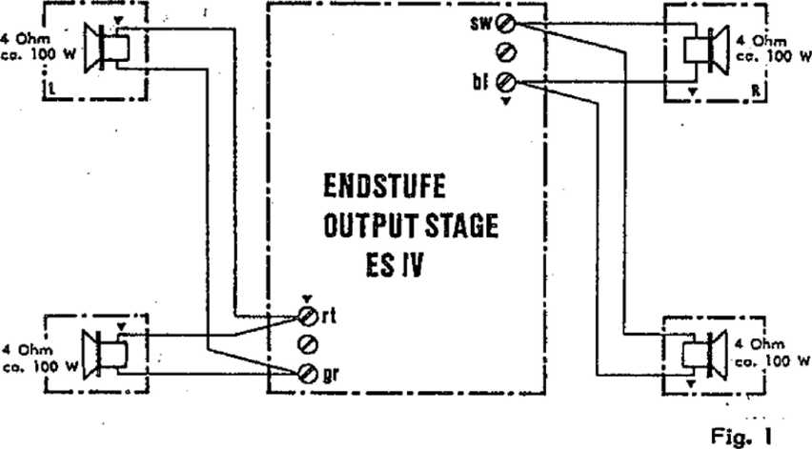
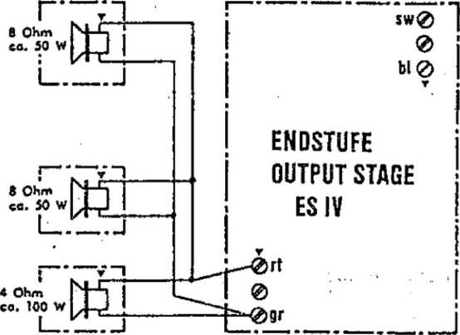
Fig. 2

Mono mode; sound system for separate rooms; see Fig. 3.
If the volume Is to be controlled independently from 2 rooms, both cabinet speakers can be connected to one channel. The loudspeaker for the other room can then be connected to the free channel. For that a Jumper has to be soldered at DR 202 (see cut-out PCB central unit). For this Independent procedure a volume control with separate controls is necessary (see remote control).
ROOM I
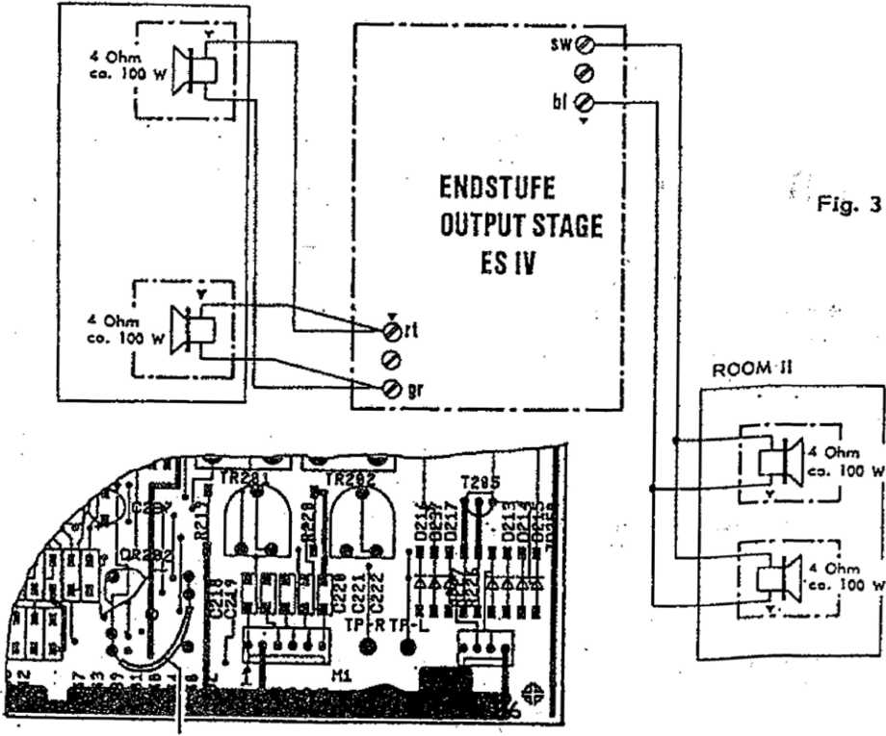
Bridge Detoil from
Circuit Board

US MO
Additional Loudspeakers and Separate Control
If even more speakers are to be connected whereby the total impedance drops below 2 ohms, an output transformer has to be used (see schematics ’’loudspeaker connection" and unit description "OUTPUT TRANSFORMER"). Cabinet speakers (Fig. 4) In serial connection result In lower volume!
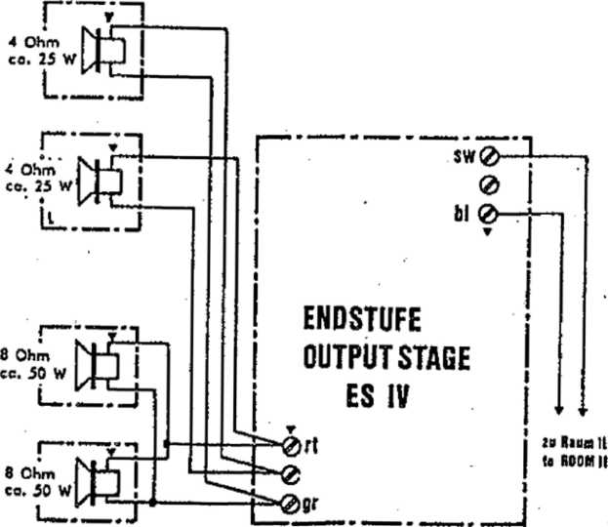
I
Fig. 4
II
III
IV

An auxiliary simplifier can be connected for Independent stereo control of other rooms as well as for Increased power requirements.
See also unit description "Central Unit", connection of auxiliary amplifier,, and "Accessories", tape recorder connection cable or CD-audio connection.

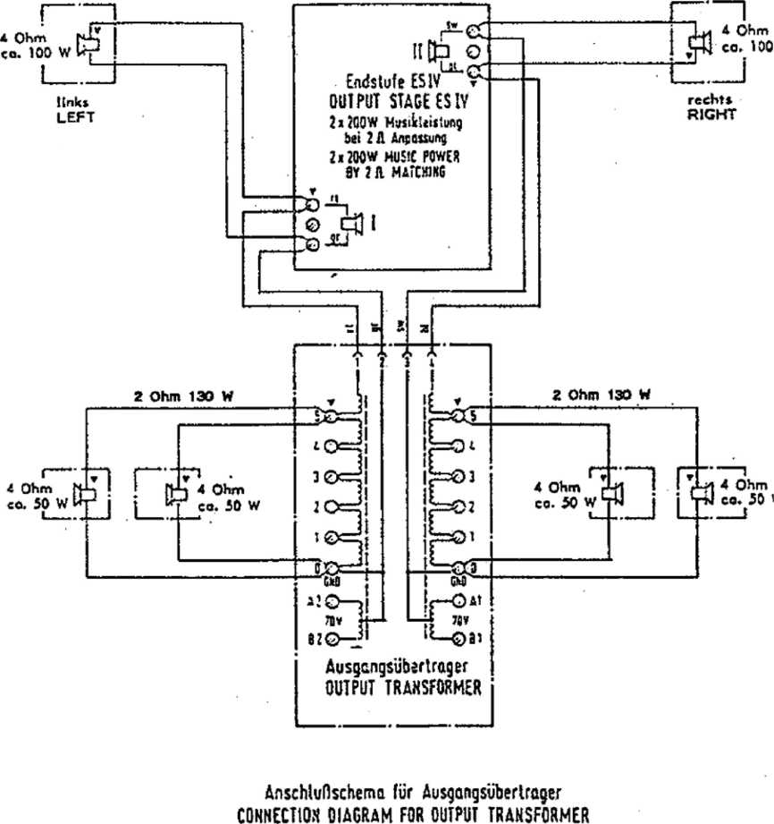

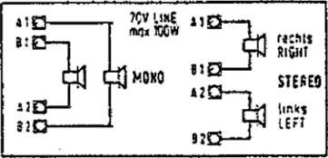
hchwei im susrt m uon ronsotims youehaije*.
Kltaftf  IERMTNA1  POSITION | 2 A | Lc  a t | tu1spr*che  SPEAKER  IA | r  81 | 15.1
o*s | 130 vr | 100 w | 7W | tsw | ttW
8-t | sow | tow | 30 W | tew | ew
8*1 | 30W | 2tW | TSW | 8W | iw
8*2 | 15 W | 12W | UW | IW | tw
0*1 | J,7W | 3W | UW | 1W | 0,5 W

HUSIIEAUTOMAUN
PHONOGRAPHS
ES IV - CD UCBXOiOEY
lim KgiR* UiX&USWUtHP
swtcr 10 IcCMftiL MOOiFlCiTWi WITHOUT OBUCJflOX
TO MMlfr imnttf UREiOr OtUVEtfS *
taulsprecheranschlufl SPEAKER CONNECTION
Anschtufl fur max. Ausgongsleislung CONNECTION FOR MAX. POWER OUTPUT
 | i4K . |2n^{f}
31 01 19, 1'Cufl |  | -|— »-*

SPARE PARTS LIST FOR NSM-PHONOGRAPH
FIREBIRD FIRE COUNTRY
This spare parts list Is applicable for NSM-Phonograph: FIREBIRD
FIRE COUNTRY
Every spare part order should contain the following:
- Model
- Serial number
- Quantity
- Part number
- Description
Example
Model | Serial-Number | QTY | Part-No. | Descrl ptlon | Data
FIRE- | 02 904 | 1 | 174 788 | LINE TRANSFO | CD-Player
BIRD |  | 2 | 224 188 | BALLAST | VG 13/2 KY
COUNTRY |  | 1 | 225 343 | STARTER | S2
ATTENTION!

Precise orders save unnecessary questions and bring the best results. ORDER SPARE PARTS THRU YOUR NSM-DISTRIBUTOR!
Information and illustrations contained In this spare parts Net, are correct at the time of going to press.
NSM-AKTIENGESELLSCHAFT, Saarlandstrafie 240 - W-9630 BINGEN am Rhein
INDEX
UNITS and ACCESSORIES CABLE HARNESSES
Page 119
Page 120-123 Page 124-125 Page 126-127 Page 128-129
CABINET
l. •
FRONT FRAME -FIREBIRD- BUTTON
FRONT FRAME -COUNTRY-
PHONOGRAPH “FIREBIRD
POS. PART-NO.
DESCRIPTION
DATA
QTY
FIRE COUNTRY”
UNITS and ACCESSORIES
174 | 873 | CB-CONTROL UNIT CD, ASSY | see | Page | 400 ... | 1
173 | 664 | CB-DISPLAY CD, ASSY | see | Page | 500 ... | 1
173 | 666 | CB-CENTRALE CD, ASSY | see | Page | 600 ... | 1
171 | 701 | OUTPUT STAGE 50 Hz | see | Page | 700 ... | >
171 | 702 | OUTPUT STAGE 60 Hz | see | Page | 700 ... | 1
1?3 | 470 | CD-CHANGER 100 (without Design
 |  | ^{r} Pieces) | see | Page | 800 ... | 1
209 | 795 | BACK COVER-LABEL |  | • i |  | 1
174 | 276 | VIEW GLASS |  |  |  | 1
174 | 710 | CD-TITLE INDICATION II, ASSY | see | Page | 900 ... | 1
040 | 739 | MOUNTING BRACKET, ASSY |  |  |  | 1
172 | 431 | OUTPUT TRANSFORMER with CABLE | HARNESS |  |  | 1
174 | 258 | IR-REMOTE CONTROL, ASSY, with 5 | m Connecting Cable |  |  | 1
206 | 783 | SENDER |  |  |  | 1
173 | 178 | RECEIVER |  |  |  | 1
171 | 743 | REMOTE CONTROL | w. | 5 m CABLE |  | >
172 | 077 | REMOTE CONTROL | w. 20 m CABLE |  |  | 1
173 | 996 | WALLBOX-CONNECTION, ASSY |  |  |  | 1
116 | 435 | DEVICE SYSTEM, ASSY | NSM-DATA |  | -PRINT | 1
173 | 348 | CASH COUNTER, ASSY |  |  |  | 1
174 | 648 | CB-AUDIO-CONNECTION |  |  |  | 1
206 | 796 | CB-INTERFACE RS 232 |  |  |  | 1

 | CABLE HARNESSES
171 182 | CENTRAL UNIT -- CONTROL UNIT | 15 prongs | 120 Ig | 1
171 783 | CENTRAL UNIT — CONTROL UNIT | 12 prongs | 120 Ig | 1
174 012 | DISPLAY |  |  | 1
174 000 | CENTRAL UNIT — OUTPUT STAGE |  |  | 2
174 022 | CENTRAL UNIT — LINE TRANSFO |  |  | 1
174 023 | TRANSFORMER -- CD PLAYER |  |  | 1
174 024 | KEY- a d CABINET SWITCH |  |  | 1
175 044 | KEYBOARD LIGHTING |  |  | 1
175 047 | LINE WIRING |  |  | 1
174 027 | CD-AUDIO |  |  | 1
175 045 | TITLE INDICATION |  |  | 1
174 038 | CENTRAL UNIT -- CD PLAYER | 10 prongs | 1250 Ig | 1
174 037 | CONTROL UNIT — CD PLAYER | 8 prongs | 1550 !g | 1
175 067 | BUTTONS |  |  | 1

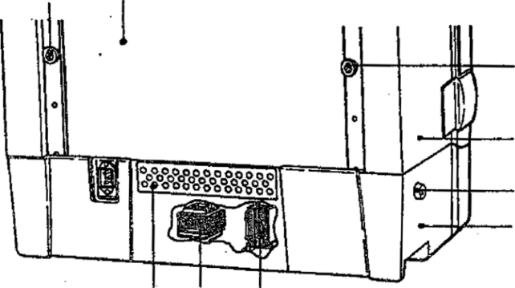
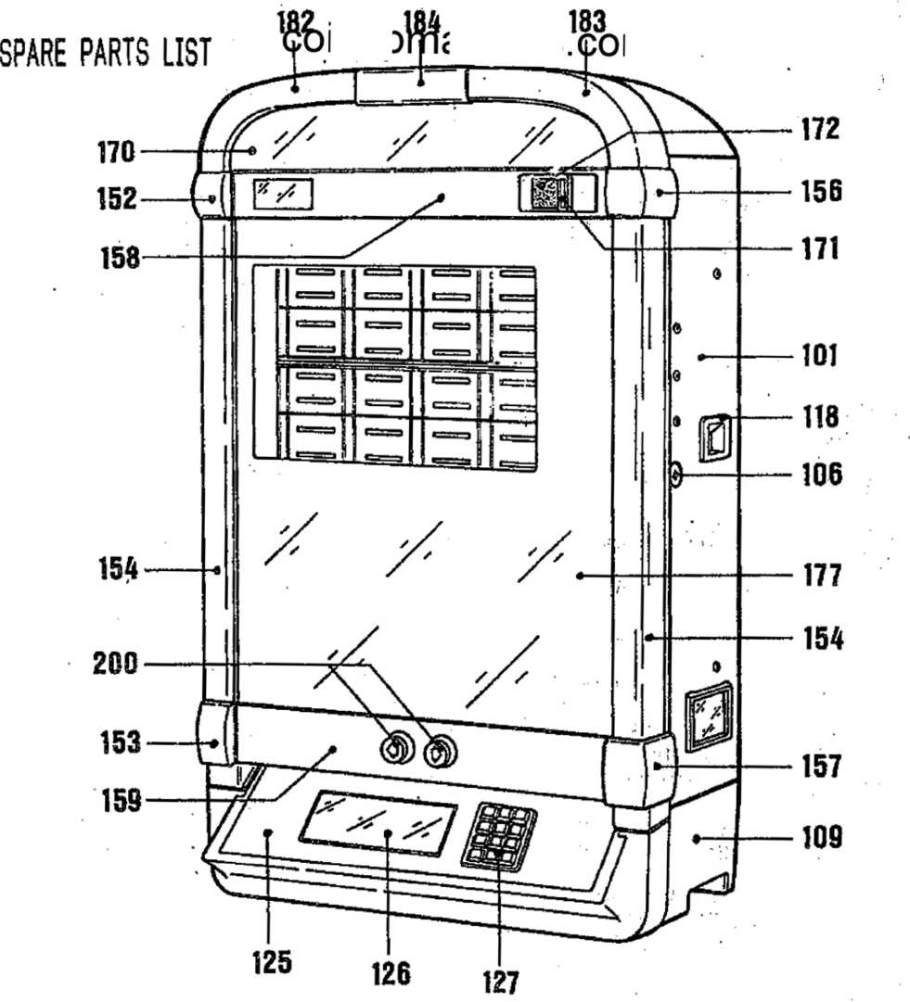
103 102
110 113 1
Vl12
103
101
114
109
1 20
t75M0

POS. PART-No. DESCRIPTION DATA QTY
PHONOGRAPH “FIREBIRD
FIRE COUNTRY"
101 | 174 064 | CABINET, PRE-MOUNTED | for USA only | >
 | 173 795 | CABINET, PRE-MOUNTED |  | 1
102 | 173 696 | BACK COVER | % | 1
103 | 112 462 | GUIDE PARTS |  | 4
104 | 114 674 | CLOSING RAIL |  | 1
105 | 211 474 | CLOSING BRACKET |  | 2
105 | 206 676 | LOCK |  | 1
 | 206 718 | SPARE KEY |  | 1
107 | 112 959 | CLOSED, STAMPED |  | 1
 | 205 722 | TENSION SPRING |  | 1
108 | 113 326 | HINGE-BOTTOM PART, ASSY |  | 2
109 | 173 501 | BOTTOM PART |  | 1
110 | 173 692 | VENTILATION PLATE |  | 1
111 | 173 697 | TRANSFO PLATE |  | 1
112 | 223 423 | LINE TRANSFORMER |  | 1
113 | 174 788 | LINE TRANSFORMER, ASSY | (CD-Player) | 1
 | 225 907 | TRANSFO-FUSE |  | 1
114 | 222 505 | KEY SWITCH |  | 1
115 | 174 376 | COIN TUBE (CASH BOX) |  | 1
 | 174 377 | COVER PLATE  »• |  | 1
116 | 173 725 | COIN RETURN LEVER, STAMPED |  | 1
 | 173 726 | BAFFLE LEVER, STAMPED |  | 1
117 | 173 655 | COIN RETURN PLUNGER |  | 1
 | 205 265 | PRESSURE SPRING 7 | (COIN MECHANISM) | 1
 | 173 727 | HOLDING BRACKET, STAMPED |  | 1
 | 173 954 | FLAT SPRING | i | 1
118 | 029 335 | COIN RETURN CUP | I ' | 1
 | 102 495 | COIN LID  ' l |  | 1
119 | 172 139 | CB-MARS-COIN ACCEPTOR, ASSY |  | 1
120 | 222 509 | PUSH BUTTON SWITCH | CABINET SWITCH  t | 1
121 | 173 722 | BRACKET, ASSY RIGHT | for CENTRALE and | 1
122 | 173 723 | BRACKET, ASSY LEFT | CONTROL UNIT • | 1
123 | 174 383 | CASH-BOX |  | 1
124 | 206 656 | Cyl.-LOCK |  | 1
 | 173 908 | CLOSING LEVER |  | 1
125 | 173 708 | CONSOLE |  | 1
126 | 174 014 | GLASS, PRINTED | GERMAN | >
 | 173 794 | GLASS, PRINTED | ENGLISH | 1
127 | 173 900 | KEY BOARD, ASSY |  | 1

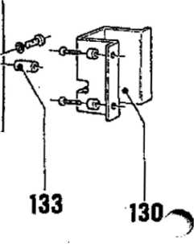

POS. PART-NO. DESCRIPTION DATA QTY
128 | 173 670 | LAMP MASK | 1
 | 225 587 | LAMP SOCKET | 1
 | 226 056 | LAMP | 12 V 2 W 1
129 | 176 020 | BACK PLATE II | \ *' ¹
130 | 176 022 | LOCKING PLATE II | J 1
131 | 176 023 ; | AXLE | / f. TITLE 1
132 | 175 204 | CLIP : - | \ INDICATION II 1
133 | 176 024 | BUSHING | / 1
134 | 176 048 | BEARING PLATE II | 1 1
135 | 217 391 | BALL HANDLE | ] 1

136 | 114 654 | uuaru  GUARD |  | 1
137 | 114 728 | VENTILATION PLATE |  | 1
138 | 174 004 | CONTROL-LOUDSPEAKER, ASSY |  | 1
5 | - 173 777 | HOLDING PLATE |  | 1
q: o  h-t  U- O | 224 215 | BALLAST | KX 4/6/8 D 8 W | 2
 | 224 188 | BALLAST | KX 13 D | 3
. o:  CD CD | - 223 421 | PRE-TRANSFORMER | for 117 V only | 1

167 184 167 168
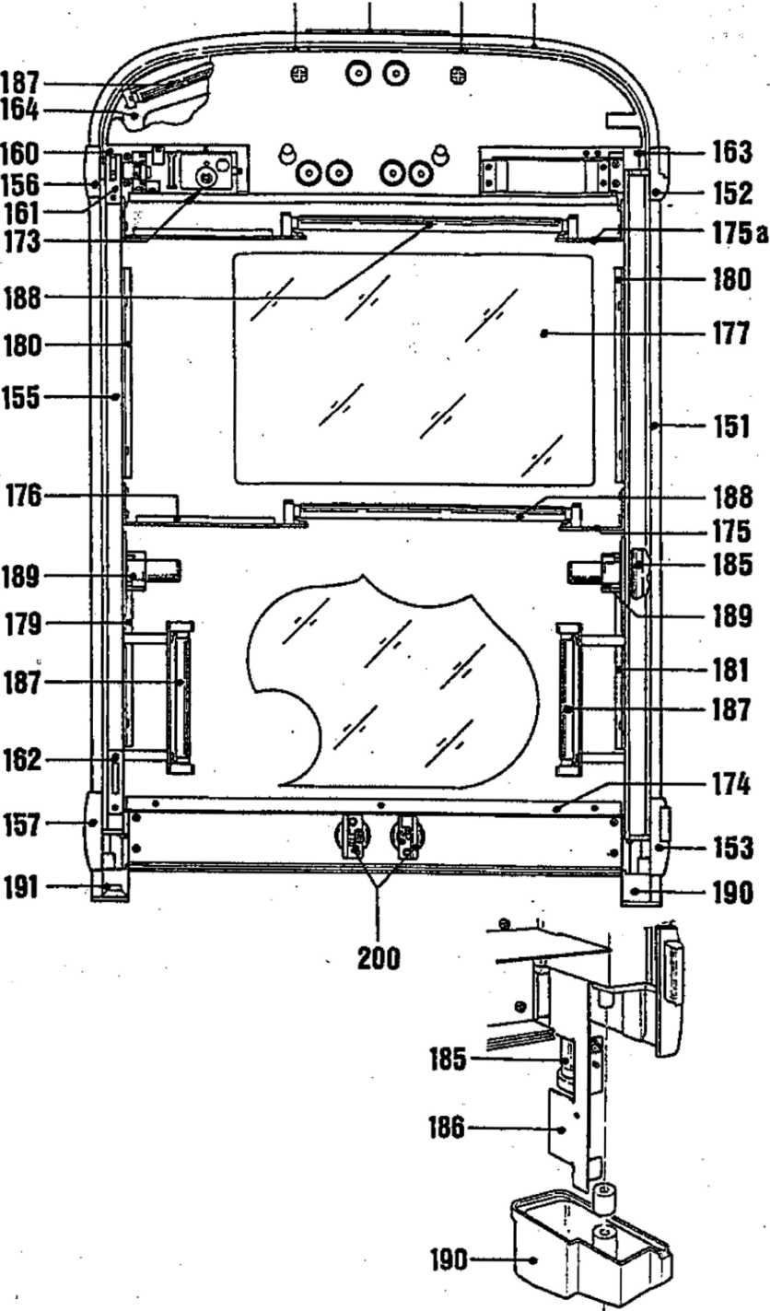

POS. PART-No. DESCRIPTION
DATA OTY
FRONT FRAME FIREBIRD
151 | 250 336 | LONGITUDINAL PROFILE, LEFT
152 | 250 273 | EDGE CONNECTOR, UPPER LEFT
153 | 250 275 | EDGE CONNECTOR, LOWER LEFT
154 | 212 422 .. | LAMP MASK
155 | 250 337 | LONGITUDINAL PROFILE, RIGHT
156 | 250 274 | EDGE CONNECTOR, UPPER RIGHT
157 | 250 276 | EDGE CONNECTOR, LOWER RIGHT
154 | 212 422 , | LAMP MASK
158 | 173 703 | CROSS PROFILE, UPPER ASSY
159 | 175 041 | CROSS PROFILE, LOWER ASSY
160 | 115 082 | HOLDING BRACKET, RIGHT
161 | 114 679 | CLOSING PLATE, UPPER
162 | 114 680 | CLOSING PLATE, LOWER
163 | 115 083 | HOLDING BRACKET, LEFT
164 | 175 494 | CARRIER PLATE, STAMPED
167 | 114 682 | HOLDING BRACKET
168 | 250 340 | TERMINAL PROFILE, UPPER CURVED
170 | 212 495 | FRONT PLATE
 | 206 581 | DUPLEX PROFILE
171 | 173 710 | COIN INSERT
172 | 175 023 | BUTTON I, PRE-MOUNTED
173 | 205 720 | PRESSURE SPRING
 | 209 963 | MASK, LEFT
 | 209 964 | MASK, RIGHT
174 | 173 905 | COVER, LOWER
175 | 175 033 | LAMP HOLDER, LEFT LOWER
175a | 175 227 | LAMP HOLDER, LEFT UPPER
176 | 175 032 | LAMP HOLDER, RIGHT
177 | 204 925 | FRONT GLASS
 | 206 519 | RUBBER PROFILE
 | 206 520 | RUBBER PROFILE
179 | 175 037 | GLASS HOLDER, RIGHT LOWER
180 | 175 034 | GLASS HOLDER, UPPER
181 | 175 035 | GLASS HOLDER, LEFT LOWER
182 | 175 469 | LAMP MASK, UPPER LEFT
183 | 175 468 | LAMP MASK, UPPER RIGHT
184 | 176 141 | SOCKET for MASK

1
1
1
1
1
1
1
1
1
1
1
1
1
1
1
2
1
1
1
1
1
1
1
1
1
1
1
2
1
m ro
1
2
1
1
1
1

SPARE PARTS LIST
ro ro ro N) hJ ro ro i\> ro -*• ro^o
DATA QTY
185 | 226 | 075 | FLUORESCENT LAMP | 13 W
186 | 173 | 732 | LAMP HOLDER, LEFT PRE-MOUNTED
 | 173 | 733 | . LAMP HOLDER, RIGHT PRE-MOUNTED
187 | 226 | 072 | FLUORESCENT LAMP | 4 W
 | 209 | 970 | FOIL, RIGHT
 | 209 | 969 | FOIL, LEFT
 | 209 | 764 | FOIL, SHORT
 | 209 | 975 | FOIL, UPPER RIGHT (SHORT)
 | 209 | 845 | FOIL, SHORT
188 | 226 | 038 | FLUORESCENT LAMP | 8 W
189 | 225 | 364 | STARTER HOLDER
 | 225 | 343 | STARTER | S 2
 | 225 | 040 | STARTER | S10
190 | 173 | 712 | ADAPTER, LEFT
191 | 173 | 711 | ADAPTER, RIGHT

I I ' I . ) ■ I I n~.
POS. PART-No. DESCRIPTION
2
1
1
4
1
1
1
1
2
2
200 | 174 | 448
201 | 115 | 608
202 | 174 | 741
203 | 115 | 627
204 | 205 | 798

BUTTON. ASSY
HOUSING
BUTTON, PRINTED BUTTON, COVER PRESSURE SPRING
small round
small round
205 | 206 | 615
206 | 175 | 048
207 | 115 | 612
208 | 222 | 515
209 | 225 | 587
210 | 226 | 049
211 | 115 | 611

RING (0,5 mm thickness) RING (2,5 mm thickness) COVER
MICRO SWITCH LAMP SOCKET LAMP ADAPTER
12 V 2 W

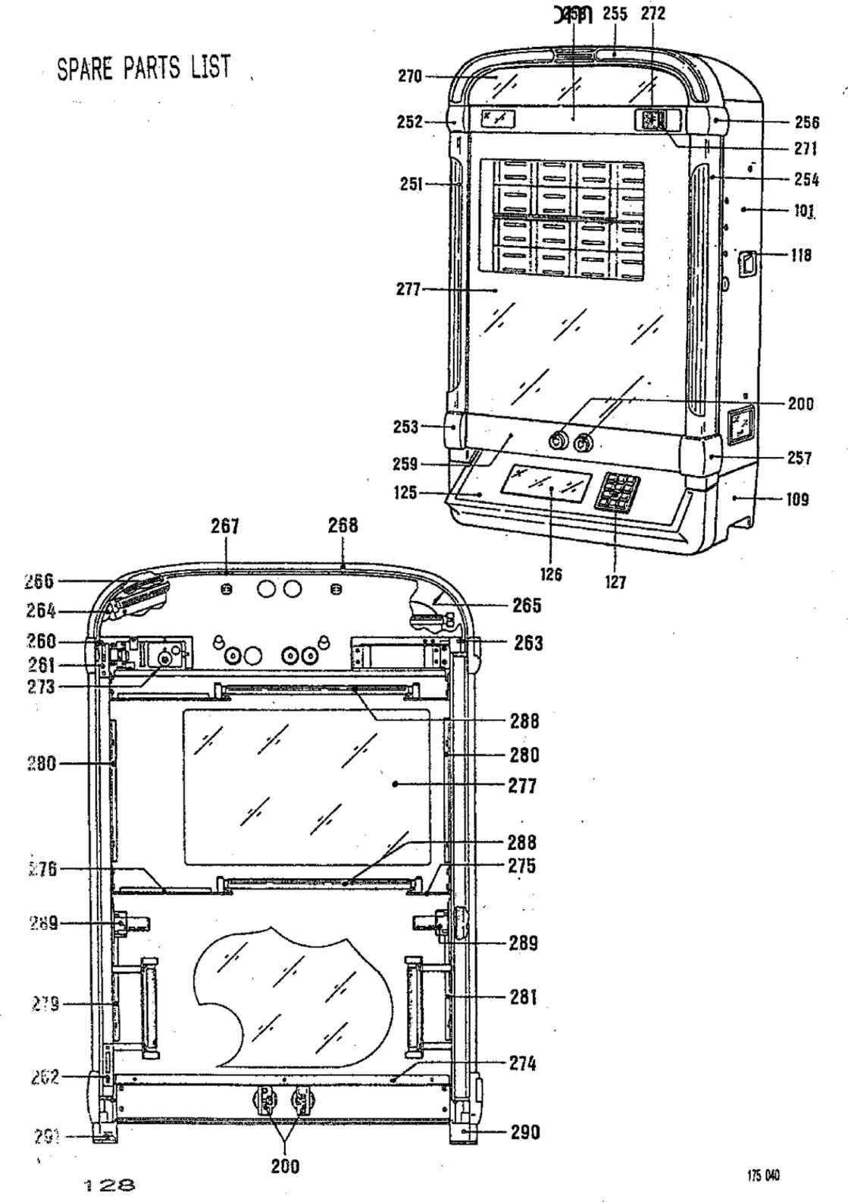

POS. PART-NO. DESCRIPTION DATA QTY
FRONT FRAME FIRE COUNTRY
251 | 174 526 | FRAME PIECES, LEFT | CLASSIC DESIGN | 1
252 | 250 320 | EOGE CONNECTOR, UPPER LEFT |  | 1
253 | 250 321 | EDGE CONNECTOR, LOWER LEFT |  | 1
254 | 174 525 | FRAME PIECES, RIGHT | CLASSIC DESIGN | 1
255 | 174 527 | FRAME PIECES, UPPER | CLASSIC DESIGN | 1
256 | 250 322 | EDGE CONNECTOR, UPPER RIGHT |  | 1
257 | 250 323 | EDGE CONNECTOR, LOWER RIGHT |  | 1
258 | 175 053 | CROSS PROFILE, UPPER ASSY |  | 1
259 | 175 054 | CROSS PROFILE, LOWER ASSY |  | 1
260 | 115 082 | HOLDING BRACKET, RIGHT |  | 1
261 | 114 679 | CLOSING PLATE, UPPER |  | 1
262 | 114 680 | CLOSING PLATE, LOWER |  | 1
263 | 115 083 | HOLDING BRACKET, LEFT |  | 1
264 | 174 945 | CARRIER PLATE, STAMPED |  | 1
265 | 250 314 | PROFIL for LAMP MASK, LEFT |  | 1
266 | 250 315 | PROFIL for LAMP MASK, RIGHT |  | 1
267 | 114 682 | HOLDING BRACKET |  | 2
268 | 250 316 | TERMINAL PROFILE, UPPER |  | 1
270 | 115 494 | FRONT PLATE |  | 1
 | 219 152 | TRIMPLATE, UPPER |  | 1
 | 206 581 | DUPLEX-PROFILE |  | 1
271 | 173 710 | COIN INSERT |  | 1
272 | 175 023 | BUTTON I, PRE-MOUNTED |  | 1
273 | 205 720 | PRESSURE SPRING |  | 1
 | 209 963 | MASK, LEFT |  | 1
 | 209 964 | MASK, RIGHT |  | 1
274 | 173 905 | COVER |  | 1
275 | 175 033 | LAMP HOLDER, LEFT |  | 2
276 | 175 032 | LAMP HOLDER, RIGHT |  | 2
277 | 204 929 | FRONT GLASS |  | 1
 | 206 519 | RUBBER PROFILE |  | 2
 | 206 520 | RUBBER PROFILE |  | 2
279 | 175 037 | GLASS HOLDER, RIGHT LOWER |  | 1
280 | 175 034 | GLASS HOLDER, UPPER |  | 2
281 | 175 035 | GLASS HOLDER, LEFT LOWER |  | 1
285 | 114 699 | HINGE-BOTTOM PART |  | 2
288 | 226 038 | FLUORESCENT LAMP | 8 W | 2
289 | 225 364 | STARTER HOLDER |  | 2
 | 225 040 | STARTER | S10 | 2
290 | 173 712 | ADAPTER, LEFT |  | 1
291 | 173 711 | ADAPTER, RIGHT |  | 1
200 | 174 488 | BUTTON, ASSY | see Page 127 | 2

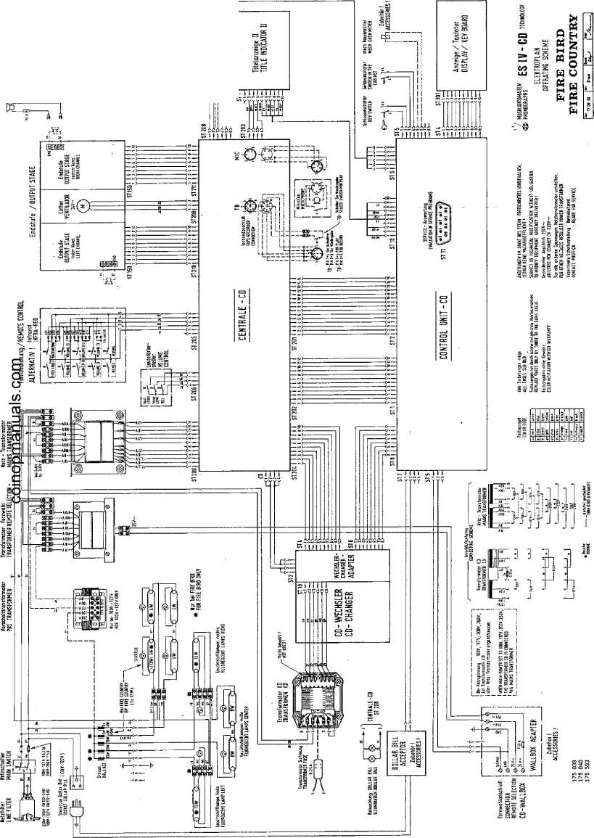
s
 |  |  |  |  | Jl fill
!i  ii | j  ii |  | i  SS |  | SMs>$l

OPERATING INSTRUCTIONS
S '' V •
FOR NSM-PHONOGRAPHS i# w-eo txchnqlmy
to
Technical Information, Assy | 174 903 | SILVER CITY
 | 174 831 | SILVER SKY
 | 174 486 | FASCINATION
 | 175 274 | SOUNDMASTER
; ..... | 175 040 | FIREBIRD/COUNTRY
 | 176 046 | THE PERFORMER "GRAND*'

j

- PLAYING SEQUENCE
  - Operation after switching on
  - - jStandby
  - Credits
  - Selection
  - Play mode
- ADJUSTMENTS WITH REMOTE CONTROL
  - Volume controls
  - Muting
  - Free'.credits
  - Background music
  - Key switch
- SERVICE OPERATION - short program for price settings
- CD change / cash collection
•TOP TEN HITS—*
SE LECTOR and \ DISPLAY PANEL
^SELECTION-
NOW PLAYING
iivXmMC> :
«gANK
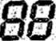
AT.Trti5 XOCAIlOH.
TUNE NUMBER -k
•ift *i •• .»**• v.*
background credits your selection
,T| | 2  rr—K | 3  —
• ?  m | 7S | 1  el  ’*³
M | I^{s} | 9 |
 | of | fit

top ten hits of this location
error v presS'C')
O *
1 PLAYING SEQUENCE
. * '^{A}*r
The functional sequence, starting with "power on", standby credit, selection and playing of selected title to the rest position Is described below.
The technical assembly and the working together of the components can be seen in the /‘electronic schematics". Compare the descriptions with the illustration of the display / keyboard above.
- Operation after Switching on
Immediately after switch-on the memory components -on the CONTROL UNIT- and all preprogrammed values are phecked.
Display 1 shows then for 2 sec. the program index
If an error is found during checking, error display Er xx is then shown for 2 sec.
With Er 31 (unverified memory contents) and Er 40 (price settings incorrect) Display 1 with Pxx shows the correct program step which needs to be reprogrammed. See description of service programs.
With other Er-dlsplays, even during operation, proceed according to the instructions in “Trouble Shooting".
- Standby Hit display:
The. microprocessor of the CONTROL UNIT figures out of the 30 titles just played before the ones played most.
On Display 3 the title numbers of the 10 most popular titles, whose rankings (1-10) are shown on Display 2, are changed in intervals of 2 sec. Also "10 top hits" lights up.
When pushing "H”, the hit display can be stopped for 16 sec; every press of the key causes an advance to the next hit.
Note: When the popularity counters are erased (program step P 10), the hit parade is erased, too. In that case "0" appears for ranking until records are played again.
Random Play:
In program step P24 a time interval can be set for random tune playing.
Conditions for a random title to be played:
@ Phonograph in standby mode $ No credit available ■‘8 Microphone switch not being used 0 No muting
$ Set'time is expired .
- Credits (not for HIDE-AWAY)
See unit description "Coin and Bill Validation".
After insertion of a coin the "hit display” Is interrupted, lamp "10 top hits" goes off and "credit" and "your selection" light up. Display 2 shows the number of credits.
For every selection credit is deducted.
If not enough credits are available for the selection, “credit" lamp flashes.
If no more coins are inserted within 16 sec. or no selector key is pressed, the mode changes to "hit display".
Frea-credit switch (add. key), below the mechanical coin acceptor or on the adapter PCB with electronic coin vaiidators, Is only possible when the cabinet lid is open and the cabinet interlock switch is in service position (press add. button once = 1 credit). These credits are not registered statistically.
Starting with program index 0003 selections can be made without credits after pulling out the cabinet switch and going back to the regular program (2 x ”C" key).
Attention! The machine Is furnished with an interlock switch which must be manually set in service position (pull out). The switch resets automatically when closing the lid.
Note: Credits remain stored during "power off/on".
If the computer detects no activity on the phonograph within 1 hour, the stored credit is cancelled.
1 .A- Selection
Title Selection: The four-digit number of the desired title has to be entered (2 digits each for disc and track). "Credit" and "your selection" light up. The selection can be corrected by pressing "C" up to 2 sec. after pressing the 4th digit.
Album Selection: When entering Track 00, all titles of a CD are automatically played (i.e. 0100 = all titles of Disc 01).
The number of credits which are deducted when selecting an album can be programmed in step P46.
When programming "0”, album selection Is blocked.
With open cabinet switch (interlock lever pulled out) no credit is deducted when selecting.
If the entry is incorrect, e.g. higher than the programmed number of CD tracks which can be selected or an unallowed selection of albums, "error" flashes. In that case, press "C" and repeat the selection.
One credit is deducted for each selection of a title. With album selections credits are deducted as per the programming in program step P46. If there is not enough credit available, "credit" lamp flashes.
- sec. after selection "hit display” Is switched on automatically again.
Note: If a background or random title is playing during selection, the volume is fading and the selected tune is being played.
When selecting a higher title number than recorded on the CD, the first title (track) of the CD will be played automatically.
1-5 Play Mod©
After selection the microprocessor of the CONTROL UNIT moves the pickup of the CD changer to the selected CD and pulls it with its holder out of the magazine into the pickup. The pickup brings the CD to the disc player where it is then played.
Just before play the number of the title is shown on Display 1 ("selection now playing"). After the disc Is played, the display is erased and the CD is transported back to its magazine space.
Note: If a error occurs with the CD changer or the player, "Er 7x” or ”Er 6x“ appears for 2 sec. In that case proceed according to the description in "Trouble Shooting".
Limiting Plaving Time for a Title (Track)
In Service Program P30 the time that a title is to be played maximum can be set in minutes.
After expiration of this time the volume for that title is fading and then muted.
When setting "O" (default), there is no limit in playing time.
Sequence of Tunes Playing
In Service Program P31 one can set in which sequence the selected titles are played.
Settings: 0 = in sequence of selection (FIFO)
- = in numerically increasing sequence
- = random sequence
Limit of Playing Titles on the Same CD
One can set in Service Program P32 how many titles can be played consecutively on the same CD.
With 0 (default) there Is no limit.
Attention!
When playing a test compact disc, the description that comes with the test disc is to be exactly adhered to. By any means, it Is to be avoided to give sine signals with peak signal "OdB" at full volume level to the loudspeakers for more than 1 sec.
But also other unfiitered noises and high-frequency signals (which are only used for measuring purposes) can damage the amplifier and loudspeakers at full volume.
When checking channel separation, this test can only be done with a frequency of 1 KHz.
1 .& Titles display 8y pushing the keys respectively title holders are moved into the corresponding direction. Upon each key operation two new CD-covers including titlestrips are shown. ln case of a limitation of selectable CD’s via service step P22 only the corresponding title holders are shown.
Note: A problem with the title display will initiate error code "Er 9x". Following instructions In paragraph 14 (trouble shooting).
i • ■
- ADJUSTMENTS WITH', REMOTE d . : •
CONTROL :>
The phonograph can optionally be equipped with cable-type remote control or infra-red remote control. All functions and the operation of both models are identical. Therefore, this description is valid for both of them.
The button-control box attached to the rear of the cabinet allows common control of both channels “+" or and “REJECT”.
Information about the functions of different controls is presented in the unit description “Remote Control".
Note: The button volume control is not present with wallboxes such as the "CD FIRE" or the "CD HIDE AWAY".
- 1 Volume Controls We differentiate between two volumes:
- ) The normal volume of selected titles and random play titles
- ) The background volume of background'titles
For selected titles and random titles or with microphone and tape mode the corresponding volume is adjustable; background volume only with background mode:
Key "I" for the left channel; Key "II" for the right channel; "+" = louder, "-" = quieter. When pushing center key (I+II), the channels are regulated together. If they were differently set, they are first "balanced" and regulated together.
When no selection is taking place, the volume for the channels are shown in Display 3 during the adjustment in steps of "1” to "31".
At "muting" function "OFF" appears in Display 1; no more titles will be played until MUTING is cancelled. ,
The volume set at the end is stored during "power off".
The maximum possible volume for normal and background mode can be limited in service program P28 in steps of "1" to "31".
Note: To protect the amplifiers a check is made whether an overload occurs due to mismatching in 250 ms cycles.
Upon recognition of an error the volume of the corresponding channel is reduced step by step automatically by the computer until a non-critical point is reached.
The volume of both channels can be set at "0” by pressing the MUTING key; "OFF” appears on Display 1. Re-pressing of the MUTING key a VOLUME key causes the system to switch back to the previously set volume for both channels.
Note: With display “OFF” no more records are played until MUTING is switched off.
2.3 R r~ees Credits
With an "open” key switch free credits programmed in program step P23 can be called up. The following free credits are possible depending upon the settings in step P23:
- ) Number of set free credits can be called up individually step by step.
- ) Unlimited free credits can be called up individually step by step.
- ) Permanent credit when pressing key "FREE CREDIT” for the first time
(credit display "99"). When key "FREE CREDIT" Is pressed again, permanent credit is blocked.
2.4- Bac k 9 r*o«J n d Music
With an "open” key switch the background mode can be switched on with the BACKGROUND key. "Background playing” lights up.
When pressing this key again, the background mode is switched off. In the background mode "random" records are played from the upper area of the magazine. The area can be set in program step P25.
The records are played at a "specific" background volume which can be changed as desired during playing cycle from "0" up to maximum volume set in program step P28.
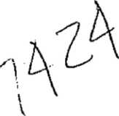
A “normal record”, selected while background music is playing, interrupts the background disc and the selected tune is played at "normal volume".
1T4 TOI m 01 / w « f TO 274 / 175 NO / 176 046
207
A key switch at the side wall serves as protection against unauthorized calling up of free credits and switching on the background mode. When the key switch is "locked", settings from the remote control are disregarded. Key switch "open" permits programmed free credits to be called up and the background mode to be switched on.
r
m
FREE BACK- CREDIT GROUND
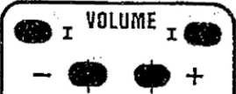
An ¹⁺¹ it
m
REJECT
V
MUTING
J REMOTE CONTROL
- Service Operation — S hort Rr-ogr-am -for- Rice Settings-
This description is a summary of a section of the service program.
A detailed description and the corresponding tables are contained in chapter 1.3 "Price Settings" and 1.4 "Monetary Value Settings".
Practical example for setting the "plays per monetary unit" and the "monetary unit settings": 1. play = 30 p 1 play = 2x25 c
- plays = 50 p 2 plays = 4x25 c
- plays = 1 £
Setting the price able (plays/monetary unit):
Programming information | Operation | Displays 1 2 3
Switch-over from play mode to service mode | pull out plunger | P01 XXX
Select a program step | Press key(s) | SP: GW:
 | ^{M}C" | P
Direct selection of program step, Display of previous setting in P41. | "41", "H". | P41  XX XXX
New setting in P41 "1 play/30 p". | ”01", "02", “H". | P41 01 030
Advance to next program step, Display of previous setting in P42. | "H" | P42  XX XXX
New setting in P42 “2 plays/50p". | "02", "050", "H". | P42 02 050
Advance to next program step, Display of previous setting in P43. | "H" | P43  XX XXX
New setting in P43 "5 plays/1 £“. | “05", "100", "H". | P43 05 100
Advance to next program step, Display of previous setting in P44. | "H“ | P44  XX XXX
For only 3 classes setting "00 000". | "00", "000", "H\ | P44 00 000
Advance to next program step, Display of previous setting in P45. | "H" | P45  XX XXX
For only 3 price classes setting "00 000" | "00", "000", "H". | P45 00 000

Caution! Press "C" key in the event of incorrect programming or when display flashes.
Press "C" key twice or close hood to return to standard program (play mode).
Monetary Value Settings:
The individual coin channels must be programmed for the associated monetary values in the corresponding program steps: Channel 1 for 20 pence in program step P51, channel 2 for 50 pence in program step P52, channel 3 for 10 pence in program step P53. Channel 4 (P54) and channel 5 (P55) are not used; both must be programmed with the monetary value "0"!
Checking the monetary value settings: Select a program step between P50 and P55 (see description under "setting price table"). After inserting a certain coin the channel associated with the coin is displayed, e.g. 50 pence
in- channel 2: Display P52 050.
¹ <
Changing the monetary settings: As a example, the 20 pence slot (channel 1) is not to be used: First enter program step P51 as described in point 1. In the coin acceptor or on the adapter PCB of electronic coin validators the respective channel has to be blocked also so that these coins drop into the coin return.
Programming information | Press keys | Displays 1 -2 3
Direct selection of program step, Display of previous setting in P51. | See teyt. | P51  XXX
New setting; no coin conversion | "000", "H". | P51 000
If the standard setting according to the table is to be used thereafter, frist switch on program step P50 (as described previously).
Ready for standard setting P50 through P5E Program standard table 1. | See text. T, "H". | P50  P50 1
H3E

Press "C” key twice or close cabinet hood and return to standard program (play mode).
I Open machine and activate cabinet switch (pull out plunger) to enter into service mode. Display 3 automatically shows the least played CD.
- By pressing T' successively, the next best CD is shown each time.
1 Unlock magazine, swing out; pull out the corresponding CD holders to change CD’s. After changing push back CD holders until they lock in.
- Change corresponding title cards, unlock flip-chart unit and flap down. Get desired program tables in position with the button on the PCB of the right-hand side of the unit.
/
- Read counters: P03 = Cash total
P04 = Counter for plays
P05 = Number of selected titles
P06 = Number of selected albums
P07 = Number of free credits provided
P08 = Number of background CD’s played
l Erase counters: P10, Code "1”, counters P01 to P08 are erased.
- For more information see "Statistics and Service Programs", Section/1.1, Statistics Program, P01 to P12!
tight gener./organ for play ***)
Max. play time for a title *)
«**) If Installed *) from Progr.-Index 004;
P01 | Popularity beginning with least played CD upwards | PQ2 | Pop. beginning with most played CD downwards | BUT.
 | NO. of (east played CO |  | No. of most played CD | 0
 | No. of next least played CD |  | No. of next most played CO | 1
 | Rank of CD displayed |  | Rank of CD displayed | 2
 | Times played |  | Tlme3 played | 3
 | Information about a cortafn CD |  | Information about a certain CD | 4
P03 | Total cash In monetary units | P04 | Counter of played titles | 0
 | Total cash cumulative In monetary unita/100 |  | Counter of played titles accumulated | 1
P05 | Number of selected title | P06 | Counter of album selections | - -
P07 | Number of free credit | poa | Counter of played album titles
P10 | Cancel of counters | P12 | Transfer of DATA PRINT **)
 | Popularity, HIT-Parade, counter P03“P06, Credit |  | Counter P03-P08 | 1. H
 | Popularity (P01, P02), HIT-Parade |  | Counter P03-P08; Settings P21-P56 | 2, W
 | Counter P03-PQ8 |  | Popularity, Counter P03“P08 | 3, H
 | Credit |  | Pop. counter P03-P06; Settings P21-P56 | 4, H

P11 P20
Data transfer and memory (storage) *)
1, H
Autom. programming of the prog, steps P21-P39 according to table
1, K
P21
P24
P27
Unit code
P22
No. max. CD-Tracks to be selected
P23 No. of free credits
x, H
Random play Interval
P25
No. of CD's progr. f, backgr. music
P26
tight gener. f. stand by ***)
X, H
P28
Maximum volume
x, H
P30
P31
Sequence of plays »)
P32
Max. titles In CD sequence *)
x. H
P38
Autorlzatlon with code numb. P39 Code number
x. H
P4D
P46
P50
P58
P60
P81
P62
Autom. programmfng of the steps P41 thru P48 (play/caah value) according to table
No. of credits for an album selection
Autom. programming of the steps P51 thru P56 (coin value acceptance) to table
Bonus credit for Bill
Test programs
Programming optional Numbers of CD-Tracks
j Read-out of error code
X, H
x, H
x, H
x, H
x, H
|xxxx, H
[0; i; 2: 3: 4. 1, h
¥«) from Progr.-Index 003. »
Input test:
Continuous Run I (playing continuously):
Continuous Run 2 (repeatedly playing):
CD s Changer test:
“2" “ Lift upwards
“3*' = Lift downwards ^—
"4“ = Grip left
"6" o Grip right *
“5" = Return holder
"0“ s Keep lift position
“3*' - Motor step, upwards *)
*'9** = Motor step, downwards *)
Time In hrs./mfn. since “power on** or start of P60/3 or P60/4 when error occurs
E r~r~or*
Display and light test:
*60
Display 1
Display 2
(Interrupt / run)
Display 3
•— Error Display
F
F
F
F
2
3
4
5
Port-No. Bit-No, Status
I
Number of errors I
Number of error6
U0P70 stepper control OPTO endposltlon
OPTO grip right
OPTO pickup center
OPTO grip left
OPSTP
OPEND
OPGRR
OPPUM
OPGRL
With Display "0“ = lit up With Display “1" = darkened
- H
- H
- H
- H
P61 Number of track numbers
P62 Error code of least error
jxxxx, H
0
Error code of previous errors (up to 10) 1
No. of CD at which error occurred 2
Cancellation of stored error code
*) from Progr.-Index 004
3
4
Er | Error | Action
Ox | EPROM | Chock or replace corresponding component or unit. See special Information In “TROUBLE SHOOTING”.
1x | RAM
2x | Program
3x | Verlfactlon
4x | Price settings
*3x | Coin mechanism/ Bill vatildator
fix | CD-Player
?x | CD-Changer
Sx | Wall box- Con nectlon
3x | Title Indication

SHORT INSTRUCTION:
For statistics and service programs; test programs, error displays.
Detailed description In Section 3 “Statistics and Service Programs" as well as Section 14 "Trouble-Shooting",
STATISTIC- AND SERVICE PROGRAMS
FOR NSM-PHONOGRAPHS
- 903 SILVER CITY 174 831 SILVER SKY
to
Technical Information, Assy
- 486 FASCINATION
- 274 SOUNDMASTER
- 040 FIREBIRD/COUNTRY
- 046 THE PERFORMER '’GRAND”

NSM
til
3
Saarlandstrate 240 6530 Bingen an Rhein
Page 301-314

1 | SERVICE PROGRAM
1.1 | Statistics program
1.1.1 | Popularity beginning with least played title | upwards
1.1.2 | Popularity beginning with most played title | downwards
1.1.3 | Reading counters
1.1.4 | Erasing counters and credits
1.1.5 | Data transfer
1.2 | GENERAL SETTINGS
1.2.1 | Standard settings
1.2.2 | Code for DATA PRINT
1.2.3 | Position settings
1.2.4 | Free credits
1.2.5 | Random discs
1.2.6 | Light organ/generator (only for phonographs with LP ligh
1.2.7 | Volumes for normal and background titles
1.2.8 | Maximum playing time
1.2.9 | Sequence of CD’s played
1.2.10 | Maximum of tunes played on the same CD
1.2.11 | Authorization
1.2.12 | Change of key code
1.3 | PRICE SETTINGS
1.3.1 | Standard settings
1.3.2 | Price table (plays/monetary value)
1.4 | MONETARY VALUE SETTINGS
1.4.1 | Standard settings
1.4.2 | Monetary values (for Channels 1 to 5)
1.5 | TESTING PROGRAMS
1.5.1 | Display test, Display 1 "P60"
1.5.2 | Entry test, Display 1 ’‘P60"
1.5.3 | Continuous Run 1
1.5.4 | Continuous Run 2
1.5.5 | Test CD changer
1.5.6 | Selection of CD and track numbers
1.5.7 | Read-out of errors

ycnci aiui
302
174 903 /174 831 / 174 488 /175 374 / 175 040 /176 046

1 SERVICE PROGRAM
When opening the cabinet and activating the cabinet interlock switch (pull out plunger), the phonograph is automatically switched from play mode to service mode.
In the service mode the user has available many valuable and easy-to-use aid programs. There are five main sections:
- Statistical programs which support the reading, evaluating, printing and erasing of all counters (P01 to P12)
- Programs which permit a standard setting by the manufacturer as well as settihgs for customers of ail machine parameters (P20 to P39).
- Programs which make possible an individual setting of a price table, but also offer the selection of a standard table out of 20 tables altogether (P40 to P46).
- Programs which make possible the individual coin value setting for five channels, but also permit programming of one standard setting available for many countries (P50 to P56).
- Testing programs which support a quick functional test of units as well as locating an error on location (P60/P61).
At delivery the phonograph is “non-coded", e.g, all data and programs are accessible in the service mode. Of course, all confidential data - they are marked in the last column of the following table by an "X^{M} - can be locked via entry of a 4-digit code number (P39).
Short Program
After opening the cabinet and activating the cabinet switch manually, the statistical program "popularity" is automatically turned on. Display 1 shows program step "P01", Display 3 shows the least played CD.
Continue on to the foliowing program steps by pressing "H'\
When desiring another program step, press "C", Display 1: "P'\ After that one can select a program step directly by entering the desired program number and pressing "H".
Return to normal program by pressing "C" twice.
Information (read-out of counters) of certain program steps through entry of code numbers.
Additional functions of certain program steps through entry of a code number and "H".
Standard settings in program steps P20, P4G and P50 through entry of table number and "H" within that program step.
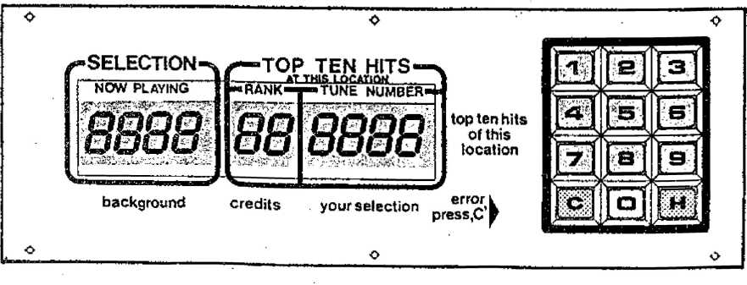

303
- Statistical p roQ r~£im
- Popularlty-from least played tl tf upward
Display | Designation | Remar ka | X
P01 | Number of least played CD. | Enter number *'0"  (Is switched on automatically).
 | Number of next least played CD, etc. upwards to the most played CD* | Advance with *1".
 | Rank of CD displayed. | Enter the number ”2".  The next display corresponds to the rank of this record Example display “S'* corresponds to the fifth least played record,
 | Total of this CD played (max. 255). | Enter number *'3*\ | If a pop. counter la greater than 200 at "power off**, all counters are divided by 2 (normalized). An “r“ appears on display 2 until the counters are reset (the pop. display Is relative).
 | Information on a certain CD. | Enter the number "4", the desired CD number and "H". The desired Information on this CD can be called up as described previously with the keye ^{M}1" through “3".

1.1.2 Popularity, | T nom | fc>est tltrlo upwards
PD2 Number of most played CD. |  | Enter number "0“  (Is switched on automatically).
Number of next most played CD etc. down to the least played CD. |  | Advance with ‘’f.
Rank of CO displayed. |  | Enter the number "2".  The next display corresponds to the rank of this record. Example display **5** corresponds to the fifth least played record.
Total of this CD played (max. 255). |  | Enter number "3*: | If a pop. counter Is greater than 200 at "power off", ell counters ere divided by 2. An "r“ appears on display 2 until the counters are reset. Get actual popularity, multiply all by 2.
Information on a certain | CD. | l : ‘  Enter the number ~4", the desired CD number and "H**. The desired Information on this CD can be called up as described previously with the keys “1" through *’3’'.

1.1.4- Counter and credit
Display | Designation | Remarks | X
PD3 | Cash balance In monetary (as programmed by the settings In P51 through P55).  5 digits. | Enter number "0"  (1 e switched on automatically). | X
 | Cash balance-accumulated-5 digits. | Enter the number "1".  Value shown must be multiplied by 100 to get total monetary units. | X
PQ4 | Play counter. | Enter number "0"  (Is switched on automatically). | X
 | Play counter, accumulated. | Enter number “i“_{f} | X
P05 | Number of selected title. | Enter number “0"  (Is switched on automatically). | X
poa | Number of album selections. |  | X
pot" | Number of free credits.^ |  | X *
PO0 | Number of background titles. |  | X

reset
Enter number "1" and ,,H“.
Enter number "2“ and "K‘\
Enter number “3** and “H". Enter number "4" and "M".
RIO Total reset of popularity (P01, P02) the
HIT-parade, the counters P03 through POfl and credits.
Resetting the popularity (P01, P02) and HIT-parade.
Resetting the counters (P03 through PQS). Cancel credits.
x
.1.5 Data trt-ans-fer
>11 Data transfer and memory (storage) with the DATA PRINT.
(from Progr.-Index 004)
Plug DATA PRINT Into "Service Socket" of control unit.
Enter Code “1" and "H\
Counters (P03-P06) and popularity will be transferred.
Display 3 "E0" appears in case of error during data transfer.
Also see description DATA PRINT.
^12 Transfer to DATA PRINT.
Note: Tf phonograph Is “coded", only the decoded values are printed out unless the code number Is entered.
(from Progr.-Index 003)
Plug printer Into the "service socket⁻ on the control unit. Enter
"1" = counters (P03 through P08) or "2" = counters (P03 through P0B), settings (P21 through P37, P39) or
"3" = counters (P03 through P08), popularity (P01, P02) or
"4" = counters, settings, popularity,
If overflow has taken place, the popularity Is relative, the multiplying of overflows Is printed out also.
If the printer does not operate, "E0" appears on display 3.
1.2 Specific Settings
- Standard Settings
Display Designation | Remarks | X
P2D Programming of steps P21 through P39 (for factory setting see table 1). | Press "1" and "H".  If values deviating from the table are desired, they* can be entered according to the following program steps. | X
Standard table for specific settings In program | step P20.
The following table shows the basic setting (factory setting) of the phonograph.
Tab.-Na Result In the Individual program step:

P2i: 0000 = unit code (for recording device)
P22: 0024 = maximum choice CD/track (100 CD'e/24 tracks)
'
P22{)200 = free credits
P24; 15 = Interval for random play In minutes
10 = Number of CD's for background P26: 1105 = Mght organ during standby P27: 1000 = light organ during play ^jP2Gc)lt6 s maximum Volume of both channels for
Only for models with light organ / luminous effects
coin-selected titles and background-CD
*)P30: 0 = No limit of playing time for a title
*)P31: 0 “ Playing In sequence of selection
*)P32: 0 = No limit on playing titles on the same CO
P39: 0000 = code number (data and program settings not coded)
*) from Progr.-Index 004
- Cod & number for DAT A PRINT
P21 Machine code number for DATA Enter code number between “0” and *’9999“ as well as x
PRINT "H*\
- Position Settings
P22 Number of maximum choke CD's , Enter desired number between "0101" and “0099'*
and tracks as well as "H”. CD-ifr. 00 * 100.
Example for 100 CD’s / 24“racks: "0024".
F r&& credits
S=*23 Number off free credits. Enter desired number and "H"..
°0" to "199": The number of free credits set can be
released Individually by the FREE CREDIT key on remote control.
“200": An unlimited number of free credits can be set and released by the FREE CREDIT ksy on remote control.
% ”201": The phonograph is continuously switched
to "free credits" when the FREE CREDIT key io pressed (Credit Display *99").
The phonograph is switched back to operating mode when the FREE CREDIT key is pressed again.
Display Designation  ^*'ª'24 Time Interval for random title. | Remarks x  Enter desired time Interval between '*0" and “255** minutes, x followed by "H". (No random titles are played when "Q"  Is entered).
P25 Number of background music CD. | Enter desired number between "0“ and **100“, followed by “H\  Background starts counting downwards starting with maximum number of CD's up (P22) to 6et number of background positions.  With setting "0** no background operation.

1-2.G Light Gondola / Light Or-gan (Only Tor models with, light organ / luminous effects)
 | A B C D
P26 Lum/nous effects for “stand by mode” or  P27 Luminous effects for "play mode’ | 0 0 0 1 Setting “A" corresponds to the switching x ill! characteristic: "0"-8low to T'-faat.  * * * * Setting *B" corresponds to speed of Inter- 13 15 vale (0-3).  Setting "C-D“ corresponds to the various types of light effects "T through “15".
s | Complete entry with the "H“-button.
P26 Continuous light for “stand by mode" P27 or  Continuous light for “play mode" | 0 0 0 0 Setting “B" corresponds to the desired x \ brightness (“0“ through "3“).  3 Compete entry with “H"-button.
P27 Light organ In "play mode". | 1 0 0 0 Setting "B^{M} Is for the desired basic x l brightness ("0“ through "3“).  3 Complete entry with the "H*'-button.

1.2.7 Volumes Tor Regular and Background Music
P28 Maximum volume. | Enter two digits each for desired maximum volume of x normally chosen and background titles as well aa "H". e.g.: 31 24  T T  ¹ Background  ———..— . — Normal

-2.B Maximum Playing Time
»30 Maximum playing time for a title (from Progr.-lndex 004) | Enter desired time In minutes between 0 and x 99 and then press “H".  With “0" no limit of playing time.
1-2.3 sequence of CD’s | playing
=»31 Sequence of CD's playing (from Progr.-Index 004) | Enter Number 0, 1 or 2 then press "H". x  - = In sequence of selection (FIFO)  - : In numerically Increasing sequence  - s random sequence

1.2.11 Authorization
_{P3}Q Authorization. Enter correct code number end
Each of the four digits Is confirmed by “P^{M}. After closing with ^{4,}H" "PPPP" Is shown and the operator Is thereby given authorization.
Only the correct code number enables access to protected _{x}... data. After closing of cabinet or going back to regular
program by pressing "C* twice, the programs are protected again.
1,2.12 Code number
P39 Code number. Changing of code number Is only possible when operator x
has been authorized In program step P38.
Enter new code number and "H**.
Each digit Is confirmed after entry with ^{M}P⁴\ After dosing with “H“ *PPPP'' Is shown. Possible entries between '’0000“ and “9999".
If “0000“ Is programmed, the machine Is not protected and access to all programs is possible without authorization.
A programmed code number la not show anymore, so please remember your code number!
- PRICE SETTINGS
1„3.1 Standard Settings, -from Program-Index 004
n***m*^—am ■iiwiii puntu ■ mmt «■— '•
Rmarto
Programming of tho program steps P41 Enter corresponding table No. and *H“.
x
¹-²’¹⁰ Mo.xi mum niia texorrr ^{C D}
x
Display Designation
P32 Maximum of tunas plae=d on the same CD (from Progr.-Index 004)
Enter desired maximum number of tunes played and then press "H".
With "0" no limit
through P46 (Standard setting). If values deviating from those In the table desired,
they can be changed according to the following program steps (P41 through P46).
Standard settings for plays per monetary value In program step P40. The result of the programming of a table ("0“ through “20“) shows the number of plays per monetary value allocated to the program steps P41 through P45. The monetary values ar programmed In monetary value units as they are set In P50 through P55: example table 17, psi: If no bonus Is to be given for a high monetary value, It is sufficient to program only the small monetary value, the total of the small values results In the larger value; example table 17; 1 x 25 c = 1 play + 100 c = 7 ploys.
Standard settings for P46 * “0".
Table- | Display of Program Number |  |  |  | Remarks/
NO. | P41 | P42 P43 | P44 | P45 | as set by tho factory
 | Sp/Gw | Sp/Gw Sp/Gw | Sp/GW | Sp/Gw
0 | 00 000 | 00 000 00 000 | 00 000 | 00 000 | no coin conversion In this setting.
1 | 01 050 | 01.050 01 050 | 01 050 | 01 050 | New Zealand 1 play * | 50 c | <5D
2 | 01 020 | 01 020 01 020 | 03 050 | 03 050 | Belgium 1 play = 3 plays = | 20,- Bfr 50,- Bfr | CD
3 | 01 005 | 01 005 03 010 | 03 010 | 07 020 | if desired, please adjust 1 play = | 5,-
 |  |  |  |  | 3 plays = | 10,-
 |  |  |  |  | 7 plays = | 20,-
<Cv | 02 050 | 02 050 05 100 | 05 100 | 12 200 | Austria 2 plays = | 6,- OS
 |  |  |  |  | 5 plays r | io,- as | CD
 |  |  |  |  | 12 plays = | 20,- os

^{02 0,0 02 0,0 05 020 05}eoirpbpmarraals.com^=ª £-SJ
12 plays = 5,- DM
^{r} * "
6 | 01 050 | 01 050 01 050 | 03 100 | 03 100 | USA | 1 play 3 plays | - 2x =■ 4x | 25 c 25 c | (jsp
7 | 02 010 | 02 010 02 010 | 12 050 | 12 050 | Norway | 2 plays 12 plays |  | 1_{t}- Kr 5,- Kr
0 | 01 010 | 01 010 03 020 | 03 020 | 03 020 | Venezuela | 1 play 3 plays (7 plays | = | - - Bot  - - Bol 5,- Bol)
9 | 01 010 | 01 010 03 020 | 03 020 | 10 050 | Ireland | 1 ptay 3 ptays 10 plays | s  ” | 10 p 20 p 50 P
10 | 03 010 | 03 010 07 020 | 07 020 | 10 050 | Switzerland | 3 plays 7 plays 16 plays | te  r  at | 1₍- sfr 2,- sfr 5,- sfr | <M>
11 | 01 030 | 01 030 02 050 | 02 050 | 05 100 | United Kingdom Denmark | - play  - plays 5 plays | I | 30 p C$h " «
12 | 01 020 | 01 020 01 020 | 03 050 | 03 050 | Yugoslavia (Oln) Finland (mK) | 1 play 3 plays | * 2x  S | s,- CE>
13 | 01 020 | 01 020 03 050 | 03 050 | 07 100 | Union of South Africa France | 1 Play 3 plays 7 plays | 2=  SS | e ('slip  v r CD
14 | 01 040 | 01 040 02 060 | 03 080 | 04 100 | Australia | - play  - plays  - ptays  - plays | = 2X = 3X = 4x  s | 20 c 20 c 20 c 1 Dollar
IS | 01 025 | Ot 025 01 025 | 01 025 | 01 025 | Canada  Dutch Antilles | 1 play 4 plays | = | 25 0  1 NAF <JT)
16 | 01 025 | 01 025 01 025 | 05 100 | 05 100 | Spain fpts) | 1 play 5 plays | = | 0,25  V | CD
17 | 01 050 | 01 050 03 100 | 03 100 | 18 500 | USA | 1 play 3 plays 18 plays | - | 50 c 1 $ 5 $
10 | 01 too | 01 100 03 2E0 | 03 250 | 07 500 | Netherlands | 1 Play 3 plays 7 plays | ~ 4x  5? | 25 C 2,5 hfl 5 hfl
19 | 01 100 | 01 100 03 200 | 03 200 | 05 300 | Japan | 1 Play 3 ptays 5 plays | s  = 2x = 3x | 100 Yen 100 Yen 100 Yen | CD
20 | 01 040 | 01 040 01 040 | 03 100 | 03 100 | Italy | 1 play 3 plays | * 2x = 2X | 200 L 500 L | CD
i „3-2 Price List: (Number of |  |  |  |  | Setectlons/Monetary |  |  | Va! ue)
Display Designation |  |  |  |  | Remarks |  |  |  | X
P41  F*42  ff»43 IP <4-4 p>4G | Number of selection* per (smallest value),  Operating display are analogous to program step P41 |  | coin |  | Enter desired number of plays coin (smallest value) and “H\  Entry sequence: 2 digits for number of plays, 3 digits for corresponding coin e.g. 01 020 correspond to one play for 20 pence.  Largest programmable number of plays up to 63, price list from 005 to 995.  Note: Ah five program steps must be programmed with the price classes In the sequence or their priority. For lass than 5 price classes program more than once or set to "00 000". |  |  |  | X  X  X  X  X
p46 | Number of required credits for one album. |  |  |  | Enter desired number and selection allowed. | "K", At “0 | no | album | X

^{SETT}mnc
Settl n gs ¹
1--4. MONETARY Standard
t
F**50 Programming of the program steps Enter corresponding table and "H"« x
P51 through P55 {Standard setting). if values other than those In the table are desired.
they can be changed according to the following program steps (P5t through P55).
The monotary value settings In the Individual program steps are associated with the corresponding coin channel:
P51 for channel 1; P52 for channel 2, etc. to P55 for channel 5. This table shows the coin values for the corresponding channel In the currency of the columns PS1 through P55.
Standard setting of P55 = "0".
Table- | Display of Program Number |  |  |  |  | Remarks/
No. | P61 (Oanll) | P62 (CM 2J | P53 CM 2) | P54 Mil | P55 (CMS) | as eet by the factory
0 | 000 | 000 | 000 | 000 | ooo | no coin conversion In | thla setting
1 | 010 | 050 | 020 | 000 | ooo
 | V DM | 5*- DM | 2DM | “l* |  | Germany
 | 1 Dol | 5 Bol | 2 Bol | “l" |  | Venezuela
 | 1,- sfr | 5,- sfr | Zr sfr | V |  | Switzerland
2 | 050 | 200 | 100 | 000 | ooo |  | CD
 | 5 S | 20 S | 10 s | *»" | “l⁻ | Austria
3 | 020 200 l | 010 100 L | 050 500 L | 000  *«■* | ooo  “»* | Italy | CD
A | 000 | 050 | 010 | 000 | ooo |  | 0  @0
 |  | 5 mK | t mK |  |  | Finland
 | "l" | 5 Kr 5 Din | 1 Kr 1 Din | “l“ | "l" | Norway  Yugoslavia
5 | 025 | 250 | 100 | 000 | ooo |  | CD
 | 25 C | 2»5 hfl | 1 hfl |  | *”l*“ | Netherland
a | 000 | 100 | 025 | 000 | ooo |  | CD
 | “l“ | 1 r NAF | 0,25 NAF |  |  | Motherland Antlllen
7 | 000 | 020 | 005 | 000 | ooo |  | CD
 | “»“ | 20 Bfr | 5 Bfr | "r |  | Belgium
8 | 010 | 050 | 100 | 000 | ooo |  | ^CD  CD
 | t Fr | 5 Fr | 10 Fr |  |  | France
 | 1 dkr | 5 dkr | 10 dkr | ”r |  | Denmark
8 | 020 | 050 | 010 | ooo | ooo | United Kingdom/
 | 20 p | 50 p | 10 p | »— |  | Ireland | CD
10 | 010 | 050 | 025 | 000 | 100 |  | CD
 | 10 c | 50 C | 25 c |  | 1 Dollar | USA
11 | 000 | 025 | 000 | 000 | 100 |  | CD
 |  | 25 C | ”l" |  | 1 Dollar | Canada
12 | 020 | 100 | 050 | ooo | 000 |  | CD
 | 20 c | 1 R | 50 c |  |  | Union of South Africa
13 | 100 | 050 | 020 | ooo | ooo |  | (Tup  CD
 | 1 Dollar | 50 c | 20 C | "»* |  | Australia
 | 100 Yen | $0 Yen | 20 Yen |  |  | Japan
H | 000 | 025 | 100 | ooo | ooo |  | CD
 | *r | 25 pts | 100 pts |  | "V" | Spain
Co!r» Accept'

Enter desired coin value for channel 1 and "H". Example: '’010*' corresponds to 10p, “020" to 20p and Monetary Setting “tOO" corresponds to 1 £.
for Note: When a coin is Inserted In the program steps
electr. Coin P50 through P55 the channel assigned to this coin
Acceptor see Is automatically displayed on display 1; P51 for channel chapter to, 2 etc. to PSS for channel 5.
Not used channels are set to “O’*!
The programmed monetary units for P51 through P55 must correspond to the unit programmed by the cash counter P03>, e.g. 050 units for 50p, 020 units for 20p and 100 units for 1 £.
P56 Bonus credits for bills. Enter desired number and “H*\ When a dollar bill x
is Inserted (Channel 5/P55), the programmed value Is added to the credit-
m
.L
Table- | Display of Program Number |  |  |  |  | Remarks/
No. | P51 (OMdi) | P52 lOwnd l) | P53 (Omd 3] | P54 lOrct <] | P55 (tanh) | as set by the factory
15 | 100 | 020 | 010 | oso | 000 |  | CD  Cm)
 | 10 Fr | 2 Fr | 1 Fr | 5 Fr |  | France
 | \ £ | 20 p | 10 p | 50 p |  | United Kingdom
16 | 050 | 010 | 000 | 020 | 000 |  | CD
 | 5,- DM | 1,- DM |  | 2.- DM | f | Germany
17 | 050 | 010 | 005 | 020 | 000 |  | CD®  CsD
 | 5,~ sfr | 1,- sfr | 1/2 sfr | 2,- 6fr |  | Switzerland
 | 500 L | (100 L) | (50 L) | 200 L |  | Italy
 | 50 c |  | 5 c | 20 C |  | New Seeland
18 | 100 | 050 | 010 | 100 | 000 | bel 4-Channel (1 A) | CD
 | 10 dkr (neu) 5 dkr |  | 1 dkr | 10 dkr (alt) -_{f}- |  | Denmark
19 | 200 | 050 | 010 | 100 | ooo |  | CD
 | 20 S | S $ | 1 S | 10 s |  | Austria
20 | 025 | 250 | 500 | 100 | 000 |  | CD
 | 25 c | 2 1/2 hfl | 5 hfl | 1 hfl |  | Net her I and

i
0
a
o
v
4
j:
'5
u / > o
.s
l
l
Monetary setting for electr. Coin Acceptor see chapter 10,
Monetary settings coinopms
*
Monetary th r<3>cj c| hi | v/a.I ues &> | (Allocated to coin channels 1
Olsplay Designation |  | Remarks , | X

P51 Coin value channel 1.
x
P52 Operation and display P53 are analogous to P54 program step P51. P55
X
X
X
x

The displays In this program step actGGlP Uf_{P}
In the event of a malfunction the defective unit can be determined or a malfunction resulting from Incorrect settings can be recognized In a simple manner with the aid of these tests. Certain displays are aids for the adjustment of the playing mechanism*
Switch on test program: Open cabinet lid pull out Interlock cabinet switch Display 1 shows “P01", press letter "C".
0l6play 1 shows *‘P“.
Press number 60 and "H“_{r} Display 1 shows ’*P60”.
P60 *
Enter “2'* and "H", Display 2 "F2^{M} (second function test).
A
1*5.1' Display T"est, Display 1 ” P60"
This program tests the lights and appears on display 2.  The test Is run through In steps:  The "FI" Is displayed for approx. | displays on the display circuit board. After starting "FI" (first function test)  - All 5 display lights together.  - The digits are switched on one after another Individually with ”8”.  - The display lamps 1 through 5 individually,  - Displays together, running through the numbers "0° through ”9‘\  2 seconds before the test repeats, Itself.
Designation |  | Remark 6
Display test -continuous test-. |  | Enter ”1“ and **H*\ Display 2 “F1“.
Stop test sequence. |  | Enter ”H". The light "10 top hits" comes on.
Contlnne test sequence. |  | Enter "H^{M} again. The light "10 top hits'¹ goes off.
Terminate test. |  | Enter "C" once, display 1 “PCO" or actuate cabinet Switch, the unit returns to
 |  | the regular program.

1-5-2 Input “Test, Display 1
In the following test the functions of all entries of Input Ports 1-6 can be tested:
Port 1, Port 2 : Control Unit
Port 3 : Keyboard (Display Board)
Port 4, Port 5 : Pickup Driver Port 6 : Title Indication
Every Input change Is shown on the display as follows;
Input Test
Display
P 2
Bit Information ^(Switch Status 1 or 0)
-Bit-Number (0 to 7)
~Port“Number:
Control Unit Control Unit Keyboard Pickup Driver
5 = Pickup Driver
108 IC9 IC 304 1C 1 1C 2
6 = Title Indication IC 1

Meaning of the displays:
1 2 3
 |  |  | EE | ! |  | 6 0

"F2" ª Input Test T " Port 1 (IC9)
*6** - Bit 6 (Key Switch)
"0" = Switch Status 0 (closed)
Instruction: The accuracy of the Inputs from tho koyboard can bo checked due to the entry connections 6imply by selecting a title!
Enter "C¹¹ 1, display *'P60" or actuate cabinet switch, the phonograph returns to the norjna! program.
Terminate test.
Enter ^{M}3" and "H", Display 2 ^{M}F3^{,t}.
After that select the CD with which to begin.
Continuous Run 1
Display:
t
oPr9n!^{l}?oPPoP1:PlP^fel?u9in.
he machine Is switched to contlnuo® election. All error, of the CO changer or CD player are registered.

EH C
-Number of errors
^{r}or 16 sec. beginning with the first
Terminate test. Actuate housing switch.
- Continuous Rum 2
The machine Is switched to continuous run. All selected titles are played for 16 sec. All errors of the CD changer or :layer are registered.
Continuous Test 2 Enter ^{m}A^{m} and ^{M}H*» Display 2 "F4*\
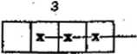
The select any title.
Display;
1

eh
Number of errors
Terminate test. Actuate housing switch.
1.5.6 CD changer T'e»st
All functions of the changer can be tested individually.
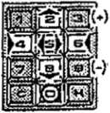
CD changer Enter "5" and ’’H”, Display 2 "F5".
Keep in mind the code numbers for the Individual changer functions as per the following keyboard illustration:
test
Input Function
- CD-Player, Start/Stop
- Lift, upwards
- Lift, downwards
- Grip left
6 Grip right
- Return holder
0 Stop lift at magazine space
- *) Motor steps, upwards (per 0,5 mrr)
- *) Motor steps, downwards (per 0,5 mm)
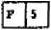
-The time In sec. during which the lift position Is held. The lift position is held after every function for 2 sec.; by touching for 10 sek.
Display:
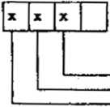
L - —OPTO stepper control OPSTP
■ —OPTO end position OPSND
OPTO grip right OPGRR
—OPTO pickup center OPPUM OPTO grip left OPGRL
Meaning of displays: OPTO lit up = "0“, OPTO darkened = "1". .
Terminate test. Actuate housing switch.
¹ -G.© Tr^fCk soleo-tlon o-f CO test records
— cninonmanual's.com— —
Track selection of CO test records (more Select the required CD record and track number and
than 15 tracks per record). | press "H^{H}, e.g. 0123 - Disc 01, Track 23.  The selected title win be stored and played after returning to play mode.

1 - £5- *7 Read-out o-f errors
P82 Error code of last error  (see descr. error displays). | Enter '*0'\  (Is automatically switched on).
Error code of previous errors (see descr. error displays). | Advance with key ”1". Up to max. 10 errors.
At error code 0x no. of CD at which error occurred.  At error code 9x no. of cover at which error occurred. | Enter "2\
Tima since power on or start of test P60/3 or P60/4 when error occurs. | Enter "2".  Display In hrs., min.
Cancellation of stored error code. | Enter "4^{M}, "1" and “H".

UNIT DESCRIPTION
CONTROL UNIT
FOR NSM-PHONOGRAPGHS
m r»-cs iscmo&tjgg
- 903 SILVER CITY 174 831 SILVER SKY
tD
Technical Information, Assy
SartarctetraBe 240 830 Bingen m Rtein
- 486 FASCINATION
- 274 SOUNDMASTER
- 040 FIREBIRD/COUNTRY
- 046 THE PERFORMER "GRAND"
4
Page 401-408/411
1 FUNCTION
- Control unit
- Processor
- Reset
- Low voltage recognition and power off
- I/O (input/output)
- Output enable
- Service plug
Spare parts list Schematics CONTROL UNIT CD
1-1 CONTROL UNIT
The heart of the control and credit unit is a microprocessor from the proven Rockwell 6500 family.
All unit’‘functions such as keyboard, display, remote control, carriage (light generator / organ), coin mechanism, title indication etc. are controlled by this unit.
Different types of malfunctions are recognized and reported as such on the display. All statistical data such as phonograph status, price adjustments and bookkeeping data are stored in the CONTROL UNIT. These as well as credits remaining are stored when the power is switched off.
Connection of the DATA PRINT is provided at Plug 11.
A number of service programs allow the read-out of statistical data, individual as well as test programs.
- Rnocessor
The processor consists primarily of the microprocessor IC 1, the EPROM IC 2, the battery RAM IC 3 and the I/O component IC 4. Address coding occurs via IC 12.
The tact generator consists of a quartz oscillator with Q 1 (4 MHz) and the frequency divider (1:4) IC 14.
1 .3 Reset
The Zener diode ZD 2 with transistors T1 and T2 serves to activate the reset when U (+5 V) is less than 4,6 V.
Transistor T2 with its antenna connection serves to recognize static discharges and interferences.
When T 2/C is LOW, reset is activated via IC 16, Pin 10, Pin 11. If T 2/C is HIGH, reset remains stored for approx. 200 msec, over the subsequent monoflop 1/2 IC 13 with timing components R 14, C 19 via IC 16, Pin 9.
1 .4 Low Voltage Recognition and Rowan Off
Resistors R 15, R 16, R 18 from a voltage divider for low voltage recognition.
R 17 and D 6 generate a hysteresis when the voltage rises again. The positive edges (10 msec, at 50 Hz, 8.3 msec, at 60 Hz) coming from T 3/C retrigger the monoflop 1/2 IC 13 with timing components R 20, C 20 (approx. 20 msec.) and IC 13, Pin 4 at LOW.
This signal is monitored by the processor via IC 4, Pin 6.
When IC 4, Pin 6 is HIGH, the program is prematurely deactivated.
1-5 I/O (Input/Output)
All I/O operations are controlled via a serial bi-directional interface (IC 4, Pin 18 = CLOCK; IC 4, Pin 19 = DATA). IC 18 selects the different input channels; IC 11 decodes the load impulses for the output channels.
Output: IC 5 and IC 6 are output ports.
Resistors R 22-40 together make two D/A converters. The DC signals obtained thereby control the volume and are conducted to the amplifiers via plugs ST 2, Pin 2, Pin 3.
Input: IC 8 and IC 9 are input ports.
The resistors, in sequence to the Input pins, protect the CMOS components.
Serial interfaces are available:
At ST 3 for control of the light generator At ST 4 for display and keyboard At ST 8 for control of CD changer At ST 10 for control of Title Indication.
- Output — Enable
A clock signal is sent by IC 4, Pin 5. Capacitor IC 26 Is charged keeps IC 15, Pin 8 at LOW.
If the clock signal does not occur, IC 15, Pin 14 is LOW and OE of IC 5 and IC 6 Is Inactive (outputs in tree state),
OE also become inactive via D 1 when reset (IC 16, Pin 11) becomes LOW.
- Service Plug
Plug ST 11 serves to connect with the DATA PRINT.
m aa / m oi i mini w w / m w mu w
404
NSM
0W* “=
m O

0!
O*⁴
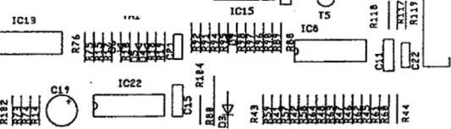
CONTROL UNIT CD
*IC2
)
-XC2.

IC1
IC12
>o
ics c« ret | IClt Cl  n
) > | ^Qf
l-J
 | nPl%
> | IC9

lo
Cl 7
IC26
IC2S
vr
-o
r
ci6 ST 1
T
ST2
ST3
ICU
ST11
IC17 C24[ C23[
I Cl 4
O

oii
IC23
IC24
ST10
2 T1 T 2
_L> I Cl 6
] oG”&
^ ' ta«
IC21
ST4
ST8
ST5
ST6 ST7 ST9
r“T
^O© 174 M3 / 174 831 / 174 436 / 175 274 / 175 WO /175 046

SPARE PARIS LIST
rnaiim ——n—1
POS. | PART-No. |  | DESCRIPTION | DATA | QTY
ST 07 | 174  225 | 873  651 | CB-CONTROL UNIT CD. ASSY PIN PANEL | 4 prongs | 1  1
ST 03,06 | 225 | 652 | PIN PANEL | 6 prongs | 2
ST 08 | 225 | 653 | PIN PANEL | 8 prongs | 1
ST to | 225 | 654 | PIN PANEL | 10 prongs | 1
ST 01 | 225 | 655 | PIN PANEL | 12 prongs | 1
ST 02 | 225 | 656 | PIN PANEL | 15 prongs | 1
ST 08 | 225 | 439 | PIN PLUG | 3 prongs | 1
ST 06 | 225 | 444 | PIN PLUG | 8 prongs | 1
ST tl | 225 | 828 | D-SUBMINIATURE-CONNECTOR | SLEEVE 9 prongs 1
Qt | 221 | 535 | OSCILLATOR QUARTS | 4 MHz | 1
IC3 | 222 | 446 | IC-SOCKET | 24 prongs | >
 | 231 | 423 | IC-MEMORY | MK 48 Z 12-20 | 1
IC2 | 222 | 447 | IC-SOCKET | 28 prongs | >
 | 175 | 102 | IC-MEMORY Program 007 | AM 27 256 DC | 1
IC1,4 | 222 | 448 | IC-SOCKET | 40 prongs | 2
K1 | 231 | 413 | IC-MICROCOMPUTER | R 65 C 02 - P 2 | 1
1C 4 | 231 | 415 | IC-MICROCOMPUTER | R 65 C 22 - P 2 | 1
1C 8,9 | 221 | 763 | IC-CMOS | HEF 4021 B | 2
1C 5,6 | 221 | 771 | IC-CMOS | HEF 4094 B | 2
IC 21-23 | 221 | 541 | IC-CMOS | F 4049 BC | 3
IC 16 | 221 | 665 | IC-TTL | SN 74 LS 00 | 1
IC 19 | 221 | 525 | IC-TTL | SN 74 LS 03 | 1
IC 1? | 221 | 652 | IC-TTL | SN 74 LS 04 | 1
IC 14,20 | 221 | 705 | IC-TTL | SN 74 LS 74 A | 2
IC 13 | 221 | 792 | IC-TTL | SN 74 LS 123 | 1
1C 12 | 221 | 653 | IC-TTL | SN 74 LS 139 . | 1
IC 18 | 221 | 852 | IC-TTL | SN 74 LS 151 | 1  1  1
1C 11 | 221 | 796 | IC-TTL | SN 74 LS 138
IC 15 | 221 | 813 | IC-LINEAR | LM 339
IC 26 | 221 | 497 | IC-LINEAR | ULN 2003 A | 1
03 | 221 | 115 | SI-DIODE | 1 N 4004 | 1
DU  4-16 | 221 | 114 | SI-DIODE | 1 N 4148 | >  16  1  1  1
ZD 1 | 221 | 539 | TRANZORB DIODE | IC TE-5
ZD2 | 221 | 948 | ZENER-DIODE | ZPD 3,9
LE01 | 221 | 466 | LIGHT EMITTING DIODE | LR 3160-F
TU | 221 | 757 | TRANSISTOR | BC 547 B | 2
T 3,5 | 221 | 283 | TRANSISTOR | BC 212 B | 2

SPARE PARTS LIST
POS. | PART-NO. |  | DESCRIPTION | DATA |  |  | QTY
C 22 | 220 | 181 | CER.-CAPACITOR | 47 pF |  |  | 1
C 23 | 220 | 242 | CER.-CAPACITOR | 68 pF |  |  | 1
C 24 | 220 | 185 | CER.-CAPACITOR | 270 pF |  |  | 1
C 18,28 | 220 | 263 | CER.-CAPACITOR | 1000 pF |  |  | 2
C 21 | 220 | 341 | CER.-CAPACITOR | 4700 pF |  |  | 1
C 1-95, |  |  |  |  |  |  | >
25,27 | 220 | 334 | MKT-CAPACITOR | 0,1 pF | 63 | V | 17
C 19,20, |  |  |  |  |  |  | >
26 | 220 | 159 | LYTIC | 4,7 pF | 63 | V | 3
C 17 | 220 | 162 | LYTIC | 10 pF | 63 | V | 1
cie | 220 | 160 | LYTIC | 100 pF | 10 | V | 1
RU, |  |  |  |  |  |  | >
116 | 221 | 600 | RESISTOR | 100 Q | } | w | 3
ft 12, I9, |  |  |  |  |  |  | >
79 | 221 | 099 | RESISTOR | 470 0 | i | w | 3
R 93 | 221 | 622 | RESISTOR | 820 0 | i | w | 1
ft 10, 87 | 221 | 029 | RESISTOR | 1 Kfi | i | w | 1
R13 | 221 | 031 | RESISTOR | 2,2 KC | i | w | 1
R 2-4, |  |  |  |  |  |  | >
102-104, |  |  |  |  |  |  | >
108-110 | 221 | 033 | RESISTOR | 3,3 KQ | i | w | 13
ft 84, 88, |  |  |  |  |  |  | >
89, 94, |  |  |  |  |  |  | >
119,101, |  |  |  |  |  |  | >
105,113 | 221 | 034 | RESISTOR | 4,7 KQ | i | w | 8
R1,15 | 221 | 172 | RESISTOR | 8,2 KQ | i | w | 2
R11,18, |  |  |  |  |  |  | >
20, 47, |  |  |  |  |  |  | >
74, 76, |  |  |  |  |  |  | >
82, 83, |  |  |  |  |  |  | >
mt, |  |  |  |  |  |  | >
96, 111, |  |  |  |  |  |  | >
112, H4, |  |  |  |  |  |  | >
115 | 221 | 035 | RESISTOR | 10 KQ | i | w | 16
R16,21, |  |  |  |  |  |  | >
27, 33-40 |  |  |  |  |  |  | >
73, 75, |  |  |  |  |  |  | >
85 | 221 | 604 | RESISTOR | 22 KQ | * | w | 14
R 17 | 221 | 601 | RESISTOR | 27 KQ | i | w | 1
ft 22-26, |  |  |  |  |  |  | >
28-32, |  |  |  |  |  |  | >
41-72, |  |  |  |  |  |  | >
38,99 | 221 | 038 | RESISTOR | 47 KQ | i | w | 44
R 14, 81, |  |  |  |  |  |  | >
86,95 | 221 | 048 | RESISTOR | 100 KQ | i | w | 4
R 80 | 221 | 273 | RESISTOR | 10 Q | i | w | 1

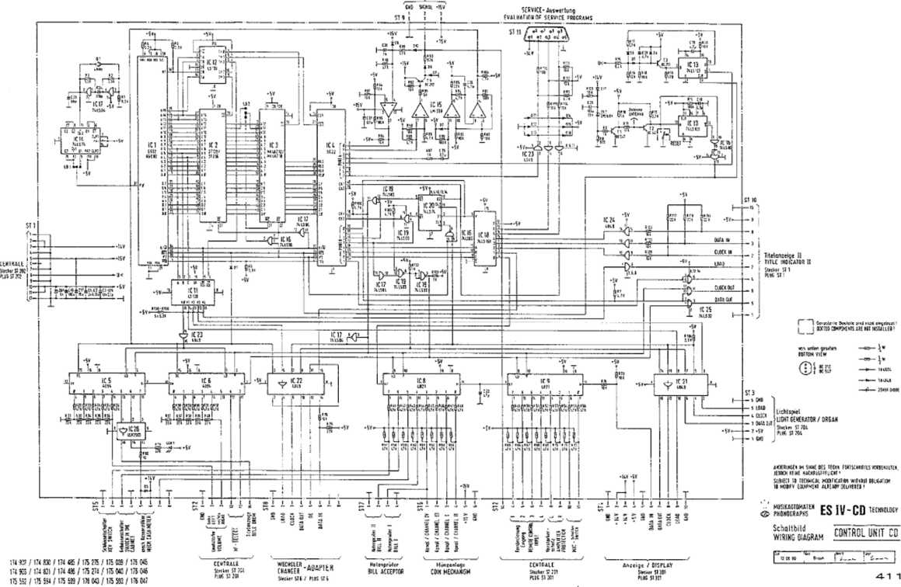
coinopmanuals.com
ft<naA)M»McMuO
CCitVfCtiOti (SMOTE SfltC'iOH W4UB0X

UNIT DESCRIPTION
DISPLAY/KEYBOARD FOR NSM-PHONOGRAPHS

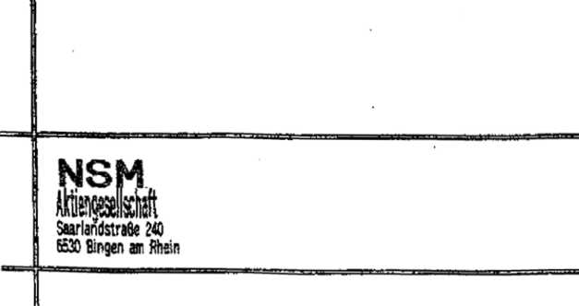
Page 501-505/511
174 903 174 831
- 486
- 274
- 040
- 046
to
Technical Information, Assy
SILVER CITY
SILVER SKY
FASCINATION
SOUNDMASTER
FIREBIRD/COUNTRY
THE PERFORMER “GRAND’’

174 *3 / 174 831 / 174 486 / 175 27*/ 175 0« / 176 044
 | FUNCTION
1.1 | Display
1.2 | Keyboard
 | Spare parts list

502

- Display
The shift registers IC 301 through IC 303 are the output ports for the display control.
The display is operated in the multiplex mode.
The segment information Is prepared for one digit with IC 302 and IC 303 via drivers IC 308 and IC 309.
The transistors T 303 through T 305 are controlled by IC 307 via IC 301 and switch on the appropriate multiplex level for 4 milliseconds.
Resistors R 332 to R 345 determine the segment current.
Lamps L 1 to L 5 are controlled statically via IC 307, Pin 12 and 14 and IC 306, Pin 19, 11, 12.
Resistors R 325 to R 329 limit the transient current.;
The load signal for the output shift registers is monitored by circuit IC 306, Pin 4 and 13; R 306; C 303; D 301.
During the duration of the load signal the display is dark.
C 303 is discharged via D 301 and IC 306, Pin 13.
OE of IC 301 to IC 303 becomes LOW and thereby inactive.
If no load signal occurs, OE becomes inactive via R 305.
Capacitor C 302 avoids lighting up of the digits after switching on.
1.2 Keyboard v .
IC 301 is an input port for the keyboard which Is connected to plug ST 302.
The circuit with diodes D 302 - D 307 and transistors T 306, T 307 codes the keyboard matrix to a 4-bit signal combination.
504 ■ 174 903 / !74 33!/174 <86 / 175 274 / 175 040 / 1W 04«

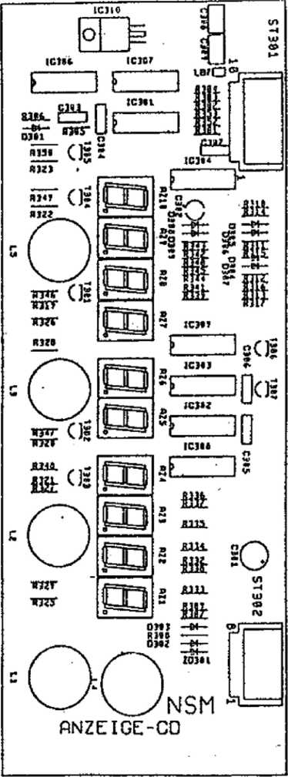
SPARE PARTS LIST

SPARE PARTS LIST
POS. | PART-No. | DESCRIPTION | DATA |  | OTY
 | 173 664 | CB-DISPLAY CD. ASSY |  |  | 1
ST 352 | 225 663 | PIN PANEL | 8 prongs 90’ |  | 1
ST 301 | 225 664 | PIN PANEL | 10 prongs 90* |  | 1
AZ1-8 | 231 416 | DISPLAY | TD SL 5150 |  | 10
 | 173 384 | TUBUS |  |  | 1
 | 171 629 | HOLDER |  |  | 4
IC 310 | 221 573 | IC-VOLTAGE | 12 V | 1 A | 1
ST 301-303 | 221 771 | IC-CMOS | HEF 4094 | B | 3
IC 304 | 221 763 | IC-CMOS | HEF 4021 | B | 1
ST 306-309 221 497 |  | IC-LINEAR | ULN 2003 | A | 4
0 301-30? | 221 114 | SI-DIODE | 1 N 4148 |  | 7
ZD 301 | 231 079 | ZENER-DIODE | ZPD 4,7 |  | 1
1301-3(6 | 231 240 | SI-TRANSISTOR | BC 636 F |  | 5
T 306, 30? | 221 283 | SI-TRANSISTOR | BC 212 B |  | 2
T 303-30? | 220 334 | MKT-CAPACITOR | 0,1 nF | 63 V | 5
C3C8,309 | 220 332 | MKT-CAPACITOR | 0,33 pF | 63 V | 2
C 302 | 220 249 | LYTIC | 1 mf | 63 V | 1
C 301 | 220 162 | LYTIC | 10 pF | 63 V | 1
R 301 | 221 611 | RESISTOR | 10 Q | i W | 1
R 306, |  |  |  |  | >
332-350 | 221 627 | RESISTOR | 1,2 KQ | J W | 20
R 332-301, |  |  |  |  | >
301-309, |  |  |  |  | >
314-31?, |  |  |  |  | >
319-323, |  |  |  |  | >
354 | 221 033 | RESISTOR | 3,3 KQ | i w | 16
R 310-213 | 221 038 | RESISTOR | 47 KQ | i W | 4
R 306 | 221 009 | RESISTOR | 1 MQ | i W | 1
R 325-329 | 231 366 | MET.-RESISTOR | 10 0 | i w | 5

- 900 KEY BOARD, ASSY
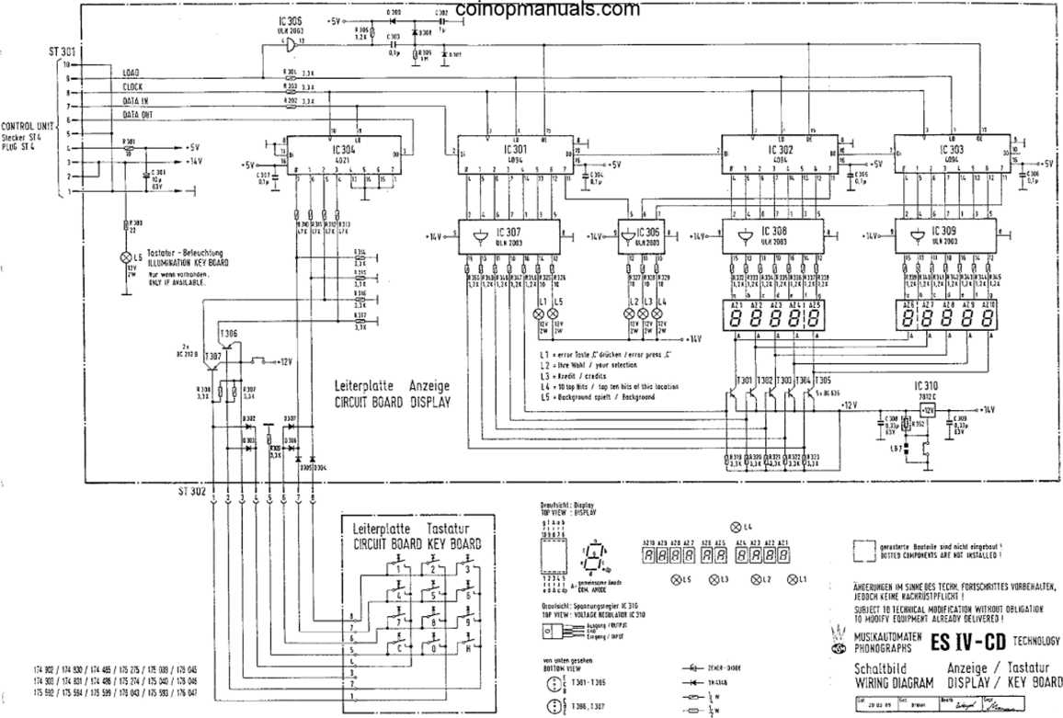
51 1

UNIT DESCRIPTION CENTRAL UNIT
\
FOR NSM-PHONOGRAPHS
- 903 SILVE 174 831 SILVErt s>nt
to
Technical Information, Assy
- 486 FASCINATION
- 274 SOUNDMASTER
- 040 FIREBIRD/COUNTRY
- 046 THE PERFORMER "GRAND"

INDEX
- FUNCTION
  - Power Supply
  - Amplifier
  - Signal path
  - Adjustment of controls
  - MIC socket, microphone connection
  - TB socket
    - Tape recorder connection
    - Connection of auxiliary amplifier
- Adjustment instructions for trimmer of centrai unit and output stage
- Repair aid
  - Output stage
  - Control of volume and muting
  - Tracing sound signal
The power supply, fan controls, stereo amplifier with inputs for microphone, CD and tape are all integrated on one circuit board.
The output stages and the fan are connected to the central unit via ST 209, ST 210, ST 211. The music power per channel is 200 watts when matched to a loudspeaker impedance of 2 ohms.
1-1 Rower Supply
.The power transformer supplies 22 V, 2 x 11,5 V and 2 x 43 V from three separate secondary coils. The supply voltage for the output stages is supplied with 2 x 43 V by a two-way rectifier (D 206) and the center tap of the transformer.
The supply voltage for the voltage regulator VR 201, +5 V is supplied with
- x 11,5 V by a two-way rectifier (D 201/202) and the center tap on the
transformer. The low voltage recognition is accomplished by D 204 and D 205. Fusing is accomplished with Si 201 and Si 202. Fusing for the output stage is accomplished with Si 204 and Si 205.
The non-control led voltage +14 V for the display and key Illumination is being picked up at capacitor C 201.
The control voltage of +15 Va, for the pickup driver, coin mechanism, control unit, remote control, luminous effects as well as the supply voitage for the preamplifier of +15 Vb, are supplied by the 22 V transformer coll
and rectified by D 207 through 210 and VR 203. Fusing is accomplished by
Si 203.
The LED’s indicate the following supply voltages at the same intensity:
LED 201 = + 5 V
LED 202 = +60 V LED 203 - +15 V a LED 204 = +15 V b
The TRIAC TIC 200 controls the output stage fan depending upon the operational state of the amplifier (REJECT); i.el the fan only runs when the amplifier is not muted.
- Ampl ifier
The stereo amplifier is equipped with two tone control IC’s, one AF switch IC, 50 diodes and 17 transistors.
The output stage Is designed without induction coils or transformers and Is therefore ironless.
At full volume level the music power is 200 watts per channel.
- Signal p at hi
The input signal MIC goes to microphone amplifier T 230 and background mixer of TA, TR 231 to Pins 4 and 6 of IC 230. The TB input is connected to Pins 3 and 7. The CD input is connected to Pin 2 and Pin 6.
In the play mode the signal goes from Pin 2 to Pin 15 respectively through Pin 6 and Pin 9,
When the microphone switch is actuated, the signal goes from Pin 4 to Pin 15 or from Pin 8 to Pi_{n} 9.
In the tape mode (TB/Pin 6 to ground) the signal goes from Pin 3 to Pin 15 or Pin 7 to Pin 9 when the switch Is actuated. In the MIC, CD or TB stage, muting is switched off regardless of the operating state of the phonograph. The stage "MIC" has priority switching.
From the AF switch (ic 230) the signal goes via an AVC (automatic volume control) T 250, T 251 at Pin 9 of the tone control 1C 251 with associated bas£ booster. Treble control is accomplished with TR 252 and bass control with TR 253. The control voltage for the volume and muting is on Pin 5; approx. 2,5 V at full volume, approx. 0 V while muting.
The DC signal for the volume setting is supplied by the control unit.
Signal Output Pins 3 and 6 of 1C 251 are routed through a network to the driver stage for the output stage.
The parallel complementary power Darlington transistors T 151 through T 154 in the output stage allow a minimum loudspeaker impedance of 2 ohms. Quiescent current compensation and thermic stabilization is accomplished with T 150, the quiescent current setting with TR 250. The amplifier Is equipped with three protective circuits against overload mismatching, thermic overload.
- ) T 155 acts as a threshold switch for the electronic fuse. When the emitter current of the output transistors exceeds a certain value, T 252 is switched through by T 155 switching on the muting and thereby limiting the current.
- ) The actuation of the electronic fuse at collector T 252 is controlled by the control unit.
When its fuse is tripped a number of times within a certain period, the volume is reduced automatically by one step each time until the electronic fuse is no longer activated.
- ) The thermal switch on the heat sink switches off the power supply to the outpuf stage when the heat sink temperature reaches approx. 90 C (cooling malfunctioning). LED 150 Is dark. The switch-on point (following cooling down) is approx. 60 C (switch-on hysteresis).
The terminating Impedance at the loudspeaker output should not be less than 2 ohms. In the case of mismatching (less than 2 ohms), or short-circuit in the loudspeaker cable, the limiting circuit Is actuated.
The result Is distorted sound reproduction or reduction of the volume. After elimination of the mismatch the amplifier Is ready for operation and the volume can be readjusted.
The volume difference between the two channels is compensated at the factory by setting the levelling potentiometer TR 254.
1 . A- Adjustment ot Controls
microphone volume
TR 230 TR 231 TR 252 TR 253
music fade-in for microphone mode
treble control
bass control
TR 230 for setting the microphone amplifier:
This adjustment is dependent upon the position of the phonograph in relation to the microphone and required microphone volume.
In case of feedback while paging, the control must be turned counterclockwise or the microphone be positioned In another direction to the speakers.
TR 231 for music fade-in in microphone mode:
There the desired music volume level during paging can be controlled.
TR 252 R and TR 252 L, treble controls, are to be set according to the locations.
The maximum. position Is suggested in acoustically balanced rooms only.
TR 253 R and TR 253 L, bass controls, must also be set according to the locations and the desired bass reproduction.
- MIC £>oo ket, M icr~op (none Con n ecti on
A dynamic microphone with an impedance of 200 ohms - 600 ohms with switch for relay control can be used.
NSM option accessories:
Microphone Order No. 224 223
Connection cable Order No. 171 880 (10 m long)
- TB Socket
- Tape Recorder Connection
The TB socket allows the music from the phonograph to be recorded on a tape recorder as well as music from a tape recorder to be played by the phonograph.
The AF signal (analog signal) for recording with a tape recorder is on Contacts 1 and 4 and can be connected directly with a stereo diode cable; Contacts 2, 7 and 8 (8 is ground).
1 .<3.2 Connection of Auxiliary Amplifier
An auxiliary amplifier can be connected to the TB socket. The AF signal can be fed directly from the TB socket (Contacts 1 and 4) to be input of the amplifier with a stereo diode cable.
The input sensitivity of the externa! amplifier should be 200 mV at a minimum input impedance of 47 KOhms.
Note: A stereo diode cable with a 5-pin plug is suitable for the above connections. In this plug Pin 1 must be connected to Pin 1; 3 to 3; etc.
The stereo recording cable is not suitable because in such cables Pin 1 is connected to 3 and 4 to 5 (crossed).
- Ad j ustment Instructions fo r Xrimmer of Central Unit: and Output: Stage
TR 150 for quiescent current adjustment of the output stage: The quiescent current must be set to 40 mA +5 mA. After replacement of the output transistor T 151 through T 154 a correction may be required.
Important! Muting is to be switched off for measuring and setting. The lift will be put in play position, the volume control is set at 0 and Si 150 or the thermal switch are replaced by an ampere meter.
TR 201 and TR 202 for adjustment of volume control voltage:
Maximum volume for regularly selected titles in program step P 28 must be programmed to ‘‘31" (full volume).
Take measurements at test points TP-L and Tp-R to ground; nominal value -
  - V (factory setting).
The internal resistance of the measuring Instrument must be greater than 1 MOhm!
After replacement of IC 251 a correction may be required.
TR 254 R and TR 254- L, level controls for adjustment of the total amplification: Set at factory to correspond to the output voltage of the CD player.
Muting must be switched off. Volume, treble and bass set to maximum.
The output voltage on the loudspeaker connection with a load of 4 ohms is approx. 10 V = 25 W power per channel, with the AVC at full level. At minimum impedance of 2 ohms the RMS output corresponds to 100 W RMS or 200 W music power at disc playing.
- Repair Aid
Amplifier integrated in central unit ES IV
Malfunction: No sound, no output power:
It is assumed that LD 201 to LD 204 glow with the same intensity and that the power supply is therefore O.K., the CD Is on the CD player being, played, and normal volume was set in program step P28 to "31".
- Output St;a g e
LD 150 on the output stage circuit board is dark. Malfunction probably located in. the output stage; check Si 150 and replace if required. If the fuse blows again, the output transistors are defective.
Remove output stage unit, pull out cover plates on the bottom. Check for short-circuit on transistors T 151/T 152 T 153/T 154 with ohmmeter. Since the transistors are connected in parallel, It is only possible to test them In pairs.
For individual testing one transistor must be unsoldered from the defective pair. After replacement of the defective transistors the quiescent current must be readjusted with TR 150 according to the adjustment instructions.
- Control of Volume and M uti n g
In the play mode approx. 2,6 V must be measured on Pin 5 of IC 251 (for full volume).
If the voltage is near 0 V, T 252 or the control "volume L and R" from the computer must be checked (reject fine).
- Tracing Sound Signal
Trace the sound signal arriving at CD plug according to the table.
The point where the signal is missing is probably the cause of the malfunction.
AF Signal Point | Cause of Malfunction When Signal Missing
C 237, C 238 | IC 230
IC 251, L/R Pin 9 | T 250 / T 251 (AVC)
R 269, L/R (2,6 V am IC 251/ Pin 5) | IC 251 L/R
T 255 L/R (collector) | T 253 L/R ' '
If the signal is there up to output stage, plug connectors to be checked. | T 255, but no output signal arrives at the ST 210/211 as well as the output stage have

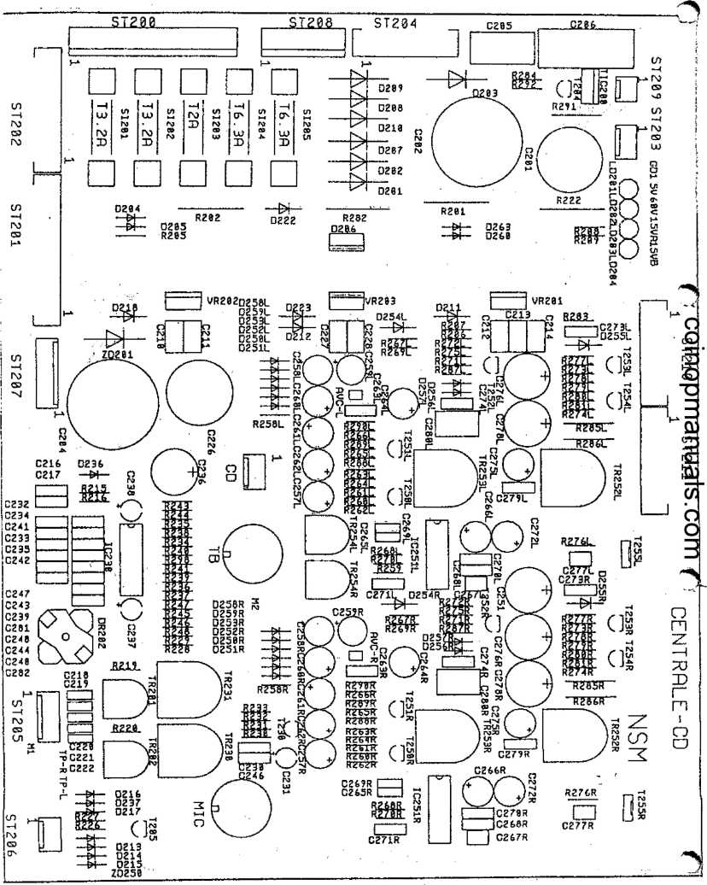

POS, PART-No. DESCRIPTION
DATA •• QTY
 | 173 | 666 | CENTRAL UNIT. ASSY |  | 50/60 HZ
SI2C3 | 225 | 538 | FUSE | by 50 Hz | T 2,5 A | 1
SI 201,202 225 |  | 029 | FUSE |  | T 3,15 A | 2
SI 204,205 225 |  | 374 | FUSE |  | T 6,3 A | 2
SI 203 | 225 | 220 | FUSE | by 60 Hz | T 2,0 A | 1
51 201,202 225 |  | 225 | FUSE |  | T 3,2 A | 2
SI 204,2® 225 |  | 218 | FUSE |  | T 6,25 A | 2
 | 173 | 730 | COOLING PLATE |  |  | 1
SI 201-205 | 225 | 689 | FUSE HOLDER |  |  | 10
 | 173 | 698 | PROFILE, ASSY |  |  | 2
 | 173 | 944 | SHIELDING COVER |  |  | 1
MIC | 225 | 244 | SOCKET |  | •S 5 prongs | 1
79 | 225 | 749 | SOCKET |  | Mab 8 SV | 1
ST 209 | 225 | 439 | PIN PLUG | RM 2,5 | 3 prongs | 1
ST 203, |  |  |  |  |  | >
206, CD | 225 | 418 | PIN PLUG | RM 2,5 | 4 prongs | 3
ST 205 | 225 | 443 | PIN PLUG | RM 2,5 | 6 prongs | 1
ST 208 | 225 | 804 | PIN PLUG | RM 3,96 | 6 prongs | 1
ST 207 | 225 | 444 | PIN PLUG | RM 2,5 | 8 prongs | 1
ST 200 | 225 | 807 | PIN PLUG | RM 3,96 | 12 prongs | 1
ST 204, |  |  |  |  |  | >
210, 211 | 225 | 654 | PIN PANEL | RM 2,5 | 10 prongs | 3
ST 202 | 225 | 714 | PIN PANEL | RM 2,5 | 12 prongs | 1
ST 201 | 225 | 656 | PIN PANEL | RM 2,5 | 15 prongs | 1
¥R 20! | 221 | 572 | IC-VOLTAGE |  | + 5 V 1 A | 1
¥R 202,233 221 |  | 476 | IC-VOLTAGE |  | +15 V 1,5 A | 2
1C 2$ | 231 | 236 | IC-LINEAR |  | TDA 1029 | 1
IC 251 RL | 231 | 089 | IC-LINEAR |  | TDA 4290-2 | 2
D 201-203, |  |  |  |  |  | >
207-120 | 221 | 463 | SI-DIODE |  | BY 251 | 7
0 211,212, |  |  |  |  |  | >
218, 222, |  |  |  |  |  | >
223, 254 |  |  |  |  |  | >
RL, 255 RL 221 |  | 115 | SI-DIODE |  | 1 N 4004 | 9
0 204, 205, |  |  |  |  |  | >
213-217, |  |  |  |  |  | >
235, 237, |  |  |  |  |  | >
251-253 RL, |  |  |  |  |  | >
256 RL | 221 | 114 | SI-DIODE |  | 1 N 4148 | 27
D 206 | 231 | 202 | SI-DUO-DIODE |  | BYV 32/100 | 1
ID 201 | 221 | 821 | TRANSZORB-DIODE |  | TVS 51-5 | 1
ID 201-204 221 |  | 466 | LIGHT EMITTING DIODE |  | LR 3160-F | 4
TIC 200 | 231 | 028 | TRIAC |  | TIC 206 D | 1

POS. | PART-No. |  | DESCRIPTION | DATA |  | QTY
T 201,253 |  |  |  |  |  | >
RL | 221 | 459 | SI-TRANSISTOR | PNP BC | 556 B | 3
T 230, SO |  |  |  |  |  | >
RL, 251 RL 221 |  | 249 | SI-TRANSISTOR | NPN BC | 550 B | 5
T 255 RL | 221 | 488 | SI-TRANSISTOR | NPN BD | 139-10 | 2
T 252 RL, |  |  |  |  |  | >
205 | 221 | 332 | SI-TRANSISTOR | NPN BC | 337-16 | 3
C 253 RL | 220 | 342 | CER.-CAPACITOR | 100 pF |  | 2
C 277 RL | 220 | 185 | CER,-CAPACITOR | 270 pF |  | 2
C 267 PL | 220 | 274 | CER.-CAPACITOR | 330 pF |  | 2
C 2*1,242 | 220 | 241 | CER.-CAPACITOR | 560 pF |  | 2
C 246 | 220 | 253 | CER.-CAPACITOR | 1 nF |  | 1
C 213,244 | 220 | 400 | KT-CAPACITOR | 1,5 nF |  | 2
C 259 RL | 220 | 401 | KT-CAPACITOR | 3,3 nF |  | 2
C 218-222, |  |  |  |  |  | >
265 RL, |  |  |  |  |  | >
in RL | 220 | 435 | KT-CAPACITOR | 4,7 nF |  | 9
C 258 RL | 220 | 429 | MKT-CAPACITOR | 0,15 pF | 100 V | 2
C2T0RL | 220 | 335 | MKT-CAPACITOR | 0,022 pF | 63 V | 2
C 216,217, |  |  |  |  |  | >
230, 234, |  |  |  |  |  | >
235, 239, |  |  |  |  |  | >
210,271 RL, |  |  |  |  |  | >
273 RL, 281, |  |  |  |  |  | >
282 | 220 | 334 | MKT-CAPACITOR | 0,1 pF | 63 V | 13
C 274 RL | 220 | 333 | MKT-CAPACITOR | 0,22 pF | 63 V . | 2
C 210-214, |  |  |  |  |  | >
227, 228, |  |  |  |  |  | >
250 RL | 220 | 332 | MKT-CAPACITOR | 0,33 pF | 63 V | 9
C 205 | 220 | 336 | MKT-CAPACITOR | 2,2 pF | 63 V | 1
C 206 | 220 | 460 | MKT-CAPACITOR | 3,3 pF | 63 V | 1
C 258 RL, |  |  | ; |  |  | >
259 RL | 220 | 243 | TAN-CAPACITOR | SF 100 pF 3 V |  | 4
C 260 RL | 220 | 249 | LYTIC | 1 pF | 63 V | 2
C 231, 237, |  |  |  |  |  | >
238, 257 RL, |  |  |  |  |  | >
262 RL, 284 |  |  |  |  |  | >
RL | 220 | 159 | LYTIC | 4,7 pF | 63 V | 9
C 261 RL, |  |  |  |  |  | >
286 RL, 275 |  |  |  |  |  | >
RL | 220 | 162 | LYTIC | 10 pF | 63 V | 6
C 272 RL | 220 | 389 | LYTIC | 47 pF | 10 V | 2
C 276 RL, |  |  |  |  |  | >
278 RL | 220 | 158 | LYTIC | 47 pF | 40 V ⁴ | 4
C 236 | 220 | 160 | LYTIC | 100 pF | 10 V | 1
C 251 | 220 | 250 | LYTIC | 100 pF | 25 V | 1
C 226 | 220 | 289 | LYTIC | 1000 pF | 40 V | 1
C 201 | 220 | 283 | LYTIC | 2200 pF | 25 V | 1
C 202 | 220 | 286 | LYTIC | 4700 pF | 25 V | 1
C 204 | 220 | 287 | LYTIC | 4700 pF | 40 V | 1

POS. | PART-NO. |  | DESCRIPTION | DATA |  | QTY
r m ri | 221 | 095 | RESISTOR | 6,8 Q | 4 W | 2
R 283,279 |  |  |  |  |  | >
RL, 287 RL 221 |  | 611 | RESISTOR | 10 Q | 4 w | 5
ft 206 | 221 | 620 | RESISTOR | 22 a | 4 W | 1
f 2J7 Rl | 221 | 096 | RESISTOR | 56 fi | 4 w | 2
R 270 Rl | 221 | 600 | RESISTOR | 100 fi | 4 w | 2
R 263 RL | 221 | 635 | RESISTOR | 180 fi | 4 W | 2
R 264 RL | 221 | 614 | RESISTOR | 330 fi | 4 W | 2
R 208 | 221 | 099 | RESISTOR | 470 Q | 4 W | 1
R 287 RL | 221 | 622 | RESISTOR | 820 Q | 4 W | 2
R 206, 207, |  |  |  |  |  | >
259 RL, 288 |  |  |  |  |  | >
RL | 221 | 029 | RESISTOR | 1 Kfi | 4 w | 6
R 275 RL | 221 | 030 | RESISTOR | 1,5 Kfi | 4 W | 2
R 209, 283 | 221 | 031 | RESISTOR | 2,2 Kfi | 4 w | 2
R 278 RL, |  |  |  |  |  | >
298 | 221 | 033 | RESISTOR | 3,3 KQ | 4 W | 3
R 262 RL | 221 | 172 | RESISTOR | 8,2 Kfi | 4 w | 2
R 266 RL, |  |  |  |  |  | >
226, 234, |  |  |  |  |  | >
289 RL, 292 221 |  | 035 | RESISTOR | 10 Kfi | 4 w | 7
R 219,220 | 221 | 501 | RESISTOR | 18 Kfi | 4 w | 2
R 288 RL, |  |  |  |  |  | >
227 | 221 | 604 | RESISTOR | 22 Kfi | i W | 3
R 290 RL | 221 | 037 | RESISTOR | 33 Kfi | 4 W | 2
R 230, 243 |  |  |  |  |  | >
248, PI Rl 221 |  | 038 | RESISTOR | 47 Kfi | 4 W | 9
fi 274 RL | 221 | 039 | RESISTOR | 56 Kfi | 4 W | 2
R 258 RL | 221 | 629 | RESISTOR | 68 Kfi | 4 w | 2
R 251 RL | 221 | 044 | RESISTOR | 82 KQ | 4 w | 2
R 273 RL | 221 | 048 | RESISTOR | 100 Kfi | 4 w | 2
R 272 RL | 221 | 045 | RESISTOR | 150 KQ | 4 W | 2
R 215, 216, |  |  |  |  |  | >
234-241 | 221 | 049 | RESISTOR | 470 Kfi | 4 W | 10
R 265 RL | 221 | 981 | RESISTOR | 560 Kfi | 4 W | 2
R 260 RL | 221 | 041 | RESISTOR | 820 Kfi | 4 w | 2
R 228, 229, |  |  |  |  |  | >
232, 233 | 221 | 009 | RESISTOR | 1 MR | 4 w | 4
R 231 | 221 | 982 | RESISTOR | 3,3 MR | 4 w | 1
R 285 RL | 221 | 230 | RESISTOR | 470 Q | 4 w | 2
R 291 | 221 | 183 | RESISTOR | 1 Kfi | i w | 1
R 286 RL | 221 | 210 | RESISTOR | 1,5 Kfi | 4 w | 2
R 201,202, |  |  |  |  |  | >
282 | 221 | 692 | WIRE WOUND RESISTOR | 1Q | 1 w | 3
R 222 | 231 | 232 | WIRE WOUND RESISTOR | 6,8 Kfi | 1 w | 1
TR 252 RL, |  |  |  | . | - | >
252 RL | 231 | 086 | TRIMMER RESISTOR | 10 Kfi | 0,15 W | 4
TR 230 | 231 | 233 | TRIMMER RESISTOR | 1 Mfi | 0,15 W | 1
TR 231 | 231 | 234 | TRIMMER RESISTOR | 2,5 Mfi | 0,15 W | 1
TR 252 RL, |  |  |  |  |  | >
253 RL, TR |  |  |  |  |  | >
230, TR 231 231 |  | 235 | SHAFT | rot Nr. 5214 |  | 6
TR 201,202 221 |  | 278 | TRIMMER RESISTOR | 10 Kfi | 0,1 W | 2
TR 254 Rl | 221 | 414 | • TRIMMER RESISTOR | 100 Kp | 0,1 W | 2

ST 210 l«i»<f I«*«l I l£ft DiiUHEL ST 211 «>»» *««i / right tNikuti —10 -BOV — 5 .60V o *80 V
f|— J fow! MSI I UiSE IW
- Bak.cs I1SS / 865E IKS S elekUao. Sickening 3 ElECIREX, FUSE (. Milleniparnung / CfH’fR WLUGE 0 CKO
- C.HD
•ST 201
- 7 O Ftrn&gjfanyng
-6 3 ; Etnfnng
- 5 2 ii »EMoif mm
»l | J HtfUl
-1S lilfelao7«ige / IlTL'E 9RUM -tt Rf-SE1CC11
- 8 links t LffT *1 Vfrslflrkrft^ul2
- 9 fechls/RlWU AMPIIMW N0UCT.
-12 Wf-IELECI 2
-10 Hkrofooscidlttr/MECftomNE SWITCH
-IT
-It.
-1 C*P
SuhtrNjngtn fcur iuich mlihj mit glfichrn Wprlrn rr«tjm REP-IACE FUStS OKI* Vi THOSE Of 1H£ SAXE VJIUE.
ANDERURGES W SINKS CCS 5ECHN FGRTSCHRiTifS Y0RBEHALTEK. JEOOCH KEINE NACHfitiSTPf LICHT !
SUBIECT TO TECHNICAL MODIFICATION WITHOUT OBLIGATION TO MODIFY F1U1PMEKI ALREADY DELIVERED!
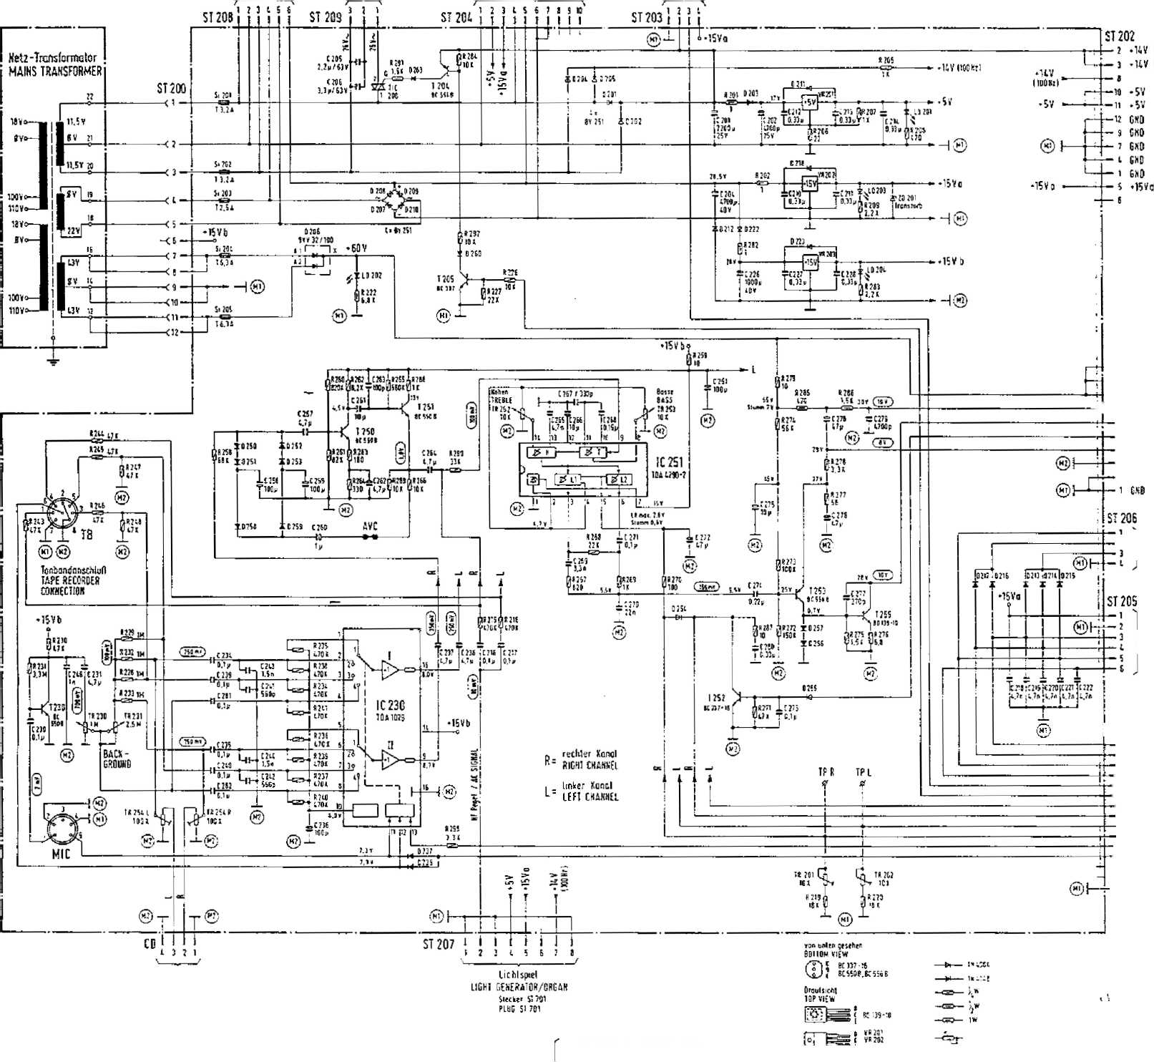
. Jltelgiunje El flecker SI 1
caiaopmMMSSJQraL
Zusntzbelaiditung ADOf'DHAt lUUHimliati
Lgflfr 1Endsli.lt!
vEKTH.Aicfi iobtput s’agei
WECHSLEl CHANGER - ADAPIER PLUG SR
TITLE BSUH 1CB PRGGRAH LID Plus SUM i
. 3 [ Lmjtstdrlcpsleller I Totten I f VOLUME CONTROL iKEYS]
fernbeditnung 'HEM0IE CONTROL
WECTtSLEft-ADAPTER CHANGER-ACAP1ES
Stttker SI 2 PLUG ST 7
MT-Ptgel hr llHr_ LavtsJciltifcdtrv&i! mqi
JlflM.r imd 8«ie mn* , rail AvC $mcM« irul flrttrtuiiylitiii Wlmflrr
&'EidNSO«nftvn^ griKMttfi iM Wtiulc* Ri = IDMJL
A[ Sffiiii;. VOlTjtfS tl MStifri. flUIXE CflltTWH. U Mil 7«fLE> AW Sasses MU ,WlTP live MtsSJjSfU WllM ELEdWtlf VtH1Mr.fR PC VO INCH MEASIJREO w;TH WllMflffl *. .ICMft JKKS
■« iriirtmpr-tfjecfttcnd TRIMMER SftiSJ&A
:»i Lc’J sHiLXHfr
itcHr EMiTT^ffliai
—!■: ii
f“ '"1 S|wrniuru)j<t§lEf
LJ WLTflCf ftfCLLtfGR
II u nnn.fl Wtrspciuiunistikwinunj
CONTROL UNIT CO Sletkv ST I
nos si i
EndstuU OUTPUT STAGE StKkti Si 15 0 PLUG SI 150
CONTROL UNIT CO
Sleeker SI 7
piug si;
174 902 / 174- 830 j 174 4® / 175 275 /175 C32 /175 W5
- 903 / 1^{J}4 631 / !?4 456 / 175 274 / 175 040 l 175 046
- 592 / 175 594 / 175 529 / 176 043 / 175 £53 / 176 047
• MUS IK AUTOMATED © PHONOGRAPHS
Schattbild
ESIV-GD TECHNOLOGY
CZ>
WIRING DIAGRAM ^TRALE-CO
ET^-;
12 Of. 3A | Broun | vt*~

621

UNIT DESCRIPTION
CD CHANGER
FOR NSM-PHONOGRAPHS

Page 801-815/821*822
to
Technical Information, Assy
174
174
174
- 175
903
831
486
274
040
SILVER CITY SILVER SKY FASCINATION SOUNDMASTER FIRE BIRD/COUNTRY
raft
Siarfarvjstrafle 240 6530 Singen ai Rhein
8

- PICKUP FUNCTION
  - Transport
  - Pull holder
  - Return holder
    - Feature
- PICKUP DRIVER
  - Lift control
  - Grip control
  - CD-Player control
- PLAYER
  - . Disc player COM 3
  - Servo panel
- PCB DECODER BOARD
- MAGAZINE
- CD CHANGER 100, test, set, adjust
  - GENERAL INFORMATION
  - MAGAZINE
  - PLAYING UNIT
  - LIFT
Spare parts lists
The pickup serves to transport the CD’s between the magazines and the player.
ATTENTION! When the CD changer has the switch at the window (upper right), the transport does not function if the window is open.
If the window is opened while the CD is playing, the title will be played to the end, but the CD will only be transported back after the window is closed.
- T ra.nspor'-t
The lift is moved via a stepping motor controlled by the microprocessor of the control unit. The distance between 2 CD slots is 8 motor steps (1 opto counter step).
During the run the Sight barrier OPTSP, which Is directly connected to the arivewheel, checks the motor’s position every 4 steps. Stepping errors are immediately recognized and displayed with Er 75.
Together with the light barrier OPEND the end position of the lift is verified. Should a mistake appear here (signal too late or early) the display shows Er 76.
- Pull Holder
With both grip levers, brought into lock position by CD motors MOGRL for left and MOGRR for right, the CD holders with their CD’s are pulled out of the magazine. The light barrier OPPUM reports the correct position of the CD holder in the pickup unit.
If there is no report 2 sec. after switching on the motor, the display will show Er 71 for the left magazine or Er 72 for the right magazine.
- Return Holder
To return a CD holder to its magazine, either motor MOGRL for the left magazine or MOGRR for the right magazine is switched on in the opposite direction.
Light barriers OPGRL or OPGRR report the end position of the grips.
If the report does not appear within 2 sec, after switching on the motor, the display shows Er 73 for the left magazine or Er 74 for the right magazine.
- Feature
If you want the CD to remain on the player after it finishes playing, the solder bridge LB3 on the pickup driver board must be connected. „ .
If the cabinet switch is pulled out, the tray with the CD is returned to the magazine.
- PICKUP DRIVER
  - L-i-f-t Control
With output port IC3 the microprocessor of the control unit controls switch transistors T 2~5 via drivers T 6-9. These drive the unipolar coil of the stepping motor (ST4, Pin t-6). Using signal OPSTP (ST4, Pin 7) the microprocessor controls the position of the motors.
Together with signal OPEND (ST 3, Pin 8) the end position of the lift Is reported via input port IC 1.
  - Grip Control
Both of the grip motors (MOGRL for the left magazine and MOGRR for the right magazine) are driven from the double motor bridge IC 6 via output port IC 3.
While pulling a CD from the magazine the signal OPPUM (ST 3, Pin 7) reports the end position of the CD holder in the pickup to the microprocessor of the control unit.
While returning the CD it recognizes the end position of the grips via signals OPGRL (ST 3, Pin 5) for left and OPGRR (ST 3, Pin 6) for right.
  - Control of -the CD Player
Microcomputer IC 8 (T018) is used to convert the Incoming serial data in I²C-Bus format from the decoder pane! into parallel signals that can be processed.
The microprocessor of the control unit communicates with it via ports IC 4 and IC 2.
RLAYER
- Disc Player O D M 3
The CDM3 contains the components laser diode, play motor, radial motor, and focus unit.
It reads the data from the CD.
- Se r' vo Panel
The servo panel contains the components to control the CDM3.
They consist primarily of the photodiode signal processor, the radial error processor, the drivers for the laser diode, the focus unit, the radial motor and the playing motor.
4- RGB D EE GOD E R BOARD
The components servoprocessor, decoder, digital filter, DA converter and NF output driver are combined on the decoder board. It also contains the circuit to process the complete power supply for decoder board COM3 and servopanel.
5 MAGAZINES
- equal magazines that are equipped with 50 CD holders each are in the CD changer. With different CD holders it is possible to play 5- or 3-inch CD’s, The magazine can be swung out and totally taken out.
Equipping with or changing CD’s can be done simply by taking out the respective CD holders, inserting the new CD into the holder and pushing it back till locks in the magazine.
- CD CHANGER 1 OO,
test, set, adjust
- 1 GENERAL INFORMATION
Please note the illustration of the CO changer on the last page regarding the following text.
After exchanging units their functions must be checked and, if needed, certain adjustments must be made.
To exchange the playing unit the CD changer can remain in the phonograph. But to remove or install the lift the changer has to be removed from the machine; tests and adjustments are only possible at a bench tester or at the machine with appropriate extensions!
Take care that the changer is set down on supports so that the board disc (12) or the main axle (14) which protrude from the cabinet floor are not pushed inside. Otherwise the board disc wiM jam the gear (2); a displaced axle changes the position of the upper distance sleeve so that the lift drives against it and blocks!
In service program step P60, Pt. 1.5.5 ‘’Test CD Changer" the grips can be moved left or right with Keys "4"/^{M}5" or "6"/"5” and the lift can be moved up or down with key “2"/"8". With Key 1 the CD player can be started and stopped.
For fine adjustments of the lift position the lift can be moved with Key "3" {+) or ⁴¹9" (-) one motor step at a time (equals about 0,5 mm height difference) either up or down; this option Is available for ES-IV CD phonographs as of Program Index 004.
The distance between two magazine slots Is 8 motor steps (or 1 opto step.). In the displays the present status of the respective opto mask and the time in seconds during which the lift position is held are shown.
  - MAGAZINE
The magazines in swung-in and locked position are supported by height- adjustable studs. Changing the height setting can be necessary when the lift is exchanged; setting see Pt. 4 "Lift".
  - F> LAYING UNIT
To exchange the playing unit with CD player 1 remove both magazines S pull lift up on belts
H swing support clamps on chassis of playing unit out
- carefully (!) pick up playing unit, watch balance washers under cabinet
- open plug connections
E Installation of playing unit in opposite sequence a function test:
remove decorative cover (01) and check if axle of suspension ptatb is in the center of the upper lift bore.
- choose CD, check if CD Is securely clamped In play position, further tests see Pt. 4 "Lift".
To exchange the lift as well as to check and adjust the opto coupler of the CD changer, completely remove the CD changer, disconnect cables, remove rear wall.
I From the rear side of the machine pull lift (04) up by the gear belt (02), interrupt connection between lift and gear belt by unscrewing the gear belt lock (03).
- Pull out plug of connecting cable (06).
- Remove board disc (12) after removal of washer.
fl Pull distance sleeve (13) at bottom of main axle (14) from cabinet floor upwards; remove securing clamp of main axle from inside of cabinet.
I Remove securing clamp of guiding axle (10) from inside of cabinet.
I Pull guiding axle down through floor of cabinet.
- Push main axle down until upper distance sleeve can be removed. ...
If main axle is pulled out all the way, do not mistake upper and. lower distance sleeves; they are of different length!
- Remove lift; mount exchange lift in opposite sequence.
- Function test, basic setting; CD changer must be completely connected to operate either with extensions to phonographs or a bench tester:
turn on test program P60/5, "test CD changer" F5. All functions of the changer can be checked, see excerpt of service program below:
All functions of. the changer can be tested Individually.
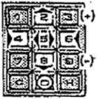
CD changer Enter -S" and H", Display 2 "F5".
Keep In mind the code numbers for the Individual changer functions as per the following keyboard Illustration;
test
Input Function
CD-Player_{t} Start/Stop Lift, upwardw lift, downwards Grip left Grip right fiat urn holder Stop lift at magazine space *) Motor steps, upwards (per 0,5 mm)
1
2
8
- 6
- 0 3 9
*) Motor steps, downwards (per 0,5 mm)
-The time In sec. during which the Itft position Js held. The lift position is held after every function for 2 sec.; by touching *0" for 10 sek.
Display;
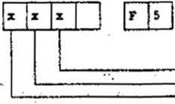
-OPTO stepper control GPSTP
-OPTO end position OPEND
•OPTO grip right OPGRR
•OPTO pickup center OPPUM
-OPTO grip left OPGRL
Meaning of displays; OPTO lit up * ”0**, OPTO darkened = "I**.
Terminate test. Actuate housing switch.
The basic setting occurs In parked position at Magazine Slot 25/75. Drive pick-up to this position with Keys “2" and "8".
The lift is held after each function in this position for 2 sec.; with Key "0” for 10 sec.
Drive cassette in and out with Keys ‘'4"/"5" or "6"/"5 Check function for smooth movement.
The respective grip lever must fall into the cassette w/o hindrance!
To adjust lift height loosen belt lock and move up or down; then tighten screws!
Move lift down one motor step (about 0,5 mm height difference) with Key "9" (-); same test for smooth movement.
Drive to normal park position with key “0" and with Key ”3“ (+); switch lift one motor step above normal position. Same check for smooth movement.
Set magazine height: If magazine slots do not align with lift, then adjust lift only to one magazine at first. After that the other magazine Is adjusted with support screw (11/15) to the correct height.
The light barrier (08) on the step motor must In parked position 25/75 be In the center of the opto scanner OPSTP (09) (status display of OPSTP In display = “1“). If necessary, loosen screw on hexagon bolt and set PCB with opto coupler to center of mask.
To adjust opto coupler OPEND (05) lift must be driven down to bottom. Drive lift upwards with Key "3” (press 4 times) or manually with one half opto step; the mask (16) must release OPEND (05) when OPSTP (09) opens the light mask, displayed by “O”. Adjustment done by shifting of light mask angle (16) of OPEND, displayed by transition of "0" to T or "1“ to "0".
Select CD in normal program. In the parked position of the playing position the lift must have a gap to the lower end position.
The distance between a cassette and the clamping dish should be at least 1 mm during a gripping procedure. So that the clamping dish can be magnetically attracted, the decorative cover must be In place. The CD must run w/o touch and grinding sounds when in a suspended position.
To test the function get cassette with CD from magazine by pressing correct keys and place it on CD player In play position.
Turn on CD player with Key "1“. After test with Key ”1“ or any of the other function test keys turn off CD player. The clamping dish must clamp down on CD exactly In center.
- Check function of fork light masks OPGRR, OPGRL, OPPUM as per test "F5“. The respective mask must cover the light barrier In its entire breadth when Status Display "1" is shown and may not touch the housing physically.
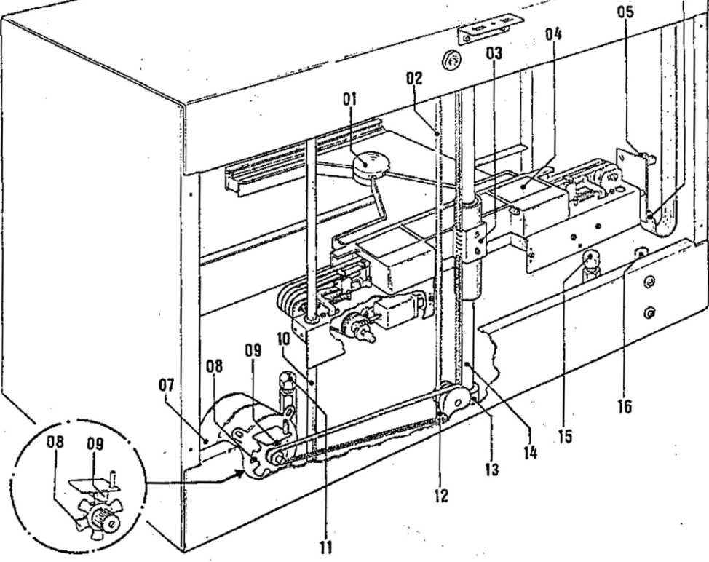
CD CHANGER, COM R L.

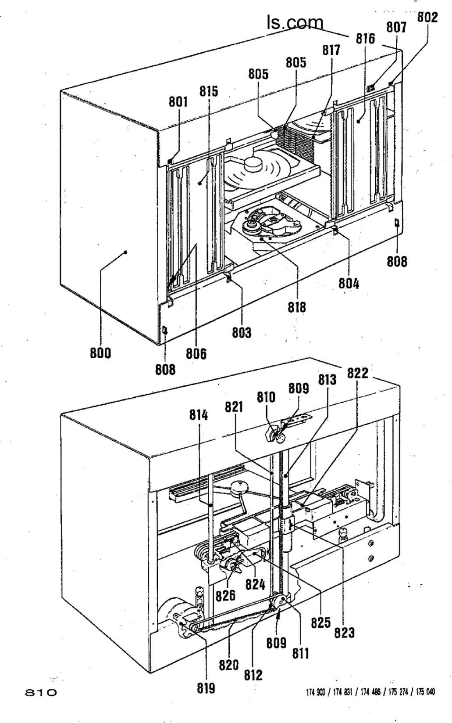

POS. | PART-NO. | DESCRIPTION | DATA | QTY
 | 173 470 | CD-CHANGER 100. STANDARD | without design parts | 1
 |  |  | without magazines
800 | 173 487 | CABINET, welded |  | . 1
801 | 174 296 | CLOSING LEDGE, left upper |  | 1
802 | 174 297 | CLOSING LEDGE, right upper |  | 1
803 | 174 294 | CLOSING LEDGE, left lower |  | 1
804 | 174 295 | CLOSING LEDGE, right lower |  | 1
805 | 173 485 | CONTROL KNOB |  | 2
806 | 206 655 | CONNECTION AXLE |  | 2
807 | 222 531 | MICRO SWITCH f. CONNEC. BLOCK | E63-10K | 1
808 | 174 293 | , FLAT SPRING for VIEW GLASS |  | 2
809 | 173 538 | SCREW SLEEVE, ASSY | . , | 2
810 | 173 522 | STEP WHEEL, MOUNTED |  | 1
811 | 173 521 | WASHER 48 |  | 1
812 | 173 526 | BOARD WASHER |  | 1
813 | 173 558 | AXLE |  | 1
814 | 173 559 | GUIDE AXLE |  | 1
 | 174 275 | VIEW GLASS, MOUNTED (GALAXY) |  | >
 | 174 276 | VIEW GLASS, MOUNTED (FIRE) |  | >
 | 174 277 | VIEW GLASS, MOUNTED (HIDE AWAY) |  | 1
 | 174 265 | BRIDGE |  | 1
 | 173 635 | LIGHTING, ASSY |  | 1
815 | 173 491 | MAGAZINE LEFT, MOUNTED (without CASSETTE) |  | 1
 | 209 737 | NUMBER STRIP, 01 - 50 |  | 2
816 | 173 499 | MAGAZINE RIGHT, MOUNTED (without CASSETTE) |  | 1
 | 209 779 | NUMBER STRIP, 51 - 100 |  | 2
817 | 174 536 | CASSETTER CD 120 | only 10 piece
817 | 174 537 | CASSETTE CD 80 | only 10 piece
 | 212 425 | TRANSPORT GUIDE for CASSETTE |  | 2
018 | 173 551 | PLAY BACK UNIT, ASSY | with CD-PLAYER | 1
819 | 173 518 | STEP MOTOR, ASSY |  | 1
820 | 206 644 | BELT | MXL 195 | 1
821 | 206 643 | BELT | MXL | 1
822 | 173 607 | LIFT, ASSY |  | 1
 | 206 629 | RUBBER RING | 1
 | 209 776 | LABEL | NSM 100 CD | 1
 | 174 220 | DECOR COVER |  | 1
823 | 173 614 | BELT LOCK |  | 1
824 | 173 581 | LIFT AXLE |  | 1
825 | 173 606 | MOTOR, ASSY |  | 2
826 | 173 630 | GEAR, MOUNTED |  | 2
 | 173 552 | CB-CASSETTCONTROL, ASSY |  | 1
 | 173 563 | CB-STEPPER, ASSY |  | . 1
 | 173 507 | CB-DECODER BOARD, ASSY |  | 1
 | 173 665 | CB-PICK UP DRIVER, ASSY |  | 1
 | 173 510 | CB-LIFT ADAPTER, ASSY |  | 1
 | 173 557 | CB-MOTORCONTROL, ASSY |  | 2
 | 173 508 | CB-CHANGER ADAPTER, ASSY |  | 1

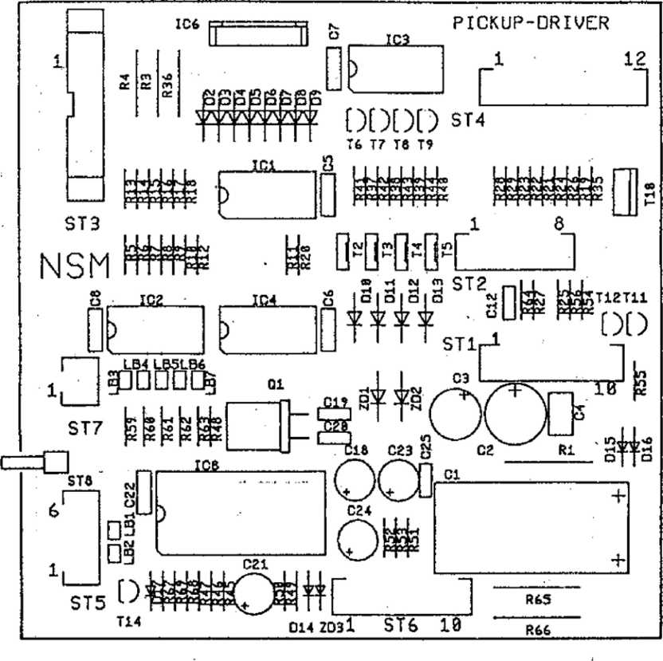

POS. | PART-No. |  | DESCRIPTION | DATA |  | QTY
 | 173 | 665 | * •  CB-PICK UP DRIVER. ASSY |  |  | 1
sr os | 225 | 392 | PIN PLUG | 2 prongs | 90# | 1
sro3 | 225 | 912 | PIN PLUG | 14 prongs |  | 1
ST 07 | 225 | 650 | PIN PANEL | 2 prongs |  | 1
ST 05 | 225 | 850 | PIN PANEL | 5 prongs |  | 1
ST 02 | 225 | 653 | PIN PANEL | 8 prongs |  | 1
ST 01 | 225 | 654 | PIN PANEL | 10 prongs |  | 1
STM | 225 | 655 | PIN PANEL | 12 prongs |  | 1
01 | 221 | 535 | OSCILLATOR QUARTZ | 4 MHz |  | 1
 | 222 | 447 | IC-SOCKET | 28 prongs |  | 1
1C 8 | 231 | 409 | IC-MICROCOMPUTER | T 018 • MAB 8441 |  | 1
ice | 231 | 303 | IC-LINEAR | L 298 |  | 1
1C 3,4 | 221 | 771 | IC-CMOS | HEF 4094 | B | 2
IC 1,2 | 221 | 763 | IC-CMOS | HEF 4021 | B | 2
014-16, 17 | 221 | 114 | SI-DIODE | 1 N 4148 |  | 4
0 2-13 | 221 | 822 | SI-DIODE | BA 157 |  | 12
D 18,19 | 221 | 115 | SI-DIODE | 1 N 4004 |  | 2
201,2 | 231 | 326 | ZENER-DIODE | ZY 24 |  | 2
I 11, 14 | 221 | 283 | SI-TRANSISTOR | BC 212 B |  | 2
T 6-9, 12 | 221 | 757 | SI-TRANSISTOR | BC 547 B |  | 5
T 2-5 | 221 | 777 | SI-TRANSISTOR | BD 679 |  | 4
T10 | 231 | 150 | SI-TRANSISTOR | TIP 130 |  | 1
C 19, 20 | 220 | 266 | CER.-CAPACITOR | 27 pF |  | 2
C12 | 220 | 342 | CER.-CAPACITOR | 100 pF |  | 1
C 5-8,22 | 220 | 334 | MKT-CAPACITOR | 0,1 pF | 63 V | 5
C 4 | 220 | 332 | MKT-CAPACITOR | 0,33 pF | 63 V | 1
C 21 | 220 | 249 | LYTIC | 1 PF | 63 V | 1
C18 | 220 | 389 | LYTIC | 47 pF | 10 V | 1
C 3 | 220 | 160 | LYTIC | 100 pF | 10 V | 1
C 2 | 220 | 391 | LYTIC | 220 pF | 25 V | 1
Cl | 220 | 165 | LYTIC | 470 pF | 40 V | 1
R 64 | 221 | 606 | RESISTOR | 47 Q | i W | 1
R 25,54 | 221 | 600 | RESISTOR | 100 Q | J W | 2
R 35 | 221 | 632 | RESISTOR | 160 Q | i W | 1
R 37-40 | 221 | 614 | RESISTOR | 330 Q | i W | 4
R 56,67 | 221 | 099 | RESISTOR | 470 D | i w | 2
R 45,49 | 221 | 029 | RESISTOR | 1 kQ | i W | 2
R 27-29 | 221 | 033 | RESISTOR | 3,3 kQ | i w | 3
R 46, 47 | 221 | 034 | RESISTOR | 4,7 kQ | i w | 2
R 26, 41-44, |  |  |  |  |  | >
68, 63. | 221 | 035 | RESISTOR | 10 kQ | i w | 7
R 5-12 | 221 | 603 | RESISTOR | 12 kfl | i W | 8
R 13-20,55 221 |  | 036 | RESISTOR | 15 kQ | i w ' | 9
R 21-23, |  |  |  |  |  | >
59-63 | 221 | 604 | RESISTOR | 22 kQ | i W | 8
8 24 | 221 | 048 | RESISTOR | 100 kQ | i W | 1
Rtf | 221 | 009 | RESISTOR | 1 MQ | i w | 1
R 3 | 221 | 392 | RESISTOR | 390 Q | i w | 1
R1, 36, 65 | 221 | 692 | WIRE WOUND RESISTOR | 1 Q | 1 w | 3
 | 231 | 418 | WIRE WOUND RESISTOR | 2,7 Q | 1 W | 1

POS. | PART-No. | DESCRIPTION | DATA |  | QTY
 | 173 508 | CB-CHANGER ADAPTER. ASSY |  |  | 1
ST 3 | 225 418 | PIN PLUG | 4 prongs |  | 1
ST X | 225 412 | PIN PLUG | 4 prongs | 90' | 1
SI 12 | 225 660 | PIN PANEL | 2 prongs | 90' | 1
STI | 225 661 | PIN PANEL | 4 prongs | 90' | 1
ST 9 | 225 652 | PIN PANEL | 6 prongs |  | 1
ST (0 | 225 662 | PIN PANEL | 6 prongs | 90' | 1
ST 1,11 | 225 653 | PIN PANEL | 8 prongs |  | 2
STS | 225 663 | PIN PANEL | 8 prongs | 90' | 1
STS | 225 654 | PIN PANEL | 10 prongs |  | 1
ST 1 | 225 664 | PIN PANEL | 10 prongs | 90' | 1
STB | 225 655 | PIN PANEL | 12 prongs |  | 1

cn
H -tv f-*
CT*
n

co
CO —I ro
co
4^. | 1 | r | h
is  <5> |  |  | r_C5U | t±
CO
-H
UJ

no
CO
H
00
CO —i p
STll
~r
CO CO
LA -Nl
WECHSLER-POPPTER
CO
-H
-o-
ST12
SPARE PARTS LIST
POS. PART-No. DESCRIPTION DATA QTY
14 prongs 16 prongs LTH-301
 | 173 510 | CB-LIFT ADAPTER. ASSY
ST 2 | 225 892 | PLUG
STI | 222 445 | IC-SOCKET
OPEND | 231 322 | OPTO-COUPLER
UIFT-nDflPTER

1
1
1
1
□
STi
C
1 •
NSM
J

ST2
PI
2
- 563 CB-STEPPER. ASSY
231 322 OPTO-COUPLER
LTH-301 4 prongs
112 464 CABLE HARNESS
- 557 CB-MOTORCONTROL. ASSY
1
1
POS. PART-No. DESCRIPTION
DATA
QTY
231 322 OPTO-COUPLER LTH-301
SPARE PARTS LIST
■ ■ .. , ■ ■■ > - .. ,,_{F} ■ ..... . ■■ ■■■■.. ■ , ■_ ■ ■■
POS. PART-No. DESCRIPTION DATA QTY
173 636 CABLE HARNESS: LIFT 1
173 639 CABLE HARNESS: PICK UP - CABLE I 1
173 641 CABLE HARNESS: PICK UP - CABLE II 1
173 644 CABLE HARNESS: TRAILING CABLE 1
151 645 CABLE HARNESS: DECODER CABLE I 1
173 646 CABLE HARNESS: DECODER CABLE II 1
173 647 CABLE HARNESS: DRIVER CABLE I 1
173 648 CABLE HARNESS: DRIVER CABLE II 1
173 649 CABLE HARNESS: DRIVER CABLE III 1
- 740 CABLE HARNESS: NF - CABLE 1
- 185 CABLE HARNESS: SWITCH 1
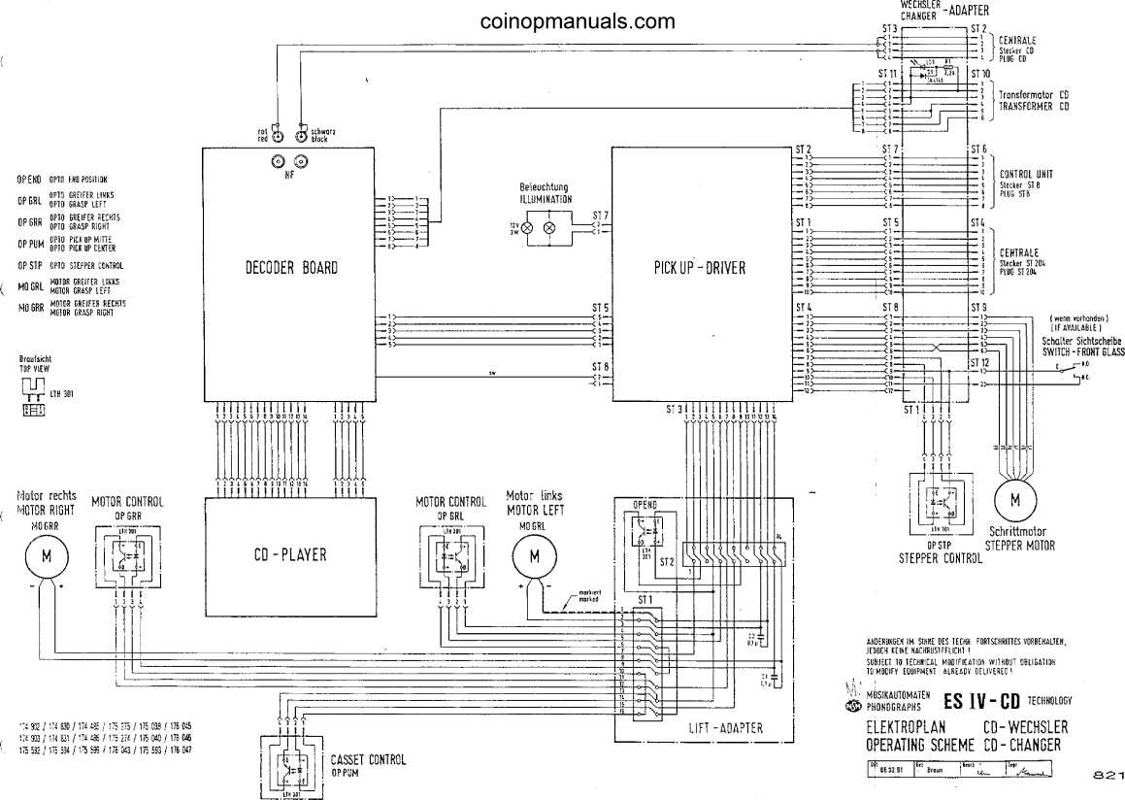

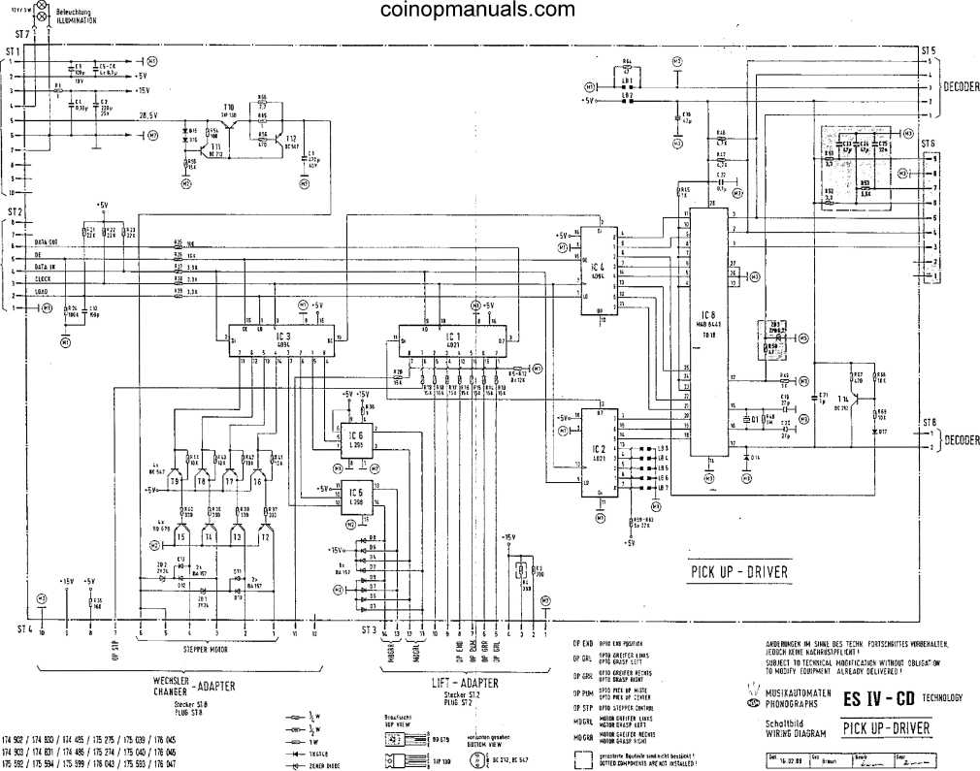
WECHSLER CHANGER ‘ ADAPTER
Sleeker S11 PLUG ST t
WECHSLER CHARGER "
ADAPTER
StecVef SI 7 PtBG sn

UNIT DESCRIPTION
TITLE INDICATION II FOR NSM-PHONOGRAPH

Page 901-*911
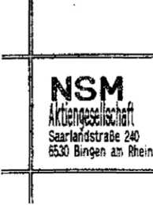
to
Technical information, Assy
174 | 903 | SILVER CITY
174 | 831 | SILVER SKY
174 | 486 | FASCINATION
175 | 274 | SOUNDMASTER
175 | 040 | FIREBIRD/COUNTRY
176 | 046 | THE PERFORMER "GRAND''

9

1_1 F³ C EJ Title display
The PCS is connected to the serial interface and +5 V of the control unit via ST 1. +15 V and +14 V are also conducted via ST 1.
The constant voltage of +15 V supplies motors and opto couplers.
Shiftregister IC 2 is the output port for motor driver IC 3, which controls the motor for stacker movement (MO MOV) and the gripper motor (MO GR).
Shiftregister IC 1 is the input port for opto couplers and push buttons. Light barriers GRL and GRR control the endposltion of the gripper (carrier). M0V1, M0V2 and MOV3 supervise various positions during the stacker movement. Any blocking will be recognized and displayed by error code Er 9x.
Pushbuttons TL and TR in the PCB are service keys for moving title holders.
They are identical with pushbuttons (<—) and (—>) on the front of the phonograph.
1-2 Movement: of “title holder's
By pushing the keys "left" respectively “right" two title holder will be moved into the corresponding direction (from program index 08).
A complete movement consists out of following phases: If i.e. the key "left" is pushed, at first the position of the gripper will be checked and -if required- the front gripper positioned in front of the right hand stack. Both stacks are level. Now the right stack moves to the front while the left one moves back simultaneously until the grippers enter the carrier slots of the corresponding title holders. Then the grippers move the title holder to the other side. In the final position the right hand stack will be moved forward while the left hand stack will be moved backward until they are level. The grippers will be brought back to their starting position. In case of a limitation of selectable CD’s via service step P22 only the corresponding title holders will be shown. A movement to the right beyond the highest cover number as well as to the left below cover number 1 is not possible.
- Exchange of defective -tl-tles holders
When defective title holders can still be driven to the front by the motor, the exchange of the holder should be performed there.
For removal, the center of the title holder has to be bent slightly forward until it jumps out of the top guide. The insertion of the new title holder works accordingly.
When the transportation by motor is impossible due to jamming, all title holders in front of the jamming location have to be removed. After correcting the problem the title holders have to be Inserted in the same sequence (Fig. 1).
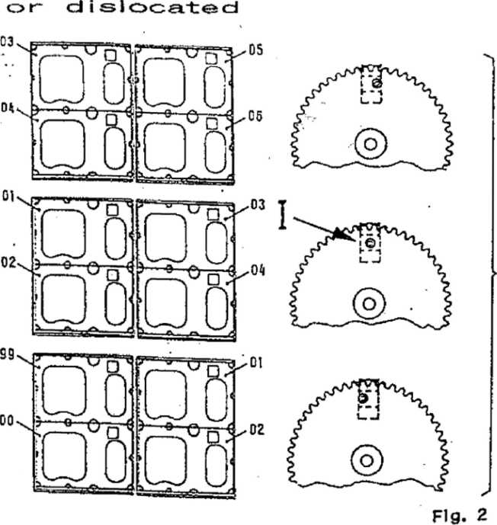
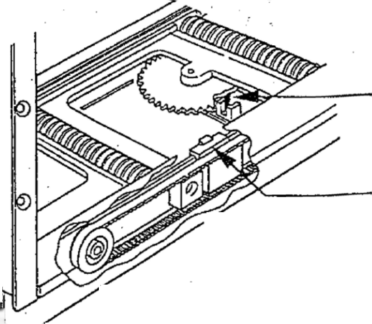
When all title holders are removed and the motor has turned, the synchronization has to be readjusted.
T .A- Jammed
-ti-tle holders
Fig. 1
Insertion of ail ti-tle ( S y r> c h r o n i z at ion)
hiol ders
view from under neat:
End position right or left
view from above, without title holders Fig. 3
During Insertion of the title holders it is important, that the pin of the counter wheel is positioned exactly in the center of the opto coupler "sync" (Fig. 2/1, 3/1).
The belt drives for the title holders (Fig. 3/II) have to be in their end position. When this is not the case, one of
the pushbuttons < > or the jp
service button TL/TR has to be \ used, until position I and [L
the end position are reached.
Now the synchronization has the correct relation to the position of the title holders. The title holders have to be inserted into the worm drives starting from the rear end. In order to do this the title holder has to be bent slightly forward in the center until it fits In the guide.
It should be started at the left rear end with ”53'’ (see Fig. 4) then ”55", “57" etc until "01"; on the right side it starts with ''51", the ”49”, "47" until "03".
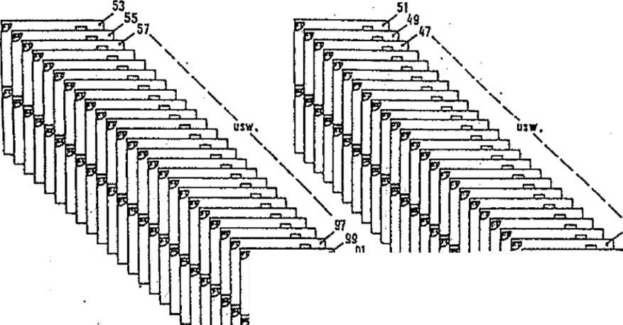
Sequence of title holders (for synchronization)
Fig. 4
7 | >
y | ED

-  7 | rz. -  B
7 | 0

NOT El Special care has to be taken during insertion that the first holder has to be inserted into to last slot of the worm drives and the next into the following slot directly in front. If one slot is accidently skipped, all following title holders have to be removed again.
- Operation tests
Service-program-step P60, Input test "F2" allows testing of IC1 inputs, port
- The result is shown on display 3:
The switching position of any give opto couplers is shown on the first riinit from the right "0" = closed, "1" = open —^ ¹⁹¹¹
The opto coupler is shown on the second digit from the right Gripper opto ”0“ = GRL,
^{M}r = GRR.
Switching wheel opto "2" = MOV1,
"3" = M0V2,
“4" = MOV3.
Counting wheel opto "5" = SYNCHRON.
Directional pushbuttons “6“ = TL,
"7" = TR.
The port number is shown on the third digit from the right.
"6“ = Port 6 on IC 1
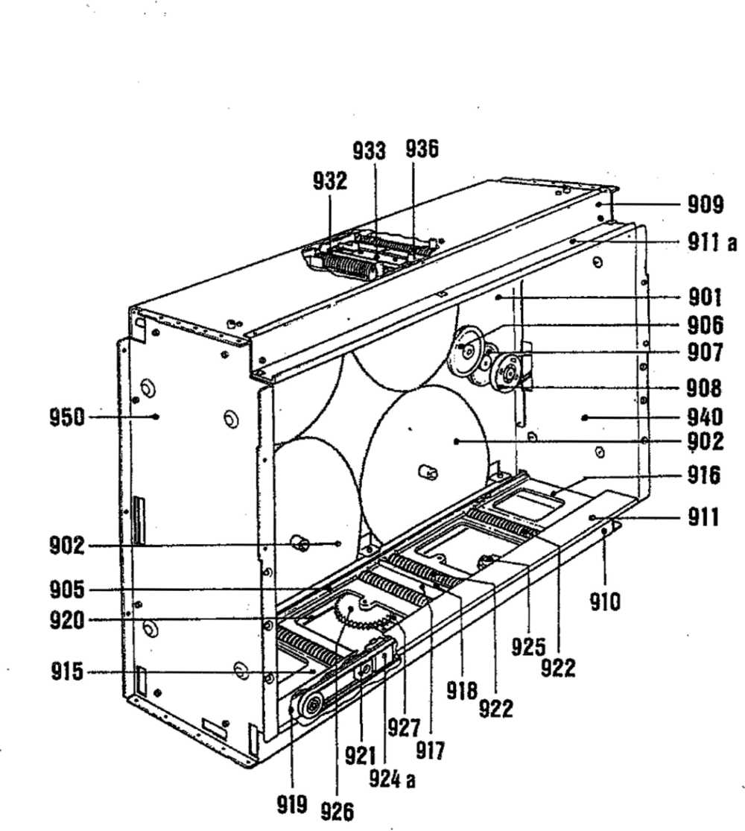

POS. | PART-No. |  | DESCRIPTION | DATA |  | QTY
900 | 174 | 710 | CD-TITLE INDICATION II. ASSY |  |  | 1
901 | 174 | 917 | CABINET PLATE, STAMPED |  |  | 1
 | 206 | 100 | PLASTIC BEARING | STAR-NYLINER |  | 4.
902 | 174 | 753 | TOOTHED WHEEL | Z - 150 |  | 4
903 | 174 | 876 | SHIFTING WHEEL |  |  | 1
904 | 174 | 929 | CB - SHIFTING WHEEL, ASSY |  |  | 1
905 | 174 | 799 | GUIDE |  |  | 1
906 | 174 | 886 | GEAR WHEEL | Z = 58 |  | 1
907 | 174 | 875 | GEAR WHEEL | Z = 48 |  | ■ 1
908 | 174 | 878 | BELT WHEEL | Z = 52 |  | 1
 | 174 | 879 | WASHER . |  |  | 1
909 | 174 | 848 | COVER, UPPER |  |  | 1
910 | 174 | 847 | COVER, LOWER |  |  | 1
911 | 174 | 900 | MASK | LOWER | WHITE | 1
911a | 175 | 123 | MASK | UPPER | BLUE | >
 | 175 | 124 | MASK | UPPER | YELLOW | 1
912 | 174 | 950 to |  |  |  | >
 | 174 | 999 | TITLE HOLDER II |  |  | 50
913 | 206 | 880 | SCOTCH BUMPON |  |  | 8
 | 219 | 185 | TITLE STRIP |  |  | 120
 | 212 | 509 | TITLE COVER |  |  | — ”
914 | 175 | 925 | GUIDE PLATE |  |  | 1

 |  | LOWER DECK
915 | 175 077 | TRAVERSE I, ASSY |  | 1
916 | 174 881 | TRAVERSE II |  | 1
 | 175 944 | TRAVERSE II from | SERIAL-Nr. 9025 | 1
917 | 174 797 | TRAVERSE, MIDDLE |  | 1
 | 175 322 | TRAVERSE, MIDDLE from | SERIAL-Nr. 9025 | 1
918 | 175 321 | BRACKET |  | 1
 | 741 008 | BALL e> 6 DIN 5401 |  | 2
 | 205 834 | SPRING |  | 2
919 | 174 906 | HOLDING BAR |  | 1
920 | 174 931 | HOLDING BAR, REAR SIDE |  | 1
 | 175 923 | HOLDING BAR, REAR SIDE | from SERIAL-Nr. 9025 | 1
921 | 206 794 | LOSS |  | 2
922 | 174 751 | WORM, ASSY, LOWER |  | 4
 | 206 100 | PLASTIC BEARING | STAR-NYLINER | 4
923 | 174 898 | BELT WHEEL | Z = 28 | 2
924 | 206 776 | BELT | Typ S2 M800 | 2
924a | 174 846 | DRIVE. FRONT SIDE |  | 1
 | 174 882 | DRIVE. REAR SIDE |  | 1
 | 175 922 | DRIVE, REAR SIDE from SERIAL-Nr. 9025 |  | 1

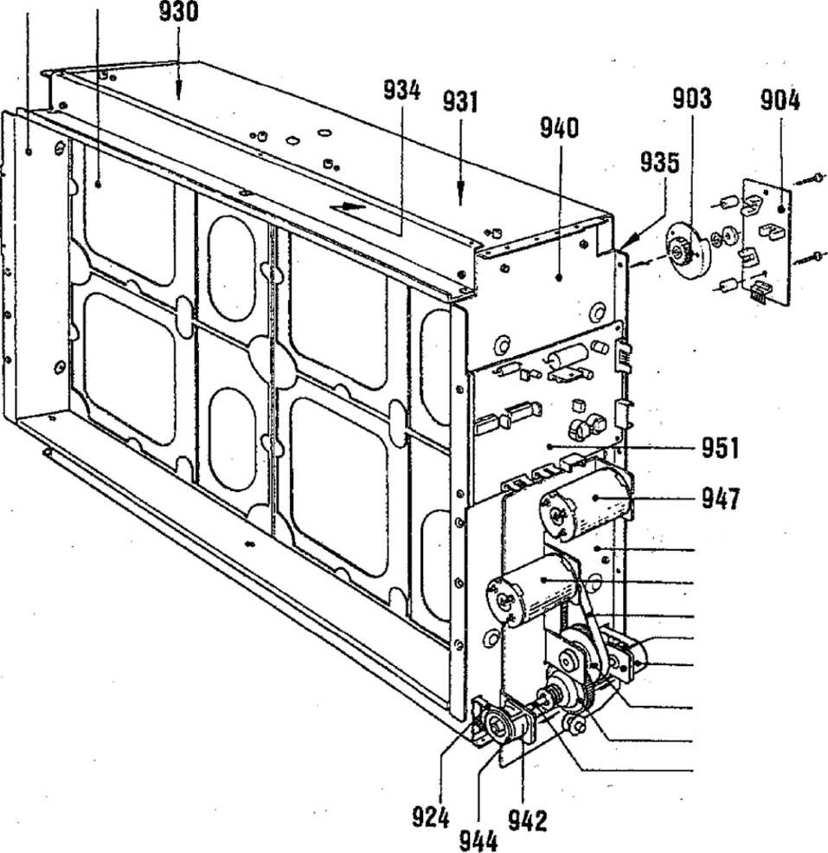
950 912
941
947
948
944
942
946
945
943

SPARE PARTS LIST
POS. PART-No. DESCRIPTION
DATA
925 | 174 | 930 | CB - DRIVE, ASSY to TRAVERSE I/H | 2
926 | 174 | 885 | COUNTER | 1  1
927 | 175 | 078 | CB - COUNTER, ASSY
 | 225 | 412 | PLUG CONNECTOR 4 prongs 90° | 1
 | 231 | 322 | COPPLER PLATE LTH-301 | . 1
 | 175 | 103 | CABLE HARNESS: SHIFTING WHEEL | 1
 | 175 | 104 | CABLE HARNESS: DRIVE UPPER DECK | 1
930 | 174 | 791 | TRAVERSE I | 1
 | 175 | 943 | TRAVERSE I from SERIAL-Nr. 9025 | 1
931 | 174 | 881 | TRAVERSE II | 1
 | 175 | 944 | TRAVERSE II from SERIAL-Nr. 9025 | 1
932 | 174 | 797 | TRAVERSE, MIDDLE | 1
 | 175 | 322 | TRAVERSE, MIDDLE from SERIAL-Nr. 9025 | 1
933 | 175 | 321 | BRACKET | 1
 | 741 | 008 | BALL 0 6 DIN 5401 | 2
 | 205 | 834 | SPRING | 2
934 | 174 | 798 | HOLDING BAR I | 1
935 | 174 | 931 | HOLDING BAR, REAR SIDE | 1
 | 175 | 923 | HOLDING BAR. REAR SIDE from SERIAL-Nr. 9025 | 1
936 | 174 | 764 | WORM, ASSY, UPPER | 4

SIDE PART
940 | 174 | 932 | SIDE PLATE, | RIGHT, STAMPED |  | 1
941 | 174 | 925 | MOTOR- and | GEAR PLATE, STAMPED |  | 1
942 | 174 | 926 | BELT PROTECTION, ASSY |  |  | 2
943 | 174 | 924 | DRIVE AXLE |  |  | 1
 | 175 | 270 | COUPLING | (PART 1) |  | 1
 | 211 | 271 | COUPLING | (PART 2) |  | 1
 | 205 | 807 | SPRING |  |  | 1
944 | 174 | 898 | BELT WHEEL |  | Z = 28 | 2
945 | 174 | 875 | GEAR WHEEL |  | Z = 48 | 1
946 | 174 | 878 | BELT, WHEEL |  | Z = 52 | 1
 | 174 | 879 | WASHER | % |  | 1
947 | 174 | 889 | MOTOR, ASSY |  |  | 2
948 | 206 | 789 | BELT WHEEL |  | 40 S2 M180 | 2
950 | 174 | 912 | SIDE PLATE |  |  | 1
 | 175 | 946 | SIDE PLATE | from SERIAL-Nr*. | 9025 | 1
951 | 174 | 928 | CB - TITLE INDICATION, ASSY |  | see Page S07 | 1

POS. | PART-No. |  | DESCRIPTION | DATA |  | QTY
 | 174 | 928 | CB - TITLE INDICATION II |  |  | 1
ST 4 . | 225 | 443 | PIN PLUG | 6 prongs | red | 1
ST 3 | 225 | 444 | PIN PLUG | 8 prongs | red | 1
ST 1 | 225 | 440 | . PIN PLUG | 10 prongs | red | 1
ST 2 | 225 | 710 | PIN PANEL | 4 prongs |  | 1
ST 6 | 225 | 711 | PIN PANEL | 6 prongs |  | 1
TL. TR | 222 | 404 | CONTACT BUTTON | D 6 | red | 2
iCl | 221 | 763 | IC-CMOS | HEF 4021 I | 3 | 1
!C 2 | 221 | 771 | IC-CMOS | HEF 4094 I | B | 1
IC 3 | 231 | 303 | IC-LINEAR | L 298 |  | 1
DH | 221 | 822 | SI-DIODE | BA - 157 |  | 8
03 | 221 | 114 | SI-DIODE | 1 N 4148 |  | 1
T1 | 221 | 283 | SI-TRANSISTOR | BC 212 B |  | 1
0-3,9 | 220 | 334 | MKT-CAPACITOR | 0,1 mf | 63 V | 4
06 | 220 | 332 | MKT-CAPACITOR | 0,33 pF | 63 V | 1
Cl | 220 | 162 | LYTIC | 10 mf | 63 V | 1
C 4,8 | 220 | 250 | LYTIC | 100 pF | 25 V | 2
05 | 220 | 253 | LYTIC | 1000 pF | 25 V | 1
ft 33 | 221 | 620 | RESISTOR | 22 Q | i w | 1
R 31 | 221 | 600 | RESISTOR | 100 Q | i W | 1
ft 25-27 | 221 | 033 | RESISTOR | 3,3 KG | i W | 3
ft 19,28-30 221 |  | 035 | RESISTOR | 10 KQ | i W | 4
ft 1H8 | 221 | 603 | RESISTOR | 12 KG | i w | 8
ft 2-9 | 221 | 036 | RESISTOR | 15 KG | i w | 8
R 32 | 221 | 604 | RESISTOR | 22 KQ | i w | 1
R 20 | 221 | 049 | RESISTOR | 470 KG | i W | 1
ft 23,35 | 221 | 273 | RESISTOR | 10 Q | i w | 2
R 2l_{y} 22 | 221 | 392 | RESISTOR | 390 G | J w | 2
ft 24 | 221 | 692 | WIRE WOUND RESISTOR | 1 G |  | 1
ft 36 | 221 | 169 | WIRE WOUND RESISTOR | 10 Q |  | 1

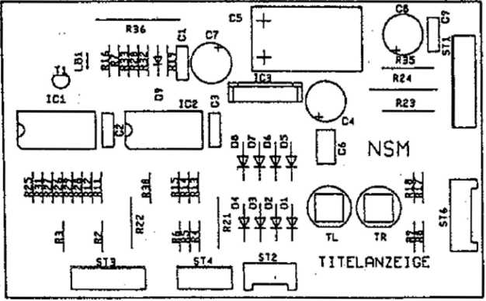

Hifer Htytwc Motor Grate IP Mitrehiw IP Jihlrod IP ttitatfantf
MffWKSWftolt MCJB3WAB CB DRIVER CB COilHTft WKEl Cl DRIVES
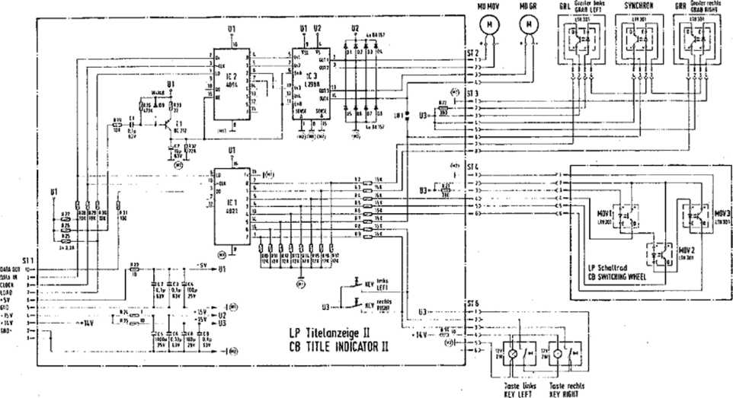
--O- V* —o- \* —a»- l«
MBtMKtl W SlWt CCS lfCiU (MCNHKSWKiUlHl. CNDinmuaKiprinM WMtl TBIKWCH HWlfttUItt WIIHIUI OBuCillO* MMOMTV 18WMIK 1HU0V Hir.ftf: •
xti Lrtw 4.-5<fn'
BtlTIH VlfW
vV
©
SdSap1?S^{1EH} ESIV-CD TECHHOLCSY
:.'u>nUi
lopmtv
Schallbild Tileianzeice II
WIRING DIAGRAM TITLE INDICATOR!:
GBD

UNIT DESCRIPTION
ELECTR. COIN- AND BILL ACCEPTOR FOR NSM-PHONOGRAPHS
XV-CB f®SW&0>OT
- 903 SILVER CITY 174 831 SILVER SKY
to
Technical Information, Assy
- 486 FASCINATION
- 274 SOUNDMASTER
- 040 FIREBIRD/COUNTRY
- 046 THE PERFORMER ’’GRAND"
Page 1001-1006
SaarlamJstraBe 240
6530 Bingen am Rhem
- MECHANICAL COIN CHUTE
- BILL VALIDATION - DOLLAR BILL ACCEPTOR
- MARS ELECTRONIC COIN VALIDATOR
  - Monetary Value Settings
  - Price Tables
  - Other Settlngs/Information
1 MECHANICAL COIN CHUTE
See also the circuit in the wiring diagram in the appendix of the "Technical Information"*
The coins that come out of the "good" channels of the coin acceptor run through different optic barriers. The optic barriers are In the coin chute under the coin acceptor.
Two photo transistors, T III and T I as well as T IV and T II are illuminated by one IR diode each (LED I and LED II).
As long as a light barrier is not interrupted by a coin, all photo transistors, T I to T IV, are switched to logically "0". So all output lines.
- - T IV,
- - T III,
- = T I-, -
- = T II are at■ logical 1y "G", i.e.- their voltage level is 1,0 V.
If a coin passes through an optic beam, the respective photo transistor is darkened for that time. The output becomes log. "1" via the pull-up resistors in the control unit, i.e. their level is 10 V.
Since T 1 is also darkened, when T III is effected by a coin (T 1 is behind T, III, both are Illuminated by the same light diode), the output from T I over T V. is kept at ’0*'. This occurs via resistors R 72, R 70; they bring transistor T V in a satiated state when T III is open.
The same goes for T IV; it is kept at "0” by T VI when a coin falls through T II. The control for T VI occurs via R 73, R 69.
The addition button is switched in sequence to T IV so that Line 1 becomes tog. ”1" at service credit.
R 67 limits the current of the luminous diodes LED I and LED II.
The output signals of the four photo transistors are evaluated in the control unit whereby line.
- = P 54,
- - P 53,
- = P 52,
- = P 51 is assigned to the monetary value setting in the service program and is to be programmed according to the coin value; see "Statistics and Service Programs", Section 1.4.
2 BILL VALIDATIOM - DO LLAR BILL AGOBRTOR
See also the circuit in the wiring diagram in the appendix of the "Technical Information".
The bill validator, after the bill has passed through and been accepted, sends as many pulses to the control unit as correspond to the value of the bill.
The output of the bill validator Is connected to the control unit via ST 9, Pins 1 and 2. 1 pulse is sent to the control unit with 1 dollar and 5 pulses with 5 dollars.
The input of the bill validator is assigned to program step P55 and is to be programmed accordingly;, see "Statistics and Service Programs", Section 1.4.
- MARS E; UECTRONIC COIN VALIDATOR
- or & different coins be checked depending on the type. The three sensors In the validator register each separately the width, material composition and pressure of each deposited coin. If a deposited coin passes the sensors, the prepared data'are passed on to a register and compared with the contents of a memory (PROM), If validation criteria are identical with a data set of the PROM, an Internal "valid¹' signal Is produced. Depending on the coin value It goes as output signal At to AS to the plug of the PCB adapter (depending an type of validator, 15 or 13 poled). From there the signal goes via the 6-pole plug to control unit CD for processing.
3.1 Monetary Val u© Settings,
The information in the "Operating Instructions" and the statistics and service program about monetary value settings refer to coin mechanisms with mechanical coin acceptors.
If a electronic validator has been Installed, the monetary value settings In the Individual program steps are assigned to corresponding output signals: P51 to signal A1 or AS, P52 to A3, P53 to A<4-, P54 to A3,
Notice: When Inserting a coin during program steps 50-55, the program step (channel P51 to P55) assigned to the coin is automatically displayed in Display 1,
The monetary values are programmed In monetary value units: "001“ * 0,10 DM, "010" * 1,- DM, "020” ' 2,- DM, "050" ^ 5,- DM. No-used channels are programmed with “000".
- pries Tables
Set the number of credit per monetary value In program steps P41 to P45 as described In the "Statistics" and Service Program, 1.3,2 Price Tables".
- Other Sottl ngs/Informatlon
When exchanging the control unit the programming has to be done in the new unit also.
Attention! When checking the monetary, value settings in P54, the cabinet switch has to be pushed tn; otherwise only one credit will be displayed Instead of set coin value.
Notice: Non-used channels can be blocked. For this purpose the bridge of the corresponding channel (A1-A5 on the PCB) has to be disconnected or conductor AS Is not connected,
when .exchanging please observe the following.;
The validators of series B1 may have different mounting studs; compare the following text to Fig, 2,
g The lower stud can be set on Pos. 1 or Pos. 2 needed. To loosen the stud position unscrew the cover (3) and puli
down, (4) .unlatch the stud, pull out and push it In at the desired position until It locks In.
a jf former validator was fastened with 2 screws, then exchange validator has to be fastened with plug-ln studs as
follows:
Drill a hole below Into the plate with a diameter of S,1 mm. Stick the stud positioned to the validator through the hole and secure it with clip 4,5 (712 011). Then screw on by upper fastening screw.
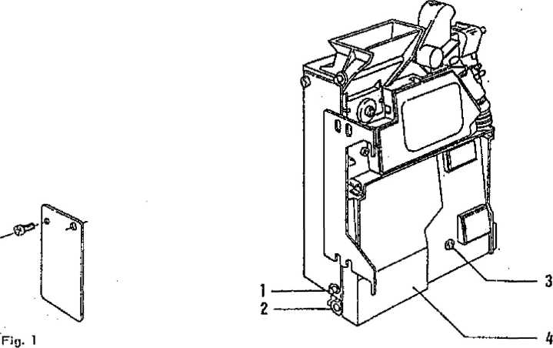
Fig. 2

Pcojiom ilept lo itl mmwhrj *vlu«i occgr- dinf lo coin values (oulpvl ligitolt).
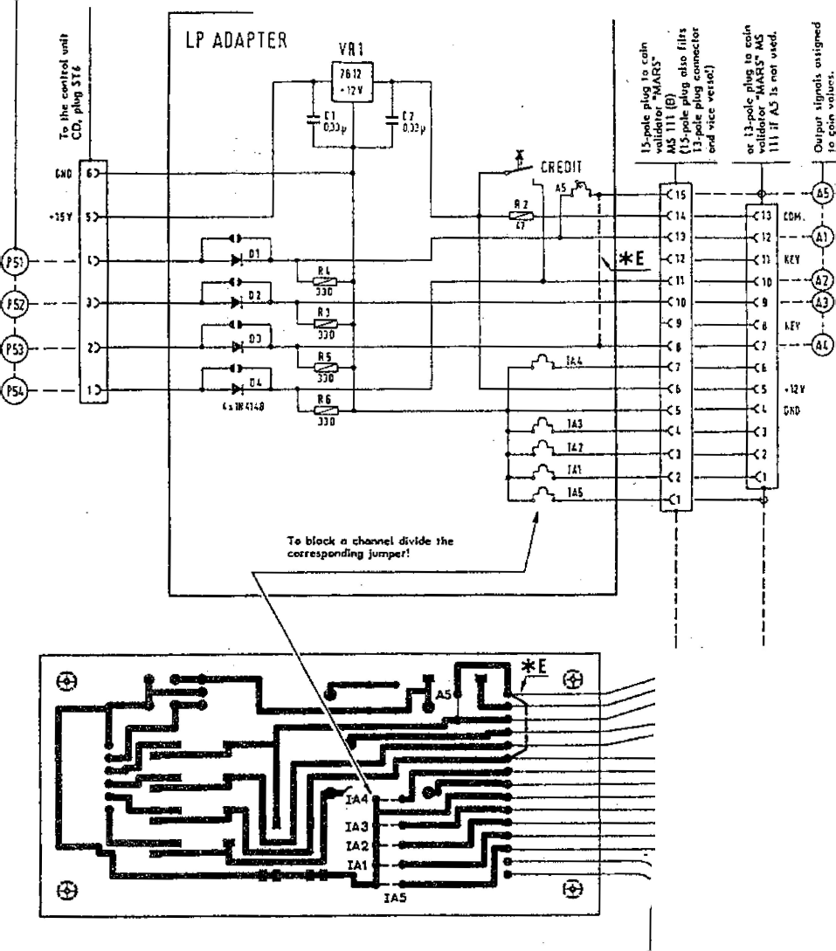
Connecllem to coin rolldalof 13-pole plug
end 15-pole plug
1 | I
IS |  | r-i-.
14 |  | u
13 |  | 13
» |  | 11
11 |  | 10
10 |  | 9
9 |  | 9
6 |  | f
V
Tf
 |  | £
7  ji |  | D  ft
p  * |  | P  j
9
■i
 |  | J
■i
a |  | ft  1
2
i

MONETARY VALUE SETTINGS SEE BACK PAGE
Programming Table for Mars-Coin acceptor
Monetary Va\lu Ings
Programming of monetary values and vat@Ojfl0pflf10Rt|0lS^{f}l'©Offl ^{(see 31}
currency 1 Monetary Values | P51 (A1/A5) |  | 2 Coin Value P52 (A3) | P53 <A4) | P54 (A2) | Olscon,  Jumpers | Coin Vatldator - Type
Germany | 050 ‘ 5,- OM | 010 2 1,- DM | ooo 2 oo | 020 2 ²>~ ^{DM} | IA4/IA5 | GDE58 LOOK/91/GDE55LOOC/B1
;;>-eat Britain | 100 " 1 £ 100 " 1 £ | 020 " 20p 020 2 20p | oio 2 top  010 ^{r} iop Inw]  10P iddl | 050 “ 50p 050 2 50p | IA5 A 5 | GDB 31 L00C/GGB81 LOOOC/ 01 GGSG3 L00C/02 * E
USA | ioo : i $ | 025 2 25 c | ooo 2 oo | 050 2 50 C | IA4 | GUS 20 LOOC
rtustralia | 000 ~ 00 | 100 2 i $ | 020 2 20c | 200 2 ² S |  | GAS XX LOOC 01/ GAS 1A LOOC
 | 200 2 2 $ | 000 2 (50c) | 020 2 20c | 100 2 1 * | IA3 | GAS 28 LOOC
i; ranee | 100 2 10 F | 020 2 2 F | 010 2 ¹ F | 060 2 5 F |  | GFR 19 LOOC
 | • 100 10 F low " 10 F Ire*) | 020 2 2 F | 010 2 1 F | 050 2 5 F |  | GFR 95 LOOC / Bl . * F
Denmark | 000 2 00 | 050 2 6 dkr | 010 2 1 dkr | -100 2 10 dkr |  | by 3-Canal GDK xx LOOC
 | too 2 ¹⁰ dkr | 010 2 1 dkr | 000 2 0,25 dkr | 050 2 5 dkr | IA4 | by 4-Canal GDK 02 LOOC
 | 100 2 ¹⁰ dkr (nwl | 050 2 5 dkr | oio 2 1 ctkr | 100 2 10 rtr (<W |  | by 4-Canal GDK 1A LOOC
 | 200 2 ²⁰ dkr | 050 2 5 dkr | 010 2 1 dkr | 100 2 10 dkr |  | GDK 1D LOOC / GDK 1N LOOC
Finland | ooo 2 oo | 050 2 5 MK | oto 2 1 mk | ooo 2 oo |  | GSF 1A LOOC
Austria | 200 2 20 S | 050 2 5 S | 010 2 i s | too 2 io s | A5/IA5 | GAU 03 LOOC
Math. Anti lien | 000 | ooo | 100 2 1 naf | ooo | A5/IA5 | GNA 1 AL OOG / Bl
Switzerland | 050 2 5 Fr | 010 2 1 Fr | OOO 2 4 Fr ■ | 020 2 2 Fr | IA4/IA5 | GCH 31 LOOC / B1
Belgium | 050 2 50 Fr | 000 2 5.F Inn) | OOO 2 1 F | 020 2 20 F | IA3/IA4  (A3/A4) | GBE 19 LOOC / B1
 | 050 " 50 F  1 F (m) | 005 2 5 F M | OOO 2 I F Iddl | 020 2 20 F | IA4/IA5 | GBE 25 LOOC / Bl GBE 19 LOOC / 85
Metherland | 025 2 ^{25 c} | 250 2 ² i hfl | 500 2 5 hfl | 100 2 i hfl |  | GNL 37 LOOC / Bl
Italy | 050 2 500 L | 000 (100 L) | OOO (50 L) | 020 2 200 L | IA3/IA4 | GIT 06 LOOC
 | 050 2 500 L | 010 2 ioo L | OOO (50 l) | 020 2 200 L | IA4/IA5 | GH 26 LOOC / 81
USA | 010 2 00c) | 050 2 (50c) | 025 2 25c | 100 2 (1 $) | IA5 | GUS 1B LOOC / B1
Mew Zealand | 050 2 50 c | 010 2 10 c  1 SH1LUW | 005 2 5 C | 020 2 2D |  | GNZ 03 LOOC
Canada | oio 2 ic c | ioo 2 i $ | 025 2 25 c | OOO |  | GCN 1A LOOC
Snaln | 200 2 200 Pst | 050 2 50 Pst | 025 2 25 PSt | ioo 2 100 pst |  | GES 1J LOOC
Norway | 100 2 10 Kr | 010 2 1 Kr | (OOO 2 i Kr) | 050 2 5 Kr | IA4 | GN 008 LOOC
Sweden | 050 2 5 Kr | 010 2 1 Kr | OOO 2 (50 On) | 010 2 1 Kr '* | ' 1A4 | GSW 09 LOOC
Greece | (010) MP tktei | 050 2 50 Dr | 020 2 20 Dr | OOO |  | _{t}GGR 1C LOOC
K:-rea | 000 | 010 2 10 NTS | : 005 ‘ 5 NTS  - n<. . “» | ooo |  | GtW 1A LOOC
t‘\i. xlca | 000 | 000 | 010 2 1000 p | ooo |  | GME 1A LOOC
Hong Kong | 050 2 5 $ | 010 2 1 $ | ooo | 020 2 2 $ , |  | GHK 1A LOOC / Bl
Pungeria | 020 2 20 F | 005 2 5 F | ooo | I —  010 2 10 F:- '" | TA4/IA5 | GHU 1B LOOOC / B1
nailsnd | 000 | 000 | 005 * S Baht | ooo |  | GTH 1A LOOC / 02

* F A5 and IA 5 dosed
* E additional jumper from pin 15 to 8 (A5) (A4)
UNIT DESCRIPTION
REMOTE CONTROL FOR NSM-PHONOGRAPHS
174 903 SILVER CITY 174 831 SILVER SKY
to
Technical Information, Assy
SaarlandstraBe 240 6S30 Bingen am Rhein
- 486 FASCINATION
- 274 SOUNDMASTER
175 040 FIRE BIRD/COUNTRY
11
Page 1101-1105
1 FUNCTION
- Infrared remote control (wireless)
- Wired remote control.
- Installation instructions for infrared remote control
- Volume control (on rear cabinet wall)
¹ INy^feED^^ASSY.
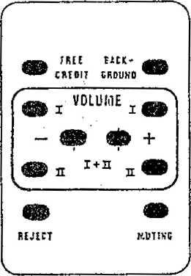
Part No. with sender Receiver
171 808' 217 817 173 178 171 883 170 459
171 743
and connection cabie (standard) Connection cable (5 m)
REMOTE CONTROL with 5 m cable Part No.

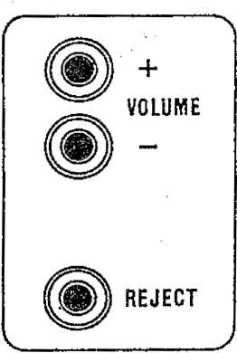
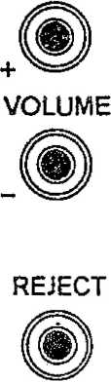
VOLUME CONTROL
Part-No. 170 212
Option: This volume control, is a remote alternative to the control installed in the device. (For- connections see par. 1.4) The cable has to be extended - any 4 pole cable can be used.
©
©

1 .1 Infrared remote: control (wireless)
The cable of the remote control receiver has to be put into plug ST 205 of the centra! unit.
Pin t supplies the +15 V voltage.
Pin 2 = GND
The commands - as per chart - are fed to the computer inputs via Pins 3 through 6 by switching to ground.
The signals go to the control unit via plug ST 201.
- Wired remote control
For remote controls with cable the plug has to be connected with ST 205 on the centra! unit (instead of infrared remote control). The corresponding channels (Pins 3 through 6) - as per chart - are connected to GND Pin 2 via the remote control diode linkage.
TASTE / KEY | A USGANGS-CODE OUTPUT-CODE | STECKER / PLUG ST 205 / PIN
VOLUME - 1 | 2/4 | 5/3
VOLUME + 1 | 4 | 3
VOLUME - II | 2/3 | 5/4
VOLUME + II | 3 | 4 -
FREE CREDIT | 1 / 3 | 6/4
BACKGROUND | 1 / 4 | 6/3
REJECT | 2 | 5
MUTING | 1 | 6
VOLUME + (I+II) | 3/4 | 4/3
VOLUME - (I+II) | 2/3/4 | 5/4/3

1-3 Installation I n st ru cci on s Tor-
Infrared R omodro Cont r*ol
The receiver with standard connection cable is mounted onto the back of the cabinet or the back of the hood when a small distance is involved. The top (receiving side) of the receiver should be mounted a little underneath the upper edge of the rear cabinet. Wallboxes and Hide-Away’s have to be mounted dose to the machine.
If a greater distance has to be bridged or an absorbing ceiling is influencing correct functioning the receiver has to be mounted in such a way on the wall or the ceiling that direct radiating of the manual sender is possible. A connection cable (5 m), Part. No. 170 459, is available for this purpose.
The connection cable of the receiver is put into plug S 205 of the centra! unit.
SECURING MANUAL SENDER
To protect the manual sender from theft, mount the bracket with two screws onto the back of the sender (see fig.). This way the sender can be secured with a chain.
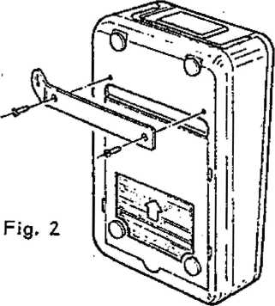

Manual sender with safety bracket and screws
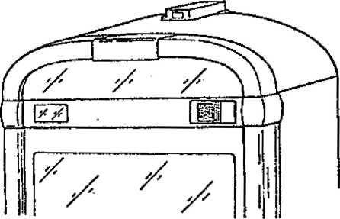
Fig. 1
1 .A- Volume Control (On R aa r~ Cabin et Wal l doe €5 not apply to w ai I boxes
and Hide-Away's).
The connection cable must be put into plug ST 206 of the central unit. When the volume keys are pressed, the computer Inputs are switched to GND via the diode linkage D 213-217.
TASTE / KEY | AUSGANGS-CODE  OUTPUT-CODE | STECKER / PLUG ST 201 / PIN
VOLUME + (I+II) | 3/4 | 6/7
VOLUME -(I+II) | 2/3/4 | 5/6/7
REJECT | 2 | 5

UNIT DESCRIPTION
OUTPUT TRANSFORMER FOR NSM-PHONOGRAPHS
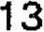
m w-e® •mwmms
6530 Bingen am Raein
Page 1301-1304
Technical Information, Assy | 174 903 | SILVER CITY
 | 174 831 | SILVER SKY
 | 174 486 | FASCINATION
 | 176 274 | SOUNDMASTER
 | 175 040 | FIREBIRD/COUNTRY
 | 176 046 | THE PERFORMER ’GRAND

OUTPUT TRANSFORMER with 'okblS'harness Part.-No. 172 431
The output transformer is connected directly to the terminals of the output amplifier. It has Input Impedance of 4 ohms and transforms the Input voltage down so that smaller output voltages are available at Connection Terminals 1 through 5 permitting speakers with lower Impedances to be connected.
A number of loudspeakers can be connected together (in parallel) up to a total maximum power of 130 W music power per channel; depending on how much power is taken directly from the amplifier.
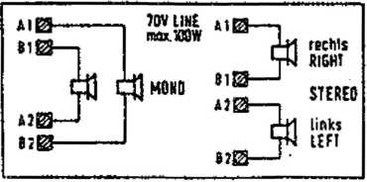
The table below shows the power required for a loudspeaker with the corresponding impedance at Connection Terminals 0*1 through 0-5. Also observe the output transformer diagram and connection schematics. Further information is given In the "TECHNICAL INSTRUCTIONS” under "Loudspeaker Connection
Endstufe ESIY OUTPUT STAGE ESIV
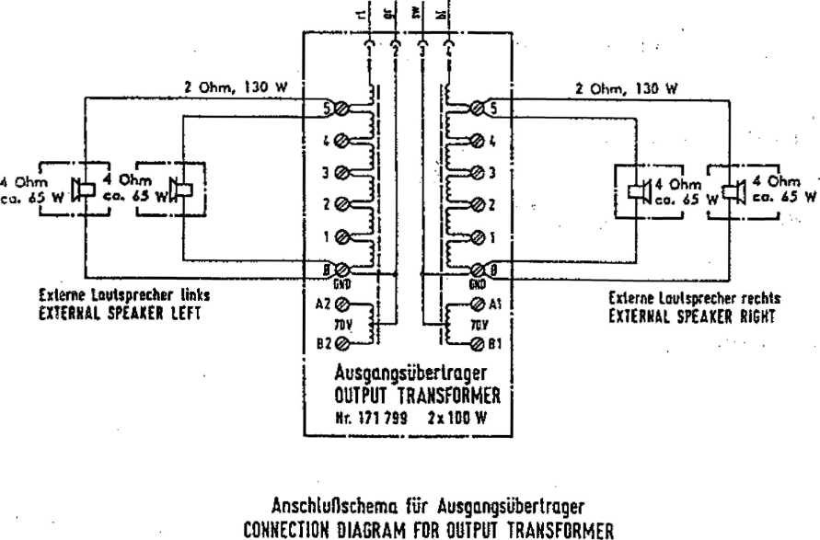
Klemtne  TERMINAL  POSITION | 7 SL | loutsprechi SPEAKER 2.5 JL | 4 A |  | T  U | 161
o-s | 130 W | 100 W | 65 W | 35 W | l!W
11 * l | 60 W | 46 W | 30 W | IS w | «W
fl * 1 | 10 W | 24 W | 15W | aw | 4W
0*7 | 15W | 12 W | 7.5 W | iw | 2 W
0 -1 | J.7W | JW | 1.8 W | tw | 0,5W

The maximum power output of the amplifier is 2x200 W music power at 2 ohms.
The following is an example of how to connect external loudspeakers to the "CD GALAXY": The phonograph itself consumes (when directly connected at
- ohm impedance) 2x70 watts.
Therefore, 2x130 W is still available for externa! loudspeakers.
For example, two 4-ohm loudspeakers each can be connected to Terminals 0-5 (see diagram) or four loudspeakers (with 4 ohms each) can be connected to Terminals 0-4.
Example for connection of wallboxes’or Hide-Away’s
If loudspeakers with 4 ohm are connected directly to a wall box or Hide- Away, the consumption is 100 watts; therefore there is only TOO watts left for the loudspeaker connected to the transformer.
Connection for Lower Phonograph Output Power
When full power is not required from the phonograph, It can be connected to the corresponding terminals of the transformer and external loudspeakers can then be connected directly to the output amplifier for higher output.
70 V - High Voltage Output
Additionally, the transformer also has a 70 V high-voltage output (A1-B1/A2- B2) for each channel.
These features are provided for operation of a widespread external loudspeaker system whereby the higher voltage keep the line losses low. Only loudspeakers with input transformers (socalled high-impedance loudspeakers of 50 ohms upwards) can be connected to this terminal, these outputs also provide a maximum of 100 W music power each, e.g. two 50 W loudspeakers (200 ohms) can be connected to each channel.
Lautsprecher-Impedanz  Loudspeaker-Impedance | Ausgangsleistung A1-B1 Output power A2-B2
50 Ohm | 100 w
100 Ohm | 50 W
150 Ohm | 35 W
200 Ohm | 28 W
250 Ohm | 20 W

The total wattage of all remote loudspeakers connected to one channel of the output transformer (whether low impedance, high impedance or combined) may not exceed max. 130 W.
Since the high-voitage coils are connected with their center, a loudspeaker connected to A1-B2 or B1-A2 radiates sound from both (stereo) channels; for this mono mode no special NF-cdupiing of the channels , ts necessary, coupiing is provided by the transformer.
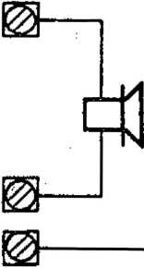
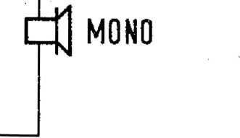
Al
Bl
A 2 B2
HV - STEREO Mode
If the loudspeakers are connected to A1-B1 or A2-B2, stereo mode is possible, but without NF-couplIng of the channels.
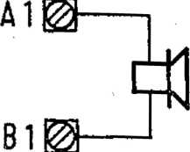
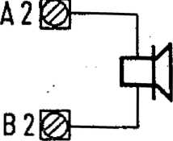
RIGHT

STEREO
LEFT ■;
TROUBLE SHOOTING FOR NSM-PHONOGRAPHS
m ncmoLoar
to  Technical Information, Assy | 174 903 | SILVER CITY
 | 174 831 | SILVER SKY
 | 174 486 | FASCINATION
 | 175 274 | SOUNDMASTER
 | 175 040 | FIREBIRD/COUNTRY
 | 176 046 | THE PERFORMER “GRAND'¹

14
Page 1401-1406
Saarlandstrafie 240 £30 Bingen am Rhein
1 TROUBLE SHOOTING
- Description of malfunction/cause
- Error displays
- Trouble shooting for NSM phonographs ES-IV/CD technology
*1-1 Description of meil-fn nction/cause
DESCRIPTION | CAUSE
Phonograph illumination and LED’s ' in central unit/CD supply do not light up. | - Power cord  - Main switch  - Power fuse (switch plate/fuse box)

Phonograph illumination okay, LED’s 1. Plug connection ST 200 of
in central unit do no light up. | central unit  - Fuses Si 201-205 of central unit  - Power transformer connection
Luminous effect lights do not light phonographs with light, generator). | - Fuse T 8 A on switch plate  - Fuses Si 701-703 as welt as  - Plug connection of luminous effects PCB
Fan for output stage does not run while disc is playing. | - Plug connection ST 209  - Triac TIC 200.  - Transistor T 204/205.
+5 V; 15 V-LED’s in central unit do not light up or are darker Fuses are okay. | - Voltage regulators VR 201-203 in central unit defective  - Short circuit in connected units.. (Pull plugs one after another and observe LED’s).
■No tone signal at loudspeaker even though a CD is playing and the volume is switched on. | 1. loudspeaker connection , 2. Plug connection of frequency network and output transformer  3. Interruption on signal wire (plug connection "ST" 4-pol. of central unit to "ST 2" on changer adapter, from "ST 3" on changer adapter to decoder board).
volume reduced by electronic protection device. | - loudspeaker mismatch (less than 2 ohms Impedance) due to remote speakers.  - Transistor T 252 defective.  - Output transistor defective.  - Control unit defective.
Poor bass reproduction. | Loudspeaker connections reversed.
Er xx-dispiay. | See "Error Displays".

m 903 / 174 831 / 174 435 / 175 274 1175 040 /176 WE | 1 403

‘1 sp lays 2 |  | 3 | Possible Causes | Corrections
 | Er | 01 | EPROM contents (CONTROL UNIT) Interrupted. | Change EPROM (IC 2).
 | Er | 10 | RAM (CONTROL UNIT} defective. | Change RAM (IC 3). After that reprogram all program steps (P20-P56).
 | Er | 11 | RAM contents (CONTROL UNIT) short-term disturbance. | No correction necessary; program Is reinitialized. Change RAM IC 3 If frequently occurring.
 | Er | 20 | Verification errors In program (CONTROL UNIT). | No correction necessary; program Is reinitialized. Change CPU IC 1 If frequently occurring.
PXX | Er | 30 | Memory contents (CONTROL UNIT) Invalid. | No correction necessary; program step Pxx (In Display i) Is automatically reprogrammed.
Pxx | Er | 31 | Memory contents (CONTROL UNIT) Invalid or not programmed. | Service step Pxx shown In Display t must be reprogrammed.
Pxx | Er | 40 | Wrong price setting. | Check price setting and, If necessary, reprogram (P41-P45, check sequence). -
 | Er | SO | Coin mechanism defective. Too much credit. | Check coin mechanism.
 | Er | fix | Error at CD player. | See Er 60 - Er 62. Ploy Interrupted after error.
 | Er | 60 | Error before playing CD (track selection).  No supply voltage present for decoder or player. | Exchange decoder board, microcomputer T0JB on pickup driver (IC 8).  Check primary fuse In CD transformer.
 | Er | 61 | No CO recognized by player.  No CD In CO tray. CD defective. Player defective.  Decoder board defective.  No supply voltage present for decoder or player. | Check CD and exchange If needed. Laser player (COM-3). Exchange decoder board.  Check primary fuse In CD transformer.
 | Er | 62 | Error after playing CD (stop). | As In Er 60.
 | Er | S3 | Track cannot be played (CO Exchange CD, check track selection.  defective) or choosing a track  number which Is too high (error  display appears only during  continuous test P60/3 or P60/4;  during regular operation track  No. i Is played whan choosing a  track number which Is too high).
 | Er | 7x | Malfunction on CD changer. | See Er 70 - Er 76. If error display does not disappear after 2 sec., error cannot be automatically corrected. No CD will be played until cabinet switch or “power on" is ectlvated.
 | Er | 70 | CO tray after playing CO Incorrect In pickup. | Check function of tight barriers OPPUM, OPGRL, OPGRR.
 | Er | 71 | Error during grip from left-side Check alignment from magazine to pickup assy and adjust If magazine. necessary. Check function of light barrier OPPUM.
 | Er | 72 | Error during grip from right-side magazine. | AS In Er 71.
 | Er | 73 | Error during replacing In left-side magazine. Malfunction of left grip lever. | Check alignment of magazine to pickup assy and adjust If needed. Check function of grip. Check function of light barrier OPGRL.
 | Er | 74 | Error during replacing of right-side magazine. Malfunction grip lever. | As In ER 73.  Check function of light barrier OPGRR.
 | Er | ?S | Malfunction during lift drive. | Check lift for Jamming. Check function and correct adjustment of light barrier OPSTP (drive wheel).
 | Er | 76 | End position of lift not o.k. | Check function and adjustment of light barrier 0PEND.

Displays t 2 | 3 | Possible Causae | Corrections
* Er | 80 | Short circuit on wallbox signal wire. | Check | wallbox connection.
Er | 90 | Title display*  three blocking In sequence, not funktlonal anymore.
Er | 91 | Blocking title display, gripper left.
Er | 92 | Blocking title display, gripper right. |  | Blocking remedy.
Er | 93 | Blocking title display, stack left.
Er | 94 | Blocking title display, stack right.

The memorized values of program steps P20 to P56 are checked after each “power on" end by activating the cabinet
switch.
An error on the programmable memory area the corresponding program steps Is show on Display 1; Pxx Er 31; the “error" lamp flashes.
After the phonograph Is turned on, the malfunction display In Display 3 and the flashing of "error" remains visible for 2 sec. After that the phonograph Is operational; without regarlng the malfunctioning program step, though.
*»Sy using serv.-progr.-step P62, the last 10 error codas can be called; see “service programs** pt. 1.5.7.
■J*3 Trouble-Shooting Chart -far NSM PhonographR ES-IV/CD Technology Conditions: Una voltage present, line connection and power supply In order.
0‘i*
^ t ntln
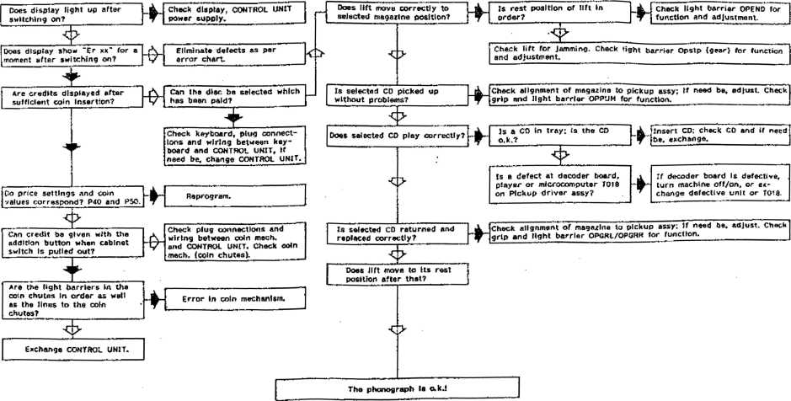
mm I wm l msul x>m l am i mm soi? i
Compare also 1.2 'Error Displays'.

it kmso TeeMMate®*
ACCESSORIES
FOR NSM-PHONOGRAPHS
to
Technical Information_{p} Assy
174 903 SILVER CITY 174 831 SILVER SKY
- 486 FASCINATION
- 274 SOUNDMASTER
- 040 FIREBIRD/COUNTRY
- 046 THE PERFORMER "GRAND"
NSM
m
SaarlandstraBa 240 6530 Bingen am Rhein
15
Page 1501-1515

- MICROPHONE with paging switch
- REMOTE CONTROL WALL BOXES
- REMOTE CONTROLS
  - Infrared remote control
  - Remote control with cable
- TAPE RECORDER CONNECTION CABLE
- OUTPUT TRANSFORMER with cable
- CASH COUNTER
- DATAPRINT
  - Data transfer and memorizing
  - Printout
B CD-AUDIO CONNECTION
- Installation in NSM-STAND PHONOGRAPHS
- Installation in NSM-WALL PHONOGRAPHS
- INTERFACE PCB CD 100 - RS 232
  - The following commands are understood and executed
  - Acknowledgements
  - Transfer Format
  - Connection Plan
  - Power Supply
- DOLLAR BILL ACCEPTOR -ARDAC MINI- (only for USA)
  - Installation instructions for Dollar Bill Acceptor in Stand Phonographs
Stacker Installation in "THE PERFORMER GRAND”
  - Installation Instructions for Dollar Bill Acceptor in Wall Phonographs
Connection via microphone socket to the central unit.
Microphone announcements are possible in any phonograph mode.
The microphone amplifier with electronic switch-over is integrated into the central unit.
The volume for the background music and microphone can be adjusted separately in the central unit.
Connection cable with pfug and microphone socket-length 10 m or 25' m (Part-No. see Spare Parts List in “Technical Instructions").
a R EE MOT" E CONTROL WALL BOXES
FIRESTREAM w. Title indication I FIRE STORM w. Title indication II
CARAVELLE I w. Title indication I CARAVELLE II w. Title Indication II
For connection to NSM phonographs in CD technology. Connection Adapter belongs to the equipment. (Part-No. see Spare Parts List in "Technical Instructions"). Detailed installation instructions are included in the adapter kit.
- REMOTE CONTROLS
- 1 Inf rared Remote Control
Wireles remote control consisting of transmitter, receiver and parts for installations. See wiring diagram for connections.
(Part-No. see Spare Parts List in “Technical Instructions").
3-3 Remote Control w i -thi Cable
The connection points are illustrated In the wiring diagram and described in unit description "REMOTE CONTROL".
(Part-No. see Spare Parts List in "Technical Instructions").
Ar TARE RECORDER CONNECTION CABLE
Connection for tape recorders with DIN input and output.
Connections for additional amplifier.
(Part-No. see Spare Parts List in "Technical Instructions").
- OUTRUT TRANSFORM ER witrhi cable
Significantly expanded adaptation capabilities and low line losses with 70 V output. (See Unit description "OUTPUT TRANSFORMER").
(Part-No. see Spare Parts List in "Technical Instructions").
© CASH COUNTER
NSM phonographs can be subsequently modified with an electro-mechanical cash counter (12. V = pulse counter).
(Part-No. see Spare Part List in “Technical Instructions").
f man / / its 274 / mow/ mm
1 503
- DATAPRINT
The printer is intended for connection to NSM phonographs ES' IV-CD Technoiogy. A detailed description is included with the printer. Putting in the paper rotf and color ribbon are described in detail in the “TECHNICAL INSTRUCTIONS” for the DATAPRINT.
- 1 Data “T r-einsTor' and M «ssrr»cor~ i zing
£ Turn ?n service program by opening cabinet and pull out cabinet switch manually, Display 1 “P01“.
1 Put in printer connector into “Service Socket” of the Control Unit.
H Enter "C", Display 1 "P".
H Enter "11" and "H", Display "PH".
£ Enter Code "1" and "H".
Counters P03 to P08 as well as popularity are transferred.
Note: Display 3 "EO" appears if an error occurs during data transfer. Counters P03 to P08 as well as popularity are reset after successful data transfer.
7-3 Transfer -to Printer
- Switch on service program by opening cabinet; if needed, puli the cabinet switch manually, Display 1 "POI ".
a Plug printer connector into socket of Control Unit.
9 Enter ”C”, Display 1 "P".
a Enter "12” and "H", Display 1 ‘P12".
a Enter code for the desired print-out and press "H".
“1" and "H" = Counters (P03 to P08)
"2^{M} and "H" = Counters and settings (P03 to P08, P21 to P37, P39)
"3” and "H" = Counters and popularity (P03 to P08, P01, P02)
"4" and "H^{M} » Counters, settings and popularity (P03 to P08, P21 to
P37, P39, P01, P02).
Note: When a popularity counter has reached vatue 200, all popularity counters are divided by half of the amount. After dividing the popularity printed out is relative; the number of divisions appears in the printout: "RELATIVE 000" to "xxx”.
If the printer does not start, ”E0" appears in Display 3.

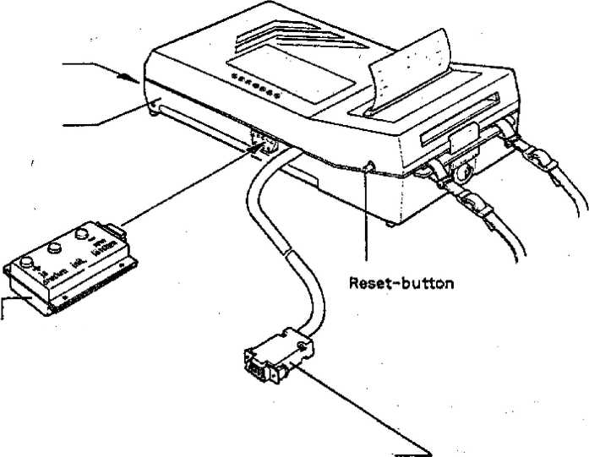
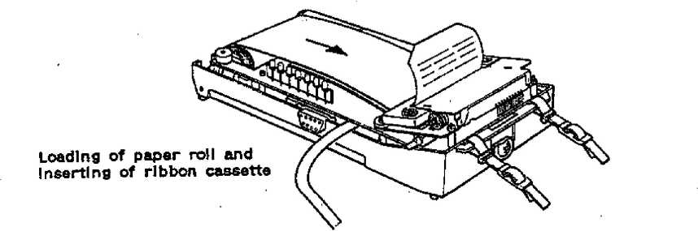
Line Socket Charge Indication
Key board
Connecting Plug

To connect an amplifier directly to the output of the CD changer an PCB CD-AUDIO (Part-No, 174 648) Is available.
The NF cable on the AUDIO PCB is to be plugged into the ,‘CD,, plug of the Central Unit. The cable from the CD changer Is to be plugged into the PCB "CD-AUDIO".
The CD AUDIO PCB is to be fastened with 4 distance holders. The following sketches show possible mounting points.
Ground has to be connected to the metal housing or with wood housings to the next grounded piece of metal.
To connect the external amplifier to the CD AUDIO high-grade connecting cables with RCA plugs on both ends are available.
Stereo cable set (2 m) Part-No. 227 533
  - Installation in M S M -Stan d Phohographs
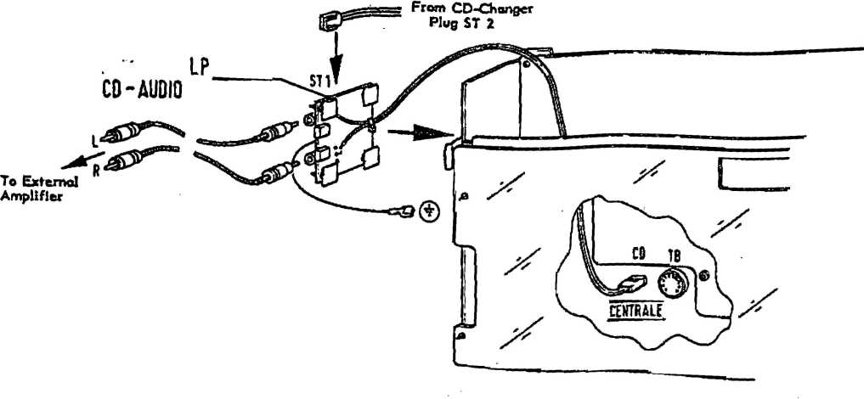

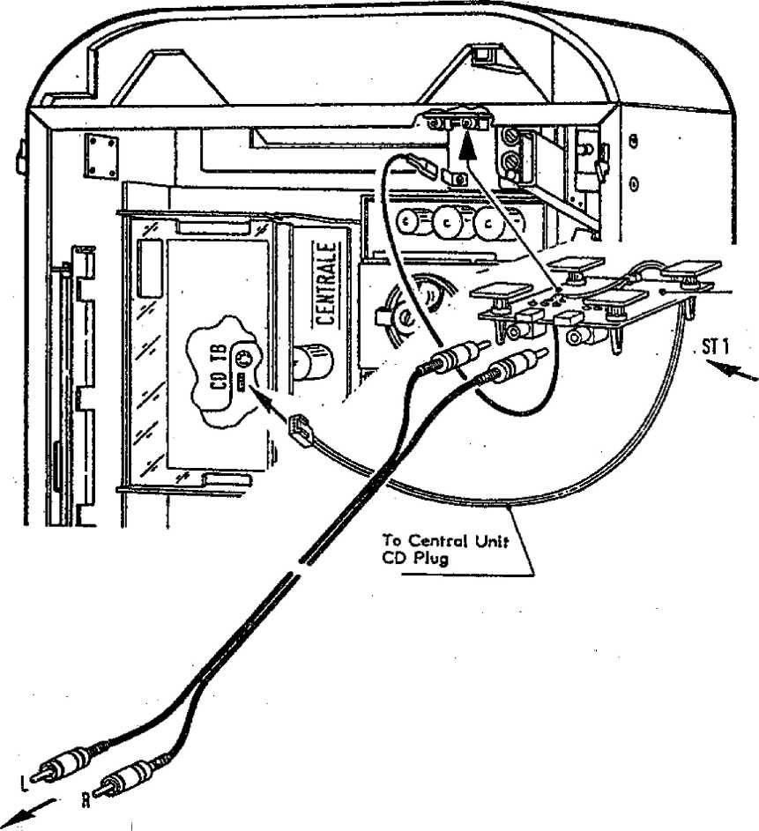
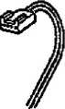
- 2 installation in NSM-Wal I Phonographs
To External Amplifier
-LP
CO-AUDIO
From CD-Changer Plug ST 2
9 INTE R F AGF ROB CD100-RS 232 FOR NSM CD CHANGE R
With the newly developed interface PCB CD100-RS 232 NSM phonographs can be controlled and evaluated with almost any computer.
The following commands are understood and executed :
10-key keypad 0 to 9 - B
C
0
F
H
M
R
U
_{v}
w
X
Y
1
Selection via keypad Background
Selection as via keypad Display request Free credit
Selection as via keypad
Muting
Reject
Vo! I -
Voi I +
Vol II - Vol II -f voi i/n - Voi I/II +
- AoKnowlod gements:
Wrong commands ?x (x = incorrectly received command)
D (display read-out) IVWWWWYYZZZZ
- = lighting status = OlOvvvv
L1 error^press C :::+— L2 your selection ::+— L3 credit
:+ L4 10 top hits
+ L5 background plays
W s= in ASCII disc/track of playing title
- = in ASCII credits
Z =■ just selected title or chart in ASCII
(WWWWYYZZZZ correspond to display of phonographs).
9= 3 Transfer FormaT;
RS 232 with V 24 drivers, 1200 Bd, 1 start bit, 8 data bits, 1 stop bit, no parity handshake via CTS and DTR no XON/XOFF, RTS is not evaluated, DCD is not connected, DSR is always on + 10 voft.
9.-4- Gonno ction R \ sin :
1 free (DCD), 2 TX, 3 RX, 4 DTR, 5 GND, 6 DSR7 free (RTS), 8 CTS, 9 free.
To connect to the 9-pole RS 232 plug of an AT compatible PC, a 1:1 connection with plug/socket (i.e. monitor extension cable, flat wire) is sufficient.
- Rowor~ Supply
Supply (via keypad connection on CD box) 8 to 12 voit, 0,25 A.
iM«r it««r i«*.t it»-r it*i>r ttti-r
Hi*f tt«*r lllnf
-ini:
g5SSZ>- *■
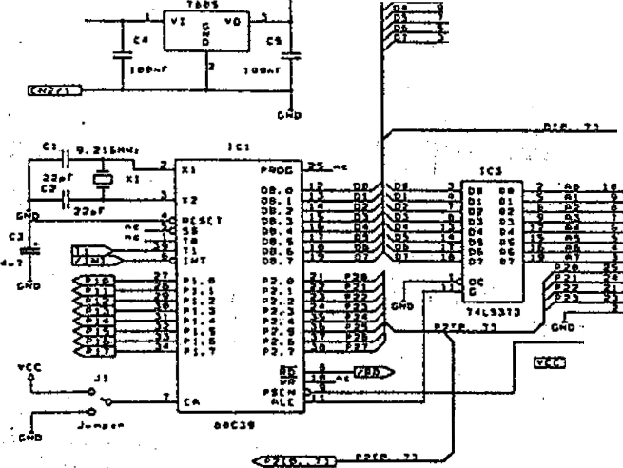
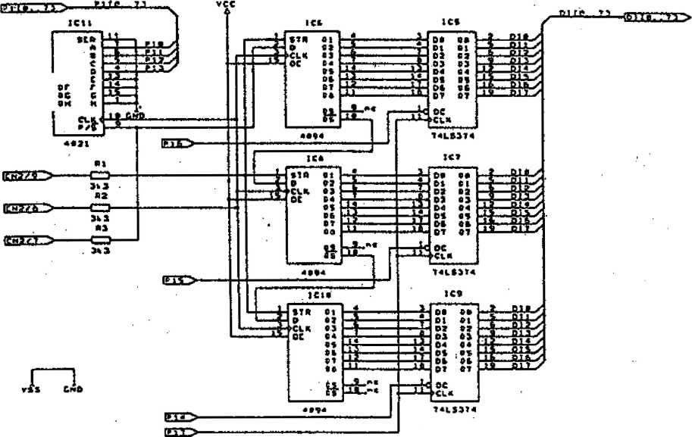
cat | CM | cej | CB4
X | X | X | X
X- | T | _x | xx_

{■I
T
CH
T
tsi ca«
X—X
■X—X. X T T
voO
''cc
IC*
r*i  ITJ  itj  t'4 | t*t
t ^{m}m
■
t aj
 | J +
l fTf I
l ■ ' # ■" J 1
 | I
 | JIJ

* .. &J |  | i 1 /
a . a: |  | m /
■ii | i aj
-t.
i | 1 DIft V
jlJ | BIT /

(iLajjJQ
juue—iwm
t«
**  "3  *3 | 04  et  M  03
*4  m c. | 0*  Ad
^ >  ajL | PT4
■
,07
jHl A
at!  ST | HC
ffcr

A.B g6-
Jtf—j
-aiy
ITCK
Till* | i**t»n* iihaMtiidif co>rir<
S.rt b, |  | atv
x-l | a*e3«-i | I. *

T 7
7 111 ■
K.-f |  |  | |<ltv
* r
 | 6, mt B*.. .' ~~ |  | a

174 903 /174 831 /174 485 /175 274 / 175 040 / 176 046
1 509

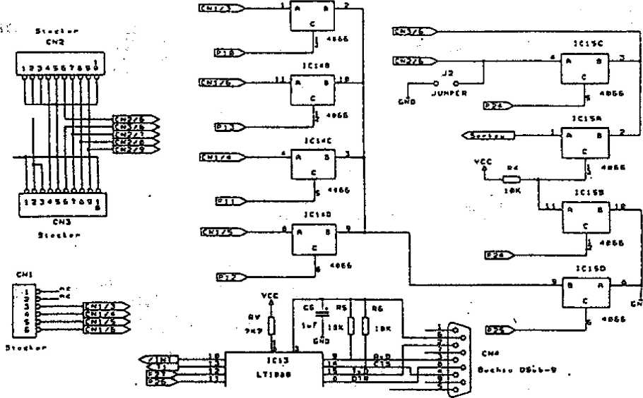
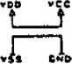
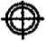
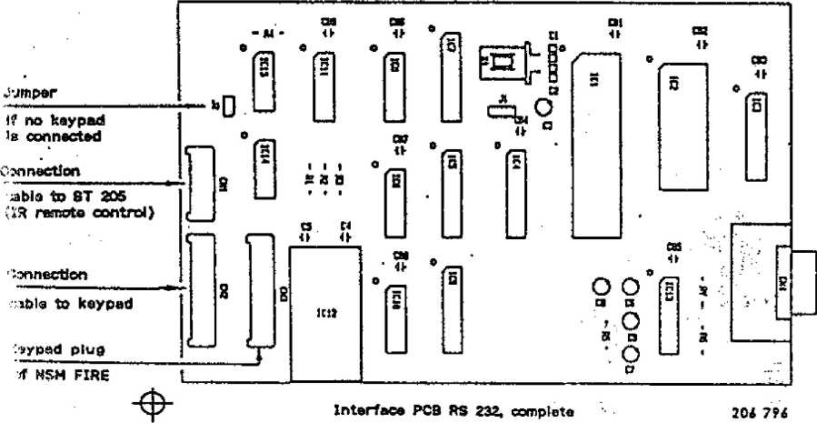
ICI*«
rew jVY >
tpcpr j;
iwt t.r
CT
t.r
S-«B
till.
im.I: |  |  | »IV
* I | »Of.) |  | 1. •
SUjLAi. | Piw-h»" ft t ITt'rm | 2 m t | _ _3

Connection on PC

DOLLAR BILL ACCEPTOR -FOR USA ONLY-
m mi m m. / m-« l m 274 / m wo / t?e o«
T 51 1
CHUTE
SIDE VIEW
1 51

10 DOLLAR BILL ACCE P TOR -ARDAC MINI— (only fo r USA) ,
* ’ ’.wy •
10-1 Installation Instructions Tor'
Dot lar Bill AooepTor' in NSM CO- Stand Phonog raphs.
i Install chute in place of cover in lid (see Fig. 1).
9 Hang dollar IbftfSvalidator Into the 2 attachment studs (Fig. 2 / Pos. 1).
The unit must/.be installed so that It dbes not interfere with the lid when closing - however, the chute must close tightly to . the dollar bill validator. . ^{r} f.'Vv.;.
The depth can.be adjusted at Fig. 2 / ifos. 2. >
The height shou Id be ad j u sted at F i g.; 2 / Pos. 3 so th at the; dpi lar bill validator is aligned with the chute infthe lid and Is guided exactly into the acceptor siot (Fig. 1).
Secure dollar bill validator with sheet metal screws F‘ 3.9 x 6.5 at Fig. 2 / Pos. 4. * •
S Install dollar bjli adapter PCB (Fig. Z /^ Pos. 6) on 2; spacers with wood * screws to the feft Inside of cabinet. /‘
’> • . ,.L.,
9 Put 2 contacts from the harness (as cari be seen id. Fig; 2 / Pos; 5) in;t< Plug Housings 6 and 7 of the 21-pole plug, " ¹
9 Mount doljar bill electronic; (control box) as shown in Illustration. _{v};
■■■ ■; - . V* / .' : *': j ; !':
B Make piu^connections from dollar bill adapter PC6, to the acceptor to - the control unit and to the control box; plug connection. Cable from cpritrol box Into plug;' plug in contppkbox into service socket. ;
’ [jS -k ‘ 'St
B- Program :prfce v setting (pla/js/monetary value) tft program step 45, e.g.’*?; "07 iOO" - 7 plays,// 1 dollar)/ a;/
. .V'? •' • i: '•
. i,'^{!i} ' /*'J. ' §. ’ , ₍
9 Program monetary value in Program Step 45, e.g; "07 100" = 7 plays ,/ fr
i Program monetary value for Channel 5 in Program Step 55; e.g. "IOO" = 1 dollar.
dollar.
STACKED TNSTALLiMlbN in "THE FfER FORMER GF^AND"
a For the .installation and de-lnstallation of the stac^. acceptor has to be removed from the phonograph and connected with .the
stacker. -• ’■ ' -
Then' the dollar -bill acceptor has to ' be Installed together/frith the stacker. For de-installation the sequence is reverse.
Vi m f 174 831 / .174 435 1 175 274 / 175 OiO /175 W6
A
! ...
B
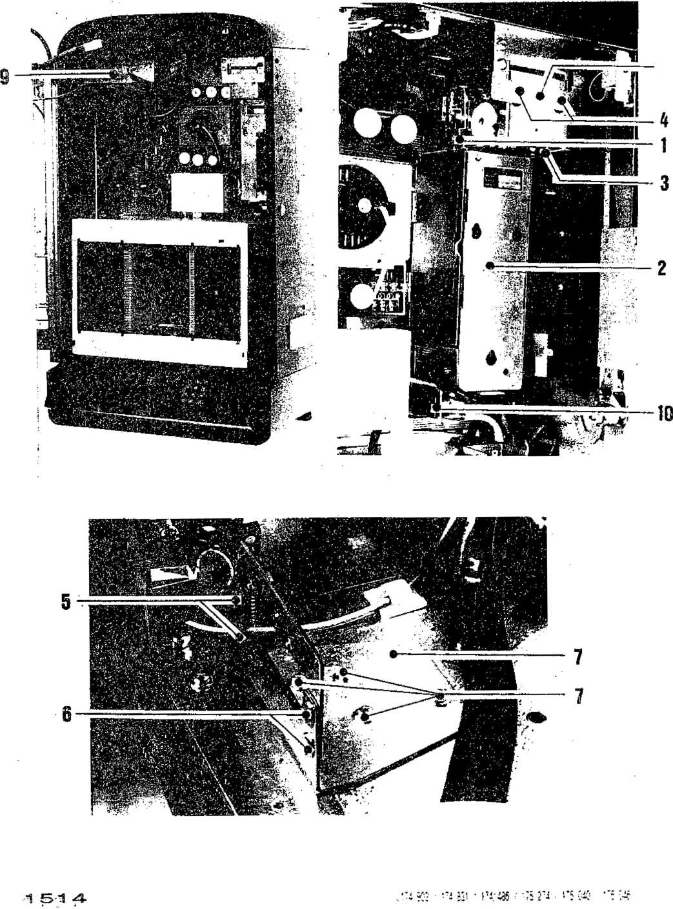

10-2 Installation instructions 'for Dollar Bill Accesory - in NSM CD — Wall Phonographs
fl Pul! up latch (Pos. 1) and adjust stacker (Pos. 2) so it is positioned vertically under the acceptor (Pos. 3).
- Hang dollar bill validator into the 2 studs (Pos. 4). The unit must be installed so that is does not interfere with the lid when closing - however, the chute must close tightly to the dollar bill validator. The depth can be adjusted by loosening the three screws (Fig. 5) and by moving the bracket. The height can be adjusted by loosening the four screws (Fig. 7) and moving in a vertical direction; bill validator must be aligned with the chute in the lid and guided exactly into the acceptor slot.
fi Secure dollar bill with screw M 4 at Pos. 8.
- Move stacker backwards into its final position until the latch (Fig. 1) locks in at the second position.
a Put the 2 contacts from the harness, as seen in Fig. 9, into plug housings 6 and 7 of the 21-pole plug.
a Mount dollar bill electronic (control box), as shown in illustration, at the top of the cabinet. First push it into rear guide studs, then mount the front side with two screws. The plastic discs serve as spacers between the control box.
B Make plug connections to the acceptor, to the stacker and to the control box. Plug power plug from control box Into service socket (Fig. 10).
a Program price setting (plays/monetary value) in program step 45, e.g. “07 100" = 7 plays / 1 dollar.
H Program monetary value for channel 5 in program step 55, e.g. "100" - 1 dollar

1 Lay harnesses so that they do not hinder other units!

212-509 Overlay II-Set Of 100

TITLE STRIP Part-No. 219 185
TITLE COVER Part-No. 212 509

KN = Kilonewton (1KN = 100 kp)
from progr.-lndex 004
from Pr09^{r}~^{lni}*^{x} <X>«
006

