2

UNIT DESCRIPTION CONTROL UNIT FOR NSM-PHONOGRAPGHS
m xv-c© Tscmxum

74 903 74 831
- 486
- 274
- 040
- 046
to
Technical Information, Assy
SILVER CITY
SILVER SKY
FASCINATION
SOUNDMASTER
FIREBIRD/COUNTRY
THE PERFORMER "GRAND"

1 | FUNCTION
1.1 | Control unit
1.2 | Processor
1.3 | Reset
1.4 | Low voltage recognition and power off
1.5 | I/O (Input/output)
1.6 | Output enable
1.7 | Service plug
 | Spare parts list
 | Schematics CONTROL UNIT CD
1-1 CONTROL- UNIT
The heart of the control and credit unit is a microprocessor from the proven Rockwell 6500 family.
All unit’functions such as keyboard, display, remote control, carriage (light generator / organ), coin mechanism, title indication etc. are controlled by this unit.
Different types of malfunctions are recognized and reported as such on the display. All statistical data such as phonograph status, price adjustments and bookkeeping data are stored In the CONTROL UNIT. These as well as credits remaining are stored when the power is switched off.
Connection of the DATA PRINT is provided at Plug 11.
A number of service programs allow the read-out of statistical data, Individual as well as test programs.
.2 Rr~ocesso

The processor consists primarily of the microprocessor IC 2, the battery RAM IC 3 and the I/O component IC occurs via IC 12.
IC 1. the EPROM 4. Address coding
(4 MHz) and the
The tact generator consists of a quartz oscillator with Q frequency divider (1:4) IC 14.
3 Reset

The Zener diode ZD 2 with transistors T 1 and T 2 serves to activate the reset when U (+5 V) is less than 4,6 V.
Transistor T 2 with Its antenna connection serves to recognize static discharges and Interferences.
When T 2/C is LOW, reset is activated via IC 16, Pin 10, Pin 11. HIGH, reset remains stored for approx. 200 msec, over the monoflop 1/2 IC 13 with timing components R 14, C 19 vis IC 16,
If T 2/C is subsequent Pin 9.
1 .A- Low Voltage Recognition and Rower-
Off
Resistors R 15, R 16, R 18 from a voltage divider for low voltage
recognition.
R 17 and D 6 generate a hysteresis when the voltage rises again. The positive edges (10 msec, at 50 Hz, 8.3 msec, at 60 Hz) coming from T 3/C retrigger the monoflop 1/2 IC 13 with timing components R 20, C 20 (approx.
20 msec.) and IC 13, Pin 4 at LOW.
This signal is monitored by the processor via IC 4, Pin 6.
When IC 4, Pin 6 is HIGH, the program is prematurely deactivated.

All I/O operations are controlled via a serial bi-directional Interface (IC 4, Pin 18 = CLOCK; IC 4, Pin 19 = DATA). IC 18 selects the different input
channels; IC 11 decodes the load Impulses for the output channels.
Output: IC 5 and IC 6 are output ports.
Resistors R 22-40 together make two D/A converters. The DC signals obtained thereby control the volume and are conducted to the amplifiers via plugs ST 2, Pin 2, Pin 3.
Input: IC 8 and IC 9 are Input ports.
The resistors, In sequence to the Input pins, protect the CMOS components.
Serial interfaces are available:
At ST 3 for control of the light generator
At ST 4 for display and keyboard
At ST 8 for control of CD changer
At ST 10 for control of Title Indication.
- Output — Enable
A clock signal is sent by IC 4, Pin 5. Capacitor IC 26 is charged keeps IC 15, Pin 8 at LOW.
If the clock signal does not occur, IC 15, Pin 14 is LOW and OE of IC 5 and IC 6 is inactive (outputs In tree state).
OE also become inactive via D 1 when reset (IC 16, Pin 11) becomes LOW.

- Service Plug ST 11 serves to
Plug connect with the DATA PRINT.

8
¡e
8
¡e
5
Q
§
j*
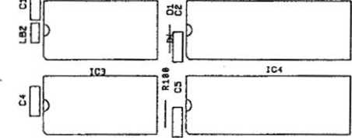
ICS C6 (C4
CONTROL UNIT CO
*IC2
STll
> |  | i
) | II
 | icn L
IC12
IC17
IC13
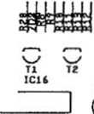
BBUy
th
1
bis ^{ICIS} i
L|o | >
icm ci icia
£
m
^ £|Eb
Tfll
T5
&
mum
]U. -C i^{Q(}—
3 ICl4 ^
]M* e=i[> nmma
MiMWI C
O
&=□ D:
IC23 1C24
NSM
IC15
ica
>

iczc ^{lcn} cm ^{1CZZ} n “ ,
ISZC
o
•<
DC
LCD
ci6 ST 1
ST2
ST3
ST4 ST8 ST5 ST 6 ST7 ST9

174 873 CB-CONTROL UNIT CD. ASSY

225
225
225
225
225
225
225
225
225
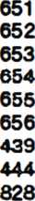
PANEL | 4 | prongs
PANEL | 6 | prongs
PANEL | 8 | prongs
PANEL | IO | prongs
PANEL | 12 | prongs
PANEL | 15 | prongs
PLUG | 3 | prongs
PLUG | 8 | prongs
ST 07 ST 03.06 SI08 STM ST01 ST 05 ST 06 ST 06 ST 11
PIN PIN PIN PIN PIN PIN PIN PIN
D-SUBMINIA7URE-CONNECTOR
SLEEVE 9 prong:
221 535
Qt
IC 3
IC2
OSCILLATOR QUARTS
IC-SOCKET
IC-MEMORY
4 MHz
24 prongs HK48 Z 12-20
446
423
222
231
222 447 175 102
28 prongs AM 27 256 DC
IC-SOCKET
IC-MEMORY
Program 007

P 2 P 2
2
2
3
IC 1,4 222 448
ICI 231 413
IC« 231 415
IC U 221 763
IC 5,6 221 771
IC 21-23 221 541
t16 221 665
IC » 221 525
IC 17 221 652
IC 14,50 221 705
ICH 221 792
ICC 221 653
K16 221 852
IC 11 221 796
IC 1$ 221 813
IC 26 221 497
IC-SOCKET IC-MICROCOM PUTER IC-MICROCOMPUTER
IC-CMOS
IC-CMOS
IC-CMOS
IC-TTL
IC-TTL
IC-TTL
IC-TTL
IC-TTL
IC-TTL
IC-TTL
IC-TTL
IC-LINEAR
IC-LINEAR
40 prongs R 65 C 02 R 65 C 22
HEF 4021 B HEF 4094 B F 4049 BC SN 74 LS 00 SN 74 LS 03 SN 74 LS 04 SN 74 LS 74 A SN 74 LS 123 SN 74 LS 139 SN 74 LS 151 SN 74 LS 138 LM 339 ULN 2003 A

!21 115
03 01, 4-i ZU 1 20 2 1(0
221 114 221 539 221 948 221 466
SI-DIODE
SI-DIODE
TRANZORB DIODE
ZENER-DIODE
LIGHT EMITTING DIODE
1 N 4004 1
1 N 4148 16
IC TE-5 1
ZPD 3,9 1
LR 3160-F 1

2
2
T1, t 221 757
- 221 283
TRANSISTOR BC 547 B
TRANSISTOR BC 212 B

220 181 220 242 220 185 220 263 220 341
C 22 C23 CM C 16,28 C 21 CMS, 25,27 C B, 20,
220 334
63 V
63 V 63 V 10 V
220 159 220 162 220 160
26
C !i C11
RU,
116
R12,1! 73
221
600
099
622
029
031
033
- 172
\ W
i w i w i w Ì w
221
221
221
221
R 93 R 10, 87 R13 R 2-6, M, 106*18)
R 84. 88, 89,34, 110,101, IDS, 113 R1,15 R 11, 18, 20.47,
74, 76,
82, 63, 90-92, 96,111, 112, IK, 115
R16,21, 27,13*40 73,75,
85
R17 R 22*26, 28*32, 41-72,
98,99 R 14,81, 88,95 R 80
221
i W i w
i W
221
221
22
036
604
601
038
048
273
i W
i W i W
i w i w
i W
221
221
221
221
221
CE R.-C APACITOR 47 pF
CE R.-CAPACITOR 68 pF
CER.-CAPACITOR 270 pF
CER.-CAPACITOR 1000 pF
CER.-CAPACITOR 4700 PF
MKT-CAPACITOR 0,1 pF
LYTIC 4,7 pF
LYTIC 10 pF
LYTIC 100 pF
RESISTOR 100 0
RESISTOR 470 0
RESISTOR 820 0
RESISTOR 1 Kfi
RESISTOR 2,2 KQ
RESISTOR 3,3 KQ
RESISTOR 47 KO
RESISTOR 100 KO
RESISTOR 10 0
RESISTOR 4,7 KO
RESISTOR 8,2 KO
RESISTOR 22 KQ
RESISTOR 27 KO
RESISTOR 10 KO

^ X 2 Sßö
*§2 —
B SB S ux 3gR
S biôi
8 3? S ST5
^•7: X vuMiiuuiw , ¹ -‘ H w W » «r» S«IK» j ,_
H 8 9 UnmUW i' I—
Mil» n IK 1 .
sf Zi 5 «MH I ** P, %. O«' ' f-
M¡0IUS*WI1S¡_ -l£.
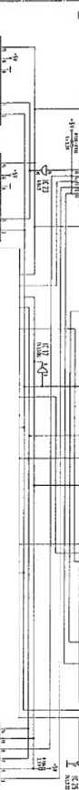
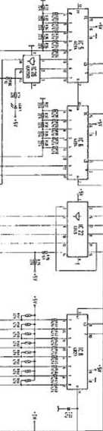
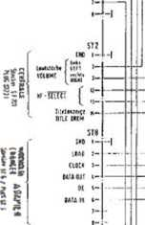
sí"
It
« till
j-
' Mme / MMKi I §f - «ma / :«*. ;
imx/cumi
f? *• vwi I íilIHi i §" .K
—2 - «
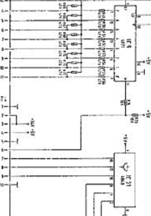
hoAKMM £>rçeM UH*«* 7.1S mi-
itXl r- ®8J *■<
iua
fWIÎCIÔ
mti
ICI«
SiriT
:
««
- uv
- a* •ÎT us
ils II IIS ce
cwu
;c*
us
¡I
© :•
171 ^{s}? *1 Pli • 5? ?! h gl
V 1" ^{ä|} í»i ^{f} ¹ a M
PS? p-i ^{r} s 2 =ï ^
r- o -Si
ì * I 1
- U S 5 5
«fil
ï**i
f
mi
H ^
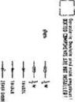

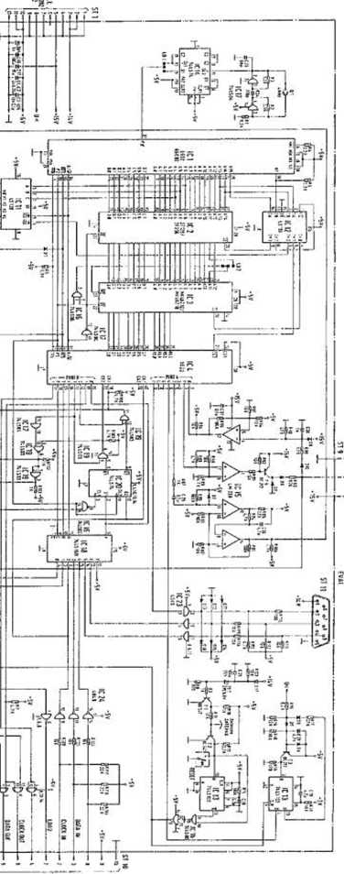
o
o
i
p
IÛ)
ID
c
(/>
b
o
1§ ³
«a
lì
RS
» C
S3
I
1
«il
I'«
éJ¡
£
I

UNIT DESCRIPTION

DISPLAY/KEYBOARD FOR NSM-PHONOGRAPHS
38 ¡T9-® S3 tSBÈBWBS

to Technical Information, Assy 174 903 SILVER CITY 174 831 SILVER SKY
- 486 FASCINATION
1 75 274 SOUNDMASTER
- 040 FIREBIRD/COUNTRY
- 046 THE PERFORMER ‘GRAND’

5
Page 501-505/511
ttnjpHt
Saarlandstraöe 240 BÏÏ Bingan am Rtwin

IND EX
1 FUNCTION
- Display
- Keyboard
Spare parts list
The shift registers IC 301 through IC 303 are the output ports for the display control.
The display is operated in the multiplex mode.
The segment information Is prepared for one digit with IC 302 and IC 303 via drivers IC 308 and IC 309.
The transistors T 303 through T 305 are controlled by IC 307 via IC 301 and switch on the appropriate multiplex level for 4milliseconds.
Resistors R 332 to R 345 determine the segment current.
Lamps L 1 to L 5 are controlled statically via IC 307, Pin 12 and 14 and IC 306, Pin 19, 11, 12.
Resistors R 325 to R 329 limit the transient current.-;
The load signal for the output shift registers is monitored by circuit IC 306, Pin 4 and 13; R 306; C 303; D 301.
During the duration of the load signal the display is dark.
C 303 is discharged via D 301 and IC 306, Pin 13.
OE of IC 301 to IC 303 becomes LOW and thereby inactive.
If no load signal occurs, OE becomes inactive via R 305.
Capacitor C 302 avoids lighting up of the digits after switching on.

1 .2 Key board
IC 301 is an input port for the keyboard which Is connected 302.
to plug ST T 307 codes
The circuit with diodes D 302 - D 307 and tranfeistors T 306, the keyboard matrix to a 4-bit signal combination.
ST381
5T302
□ CH5
JIL
r~~icn<
flT'
o
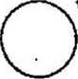
^¡lili lllsV_y 116 il
n  a  T3M | a | \ T»
sÿ***¹
BZH BIT *t% ftZT
«4 m, nt mi _{E2}£ > v O
BHBH~Oi
150» O
O
Mil
Jl
n
6L

u

POS. PART-No. DESCRIPTION DATA QTY
ÇB-DISPLAY CD. ASSY
173 664

p;
P
ST 302 225 553
ST 301 225 664
PANEL 8
PANEL 10
prongs 90 1
prongs 90* 1

«1-8 231 416
TD SL 5150
DISPLAY

TUBUS
HOLDER
173
171
384
629
1
4

573
771
763
491
1
3
IC 310 221
ST 301-303 221 IC 304 221
ST 306-309 221
IC-VOLT AGE IC-CMOS IC-CMOS IC-LINEAR 12 V 1 A HEF 4094 B HE F 4021 B ULN 2003 A

0 301-307 | 221 | 114 | SI-DIODE | 1 N 4148 | 7
20 391 | 231 | 079 | ZENER-DIODE | ZPD 4,7 | 1
7 »1-306 | 231 | 240 | SI-TRANSISTOR | BC 636 F | 5
1 306, 307 | 221 | 283 | SI-TRANSISTOR | BC 212 B | 2
MKT-CAPACITOR 0,1 nF
63
63
63
63
i W i W
2
w
w
w
w
T 303-3ÛJ 220 334 C3CS, 3» 220 332 C 302 220 249
C3ÔI 220 162
R 381 221 611
R 306s
332 350 221 627
R 302-304,
301-309,
314-117,
319-323,
354 221 033
R 310-113 221 038 R 3CS 221 009 R 325-329 231 366
MKT-CAPACITOR 0,33 PF
LYT1C 1 pF
LYTIC 10 pF
RESISTOR 10 O
RESISTOR 1,2 KQ
RESISTOR 3,3 KQ
RESISTOR 47 KQ
RESISTOR 1 MQ
MET.-RESISTOR 10 fi

173 900 KEY BOARD, ASSY

_{r}.
1“
ifl
t=»
oc
li
IS
w
S'S
■<( C3
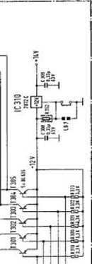
fe §
I I I ~ %
Ü s *“
Ï St»
IL. 5S 5»
sg 3» ¡“¡
* = sis CO
gS?5 " *1 S| gs
lisi ¡1
Ig 6k 2s
IIii si *©
« =j
•f|
}
i
is
15
■25
Is
X
II
2:
•=i
si
S.U
~J
—. é
gioì 5® 2 . 5© ®
§ »Ëà
I
s(g) sE - 3E <S> 3E SE
■H
i
?
11
If
i!«
ili
iíí
il
U , M
1 ill 0 ?ï©o
•ÜJ-
II
is
IS
ttT
ï-îT
iv'E'i
IÏÎ
Q
_{V}J“
5 ® ul
Q.|—
Sq
3S
>-
jp<t
sg
<t o C3
iS
If
«Í 3
Ü2
"t
i'

OE
I-cbIS

83
!ä
S
s-
o»
•■**
S»
88 8
*e s
is i
«« ■£
s§*
ss_s
55»
ß» ¿K
2 5«
ff« »
gí ç

.si.
s
i
en Ç co "
5=>et
•D"
co
CO -T en g
U³rv
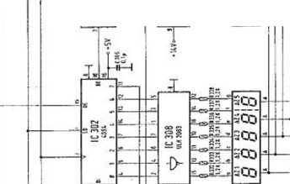
T
JL
SI
¥
T
fr
•■*.
2
x
5
a
7;
x
V
Ä
5
s
t
L=.
£
&-Ä
fc-A
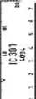
*ZE
« *5
o £.-
, «i
Q.
O
Z
5
P
5
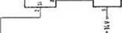
S
-i-l
§5
■»-I
k
T s * h"h
sco ■4 co Seo SCO SCO
^{L}^fr
•<S^

u.-
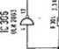
Si
A
H
Hl-I
5=

153

Ì ?
*¿S
H—
I“
¿I
If
•d. <*
la

C-O
co
H
a
Ils

UNIT DESCRIPTION CENTRAL UNIT
\

FOR NSM-PHONOGRAPHS

to
Technical Information, Assy
174 903 SILVE
174 831 SILVErc 5>M
- 486 FASCINATION
- 274 SOUNDMASTER
- 040 FIREBIRD/COUNTRY
- 046 THE PERFORMER "GRAND"

Itcpttl
Saartmdstraflt NO 5538 Bftgen n Rhein
6
Page 601-611/621

INDEX
1 | FUNCTION
1.1 | Power Supply
1.2 | Amplifier
1.3 | Signal path
1.4 | Adjustment of controls
1.5 | MIC socket, microphone connection
1.6 | TB socket
1.6.1 | Tape recorder connection
1.6.2 | Connection of auxiliary amplifier
2 | Adjustment instructions for trimmer of central unit and output stage
3 | Repair aid
3.1 | Output stage
3.2 | Control of volume and muting
3.3 | Tracing sound signal

The power supply, fan controls, stereo amplifier with inputs for microphone, CD and tape are all integrated on one circuit board.
The output stages and the fan are connected to the central unit via ST 209, ST 210, ST 211. The music power per channel is 200 watts when matched to a loudspeaker impedance of 2 ohms.
- Rower Supply
.The power transformer supplies 22 V, 2 x 11,5 V and 2 x 43 V from three separate secondary coils. The supply voltage for the output stages Is supplied with 2 x 43 V by a two-way rectifier (D 206) and the center tap of the transformer.
The supply voltage for the voltage regulator VR 201, +5 V Is supplied with 2 x 11,5 V by a two-way rectifier (D 201/202) and the center tap on the transformer. The tow voltage recognition is accomplished by D 204 and D 205. Fusing is accomplished with Si 201 and SI 202. Fusing for the output stage Is accomplished with Si 204 and SI 205.
The non-controlled voltage +14 V for the display and key Illumination is being picked up at capacitor C 201.
The control voltage of +15 Va, for the pickup driver, coin mechanism, control unit, remote control, luminous effects as well as the supply voltage for the preamplifier of +15 Vb, are supplied by the 22 V transformer coll and rectified by D 207 through 210 and VR 203. Fusing is accomplished by Si 203.
The LED’s indicate the following supply voltages at the same intensity:
LED 201 = + 5 V
LED 202 LED 203 LED 204 The TRIAC
+60 V + 15 V a +15 V b TIC 200
controls the output stage fan depending upon the operational state of the amplifier (REJECT); i.el the fan only runs when the amplifier is not muted.
- Amplifier
The stereo amplifier is equipped with two tone control ic’s, one AF switch IC, 50 diodes and 17 transistors.
The output stage is designed without Induction coils or transformers and is therefore Ironless.
At full volume level the music power Is 200 watts per channel.
3 Signal path
to microphone amplifier T 230 and background 4 and B of IC 230. The TB input is connected to is connected to Pin 2 and Pin 6. goes from Pin 2 to Pin 15 respectively through
The Input signal MIC goes mixer of TA, TR 231 to Pins Pins 3 and 7. The CD input In the play mode the signal Pin 5 and Pin 9.
When the microphone switch is actuated, the signal goes from Pin 4 to Pin 15 or from Pin 8 to Pin 9.
In the tape mode (TB/Pin 6 to ground) the signal goes from Pin 3 to Pin 15 or Pin 7 to Pin 9 when the switch is actuated. In the MIC, CD or TB stage, muting is switched off regardless of the operating state of the phonograph. The stage '■MIC" has priority switching.
From the AF switch {IC 230) the signal goes via an AVC (automatic volume
control) T 250, T 251 at Pin 9 of the tone control IC 251 with associated basé booster. Treble control Is accomplished with TR 252 and bass control with TR 253. The control voltage for the volume and muting is on Pin 5; approx. 2,5 V at full volume, approx, 0 V while muting.
The 0C signal for the volume setting is supplied by the control unit.
Signal Output Pins 3 and 6 of IC 251 are routed through a network to the
driver stage for the output stage.
The parallel complementary power Darlington transistors T 151 through T 154 In the output stage allow a minimum loudspeaker Impedance of 2 ohms. Quiescent current compensation and thermic stabilization Is accomplished with T 150, the quiescent current setting with TR 250. The amplifier Is equipped with three protective circuits against overload mismatching, thermic overload.
- ) T 155 acts as a threshold switch for the electronic fuse. When the emitter current of the output transistors exceeds a certain value, T 252 is switched through by T 155 switching on the muting and thereby limiting the current.
- ) The actuation of the electronic fuse at collector T 252 is controlled by the control unit.
When its fuse Is tripped a number of times within a certain period, the volume Is reduced automatically by one step each time until the electronic fuse Is no longer activated.
- ) The thermal switch on the heat sink switches off the power supply to the output stage when the heat sink temperature reaches approx. 90 C (cooling malfunctioning). LED 150 Is dark. The switch-on point (following cooling down) Is approx. 60 C (switch-on hysteresis).
The terminating impedance at the loudspeaker output should not be less than 2 ohms. In the case of mismatching (less than 2 ohms), or short-circuit in the loudspeaker cable, the limiting circuit Is actuated.
The result Is distorted sound reproduction or reduction of the volume. After elimination of the mismatch the amplifier Is ready for operation and the volume can be readjusted.
The volume difference between the two channels is compensated at the factory by setting the levelling potentiometer TR 254.

1.4- Adj ustment of Controls
TR 230 - microphone volume
TR 231 = music fade-in for microphone mode
TR 252 = treble control
TR 253 = bass control
TR 230 for setting the microphone amplifier:
This adjustment is dependent upon the position of the phonograph in relation to the microphone and required microphone volume.
In case of feedback while paging, the control must be turned counterclockwise or the microphone be positioned In another direction to the speakers.
TR 231 for music fade-in in microphone mode:
There.the desired music volume level during paging can be controlled.'
TR 252 R and TR 252 L, treble controls, are to be set
according to the rooms only, according to the
locations. .
The maximum.position Is suggested In acoustically balanced
TR 253 R and TR 253 L, bass controls, must also be set locations and the desired bass reproduction.
- 5 MIC socket, Microphone Connection
A dynamic microphone with an Impedance of 200 ohms - 600 ohms with switch for relay control can be used.
NSM option accessories:
Microphone Order No. 224 223
Connection cable Order No. 171 880 (10 m long)
_© T E3 Socket
-5-1 Tape Recorder Connection

The TB socket allows the music from the phonograph tape recorder as well as music from a tape recorder phonograph.
to be recorded on a to be played by the

The AF signal (analog signal) for recording with a tape recorder is on Contacts 1 and 4 and can be connected directly with a stereo diode cable; Contacts 2, 7 and 8 (8 is ground).

- 6-2 Connection of Auxiliary Amplifier
An auxiliary amplifier can be connected to the TB socket. The AF signal can
be fed directly from the TB socket (Contacts 1 and 4) to be Input of the
amplifier with a stereo diode cable.
The input sensitivity of the external amplifier should be 200 mV at a minimum Input impedance of 47 KOhms.
Note: A stereo diode cable with a 5-pln plug is suitable for the above
connections. In this plug Pin 1 must be connected to Pin 1; 3 to 3; etc.
The stereo recording cable is not suitable because in such cables Pin 1 Is connected to 3 and 4 to 5 (crossed).
2 Adjustment Instructions for. Trimmer of Central Unit: and Output Stiage
TR 150 for quiescent current adjustment of the output stage: The quiescent current must be set to 40 mA +5 mA. After replacement of the output transistor T 151 through T 154 a correction may be required.
Important! Muting is to be switched off for measuring and setting. The lift will be put In play position, the volume control is set at 0 and Si 150 or the thermal switch are repfaced by an ampere meter.
TR 201 and TR 202 for adjustment of volume control voltage:
Maximum volume for regularly selected titles in program step p 28 must be programmed to "31 “ (full volume).
Take measurements at test points TP-L and TP-R to ground; nominal value =
- V (factory setting).
The Internal resistance of the measuring Instrument must be greater than 1 MOhm!
After replacement of IC 251 a correction may be required.
TR 254 R and TR 254 L, level controls for adjustment of the total amplification: Set at factory to correspond to the output voltage of the CD player.
Muting must be switched off. Volume, treble and bass set to maximum.
The output voltage on the loudspeaker connection with a load of 4 ohms is approx. 10 V - 25 W power per channel, with the AVC at full level. At minimum Impedance of 2 ohms the RMS output corresponds to 100 W RMS or 200 W music power at disc playing.
3 Repai r Aid
Amplifier integrated in central unit ES IV Malfunction: No sound, no output power:
It is assumed that LD 201 to LD 204 glow with the same Intensity and that
the power supply is therefore O.K., the CO Is on the CD player being,
played, and normal volume was set in program step P28 to "31".
- 1 Output Stage
LD 150 on the output stage circuit board is dark. Malfunction probably located in. the output stage; check Si 150 and replace if required. If the fuse blows again, the output transistors are defective.
Remove output stage unit, pull out cover plates on the bottom. Check for
short-circuit on transistors T 151/T 152 T 153/T 154 with ohmmeter. Since the transistors are connected in parallel, It Is only possible to test them In pairs.
For individual testing one transistor must be unsoldered from the defective pair. After replacement of the defective transistors the quiescent current must be readjusted with TR 150 according to the adjustment instructions.
  - Control o'f Volume and Muting
In the play mode approx. 2,6 V must be measured on Pin 5 of IC 251 (for full volume).
If the voltage is near 0 V, T 252 or the control "volume L and R" from the computer must be checked (reject line).
3_3 ~T r~a ci ng Sound Signal
Trace the sound signal arriving at CD plug according to the table.
The point where the signal is missing is probably the cause of the malfunction.
AF Signal Point | Cause of Malfunction When Signal Missing | >*•
C 237, C 238 | IC 230
IC 251, L/R Pin 9 | T 250 / T 251 (AVC)
R 269, L/R (2,6 V am IC 251/ Pin 5) | IC 251 L/R
T 255 L/R (collector) | T 253 L/R | •i
If the signal is there up to T 255, but no output signal arrives at the output stage, plug connectors ST 210/211 as well as th.e output stage have to be checked.
o
& 8 M _ M
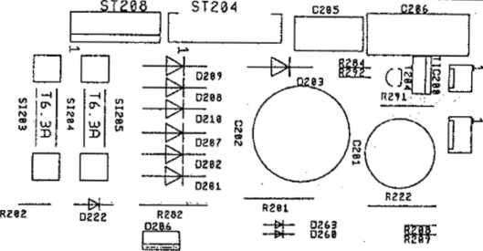
co
—<
r\>
o
O
to
—4
r\>
CD
U)
□
□ □ “4 “4
u) ¡2 ro
r» J)
S *
□ □
en
—i
ro
09
ro
w !2
ro
ro ®
S ^{M}
□
§0 ¹ °Q I
wl y tn
5^ S
ro
CD
*
w
-4
no
®
h*
0204
3È
IC273U Ü255L —* y «I^{ra} (]{! H
R283
“K?¥SU
R276L
ctr7¿ rj CZ73R S
-4
, -ro
r"
en
—i
no
es
W
en
—4
r\>
CD
er«
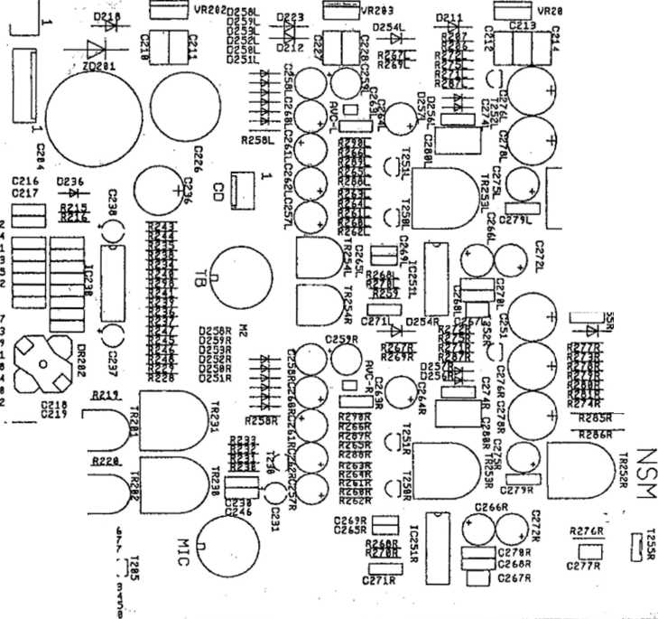
c
£
■ç
ä
et
C?'
C
Q
3
~'R28£L"
D
CZ3I
C23
CZ4
CZ3
C23
CZ4
CZ4
CZ4
CZ3
C28
CZ4
CZ4
CZ4
C28,
\
en —» ro
CD
en
O
n
;z
-H
PO
D
r*
n
i
o
o
cia
—4
-ro
Cls
cm
i—i C=J cm
,[râS
>CZZ1 j C2Z2 )
* —W— OZI —&f-~ 023
Râfc ⁰²¹ gztfcr (
OZI M- • OZI W -- OZI Z025
■o
i
70
-Í
T>
174 903 / 174 831 / 174 486 / 175 274 / 175 043
eo©

173 666 CENTRAL UNIT. ASSY 50/60 Hz

FUSE
FUSE
FUSE
by 50 Hz T 2,5 A T 3,15 A T 6,3 A
538
029
374
SI S3 225 SI 201, 22 225 SI20i, 205 225
1
2
2
SI 203 225 220 FUSE
SI »1,22 225 225 FUSE
51 205 225 218 FUSE
by 60 Hz
T 2,0 A T 3,2 A T 6,25 A
1
2
2
COOLING PLATE FUSE HOLDER PROFILE, ASSY SHIELDING COVER
SOCKET
SOCKET
17 3 730 8 2012« 225 689 173 698 173 944
1
0
2
1
KIC
79
225 244 225 749
S 5 Mab
prongs 8 SV
225 439
PIN PLUG RM 2,5 3 prongs
Sì 209 ST 203, 206, CD ST 205 ST208 ST207 ST 200 SI 2W, 210,211 SI 20? ST 201
1
>
3
1
1
1
1
>
3
1
1
PIN PLUG PIN PLUG PIN PLUG PIN PLUG PIN PLUG
225 418 225 443 225 804 225 444
225 807
RM 2,5 RM 2,5 RM 3,96 RM 2,5 RM 3,96
4
6
6
8
12
10
12
15
prongs
prongs
prongs
prongs
prongs
pron gs prongs prongs
225 654 225 714 225 656
PIN
PIN
PIN
PANEL
PANEL
PANEL
RM 2,5 RM 2,5 RM 2,5
VR 3)1 221
VR 202,233 221
572
476
IC-VOLTAGE
IC-VOLTAGE
+ 5 V + 15 V
1 A ,5 A
1
2
JC ¿jo 1C 251 RL D 201-202, 207-120 0211,212. 218, 222, 223,254 RL, 255 RL D 204,205, 213-217, 235, 237, 251-253 fit, 256 RL D2G6 ZD 201 10 20I-2G4 TIC 200
IC-LINEAR
IC-LINEAR
SI-DÎODE
231 236 231 089
TDA 1029 TDA 4290-2
BY 251
1
2
>
221 463
>
9
>
>
>
SI-DIODE
221
5
N 4004
SI-DIODE SI-DUO-DIODE TRANS20RB-DI0DE LIGHT EMITTING DIODE TRIAC
221 114 231 202 221 821 221 466 231 028
1 N 4148 BYV 32/100 TVS 515 LR 3160-F TIC 206 D
27
1
1
4
1

63 V
63
10
40
10
25
40
25
25
40
LYT
LYT
LYT
LYT]
lyt:
LYT!
LYT
C 253 i | 220 | 342
C 277 Rl | 220 | 185
C 287 RL | 220 | 274
C 241, 242 | 220 | 241
C 246 | 220 | 263
C 243, 244 | 220 | 400  401
C 269 RL | 220 | 400  401
C 218-222,
265 Rl,
279 RL | 220 | 435
C 268 Rl | 220 | 429
C 270 Rl | 220 | 335
C 2*. 217,
230, 234,
235, 239,
2«, 271 RL,
273 fil, 28L
282 | 220 | 334
C 274 ft. | 220 | 333
C 210-214,
227, 22k
230 RL | 220 | 332
C 206 C 206 | 220  220 | 336  450
C 258 RL,
259 RL | 220 | 243
C 260 RL | 220 | 249
C 231, 237,
238, 257 RL,
262 RL, 284
RL | 220 | 159
C 261 RL,
286 RL, 275
RL | 220 | 162
C 272 RL | 220 | 389
C 278 RL,
278 «. | 220 | 158
C236 | 220 | 160
C 251 | 220 | 250
C 226 | 220 | 289
C 201 | 220 | 283
C 202 | 220 | 286
C 204 | 220 | 287
T 204,253
RL 221 459
I 230, 250
11,81ft 221 249
7 255 RL 221 488
7 252 RL,
206 221 332
SI-TRANSISTOR
SI-TRANSISTOR
SI-TRANSISTOR
SI-TRANSISTOR
CE R.-CAP ACIT OR
CER-CAPACITOR
CER.-CAPACITOR
CER.-CAPACITOR
CER.-CAPACITOR
KT-CAPACITOR
KT-CAPACITOR
MKT-CAPACITOR
MKT-CAPACITOR
MKT-CAPACITOR
TAN-CAPACITOR
LYTIC
KT-CAPACITOR
MKT-CAPACITOR
MKT-CAPACITOR
MKT-CAPACITOR
MKT-CAPACITOR
LYTIC
LYTIC
LYTIC
 |  |  | >
PNP BC | 556 B |  | 3
 |  |  | >
NPN BC | 550 B |  | 5
NPN BD | 13 9—1C | ) | 2
 |  |  | >
NPN BC | 337-16 |  | 3
100 pF |  |  | 2
270 pF |  |  | 2
330 pF |  |  | 2
560 pF |  |  | 2
1 nF |  |  | 1
1,5 nF |  |  | 2
3,3 nF |  |  | 2  >
4,7 nF |  |  | >  9
0,15 pF | 100 | V | 2
0,022 UF | 63 | V | 2  >  >  \
0,1 UF | 63 | V | /  >  >  13
0,22 UF | 63 | V . | 2  >
0,33 pF | 63 | V | >  9
2.2 pF | 63 | V | 1
3,3 pF | 63 | V | 1  \
SF 100 | IlF 3 | V | /  4
1 UF | 63 | V | 2
4,7 MF
10 uF 47 pF
47 pF 100 MF 100 pF 1000 pF 2200 pF 47CX) pF 4700 UF

POS. PART-No. DESCRIPTION
DATA QTY

095
611
620
- 600 635 614 099 622
10 q
22 G 56 G 100 G 180 G 330 G 470 G 820 G
>
6
2
2
>
3
2
>
W
W
w
w
w
038
- 629
044
048
045
049
- 041
009
- 230 183 210
692
232
086
233
234
- 278 414
470 | KG
560 | KG
820 | KG
1 MQ
3,3 MG 470 G 1 KG 1,5 KG
0,15 W 0,15 W 0,15 W
4
1
>
6
2
2
 | 221
fi 29,279
Jl, 287 RL | 221
3 206 | 221
R2JTRI | 221
R 2.7D RL | 221
R 263 RL | 221
R 264 RL | 221
.8 208 | 221
R 267 RL | 221
R 206, 287.
259 RL, 288
RL | 221
R 275 RL | 221
R 209, 283 | 221
R 278 RL,
2S8 | 221
R 252 RL | 221
R 266 RL,
226, 28«.
289 RL, 292 221
R 21k 220 | 221
R 268 RL,
227 | 221
R 290 RL | 221
R23Q 249-
248, V\ RL 221
R 274 RL | 221
fi 258 Rt | 221
R2S1 RL | 221
R 278 RL | 221
R2T2 RL | 221
R 215, 216,
234-241 | 221
R 265 RL | 221
R 260 RL | 221
R 22k 229,
232, 233 | 221
R 231 | 221
R 285 RL | 221
R 291 | 221
R 286 RL | 221
R 201, 202,
282 | 221
R 222 | 231
TR 252 RL,
252 RL | 231
IR 230 | 231
7R231 | 231
IF 352 RL,
252 RL, TR
283, ÎR 231 231
TR 201,202 221
TR 254 RL | 221
029
030
031
033
172
035
501
604
037
RESISTOR
RESISTOR
RESISTOR
RESISTOR
RESISTOR
RESISTOR
RESISTOR
RESISTOR
RESISTOR
RESISTOR
RESISTOR
RESISTOR
RESISTOR
RESISTOR
RESISTOR
RESISTOR
RESISTOR
RESISTOR
WIRE WOUND RESISTOR WIRE WOUND RESISTOR
TRIMMER RESISTOR TRIMMER RESISTOR TRIMMER RESISTOR
SHAFT
TRIMMER RESISTOR TRIMMER RESISTOR
RESISTOR
RESISTOR
RESISTOR
RESISTOR
RESISTOR
RESISTOR
RESISTOR
RESISTOR
RESISTOR
RESISTOR
RESISTOR
RESISTOR
RESISTOR
RESISTOR
22 KG i W 3
33 KG i W 2
>
47 KG i W 9
56 KG i W 2
68 KG i W 2
82 KG i W 2
100 KG i W 2
150 KG i W 2
>
10 KO i W 7
18 KG i_{w} 2
>
>
10 1 W 3
6,8 KG 1 W 1
' ' ' >
>
iw 10
i W 2
i W 2
>
ì W 4
i W 1
i W 2
i W 1
iw 2
W 5
W 1
W 2
W 2
W 2
W 2
W 1
W 2
>
1 KG 1,5 KG
- KG
- KG 8,2 KG
10 KG 1 MQ 2,5 MG
6,8 Q i W 2
>
rot Nr. 5214 10 KG 0.1 W
100 KfJ 0,1 W

6
fi
e»
o
•
co
UlI
Sïü E ~ ~
98«
££’ fi
8 8*
3 £ £
s
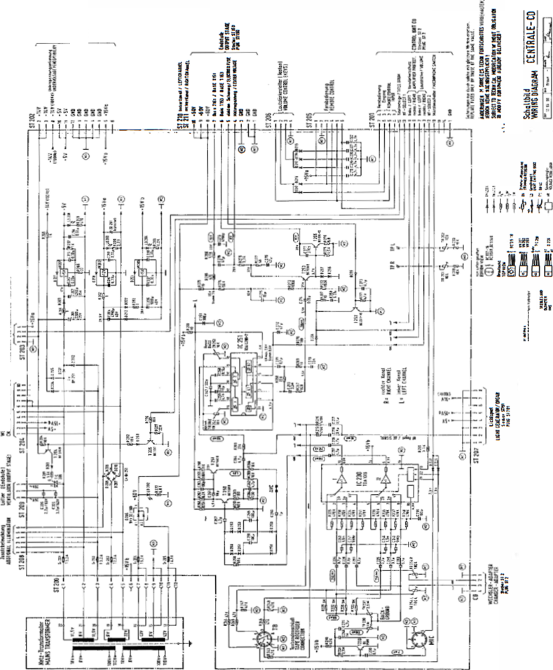
ti
IS
ss
®
-
-^{f}íi
«i $
‘7 >>
í ¡I
§&
-o-
CL
ry
i
es 5
ces
*? æ ü
«SIS
aSs
»se

UNIT DESCRIPTION

I CD CHANGER FOR NSM-PHONOGRAPHS
88 XV-CD SSSWSS&SS’

SILVER CITY SILVER SKY FASCINATION SOUNDMASTER FIRE BIRD/COUNTRY
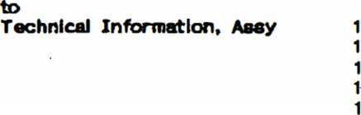
903
831
486
274
040
74
74
74
- 75

SSmfiSfl
Serlavjstrsfli 80 Page 801-815/821-822
6530 Sirwen » Rhein

INDEX

PICKUP FUNCTION Transport Pull holder Return holder Feature
1.2
1.3
1.3
2
2.1
2.2
2.3
3
3.1
3.2
4
5
6
6.1
6.2
6.3
6.4
PICKUP DRIVER Lift control Grip control CD-Player control
PLAYER
Disc player CDM 3 Servo panel
PC8 DECODER BOARD
MAGAZINE
CD CHANGER 100, test, set, adjust
GENERAL INFORMATION
MAGAZINE
PLAYING UNIT
LIFT
Spare parts lists

1 PICKUP RUNGTION
The pickup serves to transport the CD’s between the magazines and the player.
ATTENTION! When the CD changer has the switch at the window (upper right), the transport does not function if the window is open.
If the window is opened while the CD is playing, the title will be played to the end, but the CD will only be transported back after the window Is
closed.
- Transport
The lift is moved via a stepping motor controlled by the microprocessor of the control unit. The distance between 2 CD slots is 8 motor steps (1 opto counter step).
During the run the light barrier OPTSP, which Is directly connected to the drivewheel, checks the motor’s position every 4 steps. Stepping errors are immediately recognized and displayed with Er 75.
Together with the light barrier OPEND the end position of the lift is verified. Should a mistake appear here (signal too late or early) the display shows Er 76.
- Pull Holder-
r
With both grip levers, brought into lock position by CD motors MOGRL for left and MOGRR for right, the CD holders with their CD’s are pulled out of the magazine. The light barrier OPPUM reports the correct position of the CD holder in the pickup unit.
If there is no report 2 sec. after switching on the motor, the display will show Er 71 for the left magazine or Er 72 for the right magazine.
- Return Holder
To return a CD holder to its magazine, either motor MOGRL for the left magazine or MOGRR for the right magazine Is switched on In the opposite direction.
Light barriers OPGRL or OPGRR report the end position of the grips.
If the report does not appear within 2 sec. after switching on the motor, the display shows Er 73 for the left magazine or Er 74 for the right magazine.

.3.1 Feature
to remain on the player after it finishes playing, the the pickup driver board must be connected, is pulled out, the tray with the CD is returned to the
rf you want the CD solder bridge LB3 on If the cabinet switch magazine.

2 PICK UP DRIVER
- 1 Control
With output port IC3 the microprocessor of the control unit controls Switch transistors T 2-5 via drivers T 6-9. These drive the unipolar coli of the stepping motor (ST4, Pin 1-6). Using signal OPSTP (ST4, Pin 7) the microprocessor controls the position of the motors.
Together with signai OPEND (ST 3, Pin 6) the end position of the lift Is reported via input port IC 1.
  - Grip Control
Both of the grip motors (MOGRL for the left magazine and MOGRR for the right magazine) are driven from the double motor bridge IC 6 via output port IC 3.
While pulling a CD from the magazine the signal OPPUM (ST 3, Pin 7) reports the end position of the CD holder in the pickup to the microprocessor of the control unit.
While returning the CD it recognizes the end position of the grips via signals OPGRL (ST 3, Pin 5) for left and OPGRR (ST 3, Pin 6) for right.
- 3 Control of "the CD Player
Microcomputer IC B (T01B) is used to convert the Incoming serial data in I²C-Bus format from the decoder processed.
panel Into parallel signals that can be unit communicates with it via ports IC 4
The microprocessor of the control and IC 2.
- Disc Player C D M 3
The COM3 contains the components laser diode, play motor, radial motor, and focus unit.
It reads the data from the CD.
- Ser~vo Panel
The servo panel contains the components to control the COM3.
They consist primarily of the photodiode signal processor, the radial error processor, the drivers for the laser diode, the focus unit, the radial motor and the playing motor.
- RGB DE COD EE R BOARD
The components servoprocessor, decoder, digital filter, DA converter and NF output driver are combined on the decoder board. It also contains the circuit to process the complete power supply for decoder board COM3 and servopanel.
5 MAGAZINES

with 50 CD holders each are in the CD is possible to play 5- or 3-inch CD’s, out.
6imply by the holder
2 equal magazines that are equipped changer. With different CD holders it The magazine can be swung out and totally taken Equipping with or changing CD’s can be done respective CD holders, inserting the new CD Into back till locks in the magazine.
taking out the and pushing it

