2 OPERATING
INSTRUCTIONS
SERVICE
3
PROGRAMS
A- CONTROL UNIT
S DISPLAY/ KEY BOARD

TECHNICAL INFORMATION
6 CENTRAL UNIT

OUTPUT
"7.
STAGE

FOR NSM-PHONOGRAPH
Ö CD-CHANGER

FMEWm OTS ©mjJMTiW & TITLE
INDICATION
O COIN and BILL ACCEPTOR

ÉS xv-ea TscHmv
REMOTE
CONTROL
3 OUTPUT
TRANSFORMER
A- TROUBLE SHOOTING
S ACCESSORIES
•ir
TO TECHNICAL INFORMATION, ASSY -175 040-
(TITLE PAGE) Page 001/002
(630 Bingen m flbsn

The modern technology of this new NSM phonograph «FIBEKRD/COUNTÎRY* with CD changer assures the highest functional reliability. A practical diagnostic system is available for maintenance and service.
• In order to assure satisfactory operation at all times we recommend reading the technical descriptions carefully so that you are familiar with all service operations. = ' •
Ï V
The fol[owing technical documents Include:
- The -TECHNICAL INSTRUCTIONS" with Important information regarding
set-up of the phonograph, technical data, location of the components, the "cabinet“ parts list as well as the electrical plan and various wiring diagrams.
- The "OPERATING INSTRUCTIONS" with explanations regarding play And
settings as well as short Instructions for statistics and service
< programs. ^{i;}
- The "STATISTICS AND SERVICE PROGRAMS" as well as test programs and error displays. The convenient service programs help the user In maintenance and control and permit the transfer of bookkeeping and technical data Into the new NSM recording device and the printer “OATAPRINT".
4-13, The "UNIT DESCRIPftfDNS⁻ Tof control unit, display /key board, central unit, output stage, CD changer, title display, electronic coin mechanism and bill validator, remote control and output transformer with their functions and, where applicable, wiring diagram and parts list.
- “TROUBLE-SHOOTING CHART", a description of errors, error displays
as well as flow chart to determine errors.
- , "ACCESSORIES", Information cn genuine NSM accessories with
Instructions for Installation and exercising options.
The Information and Illustrations contained In these technical documents are up to date at the time of publication.
SUBJECT TO TECHNICAL MODIFICATION WITHOUT OBLIGATION TO MODIFY EQUIPMENT ALREADY DELIVERED!

Copyright by NSM Aktlengesellschaft, D6530 Bingen/Rhein 1, Germany No reprint*in full or part unless approved.
-K^i "Caution: Replace With Same Typ Fuses"
1W— "Attention: Ulltlser Un Fusible De Rechange de Même Typ"
The CD-Player with Laser pick-up used In this phonograph Is in compliance with the regulations of the F.D.A. Accession number 8 320 425
Note: This equipment has been tested and found to comply with the limits for a Class A digital device, pursuant to Part 15 of the FCC Rules. These limits are designed to provide reasonable protection against harmful interference when the equipment is operated in a commercial environment. This equipment generates, uses, and can radiate radio frequency energy and, If not Installed and used in accordance with the instruction manual, may cause harmful interference to radio communications. Operation of. this equipment In a residential area is likely to cause harmful Interference In which case the user will be required to correct the Interference at his own expense.

TECHNICAL INSTRUCTIONS

FOR NSM-PHONOGRAPHS
es xv-cö r&mmumt
TO TECHNICAL INFORMATION, ASSY -175 040-
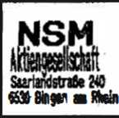
1
INDEX

PLEASE READ INSTRUCTIONS
Transport damages
Keys
Use NSM mounting bracket Observe when using an upright stand Transport devices Power connection Title strips and CD's
5
6
2.
3.1
3.2
3.3
3.4
3.5
3.6
3.7
3.8
3.9
3.10
3.11
4
5
LAYOUT OF UNITS Display / Keyboard
SPECIFICATIONS Electrical data Muslk power Fuses Lighting
Credit / Cash Input
Keyboard
Displays
CD changer
Loudspeakers
Special features
Dimensions
LOUDSPEAKER CONNECTION SPARE PARTS LIST "CABINET" OPERATING SCHEME

Storage and operation of this device is allowed In dry rooms only.
- Tr'anspor-'t: Damages
If external damage due to transport is noticed, this should recorded on the delivery slip and endorsed by the person delivery.
at once be making the
The manufacturer is not liable for damages during transport!

1 -2 Keys
One cabinet key is cash box.
To open the cabinet taped to the front glas. The other keys are In the unlock on the right side and open the door.

1-3 LJse NSM Mounting Bracket C Part —No- 04-0 739)
So that the coin mechanism can function correctly, mount the phonograph horizontally and vertically correct Therefore, we recommend the practical NSM mounting bracket.
Take care to mount the bracket untwisted since the rear of the cabinet can otherwise be twisted.
To secure the phonograph to the bracket, hexagonal screw M 10x12 -from the accessory bag- Is to be used.
Plug In connection cable before mounting (see 1.6 "Power Connection“).
TECHNICAL INSTRUCTIONS!
■f
for Mounting of the machine on the Waif
-*•
Secure mounting of the machine Is very Important since besides the danger of severely damaging the machine, the operator Is responsible for al! damages caused by an incorrectly mounted wallbox; when choosing the fastening material, take Into account the machine's whelght of 83 kg. We recommed dowel pins In sufficient quantities.
4-
The screws should be at least 6 mm In diameter!
-*■

Instance: Plastic - Wall plug
First a few tips:
- The maximum bearing capacity of nylon expansion plugs may only be achieved with the greatest possible screw diameters and with screws exceeding the plug point by the screw diameter again.
- Please ensure that with fixings In hollow brick and hollow blocks that the

expansion zone of the plug Is completely web.
anchored In at least one stone
Determination of minimum screw lenght
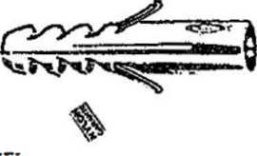
Wichtig:
mind. 1 x Schrauben-6
ixd (d=nominal diameter of screw)
+ Plug lenght
♦ Thickness of plaster and/or Insulating material
+ Thickness of mounting bracket 3 mm
tips you will have for secure fixings.
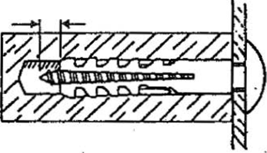
Min. screw length
If you observe these created the prerequisite
Pull-out values In kN*. Determined In each case with the largest screw dfamater (steel screw) and with flush fixing of the plug In the load-bearing anchorage base.
Concrete
Aerated
concrete
Hollow blocks
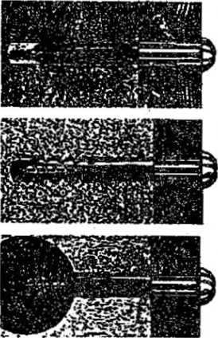
Allowance must be made for an appropriate safety factor.
building
Light
board
Pull-out values (kN)
Type-Wallplug S5 S6 | SB | S10
Wood screws dla In mm | 6
Concrete B25 | 4i5
Aerated concrete gb 3,3 | 1,2
Aerated concrete G 4 | 1.3
Solid brick Mz20 | 4,1
Perforated brick Hlz20 | 3,0
. J.-T/'J> V : -

The following points must be observed when drilling, Irrespective of the material:
- Drill hole geometry
The exact drill hole geometry dictates the load-bearing capacity of a plug. Therefore always drill at right-angles and do not change direction during drilling. This is especially to be observed in the case of soft materials.
2. Drill p
rocass

The following drilling methods drilling machine:
- Rotary - without Impact
/
- Impact drill-many impacts with amount of impact.energy. Fast
are possible depending on the type of
a low amount of Impacts with a low amount rotation

- Hammer drill - few Impacts with a high amount of Impact energy. Slow rotation.
The material determines the drill process:
- Solid materials of dense structure: Impact and hammer drilling.
- Hollow brick, materials of low strenght and aerated concrete: Only rotary so that the hole does, not become too big and in hollow brick the webs do not break out.
Never forget to remove the dust from the drill hole after drilling. Only then
Is the plug secure.
Pull - Out Values - Safety Factors:
The pull-out values (breaking loads) given in this catalog are mean failure ads determined in ait least 5 tests in uncracked building material. Failure terla may be: failure of building material, breaking of bolt, loosening of anchor, breaking of anchor.
load)
crlte
The maximum working load is calculated by dividing the pull-out value (breaking load) by the safety factor.
As a safety factor we recommed: for nylon wallpluges \r > 7.
BE
Example: In aereated concrete GB 3,3 the pull-out value for B plugs with 6 diameter screws Is 1,2 KN. Divided by safety factor 7 equals 0,17 KN = 17 Kp for 1 screw.
The weight of the machine is 83 kg; therefore, at least 83 kg / 17 Kp - 5 screws are necessary. For safety and symmetry reasons 6 screws are to be used (see sketch).
'Œ

When fixing the machine to the wali, make sure the vent Is not hindered, in Its function. When using the mounting bracket, there is normally enough distance between cabinet and wall for air circulation. Plush wall hangings decrease this distance; In that case the bracket has to be fastened to a flat board. Do not mount machine above heaters!

A- Observe Uprlg bit
When Usl Sta n d
n g an

If the machine is mounted on a stand, Is must fall over. Therefore, It is recommended to use stand. With approx. 15* angle the open machine be made sure that is cannot sandbags to weigh down the should not tip over!

-5 Transport Devices
Before operating the phonograph all devices for safety and protection during transport have to be removed.
Prior to any further transit the safety and protection devices have to be replaced.
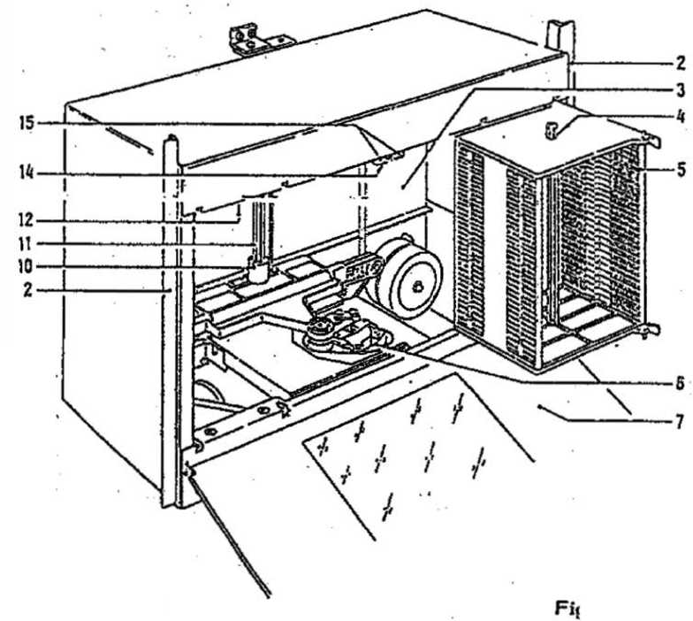
- Take off securing screws and holding bracket
If the PCB holding plate (12) is to be flipped down, the fastening screw Is to be removed.
- Push the bar locker (15) to the center and swing out left and right magazine (5).

-Remove slotted plastic pipe from the lift axle (11), grip the lift closed to lift axle (10) and pull up.
- Remove cover from playing mechanism. Remove foam padding (A) or rubber ring (B),
If applicable, which protect the radial motor.
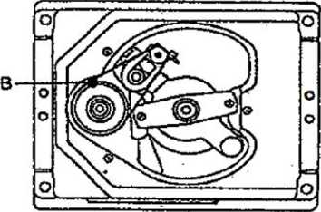
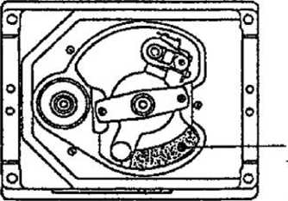
Do not insert foam padding on the cable side If safety devices have to be Installed for fur ther transport.
- Loosen CD changer by turning the four nuts (8) so far back from the bottom plate (9) that the changer moves freely.
Keep transport devices In a suitable location in cabinet for later transport!
Information for transport of CD changer:
When exchanging the changer, it may only be transported in the original packaging!
- Remove magazine, push the proper button (15) outwards and remove the unit.
Inserted CD's can be kept from falling out when the plastic pipe from the lift axle as well as a second one from the enclosed package Is put through the opening (4) and all CD's of the magazines.
- Remove design parts: Take out front glass (7).
- Put in safety and protection devices In proper sequence.
1-6 Rower- Connection
The label on the power cord shows the voltage setting by the factory.
For other voltages set voltage required on transformers.
Put In power line Into 3-poie socket on rear of cabinet.
Green-yellow of the three-wire power cord must be connected to the ground according to the International safety oode.
Check main voltage before connecting!
After plugging in the phonograph turn on the switch -located under right side of cabinet- fluorescent lights should now light up.

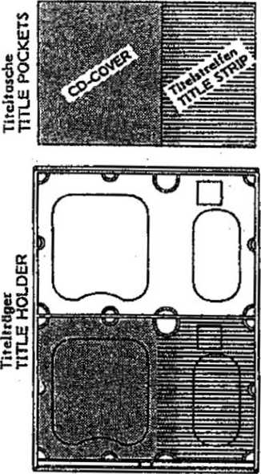
TITLE STRIP TITLE COVER
PLEASE OBSERVE!
Equipping of black title holders should be done &8 follows:
• 9 ₀ •⁴
Remove title pockets from accessory pack, Insert CD covers on the left side and written title strips on the right side In the title pocket - thicker foil side of title pocket tD; the outside - and insert then in black title holder. If the covers are bigger than 120x120 mrii, they need to cut to size - please use only title cover.
The title program displays are pressing the i— key or the —» outside of the machine or the "TL" on the title display PCB.
moved by key on the or
on the ■TR" key
Part-No, 219 185 Part-Net 212 509

In case of dislocation of title holders due to rough Transportation, please refer to section 9, paragraph 1.4 "Jammed or dislocated title holders''.
CD-Changer (Fig. 1): In order to avoid movement of the lift (Attract mode) the cabinet switch has to be pulled out. Now the device is in service mode. In addition, the CD will be returned when It remains on the player after the last track (see also: CD-Changer "Return Holder").
Push button (15) to the center, swing out the magazine, pull out tray and load with CD’s. Observe the sequence of the magazine and title strip numbers.
Take care to push In the CD trays until they rest In center and do not hinder the lift.
out the magazines push the button (15) to the outside; take one after the other!
Note: To take out magazines The CD's can magazines, by loaded CD's.
be protected against falling out, when transporting loaded putting the plastic pipes (4) through the magazines and alt

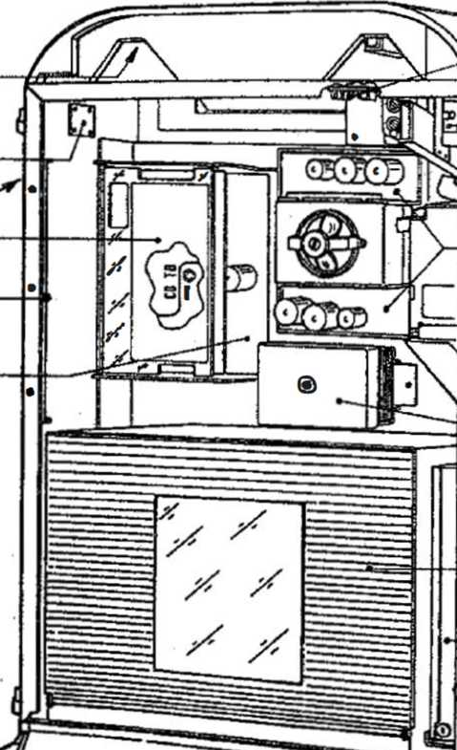
CONTROL __ LOUDSPEAKER ‘
AUDIO
CONNECTION CABINET SWITCi
OUTPUT STAGE
COIN MECHANISM
OUTPUT
TRANSFORMER
CD-CHANGER
CASH BOX
KEYBOARD
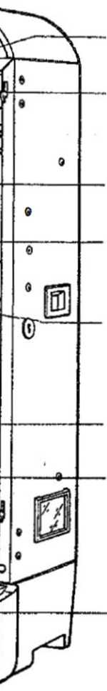
WALLBOX
CONNECTION
KEY SWITCH
CONTROL UNIT CD-
HOLDER FOR CD-TITLE INDICATION II
CD-CENTRAL UNIT -
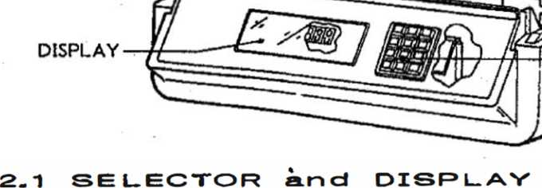
RAN E
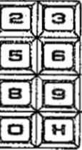
¡Mi
mi
m.
imii:

tap tan nits o! th* locat iati
background credits yotr selection

Dispioy ponel with dispicys 1_{r} 2 ond 3 os well cs 12 button selector
OS

3 SPECIFICATIONS
- Electrical Data
Main voltage: 100-260 V (variable), 50/60 Hz
Power consumption at stand by 170 W at play 450 W
- Musi k 2 x 200 watts music
Power power at 2 ohms
3-3 F u ses
Replace fuses only with those of
same value!

3.-4- Lighting
Firebird | Country
4 | 2
2 | 2
2 | 1
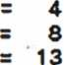
Fluorescent lamps Fluorescent lamps Fluorescent lamps
w
w
w

12 v / 2 W
Lamps
- Credit / Gash Input
Maximum credit display Is 99.
Price list adjustable individually or as per table.
Free credit adjustment / permanent credit key-operated switch for free credits and background, elect.-mech. cash counter (optional).
3-© Keyboard
10 number keys 0-9
1 correction key "C"
1 hlt-step key “H"
3.7 Displays
Display 1 with 4- seven-segment LEO’s Display 2 with 2 seven-segment LED’s Display 3 with 4 seven-segment LED’s 1 lamp display “10 top hits"
1 lamp display "background"
1 lamp display “credit’’
1 lamp display “your selection“
1 lamp display “error, press key "C"

1 1 o
mo»

NSM CD changer for maximum 100 CD s, 5- or 3 inch disc player:
Philips CD-2-system with CDM-3-playlng unit, servo panel for control of CDM-3.
- Loudspeakers
1 loudspeaker SP-3 R 8 ohms (control loudspeaker)
3.10 Special Featu res
Integrated microphone preamplifiér and connection socket for microphone with paging switch.
Computer-controlled amplifier protection for overload (mismatch).
3-1 1 Dimensions

ch
ch
ich
Height
Width
Depth
39,6
23,8
14,2

A- LOUDSPEAKER CONNECTION
The wallbox Is equipped with a control loudspeaker. For service or repair It can be connected to the terminals of one of the outputs (left or right channel) of the output stage.
The connection wires of the external loudspeakers are led through an opening In the lower cabinet part (left rear) to the inside, through the bottom in the cabinet corner upwards, and then to the connection terminals of the output stage.
Watch the ^ = polarity when connecting the loudspeaker!
The ES-IV amplifier serves an output of 2 x 200 watts music power at 2
ohms per channel.
If the loudspeaker Impedance is 4 ohms, the loudspeaker will use 2 x 100 watts muslk power (Fig. 1) from the amplifier.
In that case, the additional loudspeakers connected cannot have an
impedance of less than 4 ohms since the amplifier otherwlsewould be
"mismatched" and the overload protection would operate.
If loudspeakers with a higher Impedance are connected (Fig. 2), a number of speakers can be connected parallel. In that case, a loudspeaker with a higher Impedance would naturally be lower In volume.
The polarity ▼ must be maintained because otherwise bass reproduction would nullify itself!

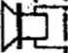
Öhm ». 100 W
li_
e>
0-
T
TT

ENDSTUFE OUTPUTSTAGE ES IV

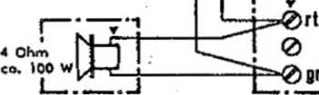

?-Ö5
SW0
<z>
bl 0

ENDSTUFE OUTPUT STAGE ES IV
iß
$ Ohm co. 50 '

I r ©
* K.
4 Ohm hHT co. 100 W [J-rL

Mono mode; sound system for separate rooms; see Fig. 3.
If the volume is to be controlled independently from 2 rooms, both cabinet speakers can be connected to one channel. The loudspeaker for the other room can then be connected to the free channel. For that a Jumper has to be soldered at DR 202 (see cut-out PCB central unit). For this Independent procedure a volume control with separate controls is necessary (see remote control).

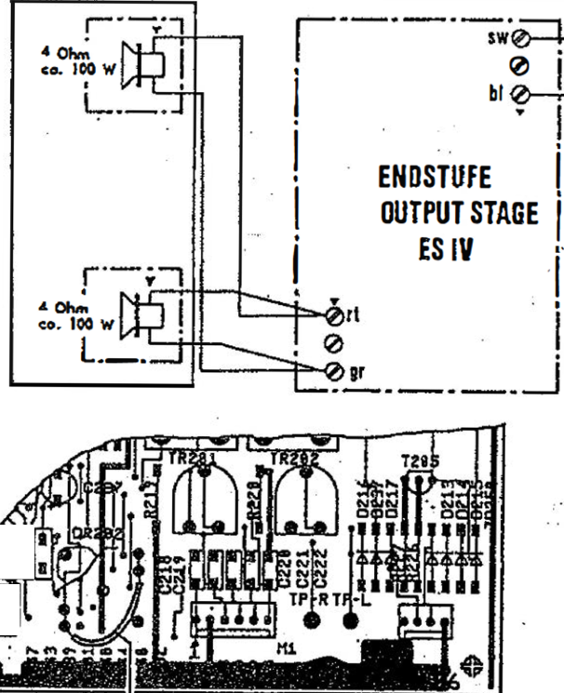
ROOM t
I
Bridge Detoil from
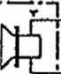
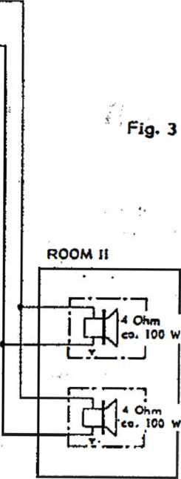
Circuit Boord

Additional Loudspeakers and Separate Control
If even mqre speakers are to be connected whereby the total Impedance drops below 2 ohms, an output transformer has to be used (see schematics "loudspeaker connection" and unit description "OUTPUT TRANSFORMER"). Cabinet speakers (Fig. 4) In serial connection result In lower volume!

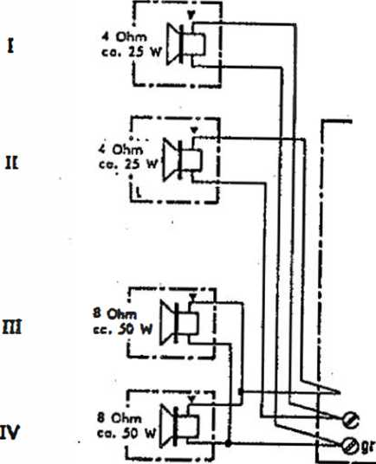
ENDSTUFE OUTPUTSTAGE ES IV
ért
20 Rina II U ROOM If
Fig.
SW0-
2> bl 0-

An auxiliary amplifier can be connected for Independent stereo control of other rooms as well as for Increased power requirements.
See also unit description "Central Unit", connection of auxiliary amplifier, and "Accessories", tape recorder connection cable or CD-audio connection.

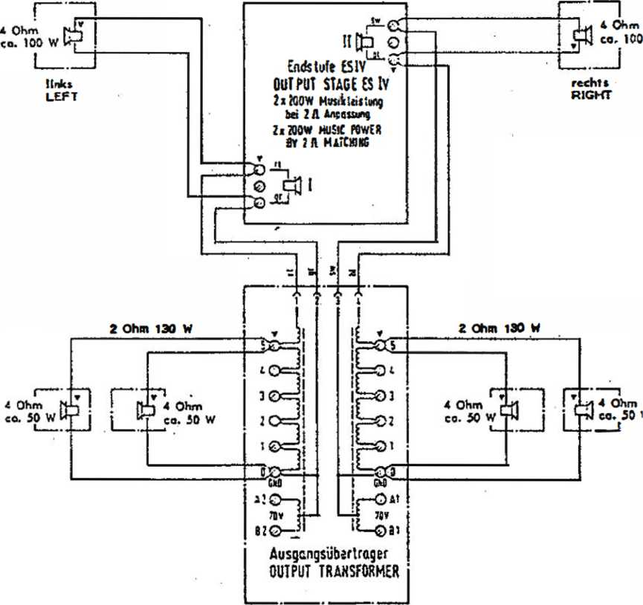
AnschluHschema fur Ausgangsubtrlrager CONNECTION DIAGRAM FOR OUTPUT TRANSFORMER
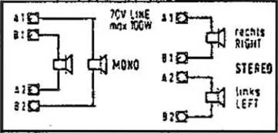
lltamt  ICKHIML  posnio* | t n | la  m | uhprKht  SPEAK»  U | r  81 | tSL
0*5 | now | rcow | TOW | (SW | aw
8-1 | 50W | aw | WW | aw | IW
0-1 | 30 W | ft* | aw | ow | IW
8-1 | WW | nw | 7.5 W | tw | tw
o-i | MW | I* | UW | 1W | o.sw
IXCCIWC'M 5« Qfi TO« mot*!» IWBUUtt. JL0X# tf i: sADiftUSirruOir t svjjtcr ifl rccMitii wooinc^nfyi wiuur »iicincx to *om eowrNisf umor otuvuK ■
issf ESIV-CD ua-oiocr

Lauisprccheronschlun SPEAKER CONNECTION
Arschtufi fur max. Ausgangsleistung
connection for max. power out pot
SPARE PARTS LIST FOR NSM-PHONOGRAPH
FIREBIRD FIRE COUNTRY
This spare parts list is applicable for NSM-Phonograph: FIREBIRD
FIRE COUNTRY
Every spare part order should contain the following:

Mode!
Serial number Quantity Part number Description
2.
3.
4.
5.

Examp
Model | Serial-Number | QTY | Part-Na | Descri ptlon | Data
FIRE | 02 904 | 1 | 174 788 | LINE TRANSFO | CD-Player
BIRD |  | 2 | 224 180 | BALLAST | VG 13/2 KY
COUNTRY |  | 1 | 225 343 | STARTER | S2

ATTENTION!
Precise orders save unnecessary questions and bring the best results. ORDER SPARE PARTS THRU YOUR NSM-DISTRIBUTOR!
Information and illustrations contained in this spare parts list, are correct at the time of going to press.
NSM-AKTIENGESELLSCHAFT, Saarfandstrafle 240 - W-0630 BINGEN am Rhein
INDEX
Page | 119 | UNITS and ACCESSORIES CABLE HARNESSES
Page | 1 20-123 | CABINET
Page | 124-125 | FRONT FRAME | -FIREBIRD
Page | 126-127 | BUTTON
Page | 128-129 | FRONT FRAME | -COUNTRY-

PHONOGRAPH "FIREBIRD
FIRE COUNTRY"
UNITS and ACCESSORIES

174 | 873
173 | 664
173 | 666
171 | 701
1717 02
50 Hz 60 HZ
CB-CONTROL UNIT CD, ASSY CB-DISPLAY CD, ASSY CB-CENTRALE CD. ASSY
OUTPUT STAGE OUTPUT STAGE
see Page 400 see Page 500 see Page 600
see Page 700 see Page 700

- 470
209 795
- 276
see Page 800
see Page 900
74 710
040 739
HARNESS
2
CD-CHANGER 100 (without Design
Piprpftl
BACK COVER-LABEL VIEW GLASS
CD-TITLE INDICATION II, ASSY
MOUNTING BRACKET, ASSY
OUTPUT TRANSFORMER with CABLE

IR-REMOTE CONTROL, ASSY with 5 m Connecting Cable SENDER RECEIVER
174 258 206 783 173 178

w. 5 m CABLE w. 20 m CABLE
REMOTE CONTROL REMOTE CONTROL
WALLBOX-CONNECTION, ASSY DEVICE SYSTEM, ASSY CASH COUNTER, ASSY CB-AU DIO-CON NECTION CB-INTERFACE RS 232
- 74'
- 07
73
16
73
74
996
435
348
648
796
NSM-DATA-PRINT
201
CABLE HARNESSES CENTRAL UNIT — CONTROL CENTRAL UNIT — CONTROL DISPLAY CENTRAL CENTRAL
120 Ig 120 Ig
171 182 171 783 174 012 174 000 174 022 174 023
- 024
- 044 175 047
- 027
- 045 174 038
- 037
- 067
UNIT
UNIT
15 prongs 12 prongs
UNIT UNIT
TRANSFORMER KEY- a d CABINET SWITCH KEYBOARD LIGHTING LINE WIRING CD-AUDIO TITLE INDICATION CENTRAL UNIT — CO PLAYER CONTROL UNIT — CD PLAYER BUTTONS
-- OUTPUT STAGE
- LINE TRANSFO
- CD PLAYER
1250 Ig 1550 Ig
10 prongs 8 prongs

c= |  | c." 1 u  t=z=a | | 1
 | ¹⁼³ | “I | —
; = | c= | 3 | ?^{TSSS}
- ■ |  | ■ I | •f—*-

/ / /,
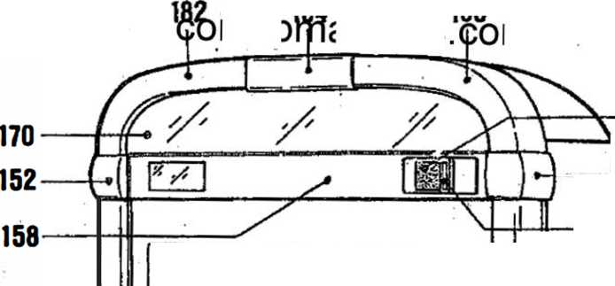
15*

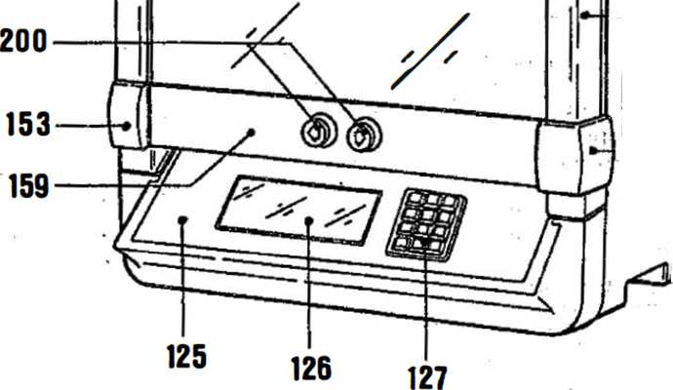
103 102
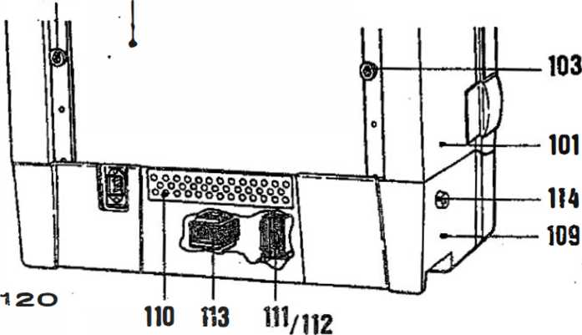

01
02
03
174 064 173 795 173 696 112 462
CK COV GUIDE
PHONOGRAPH “FIREBIRD
FIRE COUNTRY"
CABINET, PRE-MOUNTEO for USA only
CABINET, PRE-MOUNTED BACK COVER
PARTS

CLOSING RAIL CLOSING BRACKET LOCK
- 114 674
- 211 474
05 206 676
206 718
- 112 959
205 722
- 113 326
SPARE KEY CLOSED, STAMPED TENSION SPRING HINGE-BOTTOM PART,
ASSY

BOTTOM PART VENTILATION PLATE TRANSFO PLATE LINE TRANSFORMER
73 601 73 692
- 697 23 423
- 768 !25 907
22 505
74 376 74 377
09
- 11 12
13
14
15
- 17
LINE TRANSFORMER, ASSY (CD-Player)
TRANSFO-FUSE
KEY SWITCH
COIN TUBE (CASH BOX)
COVER PLATE
#« *
COIN RETURN LEVER. STAMPED BAFFLE LEVER, STAMPED COIN RETURN PLUNGER
173 725 173 726 173 655 205 265 173 727 173 954 029 335 102 495
172 139 222 509
PRESSURE SPRING (COIN MECHANISM)
HOLDING BRACKET, STAMPED
FLAT SPRING '
COIN RETURN CUP COIN LID
18
19
20
1
CB-MARS-COIN ACCEPTOR, ASSY
¡PUSH BUTTON SWITCH CABINET SWITCH
t
BRACKET, ASSY RIGHT - for CENTRALE and
- 173 722
- 173 723
BRACKET, ASSY LEFT CONTROL UNIT
CASH-BOX Cyl.-LOCK CLOSING LEVER
- 174 383
- 206 656
908
3
CONSOLE
- 173 708
- 174 014
173 794
- 173 900
GLASS, PRINTED GERMAN
GLASS, PRINTED ENGLISH
KEY BOARD, ASSY

9
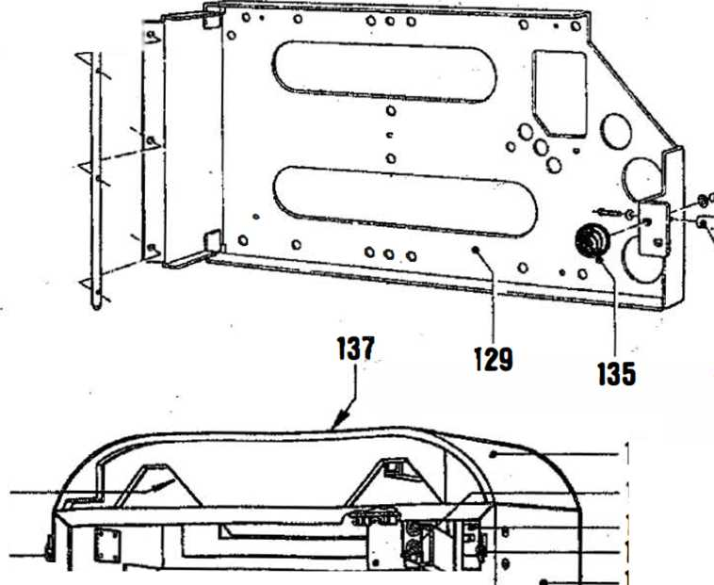
36
117
20
05
01
16
04
19
15
18
07
106
23
138
108
121
Q
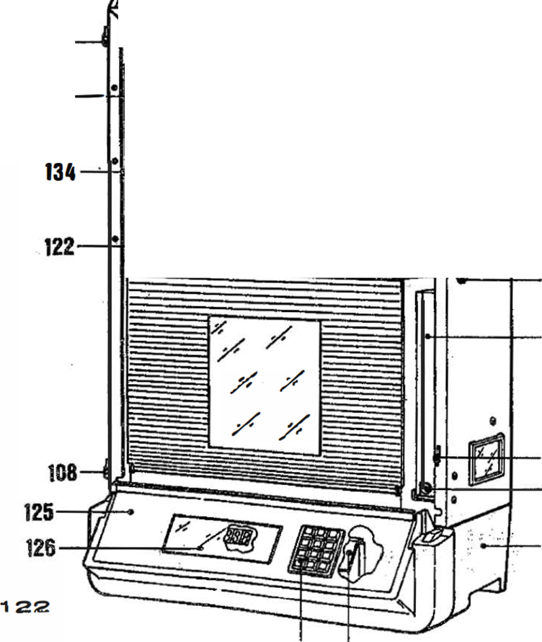
p  > | \ •"I© / ) S l( | 2>
r |  | i >
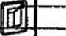
105
24
LIST
132
1

127 128

LAMP MASK
LAMP SOCKET
- 173 670
- 587
- 056
- 176 020
- 176 022
- 176 023
- 175 204
- 176 024
- 176 048
- 217 391
LAMP 12 V 2 W
BACK PLATE II
LOCKING PLATE H
f. TITLE INDICATION H
AXLE
CLIP
BUSHING
BEARING PLATE H BALL HANDLE

14 654 14 728 74 004
138
137
138
SIS
w
la- Q
. o:
> H
en où
73 777 !24 215 !24 188
223 421
uuww
GUARD 1
VENTILATION PLATE 1
CONTROL-LOUDSPEAKER, ASSY 1
HOLDING PLATE 1
BALLAST KX 4/6/8 D 8 W 2
BALLAST KX 13 D 3
PRE-TRANSFORMER for 117 V only 1

167 184 167 168
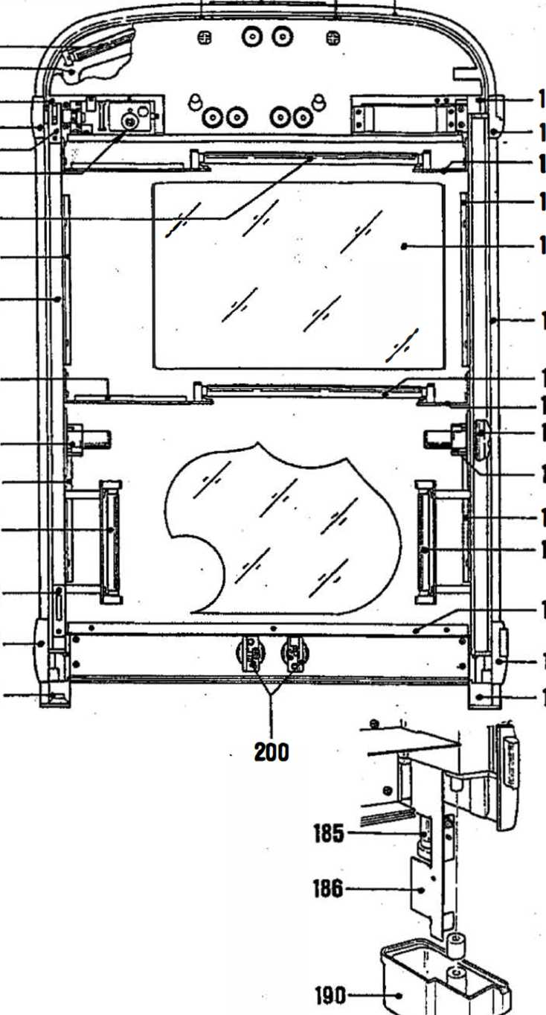
- 164
160
- 161 173
- 180
155
176
189
179
187
182
- 191
63
52
75a
80
77
151
>88
175
185
189
181
187
174
153
190
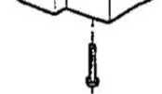

f^QNT, FRAM E FIREBIRD
LONGITUDINAL PROFILE, LEFT EDGE CONNECTOR, UPPER LEFT EDGE CONNECTOR, LOWER LEFT LAMP MASK
151 | 250 | 336
152 | 250 | 273
153 | 250 | 275
154 | 212 | 422
LONGITUDINAL PROFILE, RIGHT 1
- 250 337
- 250 274
- 250 276
154 212 422
- 173 703
- 175 041
- 115 082
- 114 679
- 114 680
- 115 083
- 175 494
- 114 682
- 250 340
EDGE CONNECTOR, UPPER -RIGHT 1
EDGE CONNECTOR, LOWER RIGHT 1
LAMP MASK 1
CROSS PROFILE, UPPER ASSY 1
CROSS PROFILE, LOWER ASSY 1
HOLDING BRACKET, RIGHT 1
CLOSING PLATE, UPPER 1
CLOSING PLATE, LOWER 1
HOLDING BRACKET, LEFT 1
CARRIER PLATE, STAMPED 1
HOLDING BRACKET 2
TERMINAL PROFILE, UPPER CURVED 1

170 212 495 FRONT PLATE
206 581 DUPLEX PROFILE

- 173 710
- 1 75 023
- 205 720
209 963 209 964
173 905 175 033 175 227 175 032
174
- 175)
176
COIN INSERT 1
BUTTON I, PRE-MOUNTED 1
PRESSURE SPRING 1
MASK, LEFT 1
MASK, RIGHT 1
COVER, LOWER 1
LAMP HOLDER, LEFT LOWER t
LAMP HOLDER, LEFT UPPER 1
LAMP HOLDER, RIGHT 2

177 | 204 925 206 519 206 520 | FRONT GLASS  RUBBER PROFILE RUBBER PROFILE | 1  2  2
179 | 175 037 | GLASS HOLDER, RIGHT LOWER | 1
180 | 175 034 175 035 | GLASS HOLDER, UPPER | 2
181 | 175 034 175 035 | GLASS HOLDER, LEFT LOWER | 1
182 | 175 469 | LAMP MASK, UPPER LEFT | 1
183 | 175 468 | LAMP MASK, UPPER RIGHT | 1
184 | 176 141 | SOCKET for MASK | 1

SPARE PARTS LIST

FLUORESCENT LAMP 13 W 2
LAMP HOLDER, LEFT PRE-MOUNTED 1
185
186
187
226 075
173 732 173 733
226 072 209 970 209 969 209 764 209 975 209 845 226 038
225 364 225 343 225 040
173 712 173 711
LAMP HOLDER, RIGHT PRE-MOUNTED 1
FLUORESCENT LAMP 4 W 4
FOIL, RIGHT 1
FOIL, LEFT 1
FOIL, SHORT 1
FOIL, UPPER RIGHT (SHORT) 1
FOIL, SHORT 2
88
19C
19"
FLUORESCENT LAMP 8 W 2
STARTER HOLDER 6
STARTER S 2 4
STARTER S10 2
ADAPTER, LEFT 1
ADAPTER, RIGHT 1

448
tlo 608
- 741 115 627
- 798
- 615
- 048 115 612 222 515
- 587
- 049 115 611
74
200
201
202
203
204
205
206
207
208
209
- 211
HOUSING small round 2
BUTTON, PRINTED 2
BUTTON, COVER small round 2
PRESSURE SPRING 2
RING (0,5 mm thickness) 2
RING (2,5 mm thickness) 2
COVER 2
MICRO SWITCH 2
LAMP SOCKET 2
LAMP 12 V 2 W 2
ADAPTER 2
BUTTON. ASSY 2

255 272
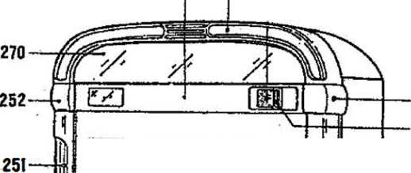
» |  | *-—~= i  t _{J}
ë=n=*T | 1 —. | *=* ! *=zz
crjrp«  ( | ! | f  ” ir
12
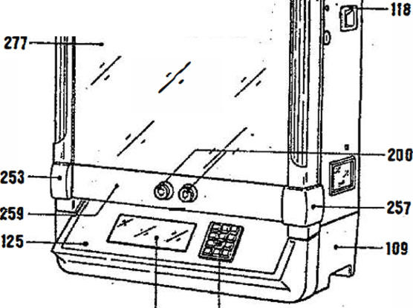
268
267
121
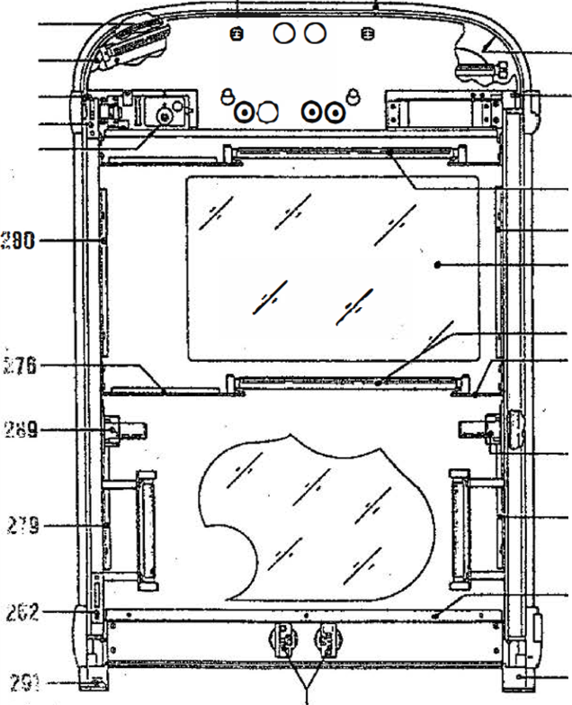
¿66
264
260
261
273
288
280
277
288
275
27 i 291
200

