Wiring Color Codes

All pinball wiring harnesses use color coded wiring to help identify wires. A wire color code is constant unless it comes to a switch or load (lamp, motor, coil, etc.), at the other side of which it would change. This means that a wire color is the same on both ends of a connector (unless a previous technician spliced a cable).

Color Codes Used In Bally Wiring

1 | red | 6 | brown
2 | blue | 7 | orange
3 | yellow | 8 | black
4 | green | 9 | gray
5 | white | 0 | no trace color
J | = jumper (color irrelevant)

The color listed in the codes is the base color. The second is the trace color. Sometimes you will have two trace colors. For example, 15 is a red wire with a white trace, 30 is a yellow wire. Many color codes are reused in the game. This is denoted by a dash and they a third number.
Yellow, Black, and Red-White are the most common wire colors used for power & ground.
Note: Sometimes red on the insulation may have faded, and may look like a faded orange, or white.

Example: For the PLUG CONNECTORS schematic:
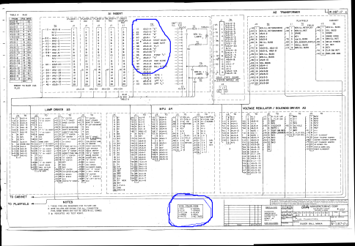

Looking at the area circled at the top:
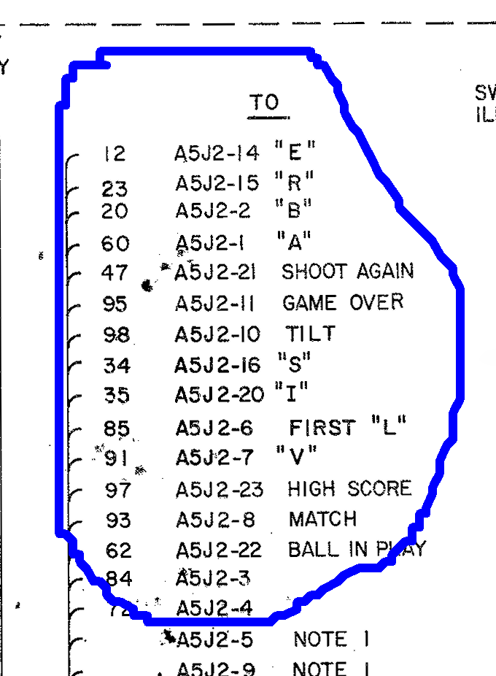

Take a look at the top few lines.
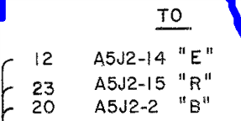
To “A5J2-14 “E” has a color code of 12.
The first digit “1” is red, and the second digit “2” is blue. So the color of the wire is Red-Blue.

The third line “To A5J2-2 “B” shows a color code of 20. The first digit 2 is blue, and the second digit “0” is no trace color. So this wire would be a solid blue color

The bottom circled section shows the color codes used.
