"Cite PHOTOFAC T
Se r v i ce r

October 15, 1949 * ,ublu#i•d for oU useu of Howard W Soms P#iotoloct Fo"ieu * V ol. 8, Nos. 73 t· 74

A DIAL CORD KNOT THAT WORKS

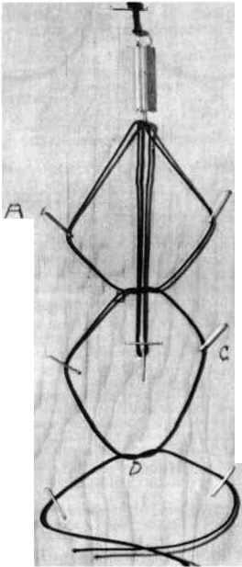J. P. Ethr idge, o( t.oulsvllle, Ceorg:la, h" a denloped an ingenious, Mndable, dlal cord kncx lhat really works . He ha• been klnd enough to permit us to s.s ht.a idea Ofl to you.

HI:. suggestion w.as bcautUully pre sented on a ne;it a nd practical dcmom1tr:uton board. A phocog;r;iph of this board will en.able you to try out his Instructions, which follow:

"Remove staples at A.

"Pull knoc B up to sprln 1 and ti&hten until the uulill tension lS on !>pttng:. Release cord and you wtll find the knoc Joell. In actual pncUce yoo c:in then turn dl:.11 knob back and torth until t h e slack LS taken up, then tighten the knot unttl the correct tension la re-ached.
A

"Remove staples at C and bring D. which ta the other ha Ir of lhe 21qu::are knot, up 1llnd Hghlen. A touch of cement wUI finlSh the job.

"It ts twice as elfecltve and takes half the lime. and ln some c;.1ses where t h e knOl
mufll be lied In a cle place tt Is the only knot C
that will do a workmanlike job. "

"In using the k not I h:'IVe found some
w:ays to f:;aclllt:ue lts use.

"Ftiure 2 Is In t'ase Of a S Ol ln the drum. The eye of the SPf'inS l.S hOoked between the lw o encl.a of the cord on eoach side of the cross·over. The cross can th en be brought down lhrwgh the slot where the other end of sprll\I can be hooked to drum.

"Flgvre 3 ts i n case of :.n eye in the drum. The c ros s -over c t:in be formed by sentlng the cord with the fingers. The op· eratlon l..!5 completed u In Figure I.

"f lKUre 4 ts a case .,.-ttere aome part, as a d I oa I plate bucket, ls In front of the drum. After tht' cord Is hooked Into eye of toprlng, use

Fig. I

a forked tool and hook sprlrc to drum. In some cuH ll b best 10 use a hook and PJll spr1111 ln from other side."

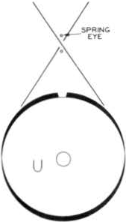
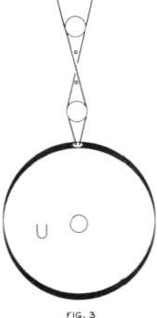ft(;i, z
r i
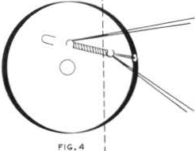'1

I
I,_ _ _ _ _ _ JI
Page I

