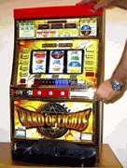

STEP 1 – OPENING THE MAIN DOOR

Unlock and open the front door with the key provided, by turning the key clockwise (to the right). On most machines, turning to the left clears error codes, but does not open the door. Inspect the interior for any loose wiring harnesses, caused by shipping.
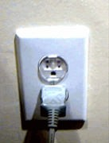

STEP 2 – GETTING POWER TO MACHINE

Plug the external AC power cord into a 120 VAC outlet (standard U.S.A. outlet).

This machine is designed for indoor use and should not be used outdoors.
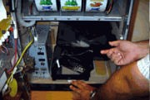

STEP 3 – REMOVING AND LOADING PAYOUT HOPPER

Locate the payout hopper and remove it from the machine. If the hopper is connected to a wire harness be sure to disconnect it first. Also, some machines have a mechanism located at the base of the hopper to help hold it in place. Press down to release hopper, then slide hopper out of track.

Loading the Hopper Insert at least 400 tokens into the top of the hopper, as this will load the hopper for payoffs.
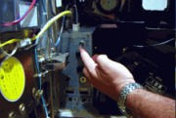

STEP 4 – TURNING MACHINE ON

Turn the machine power switch (normally located inside of machine on left side) to the ON position. The machine will go through a series of test procedures. When the INSERT MEDAL light flashes, the machine is ready for play.

On most machines, there will be two slider type switches on the power supply that are labeled with Japanese writing. These were for use in the Japanese casino and have been disabled. These were used to notify casino personnel that the machine was either out of coins or the overflow tray was full. The position of these switches will not affect the operation of your machine.
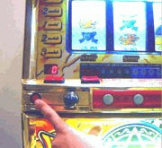

STEP 5 – SETTING CREDIT/COLLECT MODE

If the CREDIT display is lit (0), the machine is in the CREDIT mode. All subsequent winning will be added to the credit meter. If the CREDIT display is not lit, the machine is in the automatic payout mode. All subsequent winnings will be automatically dispensed in tokens by the hopper. To change between modes, press the CREDIT- COLLECT button while the machine is idle. You cannot change modes while the machine is in play or when tokens have already been inserted.

Some machines (Yamasa and Daido) will ONLY operate in CREDIT mode. This is in the programming of the machine and cannot be changed.

On many machines, the CREDIT or CANCEL (Olympia) button must be held down for 5-10 seconds to dispense coins into coin tray.
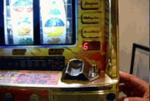

CHANGING GAME ODDS/FULL RESET PROCEDURE

If your machine is malfunctioning, we recommend resetting your machine using the following procedure. This is the same procedure used for setting the payout odds.

Game odds are adjustable to 6 different levels. Odds levels do vary by machine.

To change the odds, there will either be a key switch or a toggle switch. Power the machine off and either turn the key switch or toggle to the “ON” position. Turn the machine on. A number from 1-6 will be shown on the credit meter (or display on the back of the front door of the machine, depending on manufacturer). Use the reset button on the power supply or on the back of the door to change the odds to the desired setting. When the desired setting is reached, press down the “SPIN REELS” lever to set the odds. Turn the key switch or toggle to the off position and the machine will be ready to play.
Examples of odds are below: LEVEL 1=65-67%
LEVEL 2=72-74%
LEVEL 3=79-81%
LEVEL 4=88-95%
LEVEL 5=105-107%
LEVEL 6=115-125%

Some machines list their winning odds on a sticker inside the main door near the coin mechanism.

Payouts are AVERAGED over 10,000 coins. You may hit winning streaks and losing streaks, just like in a casino. This is normal. Since gambling is illegal in Japan, it can be common for these machines to pay out more than they take in. In Japan, tokens from these machines are exchanged for merchandise, not money.

THE ODDS WILL VARY GREATLY FROM MACHINE TO MACHINE, EVEN FROM THE SAME MANUFACTURER. ODDS MAY HAVE BEEN MODIFIED BY THE CASINO AND THE PERCENTAGE OF PAYOUTS CANNOT BE CHANGED.

GAME OPERATION

The machine has the capability of “HOLDING” (storing) 1-50 credits on the CREDIT display meter. Any win condition that exceeds the CREDIT meter limit of 50 will automatically be dispensed by the hopper in tokens. The SKILL- STOP buttons are operational ONLY when the “STOP” lights are lit over the buttons. Only one button may be pushed at a time. In case of a “JACKPOT” (777 on any illuminated payline) up to 50 credits will be added to the CREDIT display meter with the remaining coins being dispensed by the hopper. When the machine senses an abnormal condition, the machine will “LOCK UP” (tilt) and a siren will sound. Refer to the TROUBLESHOOTING GUIDE for explanation of problems and correction procedures.

BONUS GAME

Occasionally during play a BIG CHANCE (777) combination or BONUS GAME combination is HIT, thereby guaranteeing the player a predetermined number of "WINS". The machine will initially pay out the amount listed for the combination (usually 15 tokens), then the machine

will give you additional guaranteed wins during the next several plays. Depending on the bonus combination, several winning plays will occur, paying a maximum of approximately 500 coins when bonus play is complete. Bonus Games take place on the CENTER payline only.

BONUS GAME Combinations = 15 tokens + 8 guaranteed wins

BIG CHANCE Combinations = 15 tokens + 24 guaranteed wins in 3 rounds. The “Big Chance” round is set up with 3 sets of 8 guaranteed wins, between round 1 and 2 and also 2 and 3 you will notice the music changes and this is a bonus period with increased odds. This period continues until you hit a free game. It is possible to win up to 35 payouts (500 tokens) in the "Big Chance" play mode.

CHALLENGE GAME (on Type B machines) allows you to play (1 to 3 tokens) up to 200 consecutive times with increased winning odds. If you enter the Challenge Game after the Big Chance round you will have a minimum of 150 spins with increased winning payouts. If you enter the CHALLENGE GAME you must finish ALL spins. The machine cannot be reset while in this mode! It can be turned off but when you turn it back on it will still be in the “Challenge Game” mode.

After a 777 bonus game is complete, the GAME OVER light may flash or “oF” will display on the machine. If this happens, the machine must be reset. To reset the machine, insert barrel key into the front door and turn to the left or perform a full reset. ONCE A MACHINE HAS ENTERED THE BONUS GAME IT IS NECESSARY TO PLAY THE MACHINE UNTIL THE BONUS GAME IS COMPLETE.

PLAYING THE MACHINE
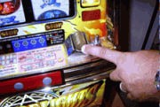

STEP 1 – INSERT TOKENS

Insert from 1-3 Tokens. (1) token will illuminate
the center payline, (2) tokens will illuminate the upper and lower paylines, (3) tokens illuminate the diagonal paylines. With all 3 tokens inserted, the maximum number of combinations are selected.

This machine has a speed loader which allows you to insert a stack of 20 tokens at one time.
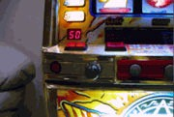

STEP 2 – CREDIT METER

At this time, if the machine is in the CREDIT mode, you may insert up to 50 additional tokens for further play. The excess amount of tokens will be displayed in the CREDIT METER. Machine will not display more than 50 credits. Any tokens inserted when the CREDIT METER displays 50 will be rejected and will drop into the coin tray
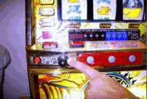

STEP 3 – PLAY HANDLE

Depress PLAY HANDLE (black or red knob).
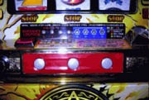

STEP 4 – SKILL STOP BUTTONS

As the reels spin, push the STOP buttons one at a time, in any order to stop the reels.

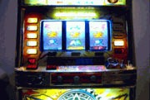

STEP 5 – WINNING COMBINATION

If a winning combination is "HIT", the corresponding win will automatically be paid out by the hopper or credited to the machines CREDIT display meter. If there are no credits on the CREDIT METER, insert 1-3 tokens to repeat game play.
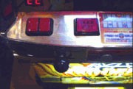

STEP 6 – BET/MAX BET button

If the machine is being used in the credit mode, the BET or MAX BET button may be utilized to credit a payline, one at a time, assuming there are credits displayed on the CREDIT meter.

On some machines, there are a 1 and 2 button. This allows the player to play either 1 or two credits. These buttons are on many machines that are “THREE CREDIT ONLY” machines.
Presence of these buttons does not guarantee that it is possible to play only one or two coins. Many newer machines are “THREE CREDIT ONLY” or “MAX BET ONLY” machines.

On some machines, the BET MAX button may not be labeled. Other machines will not have one at all. On these machines, the BET button must be pushed three times to bet all three paylines.

TROUBLESHOOTING

The following section describes troubleshooting tips to help you determine a problem, if any.

MACHINE DOES NOT POWER UP

Make sure machine is plugged into a 120 VAC outlet. Do not use an extension cord longer than 50 feet.
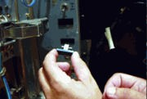

NO LIGHTS

Make sure power switch is in the ON position. Check fuses (the photo above shows the location and how to change the fuse). We check all machines before they leave our shop so this should not be a problem unless a fuse blows.

If an individual light bulb is out, turn the light socket where the bulb is out counterclockwise to remove the housing. Replace the bulb by pulling the bulb straight out. Press the replacement bulb directly into socket.

MACHINE DOES NOT ACCEPT TOKENS

Machine must be turned ON. Jackpot condition may have occurred if "GAME OVER" light is flashing. Reset machine by inserting barrel key in lower lock on front door and turn it to the left (if equipped). Otherwise, use reset button inside to reset machine.

The “INSERT MEDALS” light must be flashing or coins will not be accepted. Insure that the reels

are not spinning or there is not a bet or free play on the machine. The inside reset key switch must always be in the “OFF” position during game play.

MACHINE KEEPS PLAYING IN BONUS GAME

This may be normal, keep playing until the bonus game is complete. You may have to play as many as 250 spins to complete the Bonus Game (Big Chance Level).

COINS WILL NOT REGISTER, FALL INTO COIN TRAY

Possible coin acceptor jam, check coin acceptor and clear jam. Press reset button inside machine. Machine only holds 50 credits at a time.
Additional coins inserted will fall into money tray.

Also, see above section titled “MACHINE DOES NOT ACCEPT TOKENS.

HOPPER WILL NOT PAY OUT

Check payout hopper, make sure wire harness is plugged in and secure. Check fuses.

TROUBLE CODES
Trouble Code Displayed on Front Door of Machine:
HE - Hopper Empty - Not enough tokens for payout. Add tokens to hopper.
HO - Hopper Out - Hopper is out of tokens. Add tokens to hopper.
HJ - Hopper Jam - Remove coin hopper. Unplug wiring harness and slide hopper out. Dump out coins, some coins will remain in the lower hopper area. To clear them, spin center of hopper until all coins are free and hopper spins freely.
CE – Changer Error. Unplug and remove coin acceptor. Look for oxidation on metallic portions of coin path. If present remove with sandpaper or emery cloth.

OLYMPIA/HEIWA MACHINES ONLY

E2 – Changer Error E3 – Hopper Error
E4 – Hopper Error (normally caused when hopper is jammed or unplugged.)
E5 – Hopper Error (normally jammed)
On the Olympia machines, if you get a hopper error, try spraying the inside of the hopper with WD-40 and spin the coin dispenser in the bottom of the inside of the hopper (looks like a phone dial). Wipe away excess WD-40 with a paper towel. Refill coin hopper and test.

To clear error, reset machine by depressing RESET switch either on power supply or on the door.

Sometimes it is necessary to do a full reset. This is done by following the odds reset procedure listed above.
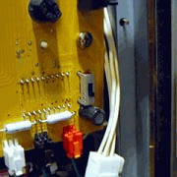

MACHINE VOLUME CONTROLS

Adjust volume control switch located on:

- Right side of speaker on inside of door near coin tray.
- OR On inside of main door (as pictured above).

Normally, speaker volume controls are three position switches in the following locations:

OLYMPIA/HEIWA– Inside of door in the upper part of door on right hand side (two three position switches, both down for lowest setting)

ARUZE/ELECO/UNIVERSAL (3-reel) – On inside of door under window for reels. All switches down for lowest setting.

ARUZE/ELECO/UNIVERSAL (4 reel) – To left of reels on the circuit board mounted on cabinet.
Two three position switches. Both in down position for lowest setting

DAIDO – Two three position switches in the center on the top of the inside of the door.

YAMASA – Black, three position switch sticking out of a translucent case under power supply mounted to bottom of cabinet. Sometimes, it is a translucent case mounted high on the inside of the door. If the reels are not backlit, there will not be a volume control on the machine.

BELLCO – Most do not have volume controls. The ones that do have a three position switch located on a circuit board mounted on the input terminals to the speaker.

ALL OTHERS – Look for one or two three position switches. Sometimes they will be very small.
They will either be on a circuit board or mounted on the speaker. If all else fails, follow the wiring to the speaker. If the machine is too loud, some customers unplug one of the speakers

GAME PLAY ON MACHINE WITH 4 OR 6 REELS
On a pachislo slot machine the additional reels let you know when you are about to win they do not increase the payout.

FEVER QUEEN (6 Reels) - The top 3 reels only spin if you are going to have a winning combination. The 3 top reels let you know which combination you are going to win on the lower three wheels. If you get a king, jack and 7 on the top reels that indicates on this turn you are going to win with one of those combinations on the lower 3 reels. As you play you will notice 7's begin to display on the top 3 reels. When you have 3-7's on the top reels you are going to hit the big bonus very soon.

ALL 4th REEL MACHINES - The 4th reel only spins to indicate you are going to win or to tease you into thinking you are going to win. The symbol the 4th reel stops on indicates the winning combination you are going to win on this turn.
Some symbols are guaranteed wins and others do not pay any tokens/coins at all.

ARUZE LCD MODELS – The LCD screen
normally has an “electronic” set of reels. This does provide additional ways to win, from free games to jackpots

BELLCO DIGISLO MODELS – When the reels line up the “DIGISLO”, a number will be displayed on the “DIGISLO” or “HIT COUNT” display. If this number is “000”, “111”, “222” to “999”, (all three numbers the same), the machine will enter the Bonus Mode.

DANGER – TO REDUCE THE RISK OF ELECTRIC SHOCK – UNPLUG MACHINE WHEN NOT IN USE AND BEFORE CLEANING

We strongly recommend use of a surge protector/power strip to protect your machine. Use the switch on the power strip to turn machine off when not in use. Any credits/bonus game will be retained in memory even when powered off.

WARNING: To reduce the risk of burns, fire, electric shock or injury to persons

A machine should never be left unattended when plugged in.

Unplug from outlet when not in use, and before putting on or taking off parts.

Close supervision is necessary when this machine is used by children, invalids or disabled persons.

Do not operate the machine with the air openings blocked. Do not seal or cover opening on back and sides of machine. Overheating can occur and cause fire, electric shock or injury to persons.

Never operate this machine if it has a damaged cord or plug, if it is not working properly, if it has been dropped or damaged or if it has been dropped into water.

Always keep the power cord away from heated surfaces.

Never drop or insert anything into any opening. Always unplug machine before attempting any service.

Do not use outdoors.

Do not use machine when standing on a damp floor, or when any part of the body is in contact with plumbing or any similar ground.

To disconnect, turn all controls to the OFF position, then remove plug from outlet.

This unit is designed to operate on standard 120 Volt 60 Hz house current.

MACHINE SPECIFIC INFORMATION FOR ARUZE, UNIVERSAL, MACY, ELECO, ELECTROCOIN BRAND MACHINES

POWER SUPPLY DETAIL
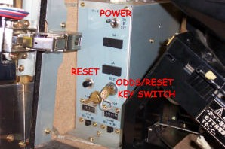

or on newer machines such as TACO SLOT and BABEL, the reset key switch is to the right of the reels:

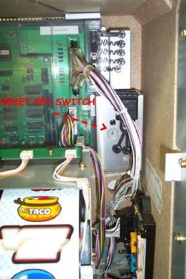

and the reset button is on the inside of the door – here:

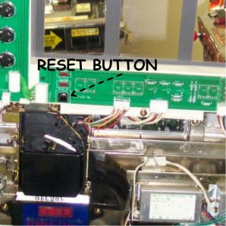

ON all 7.77” LCD screen machines such as AZTECA LEGEND, REAL VOLTAGE,
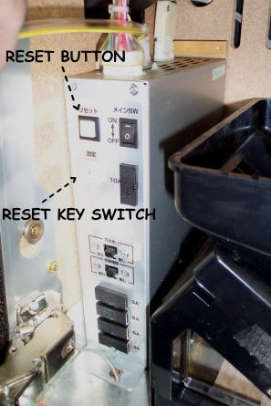
OUTLAW, and some OYAKATA machines, the following applies:

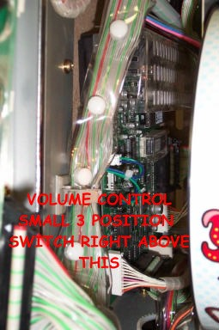
VOLUME CONTROL (MOST FOUR REEL MACHINES) – OHANABI and 7.77” LCD MACHINES HAVE NO VOLUME CONTROL.

VOLUME CONTROL (3 REEL MACHINES)
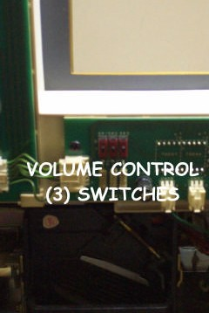

OHANABI TRANSLATION

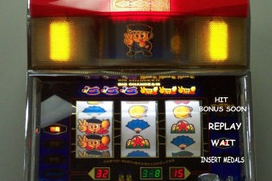

MACHINE-SPECIFIC INFORMATION FOR OLYMPIA/HEIWA BRAND MACHINES

LAS VEGAS, TOMCAT, EXHAUST, BEAT THE DRAGON, ICE STORY, I’M ANGEL, TRICK MONSTER, TAKARABUNE, SAKURA FUBUKI, GOLGO 13, and other
machines that look generally like these two machines:
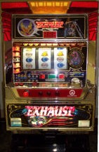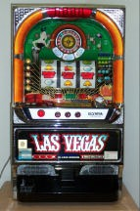

POWER SUPPLY DETAIL
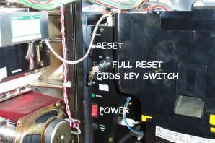

RESET SWITCH ON INSIDE OF DOOR

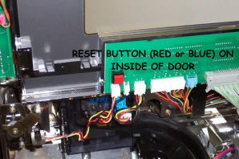

VOLUME CONTROL HIGH ON INSIDE OF DOOR, NEAR HINGES.
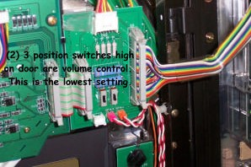

TO CHANGE FROM CREDIT TO DIRECT PLAY MODE

Hold “CANCEL” button down to dispense any coins held in the credit meter. After coins have been discharged into coin tray, hold the “CANCEL” button down for a few seconds until “--“ appears on the credit meter instead of a zero. The machine is now in direct play mode and will automatically dispense all winnings directly into coin tray.

To change back to credit mode, hold “CANCEL” button down until a “0” appears on the credit meter.

MACHINE-SPECIFIC INFORMATION FOR TAGASAKO BRAND MACHINES

BRUCE LEE, ROCKY, DREAM 7 MAX,
NILE PANIC and other machines that look generally like this:
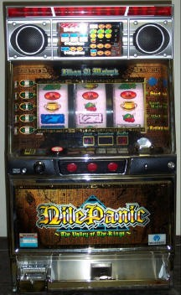

POWER SUPPLY DETAIL (BLACK ROCKER SWITCH NEAR BOTTOM OF POWER SUPPLY IS POWER SWITCH)

VOLUME CONTROL IS THREE DIALS HIGH ON DOOR. ALL SET ON ‘3’ IS A NICE, QUIET VOLUME.
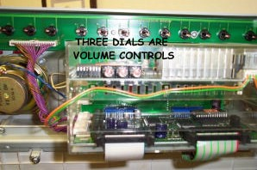

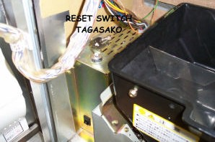

MACHINE SPECIFIC INFORMATION FOR SAMMY / ARISTOCRAT / RODEO BRAND MACHINES

LUCKYCATS, GAMERA, BETTY BOOP
and other machines that look generally like these
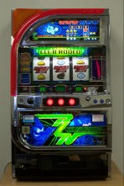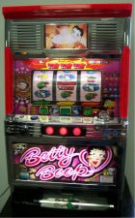

Here is the location of the reset switches
Here is the location of the volume control (some do not have volume controls)
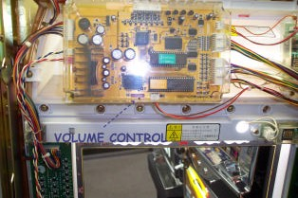

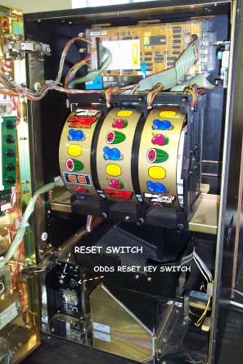

MACHINE SPECIFIC INFORMATION FOR YAMASA BRAND MACHINES

ARABESQUE, KONGDOM, SUPER RENO
and other machines that look generally like this:
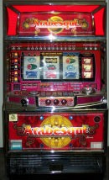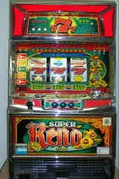

Here is the detail of the reset switches:
Very few of these machines have volume controls. Those that do will have them located here:
