

OWNER’S MANUAL

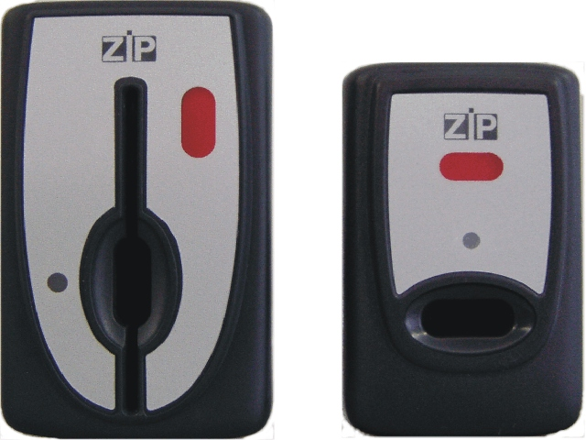

Release 1.3 - May 2004

TABLE OF CONTENTS

1 TECHNICAL DATA | Page 3
2 MAIN FEATURES OF THE SYSTEM | 3
3 DISPENSING AND CHARGE MODE | 3
Sales with Key | 3
Sales with Coins | 4
Charging the Key with Coins | 4
Charging the Key with Banknotes | 4
Charging the Key by means of a Charge Key (Red Key) | 4
4 CODES | 5
Operator Code | 5
Customer Code | 5
Department Code | 5
Machine Code | 5
Reader Code | 5
Changegiver Code | 5
Password | 5
Compatibility | 5
5 STATISTICS | 6
EVA-DTS Statistics | 6
6 DATA KEY – SETUP KEY | 7
Data Key | 7
Setup Key | 8
7 DESCRIPTION OF PARAMETERS - PROGRAMMING MENU | 9
Selling Prices | 9
Coins/Bankonotes | 9
Machines | 9
Other Parameters | 10
Black List | 12
8 DESCRIPTION OF BONUS, REWARD AND PROMOTIONS | 12
Bonus | 12
Working periods | 13
Reward | 13
Promotions | 14
Optional Display | 16
Function of the Price Tables | 17
9 RAM EXPANSION | 18
10 HOW TO USE DISCOUNT PERIODS, HOW TO USE BONUS AND HOW TO GRANT FREE SALES | 18
How to use Discount Periods | 18
How to use Bonus | 19
How to Grant Sales at Price 0 with key | 20
11 DIAGNOSTIC MESSAGES OF THE ZIP | 21
Indications Provided by the LED of the Reader | 21
Indications Provided by the Display | 22
12 OPERATING IN EXECUTIVE MODE WITH CHANGEGIVER | 23
Functioning | 23
Programming of the Change Giver | 25
13 AUTOMATIC PROGRAMMING OF CUSTOMER AND OPERATOR CODES | 26
14 PROGRAMMING | 27
15 KIT CONFIGURATION | 52
16 LIST OF STATISTICS – DATA BOX | 60
17 LIST OF STATISTICS – EVA DTS | 62

! WARNING: when using the ZIP key/card reader, the functions indicated in this manual for the key are also valid for the card,

1 TECHNICAL DATA

POWER SUPPLY VOLTAGE: 18 -28 VAC 50-60Hz
20-35 VDC

VENDING MACHINES CONNECTED: Electronic Serial EXECUTIVE, MDB, BDV
(for the MDB and BDV-slave vending machines the MDB/RR exec/RR BDV interface is required)

PERIPHERAL DEVICES CONNECTED: - 12 o 24 V validators, installing the coin, or coin-bill, interface
- bill accepters, – installing the coin-bill interface
- master o slave change-giver coin mechanisms, installing the MDB/RR exec/RR BDV interface

OPERATION: with key or card and key, according to the reader installed

COMMUNICATION WITH KEY OR WITH CARD: R.F. 125 kHz

2 MAIN FEATURES OF THE SYSTEM

- It allows sales using a prepaid amount charged into the key or into the card.
- It allows the use of validators or bill accepters for sales or for charging the key or the card.
- It can manage 5 different price categories (cash, key, 3 levels of discount with key or card)
- The system offers 10 price lines for each price category, or 60 by adding a RAM expansion.
- Up to 10 keys can be disabled, by entering their number in the “Black List”, or up to 500 keys when installing the RAM expansion.
- It allows to granting bonuses, running promotions or rewards; it is provided with working periods to desable the system and with discount bands (for all these options refer to the section “Description of Bonus, Reward and Promotions").
- It is programmed by means of the programmer or by a palmtop terminal PSION (by adding to the system a RS232 interface for PSION).
- It allows automatic setup by means of the palmtop terminal PSION or by means of the Data Key.
- It offers the possibility to collect statistical data concerning sales and money transfer. These data are collected with the Data Box, with the palmtop terminal PSION or with the Data Key and are printed by means of a personal computer.
- Communication with the PSION can be made also through IR, by adding to the system an IRDA interface.
- The functions that can be implemented with the palmtop terminal PSION can be carried out also by means of the “FLASH” NECTA Software.

3 DISPENSING AND CHARGE MODE

- SALES WITH KEY.
- Insert the key in the ZIP reader, the available credit stored in the key is automatically indicated in the display of the vending machine.
- Select a product.
- The corresponding amount is subtracted from the credit of the key and the product is dispensed.
- After the product has been dispensed the key can be extracted.
- It is possible to check on the display of the VMC the credit stored in the key by simply inserting the key in the ZIP reader.
- SALES WITH COINS.
- Program the payment system so that the validator is enabled in the menu PROGRAMMING/COINS.
- Insert coins in the slot of the vending machine, until reaching a credit sufficient to purchase the product.
- Select a product. The amount is subtracted from the key and the product is dispensed.

! WARNING
The coins can be rejected in the following situations (if the key is not inserted):
- The credit is higher than the maximum selling price programmed in the payment system;
- A product is going to be dispensed.

- CHARGING THE KEY WITH COINS.
- Program the payment system so that the validator is enabled in the menu PROGRAMMING/COINS.
- Insert the key in the ZIP reader and check that the credit present in key is displayed.
- Insert coins in the slot of the vending machine, and check that the displayed credit is increased by the value of the coins inserted.
- When the credit has been updated it is possible to extract the key and select a product.

- CHARGING THE KEY WITH BANKNOTES.
- Program the payment system so that the bill acceptor is enabled in the menu PROGRAMMING/BANKNOTES.
- Insert the key in the ZIP reader and check that the credit present in key is displayed.
- Insert banknotes in the slot of the vending machine, and check in the display that the credit is increased by the value of the banknotes inserted.
- After the credit has been updated it is possible to extract the key and make a product selection.

! WARNING
- Any credit present on the display of the VMC before inserting the key will be added to the credit of the key;
- The banknotes are rejected when the total credit into the key reaches the value programmed in the menu PROGRAMMING/OTHER PARAMETERS/MAX CHARGEABLE CREDIT.

- CHARGING THE KEY BY MEANS OF A CHARGE KEY (RED KEY)
- Program the payment system so that it is enabled in the menu OTHER PARAMETERS/CHARGE KEY ON.
- Insert the Charge Key in the ZIP reader and, if charges are available, the number and value of the charges will be displayed for 3 seconds.
- Remove the charge key from the ZIP reader and insert a selling key; the charge will be transferred to the selling key.

! WARNING
- The number of charges is not displayed if the SYSTEM TYPE is programmed as EXECUTIVE SLAVE, BDV SLAVE or MDB.
- It is possible to check the number of charges present in the key by simply inserting the key in the ZIP reader, without subtracting amounts from the key.

4 CODES

The payment system is provided with some protection codes which make unprogrammed keys incompatible.

The system is also provided with a password that prevents changes form being made to the operator code, to the credit in the keys and to some codes identifying the system.

- OPERATOR CODE (default value = 00000001)
It is composed of 8 numbers (99999999 max) and has the purpose of preventing the acceptance of keys which do not belong to the vending company that manages the ZIP payment system.
If a key with a different code from the one programmed in the ZIP system is inserted into the reader, the key is not accepted (the credit is not displayed).

- CUSTOMER CODE (default value = 000001)
It is composed of 5 numbers (65535 max) and has the purpose of preventing the use of a key among different companies served by the same vending company.
If 00000 is programmed in the key or in the ZIP CPU module, the customer code is not checked. (See TABLE 2 at the end of this chapter).

- DEPARTMENT CODE (default value = 001)
It is composed of 3 numbers (max 255) and has the purpose of preventing the use of a key among different departments belonging to the same company.
If 000 is programmed in the key or in the ZIP CPU module, the department code is not checked (See TABLE 1 at the end of this chapter).

- MACHINE CODE
It is an identification code of the VMC on which the ZIP payment system is installed.
It is composed of 6 alphanumeric characters. The machine code is collected into the statistics in both Data Box and EVA-DTS formats.

- READER CODE
It is an identification code of the ZIP payment system.
It is composed of 6 alphanumeric characters. This code is collected only in the EVA-DTS format.

- CHANGEGIVER CODE
It is an identification code of the Changegiver connected to the ZIP payment system.
It is composed of 6 alphanumeric characters. This code is collected only in the EVA-DTS format.

- PASSWORD
It is composed of 8 numbers (99999999 max) and has the purpose of protecting the programming of the operator code and preventing the charging of key with credit.
When this password is reset, the operator code is reset as well.

- COMPATIBILITY
Table 1 highlights the compatibility among codes.

Table 1

 | OPERATOR CODE | CUSTOMER CODE | DEPARTMENT CODE
CODES IN THE KEY | 12345678 | 12345 OR = 0 | 123 OR = 0
COMPATIBILITY CONDITION | EQUAL | EQUAL OR ONE OF THE TWO = 0 | EQUAL OR ONE OF THE TWO = 0
CODE IN THE PAYMENT SYSTEM | 12345678 | 12345 OR = 0 | 123 OR = 0

5 STATISTICS

The ZIP payment system retrieves several data such as: sales, money transfers, bonuses granted and other information (e.g. the black list). These data are collected with the Data Box, with the palmtop terminal PSION or with the Data Key and they can be analised or printed by means of a personal computer.
Data can be retrieved in the Data Box format (by means of the Data Box, the palmtop terminal PSION or by the Data Key), in the Excel format (by means of the Data Box, the palmtop terminal PSION or by the Data Key) or they can be retrieved in the EVA-DTS format (by means of the PSION or other terminals, but not with the Data Box or Data Key) maintaining the compatibility with the payment system CONPAS.
The different modes are selected in the menu OTHER PARAMETERS / AUDIT MODE:
DATA-BOX: retrieving statistics in the Data Box format;
EVA-DTS A: retrieving statistics in the EVA-DTS format (basic statistics)
EVA-DTS B: retrieving statistics in the EVA-DTS format (limited statistics)
EVA-DTS C: retrieving statistics in the EVA-DTS format (extended statistics)
The Data Key can be used regardless of the programming for this parameter (refer to the relevant chapter further in this manual for the Data Key use).

Data retrieved in the Data Box and EVA DTS format are indicated in the tables at the end of this
manual.

Data collection starts automatically when connecting the Data Box (or other terminal) to the connector in the ZIP unit and, when using the Data Box, it ends approximately after 3 seconds. When the data collection is completed, a red warning light in the Data Box will blink. After the data collection, all the data stored in the ZIP memory are erased but some data in EVA-DTS format (cash box, cumulative cash sales, cumulative key sales).

The data collection does not take place if two consecutive collections, in the same ZIP system, are
performed within 2 minutes.

The statistics can be displayed on the Programmer by entering the “STATISTICS” in the Data Box format.
When the RAM expansion is used and 60 price lines are available, the detailed statistics for lines from 11 to 60 are available in EVA-DTS mode only.

EVA-DTS STATISTICS
In order to collect data according to the EVA-DTS protocol, enter the menu PROGRAMMING / OTHER PARAMETERS / AUDIT MODE and choose among the parameters EVA-DTS A/B/C (see above).
Program the parameters as described below.

SELECT FLAG (ON/OFF according to the data selection terminal).
OFF = transmission of data in a single block.
ON = segmented data transmission, with identification of last block by means of the Select Flag.

BAUD RATE 9600 (ON/OFF according to the data collection terminal).
OFF= data transmission between the CPU ZIP and the collection terminal takes place with an automatically selected baud rate of 1200/2400 up to a maximum of 38400 baud.
ON = transmission of data between the CPU ZIP and the collection terminal takes place at a fixed rate of 9600 baud (the IRDA interfaces use this mode).

PASS / SECUR. CODES (ON/OFF according to the data collection terminal)
OFF= Does not perform the check of the PASS CODE and SECURITY CODE during connection of the terminal.
ON = Performs the control of codes referred to above.
The PASS CODE and SECURITY CODE, each of 4 figures (from zero to 9999), are found in the menu CODES.
To modify the PASS/SECUR CODES parameter it is necessary for the password to be enabled (this is obvious because if it were possible to insert OFF without the password, one could elude the system security).
The devices address, called for by the protocol and used for the connection to the terminal, is set at 1 (point-to-point communication).
The three parameters described above are found in the OTHER PARAMETERS menu. Finally, before making the connection with the EVA-DTS terminal, it is necessary to insert a sales key in the reader. If this is not done, connection to the terminal does not take place.

6 DATA KEY – SETUP KEY

The Data Key and Setup Key are special keys used for retrieving statistics and for the automatic
setup of the ZIP payment system. The key is the same one. It is transformed from Data Key to
Setup Key, or viceversa, using the ZIP Interface with the pc. When supplied the key is
programmed as a Setup Key.

- DATA KEY
The Data Key is used to collect statistical data from the ZIP payment system, to be transferred to
the PC by means of a PC interface.
The statistics collection with the Data Key occurs in the following conditions:
- if the operator code in the CPU ZIP is programmed = 1;
- if the operator code in the CPU ZIP is programmed with a code different from 1, data collection takes place only if the operator code of the Data Key matches the one of the ZIP CPU.
In order to retrieve data, it is sufficient to insert the Data Key into the ZIP reader and the data will
be automatically transferred into the key. When the operation is completed, a LED, located in the
reader, will blink red until the key is removed.
If the key is inserted within 3 minutes from the previous retrieving, the LED will blink red and green.

The Data Key can collect data up to 28 machines.

Here below the list of data that can be collected using the Data Key:

Audit number: cumulative collections (non resettable).
Audit: date and time entered in the Data Key when formatting the Data Key with the PC interface.
Previous audit: it is always zero.
Customer code: it always indicates DATAKEY.
Machine code: identification code of the VM (see chapter 4 Codes).
Sw version: software version loaded in the ZIP reader.

1 – CASH BOX: coins + banknotes inserted in the VM.
2 – LOADING: coins + banknotes loaded in the keys (1-3).
3 – CASH SALES: sales with cash + failed sales + overpay.
4 – KEY SALES: sales (sales + free sales + sales with discounts at full price + bonus as token + sales using reward points + sales as promotions at full price) + failed sales.
5 – SPECIAL KEY SALES: free key sales + rewards + discounts + promotions.
6 – NET KEY SALES: key sales – special key sales (4-5).
7 – TOTAL SALES CASH + KEY: Cash sales + Net key sales (3 + 6).
8 – TOTAL LOADING: cash (same value as 2 - Loading) + programmer or charge key + bonus loaded in the keys.
9 – NET KEY SALES: same value as 6 Net key sales.
10 – CURRENT KEY BALANCE: Total loading - Net key sales (8 – 9).
11 - FAILED LOADING USING CHARGE KEY: credit that failed to be loaded in the keys using charge key.

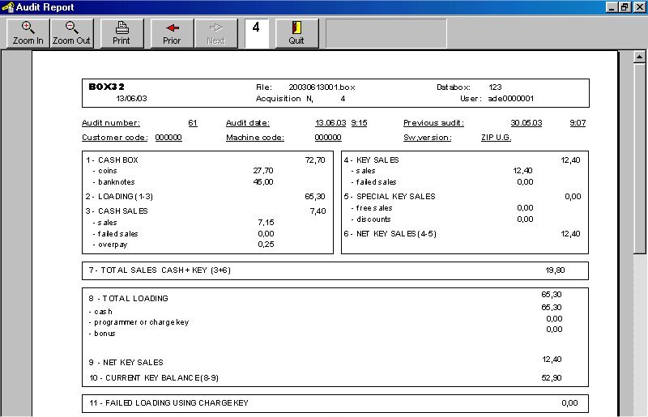

- SETUP KEY
The Setup key is a special key that allows cloning the parameters of a ZIP payment system into
a different ZIP payment system.
It is not possible to clone the price table from selection 11 to 60 included in the menu SALES
PRICES.

Procedure:
- Acquisition of parameters from a ZIP payment system (UPLOAD).
- Download of the parameters into a different ZIP payment system (DOWNLOAD).

1. Upload
- Connect the Programmer to a ZIP payment system.
- Enter the menu PROGRAMMING / OTHER PARAMETERS / SETUP KEY.
- Insert the Setup Key in the ZIP reader and wait the message DATA ACQUIRED.
- Remove the key and disconnect the Programmer.

The Setup Key is now ready to be used in a different ZIP payment system.

2.Download
Procedure:
- Insert the Setup Key in a different ZIP payment system. The transferring of the parameters from the reference ZIP payment system to a different one starts immediately and it is indicated by the blinking of the led of the ZIP reader (short RED, long GREEN).
- Wait a few seconds until the LED turns red indicating the end of the operation.
- Remove the key from the ZIP reader.

Working conditions for the Setup Key:
The following working conditions are required:
- The operator code of the ZIP payment system to be programmed is set to 00000001, or it matches the one of the Setup Key.
- The Setup Key was initialised by means of an UPLOAD using as a reference, a system with the same characteristics of the system to be programmed (e.g. optional Ram on both systems or not).

If the above conditions are not fulfilled, the operation fails.
The failure of the operation is indicated by a continuous blinking of the LED of ZIP reader until the
key is removed.

7 DESCRIPTION OF PARAMETERS - PROGRAMMING MENU

- SELLING PRICES
Menu: PROGRAMMING / SALE PRICES

Selling Prices with Cash
Menu: PROGRAMMING / SALE PRICES / CASH
The system has 10 or 60 selling prices with cash whose value can be programmed from 0 to
65535 and has to be a multiple of the Base Unit.

Selling Prices with Key
Menu: PROGRAMMING / SALE PRICES / KEY
The system has 10 or 60 selling prices with key whose value can be programmed from 0 to
65535 and has to be a multiple of the Base Unit.

Selling Prices with Key with Discounts Level 1, 2, 3
Menu: PROGRAMMING / SALE PRICES / DISCOUNT LEVEL 1,2,3
The system offers 3 Discount Levels for the key sales and a standard price for a “normal selling
key”.
The Discount Levels must be set to ON in the payment system and the selling key must be
programmed with the corresponding discount level by means of the PC Interface.
Enter the menu PROGRAMMING / SALE PRICES / DISCOUNT LEVELS 1, 2, 3 and program the
different prices for each selection.
The prices for each selection must be a multiple of the BASE UNIT.

Configuration for 10 / 60 Prices
Menu: PROGRAMMING / SALE PRICES / CONFIGURATION 10/60 PRICES.
If equipped with the RAM expansion (optional), the ZIP sytem allows to extending the price table from 10 to 60.

- COINS / BANKNOTES
Menu: PROGRAMMING / COINS / BANKNOTES

These menus are used to enable/disable coins/banknotes acceptors.

- MACHINES
Menu: PROGRAMMING / MACHINES

System Type
This menu is used to program the communication with the VMC (PROGRAMMING / MACHINES /
SYSTEM TYPE).

The available protocols are:

EXECUTIVE

CHANGE-GIVER: the system is connected to a change-giver coin mechanism, but the payment system remains as master.

EXECUTIVE SLAVE: the payment system is slave to the change-giver.

BDV MASTER

BDV SLAVE

MDB

PARALLEL (not yet implemented)

When “CHANGEGIVER” or “EXECUTIVE SLAVE” modes are selected, coins and banknotes acceptors cannot be connected to the ZIP CPU (the banknotes acceptor may be connected to the change-giver, when it is allowed by the change-giver).
When the protocol type is changed, it is necessary to retrieve the statistics.

Sale Type
Menu: PROGRAMMING / MACHINES / SALE TYPE.

SINGLE: the key must be removed after each product selection.

MULTIPLE: consecutive product selections can be made without removing the key.

Protocol
Menu: PROGRAMMING / MACHINES / PROTOCOL.

- PRICES ON THE VMC: the VMC communicates the price of each selection to the payment system.

- PRICE HOLDING: the VMC communicates the number of each selection to the payment system and payment system will define the price according to the values programmed in the menu “SALE PRICES”.

- PRICE HOLDING DISPLAY: in a selection it functions as in PRICE HOLDING;

If a product is selected and the credit in the machine is not sufficient, the display of the VMC will show the price of the selection.

Base Unit
Menu: PROGRAMMING / MACHINES / BASE UNIT

In the communication protocol between VMC and payment system, the selling price is transferred as a multiple of a coefficient called Base Unit.

Selling price has to be a multiple of the Base Unit.

The Base Unit value programmed into the ZIP payment system has to match the one programmed in the VMC.

Decimal Point
Menu: PROGRAMMING / MACHINES / DECIMAL POINT
This parameter allows fixing the decimal point in the display of the VMC (e.g. 2000 = 20,00).

Display Type VMC
Menu: PROGRAMMING / MACHINES / DISPLAY TYPE VMC

If the VMC is equipped with a 5-digits display, select 5 DIGITS.

If the VMC is equipped with a 4-digits display, there are two options:

4 DIGITS: the credit is displayed without the last digit (for example 14000 becomes 1400 and 900 becomes 90).

4 DIGITS 9999: when the credit exceeds 9999, the VMC will display the value resulting by subtracting from 1000 the Base Unit (10000 – Base Unit). A credit of 14000 and a Basic Unit of 50 is displayed as 9950, while a credit of 8900 is displayed as 8900.

- OTHER PARAMETERS
Max Chargeable Credit
Menu: PROGRAMMING / OTHER PARAMETERS / MAX CHARGEABLE CREDIT

It represents the max credit chargeable in a sale key.

! WARNING

It is advisable to program a value not exceeding 10 Euro.

Abs Max Credit
Menu: PROGRAMMING / OTHER PARAMETERS / ABS MAX CREDIT

If a key with credit exceeding this value is inserted in the ZIP reader, the key will be rejected.

! WARNING

It is advisable to program a value not exceeding 15 Euro.

Failed Sales Refund
Menu: PROGRAMMING / OTHER PARAMETERS / FAILED SALE REF.

When this option is enabled, the VMC communicates to the payment system not to subtract the price of a failed sale from the key.

Overpay
Menu: PROGRAMMING / OTHER PARAMETERS / OVERPAY

If this parameter is set to ON, when 3 minutes elapse, any credit left in the machine is cancelled. The corresponding amount is stored in the statistic “Cash Sales / Overpay”.

Buzzer
Menu: PROGRAMMING / OTHER PARAMETERS / BUZZER

It enables/disables the audible warning present in the optional 5-digits display board.

Error Messages
Menu: PROGRAMMING / OTHER PARAMETERS / ERROR MESSAGES

If this parameter is set to ON, all the error messages are visualised in the 5-digits display.

Statistics
Menu: PROGRAMMING / OTHER PARAMETERS / STATISTICS

This parameter is used to check the integrity of the data collected by the system.

If an error is detected and STATISTICS=ON was programmed, the system blocks.

On the contrary, if this parameter is disabled STATISTICS=OFF, the system continues to operate and collects the statistics even when an error is detected.

Audit Mode
Menu: PROGRAMMING / OTHER PARAMETERS / AUDIT MODE

- DATA-BOX: the payment system is set to transfer the retrieved statistics according to the Data Box standard.

- EVA-DTS A: the payment system is set to transfer the basic statistics according to the EVA-DTS standard to a terminal operating with the same protocol.

- EVA-DTS B: the payment system is set to transfer the limited statistics according to the EVA-DTS standard to a terminal operating with the same protocol.

- EVA-DTS C: the payment system is set to transfer the extended statistics according to the EVA-DTS standard to a terminal operating with the same protocol.

Charge Key
Menu: PROGRAMMING / OTHER PARAMETERS / CHARGE KEY

It enables/disables the use of the Charge Key.

Free Key Enable
Menu: PROGRAMMING / OTHER PARAMETERS / FREE KEY ENABLE

It enables/disables the use of the Free Selling Key.

Language
Menu: PROGRAMMING / OTHER PARAMETERS / LANGUAGE
It allows changing the language of system.

Initialisation
Menu: PROGRAMMING / OTHER PARAMETERS / INISIALISATION

It allowsinitialising all the parameters with default values.

Setup Key
Menu: PROGRAMMING / OTHER PARAMETERS / SETUP KEY
The Setup Key is a special key that allows cloning all the parameters of a reference ZIP payment system to another ZIP payment system.
It is not possible to clone the price table from selection 11 to 60 included in the menu SALES
PRICES.

- BLACK LIST
Menu: PROGRAMMING / BLACK LIST
- KEY BLOCK DISABLED: the Black List is not run;

- 10 KEYS: it is used to insert in the Black List up to 10 keys; the key numbers are programmed into the following Black List (“KEY NUMBER 1...10”);

- 500 KEYS: it is used to insert in the black list up to 500 keys.

! WARNING

The Black List can be extended to 500 numbers only if the ZIP payment system is equipped with the RAM expansion.

8 DESCRIPTION OF BONUS, REWARD AND PROMOTIONS

These functions are available only if the system if equipped with the RAM expansion.

- BONUS

2 levels of bonus are available: BONUS 1 and BONUS 2.

They can be granted daily, weekly or monthly.

Operating mode of BONUS 1
Bonus 1 can be granted as credit or as token.
While the bonus as credit is added to the credit stored in the key and, therefore, can be used on any machine, the bonus as token is granted on a specific machine and can be used either on the same machine or on a machine that has been enabled to use bonus 1.

Regardless of the operating mode (credit or token) it is possible to enable only specific categories of keys (keys with discount level 0 enabled, keys with discount level 1 enabled, keys with discount level 2 disabled, keys with discount level 3 disabled).

Furthermore, the amount of bonus can be programmed for each category of keys (amount of the credit or number of tokens).

Bonus granted as token, if not used is lost: for example, if 3 tokens per day are programmed and the user uses only 2 of these, the remaining one is lost. The day after 3 tokens are available.

When using BONUS 1, 7 is the max number of tokens possible to grant (daily, weekly or monthly).

Bonus granted as credit, is stored in the key even when it is not used.

Operating mode of BONUS 2

Bonus 2 can be granted as token only and up to 127 tokens can be granted (daily, weekly or monthly).

If both Bonus 1 and Bonus 2 are enabled on the same VMC, Bonus 1 must be granted as credit while Bonus 2 as token.

Like Bonus 1, Bonus 2 can be enabled only for specific categories of keys but differently from Bonus 1, Bonus 2 allows to select the selections that can be granted using the tokens.

Programming the bonus

To program the bonus enter the menu: AUX / BONUS.

Clock
Enter the menu: AUX / CLOCK

This menu allows programming date and time of the ZIP payment system.

How to enable/disable Bonus
Enter the menu: AUX / BONUS

- USE DISABLED: bonus is not enabled.

- USE ONLY SALE: the ZIP payment system allows making a vend using the bonus granted by another ZIP system, but it cannot grant bonuses.

- RECHARGE AND SALE: the ZIP payment system allows making a vend using the bonus granted by another ZIP system and can grant bonuses.

Enabled keys
Enter the menu: AUX / BONUS / ENABLED KEYS

This menu is used to enable only specific categories of keys. To enable only the keys with discount level 0 and 1, select DISCOUNT LEVEL 0, 1 = ON and DISCOUNT LEVEL 2, 3 = OFF.

Period
Enter the menu: AUX / BONUS / PERIOD

This parameter allows deciding how many bonus can be granted (daily, weekly or monthly).

If the bonus is granted as token, tokens are not added to the ones already present in the key, but they replace them. For example, if the system was programmed to grant 3 tokens per day and only 2 were used, the last one is lost and the following day 3 new tokens are granted.

If the bonus is granted as credit, the credit is added to the one already present in the key and will not be lost.

Daily period goes from 00:00 to 24:00; weekly period goes from Monday to Sunday.

Type/Value
Enter the menu: AUX / BONUS / TYPE/VALUE

Enter this menu to choose the type of bonus (credit or token) and to program the amount of bonus (number of tokens or amount of credit) for each discount level (DISCOUNT LEVEL 0, 1, 2, 3).

Selections Enabled
Enter the menu: AUX / BONUS / SELECTIONS ENABLED

This menu appears only as Bonus 2 mode and it allows enabling the selections that can be granted using a bonus as token.

For example, if SELECTION 1 = ON and the other selections are programmed to OFF, only selection 1 can be granted using a bonus as token.

- TIME BANDS

This menu allows programming up to 3 periods in which the ZIP payment system is disabled.

! WARNING

If the menu MACHINE SYSTEM TYPE = EXECUTIVE SLAVE, BDV SLAVE and MDB, only the use of the key is disabled.

Time Bands Programming
Enter the menu: AUX / TIME BANDS

- TIME BANDS 1,2,3 ON/OFF: to enable/disable the Time Bands function.

- BAND 1,2,3 ON / OFF: to enable/disable each single periods.

- START/END: for programming the start/end of the periods (hh:mm).

- REWARD
Reward consists of points or credit granted for each vend (except for those made using a
bonus).

Programming Reward
Enter the menu: AUX / REWARD PROMOTIONS / REWARD ON OFF
It allows enabling/disabling Reward mode.

Credit mode
Enter the menu: AUX / REWARD PROMOTIONS / REWARD TYPE CREDIT
Reward as credit mode consists of an amount of credit, indicated in the Discount Level 3 table,
that is added into the key after a vend.

Points mode
Enter the menu: AUX / REWARD PROMOTIONS / REWARD TYPE POINTS
Reward as points mode consists of a number of points that are stored in a specific area in the
memory of the key after a vend.
When the number of points stored in key is equal to the number of points indicated in the Discount
Level 2 table, the product is granted for free.
In the Discount Level 2 table, in fact, it is programmed the number of points needed to get a free
selection (such number can change depending on the selection); in the Discount Level 3 table
the number of points granted for each vend when using the key are programmed.
In order to use the points stored in the key, check if these points are at least equal to the number of
points needed for the product and make a selection. The product is granted for free and the
corresponding points are subtracted from the key

! WARNING
- To avoid that a selection is granted in reward mode, program the points to zero for that selection in the Discount Level 2 table; if a selection is programmed to zero in the Discount Level 3 table, no points are granted for that selection.
- The points stored in the key can be checked by using the optional 5 digits display. However, the display is not needed for the functioning of the Reward feature. The 5 digits display indicates the letter ‘F‘ and the number of points stored in the key. When Bonus and Reward are enabled at the same time, the display will show alternatively the points and the number of tokens.

Implications
- Reward can be set to ON only if Promotions and Discount Bands are programmed to OFF.
- When Reward is enabled, Discount Level 2 and 3 cannot be used and must be programmed to OFF.
- When setting the parameter REWARD TYPE = POINTS, the Discount Level 2 table in the PROGRAMMING menu includes, for each selection, the price in points for each product.
- The Discount Level 3 table includes the number of points granted for each vend with the key.
- If, however, REWARD TYPE = CREDIT, the Discount Level 3 table will include, for each selection, the amount of credit that will be added to the credit in the key when making a vend.
- Products granted as bonus will not be considered for the Reward.
- When Bonus and Reward are both enabled the priority is given to bonus (priority: bonus as token, reward, credit).

- PROMOTIONS
Promotions are gifts given to the users.
A price discount is applied (entered in the Discount Level 3 table) when a combination of products is purchased from two different machines within a defined period of time.
Example:
Let’s suppose a purchase of a coffee that costs € 1 from a VMC type A and to program, in this machine, a discount of € 0,40 in the DISCOUNT LEVEL 3 table. This discount is stored in the key together with other data, such as hour, minutes, type of machine etc.
Let’s suppose to purchase a croissant costing € 1,8 from a VMC type B within a programmed period of time. If a discount of € 0,20 was programmed in the DISCOUNT LEVEL 3 table, the croissant will be sold for € 1,2 (1,8-0,4-0,2).
Therefore:
- The discount is applied only if the second vend takes place, provided that it is done within the period of time programmed in the VMC type B;
- The two VMC have to be different (type A and type B);
- The order of the two vends is irrelevant.

Implications
The discount is linked to a combination of two VMC or groups of VMC (A and B).
VMC A is identified with the parameter MACHINE ID = A while VMC B with the parameter MACHINE ID = B.
If the first vend is made in the VMC A, here below are the possibilities:
- Another vend is made in the VMC B within a period of time. The discount granted is equal to the sum of the discount stored in the key (corresponding to the first vend made in the VMC A) and the discount programmed for the vend made in the VMC B.
- The following vend is made in the same VMC A.
- No discount is granted and the discount stored in the key related to the first vend is replaced by the discount of the second vend and the date and time are updated.
- The following vend is made in the VMC B beyond the programmed period of time.
- Same as b).

! WARNING
- When the Promotions are enabled, Reward and Discount Bands must be programmed to OFF.
- Promotions can coexist with the bonus with the following priority: Bonus as token, Promotions, Bonus as credit.
- When Promotions are enabled, the DISCOUNT LEVEL 3 table is used to program the discounts: Discount Level 3 can not be used anymore.
- If the vend is made using Bonus, it is not considered for the discount linked to the promotions.
- When Promotions are enabled, Discount Level 1 and 2 can continue to be used.
- The discount linked to the Promotions is applied only if the second vend takes place and if the two vends are made from machines with different MACHINE ID within the MAX TIME programmed in the second ZIP payment system.

Programming Promotions
Enter the menu: AUX / REWARD PROMOTIONS / PROMOTIONS / PROMOTIONS ON/OFF
To enable/disable the promotions.
- MACHINE ID: it can be either A or B.
- MAX TIME: represents the maximum period of time (minutes from 1 to 60) that can elapse between two consecutive vends.

Discount Bands
Enter the menu: AUX / REWARD PROMOTIONS / DISCOUNT BANDS
The Discount Bands are used to differentiate the key selling prices, for each price selection during the day.
Three Discount Bands are available that can be enabled/disabled individually. The starting and ending of each period can be programmed (it is not possible to overlap the 3 Discount Bands).
The selling prices for each Discount Band are taken from the Sale Prices tables Discount Level 1, 2, 3. Therefore, when the Discount Bands are enabled, the Sale Price tables related to the Discount Levels with key become prices for the periods 1, 2, 3.
However, it is possible to permit the use of keys with Discount Levels by enabling or disabling these discounts (If the key has a higher Discount Level than the one programmed in the Discount Band, the Discount Level of the key is applied, provided that it is enabled).

Programming the Discount Bands
Enter the menu: AUX / REWARD PROMOTIONS / DISCOUNT BANDS ON/OFF
To enable/disable the Discount Bands.

- OPTIONAL DISPLAY
The optional Display is used to indicate the number of tokens for the Bonus or the number of points as reward stored in the key.

When the key is not inserted in the ZIP reader, the display indicates the coins and banknotes inserted in the validator. When the key is inserted in the reader the functioning of the display depends on the programming of Bonus and Reward.
Here below the possibilities:

BONUS 1 = OFF
BONUS 2 = OFF
LOYALTY = OFF
THE DISPLAY INDICATES THE CREDIT STORED IN THE KEY

BONUS 1 =ON (CREDIT)
BONUS 2 =OFF
REWARD = OFF
THE DISPLAY INDICATES THE CREDIT STORED IN THE KEY

BONUS 1 =ON (TOKEN)
BONUS 2 =OFF
REWARD = OFF
THE DISPLAY INDICATES THE NUMBER OF TOKENS STORED IN THE KEY (e.g. b 5)

BONUS 1 =ON (CREDIT)
BONUS 2 =ON (TOKEN)
REWARD = OFF
THE DISPLAY INDICATES THE NUMBER OF TOKENS STORED IN THE KEY (e.g. b2 12)

BONUS 1 =ON (CREDIT)
BONUS 2 =OFF
REWARD = ON
THE DISPLAY INDICATES THE NUMBER OF LOYALTY POINTS STORED IN THE KEY (e.g. F 30)

BONUS 1 =ON (TOKEN)
BONUS 2 =OFF
REWARD = ON
THE DISPLAY INDICATES ALTERNATIVELY THE NUMBER OF REWARD POINTS (e.g. F 30) AND THE NUMBER OF TOKENS (e.g. b 5) STORED IN THE KEY

BONUS 1 =OFF
BONUS 2 =OFF
REWARD = ON
THE DISPLAY INDICATES THE NUMBER OF REWARD POINTS STORED IN THE KEY (e.g. F 30)

- FUNCTION OF THE PRICE TABLES
The following notes describe the functions of the Price Tables.

REWARD = OFF, PROMOTIONS = OFF, DISCOUNT BANDS = OFF.

CASH | WITH KEY | DISCOUNT LEVEL 1 | DISCOUNT LEVEL 2 | DISCOUNT LEVEL 3
Prices with cash | Prices with key | Key prices  Discount Level  1 | Key prices  Discount Level  2 | Key prices  Discount Level  3

REWARD = ON, PROMOTIONS = OFF, DISCOUNT BANDS = OFF.

CASH | WITH KEY | DISCOUNT  LEVEL 1 | DISCOUNT  LEVEL 2 | DISCOUNT  LEVEL 3
Prices with cash | Prices with key | Key prices  Discount Level  1 | Price in points  for  the selection  (see Reward) | Points or credit  rewarded after  each selection

REWARD = OFF, PROMOTIONS = ON, DISCOUNT BANDS = OFF.

CASH | WITH KEY | DISCOUNT  LEVEL 1 | DISCOUNT  LEVEL 2 | DISCOUNT  LEVEL 3
Prices with cash | Prices with key | Key prices  Discount Level  1 | Key prices  Discount Level 2 | Discounts  linked  to promotions

REWARD = OFF, PROMOTIONS = OFF, DISCOUNT BANDS = ON.

CASH | WITH KEY | DISCOUNT LEVEL 1 | DISCOUNT LEVEL 2 | DISCOUNT LEVEL 3
Prices with cash | Prices with key | Key prices  Discount Level  1  or Key price  within Discount  Band 1 | Key prices  Discount Level  2  or Key price  within Discount  Band 2 | Key prices  Discount Level  3  or Key price  within Discount  Band 3

9 RAM EXPANSION

The RAM expansion cod. 958934 makes it possible to implement the following functions in the ZIP base module:
- Bonus, Reward, Promotions,
- Expansion of price lines from 10 to 60,
- Expansion of black list from 10 to 500 keys.
- Extended collection of statistics in EVA-DTS mode (see table p. 50)
- User Groups

The RAM expansion is installed on the special plinth, present in the ZIP CPU module, following the instructions provided with the item.
If it is installed on a ZIP payment system which is already in use, it is necessary to collect the statistics prior to installation.
Furthermore, after application, if the parameter “STATISTICS = ON”, the LED on the reader will
flash red and green to indicate that a collection of statistics must be performed for resetting
purposes.

10 HOW TO USE DISCOUNT PERIODS, HOW TO USE BONUS AND HOW TO GRANT FREE SALES

- HOW TO USE DISCOUNT PERIODS

EXAMPLE 1: You want to enable access to the VMC for “Normal Users” within certain periods, while other persons may access at any time.

The “Normal Users” must have “Discount Level 0” sale keys, while persons who can access the
VMC at any time must have “Discount Level 3” sale keys.

1. Connect the Programmer and enter the “SALE PRICES” menu.
2. Program the prices with coins with the correct sale value (see note).
3. Program the prices with keys to a value greater than the “ABS MAX CREDIT” (e.g. 65535), so that no key can sell.
4. Program the correct sale price in the “DISCOUNT LEVEL 1-2-3”. Program DISCOUNT LEVEL 1-2=OFF and DISCOUNT LEVEL 3=ON.
5. Enter the menu “TIME BANDS” and program “TIME BANDS” =ON”, leaving “BAND 1,2,3 = OFF”.
6. Enter the menu “REWARD/PROMOTIOS”, sub-menu “DISCOUNT BAND” and program “DISCOUNT BAND =ON”.
7. Remaining in the menu referred to above, program the start and finish times of the periods within which everyone is enabled to use the VMC (maximum of three periods), proceeding as follows:
- Program “BAND 1=ON”
- Program start time of the period
- Program finish time of the period
- Program as above BAND 2 and 3, ensuring that there is no overlapping of periods.
8. Exit programming and disconnect the Programmer.

! WARNING

It is not possible to enable coins in the periods. Coins, if enabled, are always accepted.
If the operating mode is not desired, leave coins disabled.

EXAMPLE 2: Programming 3 Periods in which the following prices are applied:

- BAND 1 (07.00 – 09.00): price = 0.10
- BAND 2 (09.00 – 17.00): price = 0.25
- BAND 3 (17.00 – 24.00): price = 0.10

To use the Discount Bands it is necessary to:
- Program the prices to apply within the Discount Bands, in the menu PROGRAMMING/SALE PRICES.
- Enable the Discount Bands in the menu AUX/REWARD/PROMOTIONS/DISCOUNT BANDS.

! WARNING

In the case of consideration, there is a period which goes form 24.00 to 7.00. In this period the “prices with key” are applied.

1. PRICE Programming
- Enter the menu PROGRAMMING/SALE PRICES.
- Program the 10 prices in the table CASH with the same prices programmed in the VMC (full price without key).
- Program the 10 prices in the table KEY with the prices to be applied in the period which is not included in the three Discount Periods (24.00 – 7.00).
- Program the 10 prices in the table “DISCOUNT LEVEL 1” at 0.10 (price within Period 1). Leave parameter “DISCOUNT LEVEL 1 = OFF”.
- Program the 10 prices in the table “DISCOUNT LEVEL 2” at 0.25 (price within Period 2). Leave parameter “DISCOUNT LEVEL 2 = OFF”.
- Program the 10 prices in the table “DISCOUNT LEVEL 3” at 0.10 (price within Period 3). Leave parameter “DISCOUNT LEVEL 3 = OFF”.

2. DISCOUNTS BANDS Enabling
- Enter menu AUX / TIME BANDS.
- Program TIME BANDS = ON.
- Program BAND 1 = OFF.
- Program BAND 2 = OFF.
- Program BAND 3 = OFF.
- Enter menu AUX /REWARD/PROMOTIONS / DISCOUNT BANDS.
- Program DISCOUNT BANDS = ON.
- Program BAND 1 = ON.
START = 07.00
END = 08.59
- Program BAND 2 = ON.
START = 09.00
END = 16.59
- Program BAND 3 = ON.
START = 17.00
END = 23.59
- Enter menu AUX / CLOCK and set the correct date and time.

HOW TO USE BONUS
Example 1: you want to give a “gift” (bonus) of 1.00 Euro per day to key/card holders with “Discount Level zero” and nothing to key/card holders with other Discount Levels. (In this case it is a Bonus as credit, which can be granted only as “Bonus 1” mode.)

1. Connect the programmer.
  - Enter the menu AUX.
  - Enter the menu CLOCK and set the correct date and time.
  - Enter the menu BONUS, sub-menu BONUS 1, select RECHARGE AND SALE.
  - Enter the sub-menu KEYS ENABLED, select DISCOUNT LEVEL 0= On, all others = OFF
  - Enter sub-menu PERIOD, program DAILY.
  - Enter the sub-menu TYPE/VALUE, program BONUS TYPE = CREDIT, DISCOUNT LEVEL 0 = 100”and DISCOUNT LEVEL 1,2,3 = 0.
  - Exit programming and disconnect the programmer.

Example 2: Give a “Bonus” corresponding to 3 free selections per day.

It is necessary to enable the function BONUS as token. There are two types of Bonuses: Bonus 1 and Bonus 2.
The Bonus 1 can be up to 7 per day/month/year on all selections. The Bonus 2 can be up to 127 per day/month/year and are enabled / disabled selection by selection.
In this case, since disabling is not required on certain selections, Bonus 1 can be used.
Bonuses are programmed in the menu AUX / BONUS.

- - Enter the menu AUX / BONUS / BONUS 1.
- – Program RECHARGE AND SALE.
- - Program “ENABLED KEYS” -> “DISCOUNT LEVEL 0 = ON”.
- - Program “ENABLED KEYS” -> “DISCOUNT LEVEL 1 = OFF”.
- - Program “ENABLED KEYS” -> “DISCOUNT LEVEL 2 = OFF”.
- - Program “ENABLED KEYS” -> “DISCOUNT LEVEL 3 = OFF”.
- - Program “PERIOD = DAY”.
- - Program “TYPE/VALUE” -> “BONUS TYPE = TOKEN”.
- - Program “TYPE/VALUE” -> “DISCOUNT LEVEL 0 = 3”.

! WARNING

To display the number of Bonuses present in the key it is necessary to have the optional 5-digits display code 099015.

HOW TO GRANT SALES AT PRICE 0 WITH KEY

Executive Mode
It is possible to make a vend with the key at price zero, but with coin prices different from zero (price programmed in VMC).

EXAMPLE:
Price line 1 50 with coin 0 with key
Price line 2 100 with coin .50 with key

Price holding mode
It makes possible to select all desired combinations.

EXAMPLE:
Price line1 50 with coin 0 with key
Price line2 0 with coin 50 with key
Price line3 0 with coin 0 with key
Price line 4 100 with coin 50 with key

11 DIAGNOSTIC MESSAGES OF THE ZIP

iNDICATIONS PROVIDED BY THE LED OF THE READER
The LED on ZIP reader, which is normally illuminated green, is also used to display simple diagnostic messages, by means of sequences of red-green flashes. Two types of indications are provided: generic events and system events.

Generic events
These are events which cause the partial or total blockage of the payment system. The assistance of technical personnel is usually not necessary as the system automatically unblocks when the cause disappears.

Signaling:
Continuous GREEN/RED flashing at 50% of the dual-colored LED housed in the reader.

Events foreseen:
- Lack of serial communication to the VMC or to the Change Giver, if enabled.
- Machine out of order in general.
- Key/Card reading error (e.g. wrong codes, credit greater than “max usable credit”)
It disappears by extracting the key and inserting one with the correct codes.
- Key/Card writing error (e.g. improperly inserted or defective key, etc.)
It disappears by extracting the key.

System events
These are events which cause the complete blocking of the payment system. A technician’s assistance is always necessary in order to restore operation.

Signaling:
They are signaled by RED/GREEN flashing of the dual-colored LED housed in the reader. If an optional 5-digits display is used, they may also be signaled by a buzzer and brief messages.

Events foreseen:
- Error on parameters.
This is signaled by:
    - LED: 2 rapid RED flashes spaced by a GREEN pause;
    - BUZZER: 2 sound impulses;
    - 5-digit DISPLAY: “ErrEE”;
It is unblocked by modifying at least one parameter.

- Error on statistics.
This is signaled by:
- LED: 4 rapid LED flashes spaced by a GREEN pause;
- BUZZER: 4 sound impulses;
- 5-digit DISPLAY: “St-Err”;
It is unblocked after a collection of statistics or by programming STATISTICS = OFF.

- Euro conversion rate out of limit.
This is signaled by:
- LED: 3 rapid RED flashes spaced by a GREEN pause;
- BUZZER: 3 sound impulses;
- 5-digit DISPLAY: “ErrEu”;
It is unblocked by programming a value which is within the permissible limits.

INDICATIONS PROVIDED BY THE DISPLAY
These messages appear when the optional 5-digits display is used, or by inserting the Programmer and choosing the menu STATISTICS, sub-menu DIAGNOSTIC STATISTICS, item “LAST ERROR”.

E1: AREA KEY CREDIT ALTERED:
The event may be caused by erroneous reading of the key; in this case try extracting and reinserting the key. If the error persists it is due to erroneous writing of the key, because it was extracted while writing was in progress (which is in any case a very rare event). The key can be restored by means of the PC interface.

E2: INCORRECT KEY ACCESS CODES:
The codes present in the key (Operator, Department or Client code) are different than those programmed into the CPU ZIP module.

E6: ERRONEOUS KEY FUNCTION CODE

E7: KEY CREDIT OVER LIMIT:
The credit in the key is greater than the credit programmed in the CPU module, in the menu PROGRAMMING / OTHER PARAMETERS / ABS MAX CREDIT.

E8: SALE CARRIED OUT WITH NEGATIVE OUTCOME.
This is a message which appears when the sale is not successfully completed (note: the VMC provides this information to the payment system, but not all VMC do so)

E9: KEY WRITING ERROR during credit updating phase:
This event may occur when a key is extracted during a writing phase (red LED on). In some cases the event may cause the alteration of the credit area in the key (see event E1).

E10: CONNECTION ERROR between Data Box or Data Key and CPU module during the statistics collection phase:
This event occurs when you do not wait 2 minutes between two successive collections in the same payment system or when the connector has not been inserted properly.

E12: KEY WRITING PERFORMED BUT NOT VERIFIED:
This event may occur when a key is extracted during a writing phase (red LED on). If this message is displayed after having made a selection, the key may be decreased but the sale does not take place because the key was extracted.

E13: KEY ON BLACKLIST INSERTED when the Black List is enabled.

E15: TEST PERFORMANCE. The VMC has requested the performance of a test at price zero.

12 OPERATING IN EXECUTIVE MODE WITH CHANGEGIVER

- FUNCTIONING
The payment system, in Executive, can operate in three different modes:

- Executive
This is the operating mode normally used in payment systems when they operate without Change-Giver.

Payment
System
(Master)
VMC
(Slave)

- Executive “Change-Giver”
This is one of the operating modes for the connection with the change-giver. In this case the payment system acts as master towards the VMC.

Payment System
VMC
(Slave)
(Master)
Change-Giver
(Master)
(Slave)

- Executive “Slave”
This is another operating mode for the connection of the change giver coin slot. In this case it is the change giver that acts as master towards the VMC and towards the payment system.

VMC
(Slave)
Change Giver
(Master)
Payment System
(Slave)

The following table summarizes the main differences between the “Change Giver” and “Slave” modes.

CHARACTERISTIC | “CHANGE GIVER” EXECUTIVE MODE | “SLAVE”  EXECUTIVE MODE
Statistics | The Change Giver collects only the Totals since it is not able to distinguish the quantities used for Sales from those used to recharge keys. This data is handled by the Payment System. | The Change Giver collects all statistics. The Payment System collects only the statistics for Sales with key. Furthermore, the statistic “Cash Box Coins” represents cash used for key recharging.
Recharge Key | Can be used. | Cannot be used.
Sale Mode | Single or Multiple. | Single or Multiple.
Coin Recharging | Automatic, by inserting the key before or after having inserted coins. Transfer of credit takes place in steps of 100 units of the base currency. | Automatic with the following Change Givers:  - COINCO GLOBAL EURO;  - NRI G-46  Requires the use of the “Escrow” lever with the Change Giver  MARS CASHFLOW 690.

- PROGRAMMING OF THE CHANGE GIVER

CHANGE MAKER  COIN SLOT | “CHANGE GIVER”  EXECUTIVE MODE | “SLAVE”  EXECUTIVE MODE
COINCO | - Parameter C015 = 4 o 5  4 = Single Sale;  5 = Multiple Sales.  - Parameter C019 = 0  0 = Without Key Reader.  - Parameter C029 = Par. A010.  Base Unit for Key Reader.  - Parameter C030 = Max Chargeable Credit. | - Parameter C015 = 4 o 5  4 = Single Sale;  5 = Multiple Sales.  - Parameter C019 = 4  4 = With Key Reader.  - Parameter C029 = Par. A010.  Base Unit for Key Reader.  - Parameter C030 = Max Chargeable Credit.
MARS CASHFLOW 690  Menu:  SETUP -> EXEC. CFG | - Peripheral = Card Reader not installed.  - Maximum Credit = Max Chargeable Credit.  - Sale Type = Multiple. | - Peripheral = Card Reader installed.  - Maximum Credit = Max Chargeable Credit.  - Sale Type = Single.

13 AUTOMATIC PROGRAMMING OF CUSTOMER AND OPERATOR CODES

The procedure described here makes it possible for the key data to assume the values shown hereunder:
- Operator code: becomes the one programmed in the Zip
- Customer code: becomes the one programmed in the Zip
- Department code: remains unchanged
- Discount code: remains unchanged
- Key number: remains unchanged
- Credit: remains unchanged

Procedure
- Enter the PROGRAMMING menu and program the codes, prices, and the various parameters with the desired values.
- Enter the EURO menu and program:
- EURO = ON
- CONVERSION RATE = 1.00000
- NATIONAL COMMA = C
- PREVIOUS OPERATOR CODE = 1 for new keys, or the operator code already present in the
keys, if the keys are already used
- OPERATOR CODE = should not be modified, since it was programmed in the menu CODES
- Disconnect the Programmer, insert the key and wait for the LED in the ZIP reader to change from red to green before removing it.

! WARNING

The Department Code is not changed because if the keys are already in use, that code may have different values (e.g. zero for the key which must function on each Zip) while after insertion it would assume the value of the code present in the reader where the key was inserted.

14 PROGRAMMING

The programmer must be connected and disconnected with the machine switched on. If disconnection takes place after having switched off the machine, the LED in the reader will flash red and green and the payment system will not operate until a new programmer is inserted and any parameter is programmed (see “DIAGNOSTIC MESSAGES” paragraph, system events).

PROGRAMMER MENU
ZIP

CONNECT THE PROGRAMMER

INIT
DONE

ENT
PROGRAMMING

F4

CLR

F4

LANGUAGE
ENGLISH

ENT
CLR

F4
ENT
KEYS HANDLING

CLR
F4

PASSWORD

ENT

CLR

F4
ENT
STATISTICS

CLR

F4
ENT
AUX

CLR
F4
ENT

EURO

CLR

PROGRAMMING

ENT
CLR
ENT
SALE PRICES

F4

CLR
F4

ENT
COINS

CLR
F4

BANKNOTES

ENT

CLR
F4

MACHINES

ENT

CLR
F4

CODES

ENT

CLR
F4
ENT
OTHER PARAMETERS

CLR
F4

BLACK LIST

ENT

CLR

SALE PRICES

F4
ENT
CLR
SELECTION 1
150
ENT
F4
ENT
CASH

LIVELLO SCONTO 2

F4
CLR
… 2, 3, 4, 5, 6, 7, 8, 9, …
SELECTION 10
1050
F4
ENT
LIVELLO SCONTO 3

SELECTION 1
100
F4
ENT
KEY

ENT

F4
CLR
… 2, 3, 4, 5, 6, 7, 8, 9,
SELECTION 10
1000
F4
F4
DISCOUNT LEVEL 1
OFF
ENT
ENT
DISCOUNT LEVEL 1

ON
CLR
ENT
SELECTION 1
65535

F4
F4
ENT
… 2, 3, 4, 5, 6, 7, 8, 9,.
SELECTION 10
65535

F4
ENT
ENT
DISCOUNT LEVEL 2
OFF
DISCOUNT LEVEL 2

ON
CLR
ENT

SELECTION 1
65535
F4
F4
ENT
… 2, 3, 4, 5, 6, 7, 8, 9,.
SELECTION 10
65535

F4
ENT
DISCOUNT LEVEL 3

DISCOUNT LEVEL 3
OFF
ENT

ON
CLR
ENT

F4
SELECTION 1
65535
CONFIGURATION
10 / 60 PRICES

F4
ENT
… 2, 3, 4, 5, 6, 7, 8, 9,..
SELECTION 10
65535
ENT

COINS

ENT
CLR
F4
VALIDATOR
DISABLED

SALE ONLY

ENT

RECHARG.
AND SALE

F4

VALIDATOR TYPE STANDARD

STANDARD/EURO
ENT

BINARY TYPE 1/2 *

* Italy only

F4

COIN A
50

ENT

B, C, D, E, F, G,
F4

COIN H
500

ENT

BANKNOTES

ENT
CLR

ACCEPTOR
DISABLED

F4

RECHARGING ONLY

ENT

RECHARG. AND SALE

F4

PARALLEL ITALY

JCM

SMILE

SERIAL GPT
ACCEPTOR TYPE
PARALLEL GPT

ENT

F4

BANKNOTE 1
1000

ENT

F4
… 2, 3,

BANKNOTE 4
0

ENT

MACHINES

PROTOCOL
PRICES ON VMC
PRICE HOLDING
PRICE HOLDING DISP

2ND DELAY
ON – OFF (DEFAULT=OFF)
SYSTEM TYPE
* EXECUTIVE
CHANGE GIVER
EXECUTIVE SLAVE
* BDV MASTER
BDV SLAVE
* MDB
PARALLEL

ENT
ENT
ENT
ENT
ENT
ENT
ENT
ENT

ENT
CLR

F4

*= It is possible to use
a coin acceptor

F4

For “EXECUTIVE” :
SALE TYPE
MULTIPLE
SINGLE

F4

If the system is set as Executive Slave
it is present only the Base Unit
F4
BASE UNIT
1

F4
DECIMAL POINT
POSITION A ÷ E

F4
DISPLAY TYPE VMC
5 DIGITS
4 DIGITS
4 DIGITS 9999

F4
SALE DELAY
ON – OFF (DEFAULT=OFF)

F4

BDV
MACHINES

ENT
CLR

BDV SLAVE
BDV MASTER

F4
ENT

F4

SALE TYPE
MULTIPLE / SINGLE

ENT
F4

PROTOCOL
PRICES ON VMC

ENT

PRICE HOLDING

F4

BASE UNIT
1

F4
ENT

DECIMAL POINT
POSITION A ÷ E
ENT
BDV Master only

F4

AUDIT UNIT
ON/OFF (DEFAULT=OFF)
ENT

F4

SALE DELAY
ON/OFF (DEFAULT=OFF)
ENT

MDB
SYSTEM TYPE
MDB

ENT
CLR
SALE TYPE
SINGLE

F4

MULTIPLE

ENT

F4

PROTOCOL
PRICES ON VMC

PRICE HOLDING
ENT

F4

BASE UNIT
1 ….

ENT
F4

DECIMAL POINT
POSITION A ÷ E

ENT

F4

READER FEAT. LEVEL
1/2

ENT

F4

MAX RESPONSE TIME
20
ENT

F4

INTERBYTE TIME
5
ENT

F4

COUNTRY CODE
0039
ENT

CODES

ENT
CLR
ENT

F4
ENT
ENT
ENT

CLR
F4

USER GROUP *
CODE 1
USER GROUP
CODE 2
USER GROUP
CODE 3
USER GROUP
CODE 4
F4

USER GROUP
CODE 4
F4

MACHINE CODE (1)
000000
ENT

* WHEN SW FOR USER
GROUPS IS LOADED,
THE DEPARTMENT
CODE IS REPLACED
READER CODE (1) (2)
000000
BY USER GROUPS

ENT

1) CAN BE PROGRAMMED
WITH ALFANUMERIC
SYMBOLS USING F2 AND F3
BUTTONS OF THE
CHANGE GIVER CODE (1)(2)
000000
PROGRAMMER
ENT

2) FOR EVA-DTS FORMAT
ONLY
SECURITY CODE
####
ENT

ENT

DEPARTMENT CODE
000
CUSTOMER CODE
00000
OPERATOR CODE
########
PASS CODE
####
F4
F4
F4
F4
F4
F4
F4

OTHER PARAMETERS

ENT
CLR
F4
MAX CHARGEABLE CREDIT
20000
ENT
F4

ABS. MAX CREDIT
30000
F4
ENT

FAILED SALES REF.
ON/OFF

F4
ENT

OVERPAY
ON/OFF

F4
ENT
BUZZER
ON/OFF

F4
F4
F4
ENT
.
ERROR MESSAGES
ON/OFF

ENT

,
STATISTICS
ON/OFF

F4
ENT

F4
ENT
F4
AUDIT MODE
DATABOX / EVA-DTS A/..B/..C

DATA BOX/ EVA DTS
EVA DTS A/B/C

ENT
ENT

F4
F4
CLR
CHARGE KEY
ON/OFF

ENT

SELECT FLAG
ON / OFF
ENT

FREE KEY ENABLED
ON/OFF

BAUD RATE 9600
ON / OFF
ENT
F4
F4
INITIALIZATION

ENT
ENT

F4
ENT
SETUP KEY

ENT
PASS / SECUR.
CODES ON/OFF

BLACK LIST

ENT
CLR

KEY BLOCK DISABLED
ON/OFF
ENT

10/500 KEYS
F4

F4

KEY NUMBER 1
000000
ENT

F4
… 2, 3, 4, 5, 6, 7, 8, 9 …

KEY NUMBER 10
000000

ENT

KEYS HANDLING

ENT
CLR

KEYS READING
CREDIT CHANGE

F4
ENT
CLR

F4

KEYS
FORMATTING

ENT
CLR

KEYS READING
CREDIT CHANGE

ENT
CLR

INSERT KEY

KEY N. 000456
CREDIT 6900
F4
ENT

F4

CUSTOMER CODE (*)
00001

F4

DEPARTMENT CODE (*)
001

* Data reading only
F4
DISCOUNT CODE ( * )
0

F4

BONUS DD MM N (1)
02 12 7
ENT
(1) = Only if Bonus 1
is enabled
DD = day
F4
MM = month
N = number
BONUS 2 DD MM NNN (2)
02 12 127

ENT
(2) = Only if Bonus 2
is enabled.
DD = day
F4
MM = month
NNN = number
REWARD (3)
P 35
ENT

(3) = Only if
reward is
enabled.
P = points

KEYS
FORMATTING

ENT
CLR

PREV. OPERAT. CODE *
00000001

ENT

F4

KEY NUMBER
000003
F4
ENT

F4

CREDIT PROGRAMM.

ENT

F4

INSERT KEY
N. 000003

KEY INSERTED
PLEASE WAIT

Remove the key

CORRECT FORMATT.
REMOVE THE KEY

WRONG FORMATTING
REMOVE THE KEY

* NOTE: if PREVIOUS OPERATOR CODE programmed in the ZIP system is different from the one programmed in the key, when inserting the key in the reader the following message is displayed:

WRONG DATA !
REMOVE THE KEY

ENT
ENT

PASSWORD
MODIFY
PASSWORD

CURRENT PASSWORD
00000000
ENT
CLR
CLR

F4
F4

ENT

PASSWORD RESET
AND OPERAT CODE

ENT
DO YOU CONFIRM?
ATTENTION!
CLR

STATISTICS

MAIN
STATISTICS

CASHBOX COINS
S1 0

ENT
ENT

CLR
CLR
CASHBOX BANKNOTES
S2 0

CASH SALES
S3 0

FAIL CASH SALES
S4 0

OVERPAID
S5 0

F4

KEY SALES
S6 0

F4
FAILED KEY SALES
S7 0

FREE SALES
S8 0

DISCOUNTS
S9 0

LOADING KEY OTH.
S10 0

BONUS
S23 0

ENT
LIST OF BANKNOTES
ENT
LIST OF COINS

COIN A NUMBER
S11 0
CLR

F4
…...B, C, D, E, F, G ….
COIN H NUMBER
S18 0

BANKNOTE 1 NUM
S19 0

CLR
….. 2, 3 ……
BANKNOTE 4 NUM
S22 0

F4
DETAILED STAT
CASH SALES

OUT TAB. SALES
S24 0

ENT

CLR

SALES N. PR. LINE 1
S25 0

F4

... 2, 3, 4, 5, 6, 7, 8, 9 …

SALES N. PR. LINE 10
S34 0

OUT TAB. SALES
S35 0

SALES N. PR. LINE 1
S36 0

SALES N. PR. LINE 10
S45 0

F4

DETAILED STAT
KEY SALES

F4
CLR
ENT

… 2, 3, 4, 5, 6, 7, 8, 9 …

STATISTICS
DIAGNOSTICS

ENT
CLR
CUMULATIVE ACQ
S47 0

LAST ERROR
S46 8

E01
S48 0
RESETTING
STATISTICS

.. 49, 50 ……..….. 62 …
KEY WRITINGS NUM
S63 0

F4

KEY READINGS NUM
S64 0

SHORT POWER FAIL
S65 0

LONG POWER FAIL
S66 0

PROGRAM STATUS
S67 0

AUX (*)

CLOCK
DD.MM.AA HH.MM
BONUS

TIME BANDS

REWARD/
PROMOTIONS

ENT
CLR

F4

ENT

F4
ENT

CLR

F4

ENT

CLR

F4

ENT

CLR

F4

(*) ONLY WITH RAM EXPANSION

BONUS

BONUS 1
CLR
ENT
F4

BONUS 2

F4
ENT
ENT
CLR
CLR
F4
USE
DISABLED

USE
DISABLED

F4
ENT
ENT

USE SALE ONLY

USE SALE ONLY

USE RECHARG. AND SALE

USE RECHARG. AND SALE

F4
F4

KEYS ENABLED

KEYS ENABLED

ENT
CLR
ENT
CLR

DISCOUNT LEVEL 0
OFF - ON

DISCOUNT LEVEL 0
OFF - ON

ENT
DISCOUNT LEVEL 1
OFF - ON
DISCOUNT LEVEL 1
OFF - ON
ENT

DISCOUNT LEVEL 2
OFF - ON
DISCOUNT LEVEL 2
OFF - ON

DISCOUNT LEVEL 3
OFF - ON
DISCOUNT LEVEL 3
OFF - ON

F4
F4

PERIOD MONTH

SELECTIONS ENABLED

ENT
DAY
ENT
CLR
WEEK

SELECTION 1
OFF - ON
F4
ENT

TYPE/VALUE
…2,3,4,5,6,7,8,9.. (*)

SELECTION 10
OFF -- ON
ENT
CLR

BONUS TYPE
CREDIT / TOKEN

DISCOUNT LEVEL 0
0
ENT

ENT
DISCOUNT LEVEL 1
0

DISCOUNT LEVEL 2
0

DISCOUNT LEVEL 3
0
PERIOD MONTH

DAY
WEEK
F4
F4

F4

TYPE/VALUE

ENT

DISCOUNT LEVEL 1
0

DISCOUNT LEVEL 0
0
DISCOUNT LEVEL 2
0
DISCOUNT LEVEL 3
0

* By adding the RAM expansion and by enabling the parameter, the selections can be 60

TIME BANDS

ENT
CLR

F4
TIME BANDS
OFF - ON

F4
ENT

BAND 1

BAND 2

BAND 3

F4
F4

ENT
ENT
ENT
CLR
CLR
CLR

BAND 2
OFF - ON
BAND 3
OFF - ON
START
00.00
END
00.00
ENT
ENT
ENT
ENT
F4
F4

F4
F4
F4

START
00.00
ENT
START
00.00
ENT

F4
F4
F4

END
00.00
END
00.00
ENT
ENT

BAND 1
OFF - ON
F4
ENT

REWARD /
PROMOTIONS

F4

ENT
CLR

REWARD

DISCOUNT BANDS
PROMOTIONS

REWARD
OFF
REWARD TYPE
POINTS

CREDIT

ON
DISCOUNT BANDS
OFF - ON
BAND 1

PROMOTIONS
OFF - ON
MACHINE ID
A
MAX TIME
10

F4
F4
ENT
CLR
ENT
ENT
CLR
CLR

ENT
ENT
F4
ENT
F4

F4
ENT

F4
ENT
ENT
CLR

ENT
F4
ENT

BAND 1
OFF - ON
START
00.00
END
00.00
F4
F4

BAND 2

ENT
CLR

BAND 2
OFF - ON
START
00.00
END
00.00
ENT

F4

F4

BAND 3

ENT
CLR

F4
BAND 3
OFF - ON
START
00.00
END
00.00
ENT

EURO

CLR
ENT

EURO
ON - OFF
F4
ENT

F4

CONVERSION RATE
1.00000

ENT

F4

NATIONAL COMMA
POSITION A…. E

ENT

F4

OPERATOR CODE
########

ENT

F4

PREV. OPERT. CODE
00000001

ENT

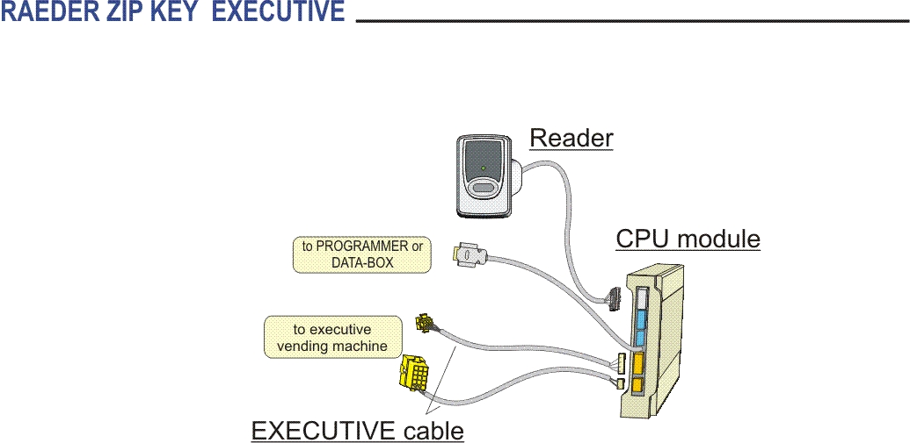

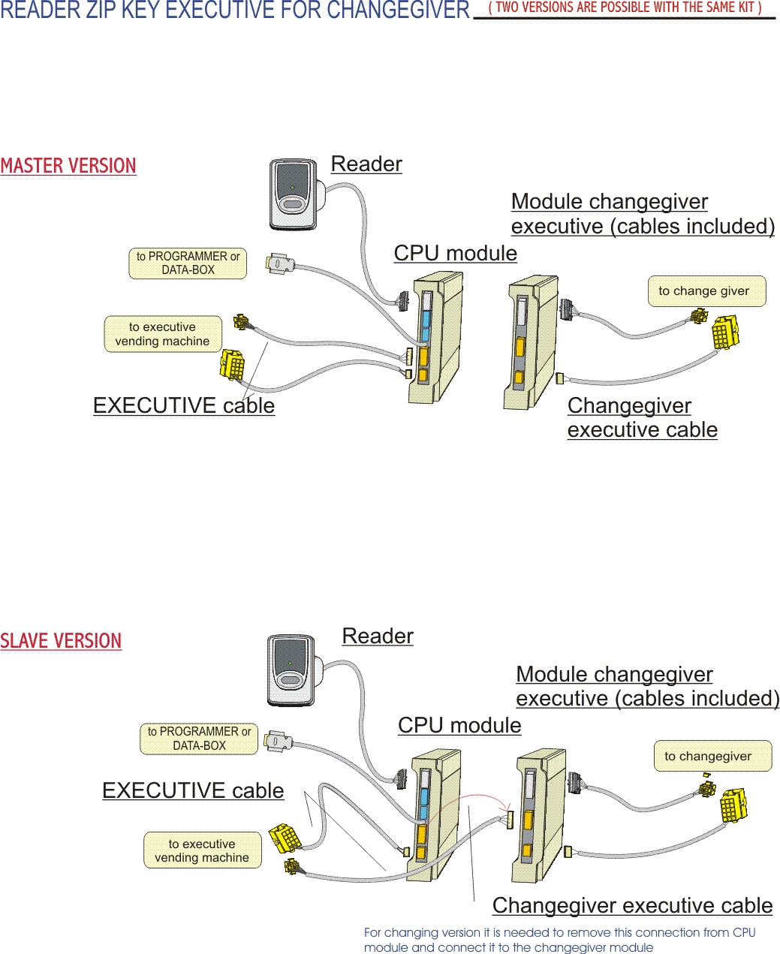

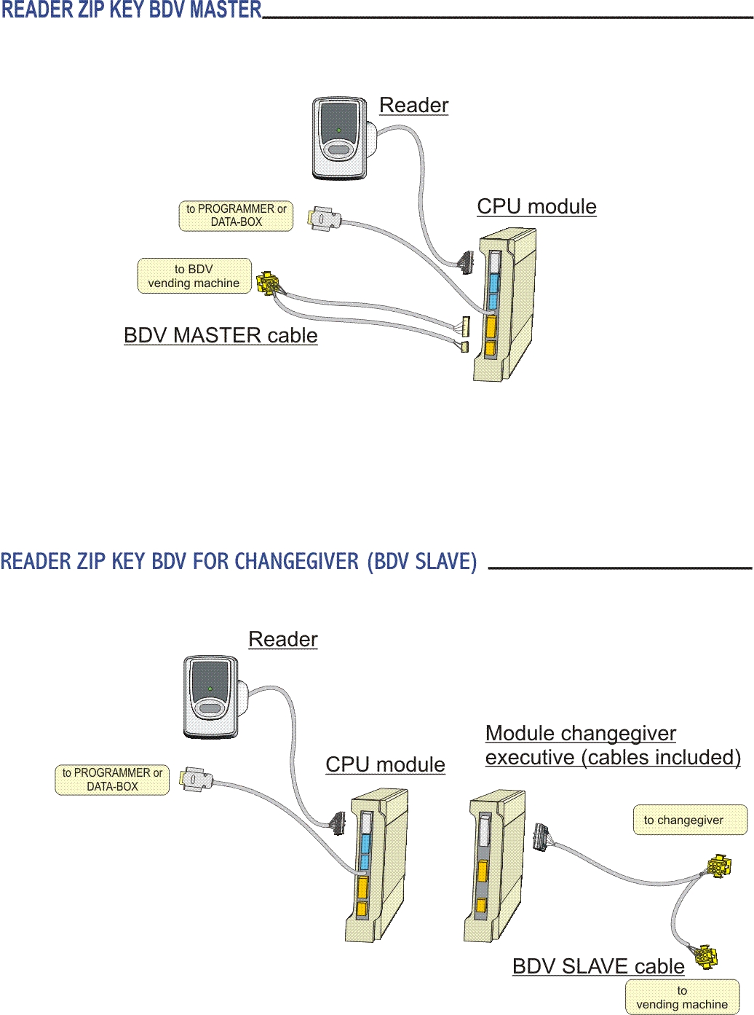

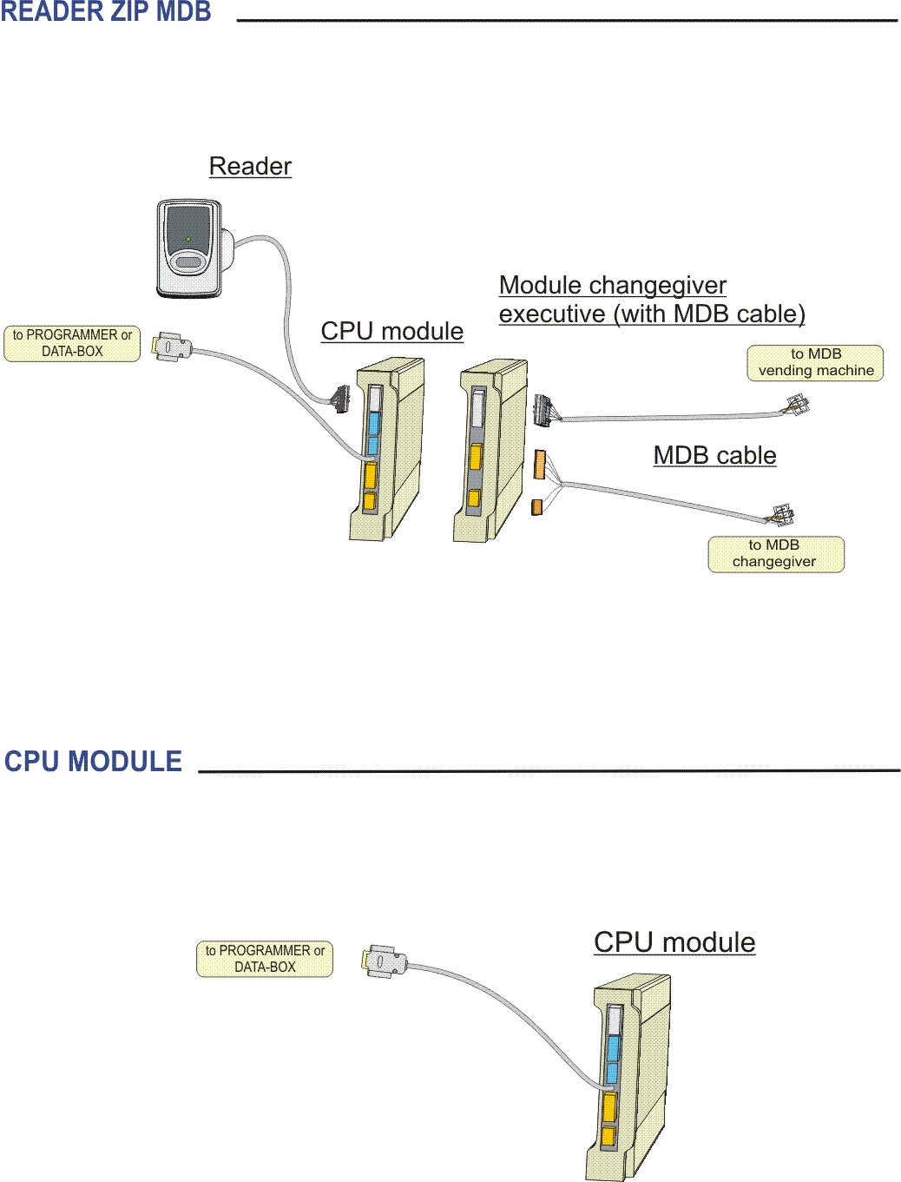

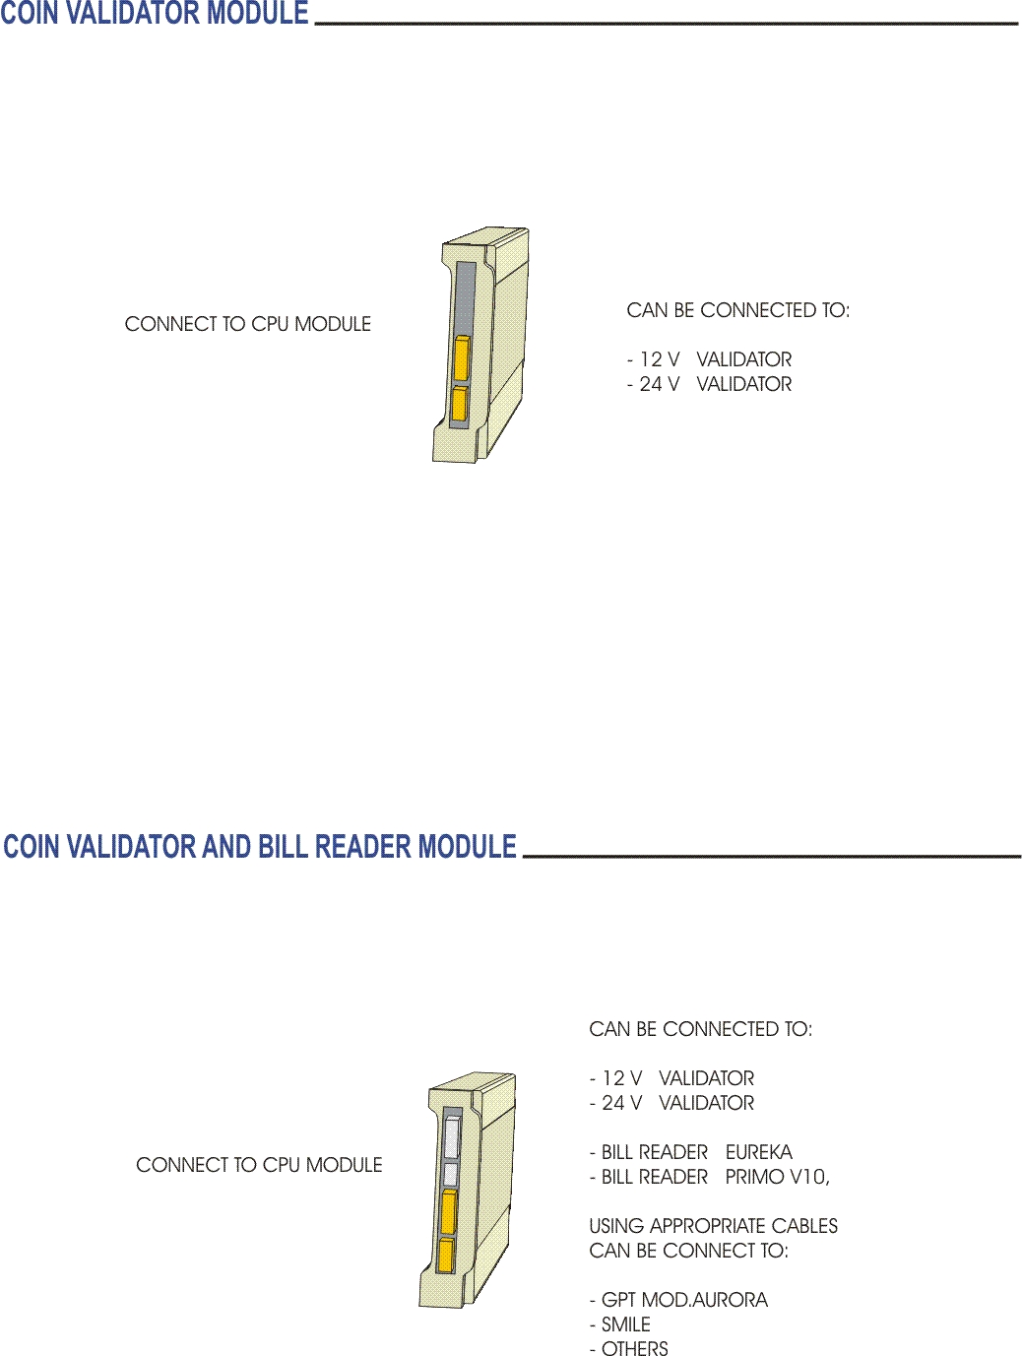

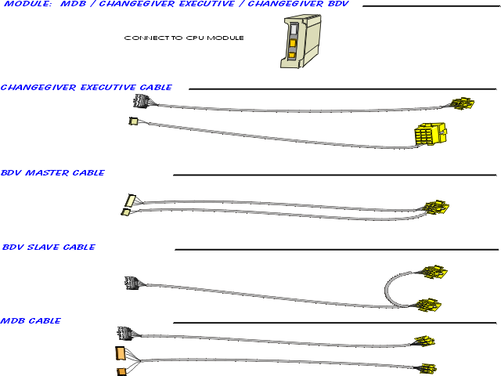

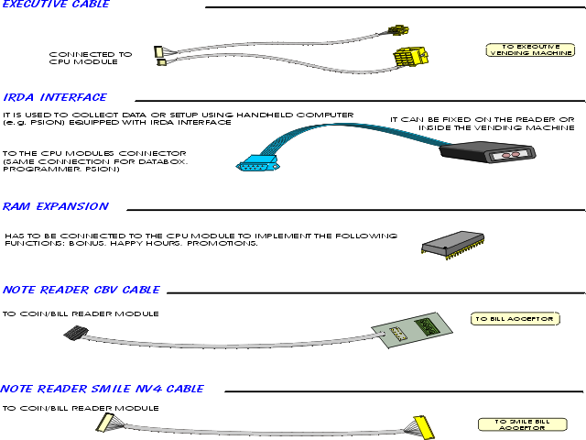

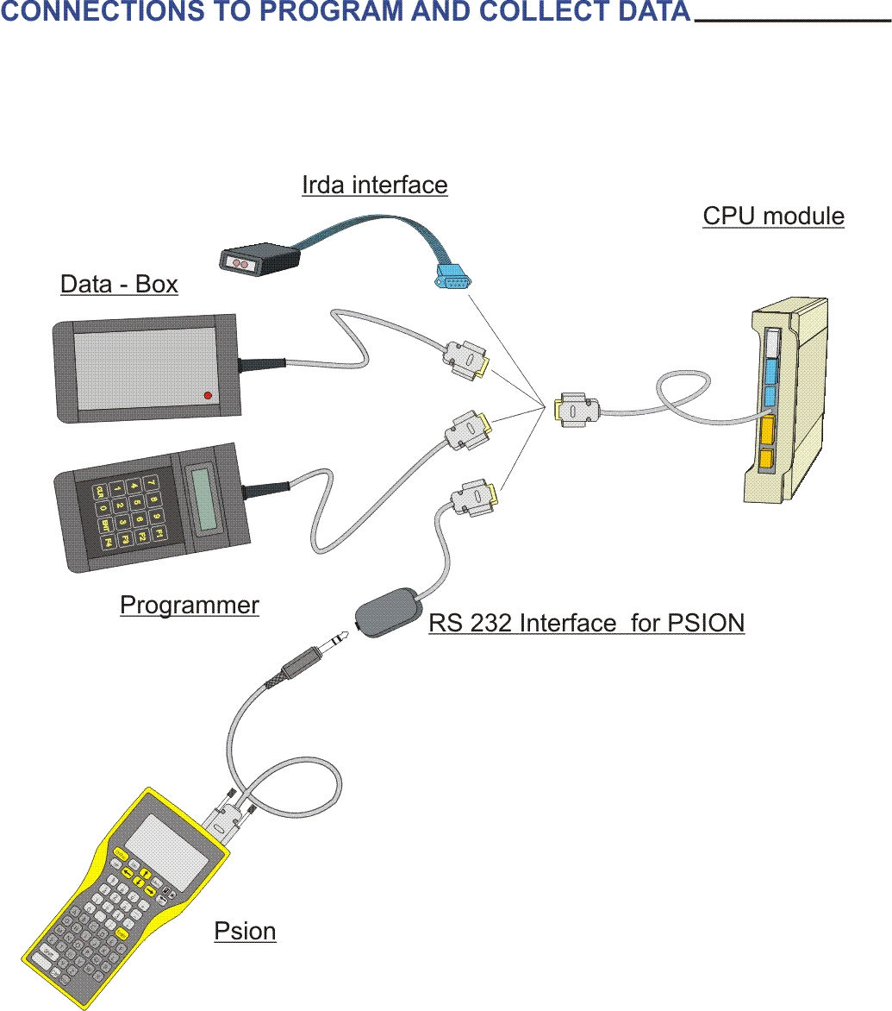

16 LIST OF STATISTICS – DATA BOX
Statistics | Description
Main Statistics
S1 | Cash box coins
S2 | Cash box banknotes
S3 | Cash sales
S4 | Failed sales with cash
S5 | Overpay
S6 | Key sales
S7 | Failed sales with key
S8 | Free key sales
S9 | Total discounts
S10 | Credit loaded in the keys with programmer and charge key
Coin List: statistics
S11 | Number of coins A
S12 | Number of coins B
S13 | Number of coins C
S14 | Number of coins D
S15 | Number of coins E
S16 | Number of coins F
S17 | Number of coins G
S18 | Number of coins H
Bill List: statistics
S19 | Number of banknotes 1
S20 | Number of banknotes 2
S21 | Number of banknotes 3
S22 | Number of banknotes 4
S23 | Total BONUS
Detailed statistics cash sales
S24 | Cash sales with prices not included in the table
S25 | Selection 1: Number of sales with cash
S26 | Selection 2: Number of sales with cash
S27 | Selection 3: Number of sales with cash
S28 | Selection 4: Number of sales with cash
S29 | Selection 5: Number of sales with cash
S30 | Selection 6: Number of sales with cash
S31 | Selection 7: Number of sales with cash
S32 | Selection 8: Number of sales with cash
S33 | Selection 9: Number of sales with cash
S34 | Selection 10: Number of sales with cash
Detailed statistics key sales
S35 | Key sales with prices not included in the table
S36 | Selection 1: Number of sales with key
S37 | Selection 2: Number of sales with key
S38 | Selection 3: Number of sales with key
S39 | Selection 4: Number of sales with key
S40 | Selection 5: Number of sales with key
S41 | Selection 6: Number of sales with key
S42 | Selection 7: Number of sales with key
S43 | Selection 8: Number of sales with key
S44 | Selection 9: Number of sales with key
S45 | Selection 10: Number of sales with key
Diagnostic statistics
S46 | SF (last occurred event)
S47 | E0 (collection number)
S48 | E1 (number of insertion of a key with incorrect credit area)
S49 | E2 (number of insertion of a key with invalid codes)
S50 | E3
S51 | E4
S52 | E5
S53 | E6 (number of insertion of a key with invalid function code)
S54 | E7 (number of insertion of the key with credit > abs max credit)
S55 | E8 (number of sales not succesfully completed)
S56 | E9 (number of key writing errors)
S57 | E10 (number of errors in the connection with Data Box and with Data Key)
S58 | E11 (failed charges with Charge Key)
S59 | E12 (number of writings in the key not checked)
S60 | E13 (number of insertions of a key included in the Black List - when Black List is enabled)
S61 | E14 (number of resets of the credit area of the key)
S62 | E15 (number of sales during test)
S63 | SA (number of key writings)
S64 | SB (number of key readings)
S65 | SC (number of short power supply failures)
S66 | SD (number of long power supply failures)
S67 | SE (system programming status)
Black List
 | STATISTICS = ON | STATISTICS = OFF
 | Key 1: key number | Coin I
 | Key 2: key number | National coin 1
 | Key 3: key number | National coin 2
 | Key 4: key number | National coin 3
 | Key 5: key number | National coin 4
 | Key 6: key number | National coin 5
 | Key 7: key number | National coin 6
 | Key 8: key number | Cumulative cash box
 | Key 9: key number | Cumulative cash sales
 | Key 10: key number | Cumulative key sales

! WARNING

Statistics and reference number (e.g. statistic S26) can be read also with the Programmer inside the STATISTICS menu.

17 LIST OF STATISTICS - EVA-DTS
Statistics | Description
BASIC EVA-DTS STATISTICS (A)
General data
 | Machine code
 | Reader code
 | Reader software version
 | Coin mechanism code
 | Collection date
 | Collection time
 | Previous collection date
 | Previous collection time
Main Statistics
S1 | Cash box coins
S2 | Cash box banknotes
S3 | Cash sales
S4 | Failed sales with cash
S5 | Overpay
S6 | Key sales
S7 | Failed sales with key
S8 | Free key sales
S9 | Total discounts
S10 | Credit loaded in the keys with programmer and charge key
Diagnostic statistics
S46 | SF (last occurred event)
S47 | E0 (collection number)
S48 | E1 (number of insertion of a key with incorrect credit area)
S49 | E2 (number of insertion of a key with invalid codes)
S50 | E3
S51 | E4
S52 | E5
S53 | E6 (number of insertion of a key with invalid function code)
S54 | E7 (number of insertion of the key with credit > abs max credit)
S55 | E8 (number of sales not succesfully completed)
S56 | E9 (number of key writing errors)
S57 | E10 (number of errors in the connection with Data Box or with Data Key)
S58 | E11 (failed charges with Charge Key)
S59 | E12 (number of writings in the key not checked)
S60 | E13 (number of insertions of a key included in the Black List - when Black List is enabled)
S61 | E14 (number of resets of the credit area of the key)
S62 | E15 (number of sales during test)
S63 | SA (number of key writings)
S64 | SB (number of key readings)
S65 | SC (number of short power supply failures)
S66 | SD (number of long power supply failures)
S67 | SE (system programming status)
 | Cumulative cash box
 | Cumulative cash sales
 | Cumulative key sales
 | TOTAL BONUS 1
 | TOTAL BONUS 2
 | TOTAL REWARDS
 | TOTAL DISCOUNTS FOR PROMOTIONS
LIMITED EVA-DTS STATISTICS (B)

! WARNING

The extended EVA-DTS statistics are available only with the RAM extansion.

Coin List: statistics
S11 | Number of coins A
S12 | Number of coins B
S13 | Number of coins C
S14 | Number of coins D
S15 | Number of coins E
S16 | Number of coins F
S17 | Number of coins G
S18 | Number of coins H
Bill List: statistics
S19 | Number of banknotes 1
S20 | Number of banknotes 2
S21 | Number of banknotes 3
S22 | Number of banknotes 4
Detailed statistics for cash sales (1<= Selection <= 10)
S25 | Selection 1: Number of sales with cash
S26 | Selection 2: Number of sales with cash
S27 | Selection 3: Number of sales with cash
S28 | Selection 4: Number of sales with cash
S29 | Selection 5: Number of sales with cash
S30 | Selection 6: Number of sales with cash
S31 | Selection 7: Number of sales with cash
S32 | Selection 8: Number of sales with cash
S33 | Selection 9: Number of sales with cash
S34 | Selection 10: Number of sales with cash
Detailed statistics for key sales (1<= Selection <= 10)
S36 | Selection 1: Number of sales with key
S37 | Selection 2: Number of sales with key
S38 | Selection 3: Number of sales with key
S39 | Selection 4: Number of sales with key
S40 | Selection 5: Number of sales with key
S41 | Selection 6: Number of sales with key
S42 | Selection 7: Number of sales with key
S43 | Selection 8: Number of sales with key
S44 | Selection 9: Number of sales with key
S45 | Selection 10: Number of sales with key
Black List
 | Key 1: key number
 | Key 2: key number
 | Key 3: key number
 | Key 4: key number
 | Key 5: key number
 | Key 6: key number
 | Key 7: key number
 | Key 8: key number
 | Key 9: key number
 | Key 10: key number
EXTENDED EVA-DTS STATISTICS (C)

! WARNING

The EXTENDED EVA-DTS statistics include the LIMITED statistics but also the following data
Detailed statistics of cash sales (11<= Selection <= 60)
 | Selection 11: Number of sales with cash
 | Selection 12: Number of sales with cash
 | ………..
 | Selection 60: Number of sales with cash
Detailed statistics of key sales (11<= Selection <= 60)
 | Selection 11: Number of sales with key
 | Selection 12: Number of sales with key
 | ………..
 | Selection 60: Number of sales with key
Detailed statistics of key sales - discount level 1 (1<= Selection <= 60)
 | Selection 1: Number of sales with key - discount level 1
 | Selection 2: Number of sales with key - discount level 1
 | ………..
 | Selection 60: Number of sales with key - discount level 1
Detailed statistics of key sales with discount level 2 (1<= Selection <= 60)
 | Selection 1: Number of sales with key - discount level 2
 | Selection 2: Number of sales with key - discount level 2
 | ………..
 | Selection 60: Number of sales with key - discount level 2
Detailed statistics of key sales with discount level 3 (1<= Selection <= 60)
 | Selection 1: Number of sales with key - discount level 3
 | Selection 2: Number of sales with key - discount level 3
 | ………..
 | Selection 60: Number of sales with key - discount level 3
Black List (11 <= Key <= 500)
 | Key 11: key number
 | Key 12: key number
 | ………..
 | Key 500: key number
Sale statistics with BONUS 1 tokens (1<= Selection <= 60)
 | Selection 1: Value of BONUS 1
 | Selection 2: Value of BONUS 1
 | ………….
 | Selection 60: Value of BONUS 1
Sale statistics with BONUS 2 tokens (1<= Selection <= 60)
 | Selection 1: Value of BONUS 2
 | Selection 2: Value of BONUS 2
 | ………….
 | Selection 60: Value of BONUS 2
Sale statistics with REWARDS points (1<= Selection <= 60)
 | Selection 1: Value of sales for REWARDS
 | Selection 2: Value of sales for REWARDS
 | ………….
 | Selection 60: Value of sales for REWARDS
Sale statistics with discount for PROMOTION (1<= Selection <= 60)
 | Selection 1: Value of sales for PROMOTION
 | Selection 2: Value of sales for PROMOTION
 | ………….
 | Selection 60: Value of sales for PROMOTION

