LAYOUT L02/L06.
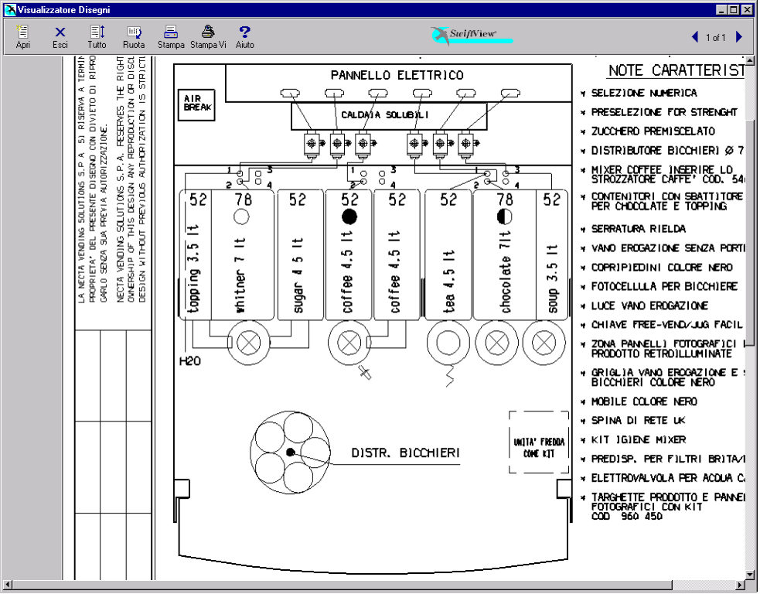

PRODUCT TABLE.

POSIT. | PRODUCT | N° DOSING | SETT. DOS.  (gram./sec.) | N° ELECTRO. | SETT. EV  (cc/sec.)
1 | Topping | 1 | 1,5 | 2 | 9
2 | Milk / Whitner | 2 | 1,5 | 2 | 9
3 | Sugar | 3 | 2,3 | 2 | 9
4 | Coffee Instant Dec | 4 | 0,6 | 3 | 10
5 | Coffee Instant | 5 | 0,6 | 3 | 10
6 | Tea | 6 | 2,5 | 4 | 15
7 | Chocolate | 7 | 3,0 | 5 | 9
8 | Soup | 8 | 2,5 | 6 | 15
/ | Hot Water | / | / | 1 | 16
/ | Carbonated Water | / | / | 7 | 17
/ | Still Water | / | / | 8 | 16
KEYBOARD SELECTION L02.

Strength - | ¤ | Strength + | ¤

SELECTION | SUGAR  N. | EX. SUGAR  N. | NO SUGAR  N.
Coffee Instant Black | 17 | 18 | 19
Coffee Instant White | 21 | 22 | 23
Coffee Instant Ex. White | 24 | 25 | 26
Chocolate | -- | -- | 27
Soup | -- | -- | 28
Hot Water | -- | -- | 29
Coffee Instant Black Decaffeinated | 37 | 38 | 39
Coffee Instant White Decaffeinated | 41 | 42 | 43
Coffee Inst. Ex. White Decaffeinated | 44 | 45 | 46
Tea Instant White | 51 | 52 | 53
Tea Instant Extra White | 54 | 55 | 56
Tea Instant Black | 57 | 58 | 59
Cappuccino Instant | 61 | -- | 62
Espresso Instant | 63 | -- | 64
EspressoChoc Instant | 65 | -- | 66
ChocoMilk | -- | -- | 67
Instant Cappuccino Decaffeinated | 75 | -- | 76
Instant EspressoChoc Decaffeinated | 77 | -- | 78
 | STILL |  | CARBONATED
Chilled Water | 81 |  | 84
Orange ( Syrop 1 ) | 82 |  | 85
Lemon (Syrop 2 ) | 83 |  | 86

PRESELECTION L02.

PRESELECTION  (N.) | DOSE VARIAT. | DESCRIPTION
Strength - | -10 % | Reduces the powder of Coffee/Tea (3 step).
Strength + | +10 % | Increase the powder of Coffee/Tea (3 step).
Extra Sugar | + 66% | Increase the dose of sugar to 66%
No Sugar | - 100% | Reset the dose of sugar of the selection
SELECTION L02.

SELECTION  (N.) | WATER DOSES | SUGAR  (to door) | POWDER DOSES
Coffee Black  ( 17 – 18 – 19 ) | Coffee Instant  40 cc |  | Coffee  1,4 gr.
 | Sugar  50 cc (tot. 90 cc) |  | Sugar  5,3 gr.
Coffee White  ( 21 – 22 – 23 ) | Coffee Instant  40 cc |  | Coffee  1,4 gr.
 | Milk  60 cc |  | Milk  1,8 gr. | Sugar  5,3 gr.
Hot Water
50 cc (tot. 150 cc)
Coffe Extra White  ( 24 – 25 – 26 ) | Coffee Instant  40 cc |  | Coffee  1,4 gr.
 | Milk  60 cc |  | Milk  3,0 gr. | Sugar  5,3 gr.
Hot Water
50 cc (tot. 150 cc)
Chocolate  ( 27 ) | Chocolate  80 cc |  | Chocolate  19,0 gr.
Hot Water
60 cc (tot. 140 cc)
Soup  ( 28 ) | Soup  150 cc |  | Soup  8,0 gr.
Hot Water  ( 29 ) | Hot Water  150 cc
Coffee Black Dec.  ( 37 – 38 – 39 ) | Coffee Instant Dec.  40 cc |  | Coffee  1,4 gr.
 | Sugar  50 cc (tot. 90 cc) |  | Sugar  5,3 gr.
Coffee White Dec  ( 41 – 42 – 43 ) | Coffee Instant Dec.  40 cc |  | Coffee  1,4 gr.
 | Milk  60 cc |  | Milk  1,8 gr. | Sugar  5,3 gr.
Hot Water
50 cc (tot. 150 cc)
SELECTION  (N.) | WATER DOSES | SUGAR  (to door) | POWDER DOSES
Dec. Extra White  ( 44 – 45 – 46 ) | Coffee Instant Dec.  40 cc |  | Coffee  1,4 gr.
 | Milk  60 cc |  | Milk  3,0 gr. | Sugar  5,3 gr.
Hot Water
50 cc (tot. 150 cc)
Tea Instant White  ( 51 – 52 – 53 ) | Tea  50 cc |  | Tea  0,9 gr.
 | Milk  60 cc |  | Milk  0,7 gr. | Sugar  5,3 gr.
Hot Water
50 cc (tot. 160 cc)
Tea Inst.Ex.White  ( 54 – 55 – 56 ) | Tea  50 cc |  | Tea  0,9 gr.
 | Milk  60 cc |  | Milk  1,1 gr. | Sugar  5,3 gr.
Hot Water
50 cc (tot. 160 cc)
Tea Instant Black  ( 57 – 58 – 59 ) | Tea  50 cc |  | Tea  0,9 gr.
 | Sugar  60 cc |  | Sugar  5,3 gr.
Hot Water
50 cc (tot. 160 cc)
Inst. Cappuccino  ( 61 – 62 ) | Coffee Instant  40 cc |  | Coffee  1,6 gr.
 | Topping  60 cc |  | Topping  8,0 gr. | Sugar  5,3 gr.
 | Chocolate  40 cc (tot. 140 cc) |  | Chocolate  9,6 gr.
Espresso  ( 63 – 64 ) | Coffee Instant  35 cc |  | Coffee  1,4 gr.
 | Sugar  30 cc (tot. 65 cc) |  | Sugar  5,3 gr.

SELECTION  (N.) | WATER DOSES | SUGAR  (to door) | POWDER DOSES
Ins.EspressoChoc  ( 65 – 66 ) | Milk  35 cc |  | Milk  1,8 gr. | Sugar  5,3 gr.
 | Coffee Instant  40 cc |  | Coffee  1,4 gr.
 | Chocolate  50 cc (tot. 125 cc) |  | Chocolate  13 gr.
Chocomilk  ( 67 ) | Chocolate  80 cc |  | Chocolate  16,0 gr.
 | Milk  60 cc (tot. 140 cc) |  | Milk  1,4 gr.
Dec. Cappuccino  ( 75 – 76 ) | Coffee Instant Dec.  40 cc |  | Coffee  1,6 gr.
 | Topping  60 cc |  | Topping  8,0 gr. | Sugar  5,3 gr.
 | Chocolate  40 cc (tot. 140 cc) |  | Chocolate  9,6 gr.
Dec. Espr. Choc  ( 77 – 78 ) | Milk  35 cc |  | Milk  1,8 gr. | Sugar  5,3 gr.
 | Coffee Instant Dec.  40 cc |  | Coffee  1,4 gr.
 | Chocolate  50 cc (tot. 125 cc) |  | Chocolate  13 gr.
Chilled Water  ( 81 ) | Still  160 cc
Chilled Water  ( 84 ) | Carbonated  140 cc
Still
20 cc (tot. 160)
Orange  ( 82 ) | Still  150 cc |  | Syrop 1  32 ds
Orange  ( 85 ) | Still  35 cc |  | Syrop 1  0 ds
 | Carbonated  95 cc |  | Syrop 1  32 ds
Still
20 cc (tot. 150)

SELECTION  (N.) | WATER DOSES | SUGAR  (to door) | POWDER DOSES
Lemon  ( 83 ) | Still  150 cc |  | Syrop 2  32 ds
Lemon  ( 86 ) | Still  35 cc |  | Syrop 2  0 ds
 | Carbonated  95 cc |  | Syrop 2  32 ds
Still
20 cc (tot. 150)

LAYOUT L06.

ATT. The layout 6 comes gotten from the layout 2 with the only modification of replace the pipette numbers 3 for throw the sugar in the mixer of the coffee instead that in the mixer of the whitner.

PRODUCT TABLE.

POSIT. | PRODUCT | N° DOSING | SETT. DOS.  (gram./sec.) | N° ELECTRO. | SETT. EV  (cc/sec.)
1 | Topping | 1 | 1,5 | 2 | 9
2 | Milk / Whitner | 2 | 1,5 | 2 | 9
3 | Sugar | 3 | 2,3 | 3 | 10
4 | Coffee Instant Dec | 4 | 0,6 | 3 | 10
5 | Coffee Instant | 5 | 0,6 | 3 | 10
6 | Tea | 6 | 2,5 | 4 | 15
7 | Chocolate | 7 | 3,0 | 5 | 9
8 | Soup | 8 | 2,5 | 6 | 15
/ | Hot Water | / | / | 1 | 16
/ | Carbonated Water | / | / | 7 | 17
/ | Still Water | / | / | 8 | 16
KEYBOARD SELECTION L06.

Strength - | ¤ | Strength + | ¤

SELECTION | SUGAR  N. | EX. SUGAR  N. | NO SUGAR  N.
Coffee Instant Black | 17 | 18 | 19
Coffee Instant White | 21 | 22 | 23
Coffee Instant Ex. White | 24 | 25 | 26
Chocolate | -- | -- | 27
Soup | -- | -- | 28
Hot Water | -- | -- | 29
Coffee Instant Black Decaffeinated | 37 | 38 | 39
Coffee Instant White Decaffeinated | 41 | 42 | 43
Coffee Inst. Ex. White Decaffeinated | 44 | 45 | 46
Tea Instant White | 51 | 52 | 53
Tea Instant Extra White | 54 | 55 | 56
Tea Instant Black | 57 | 58 | 59
Cappuccino Instant | 61 | -- | 62
Espresso Instant | 63 | -- | 64
EspressoChoc Instant | 65 | -- | 66
ChocoMilk | -- | -- | 67
Instant Cappuccino Decaffeinated | 75 | -- | 76
Instant EspressoChoc Decaffeinated | 77 | -- | 78
 | STILL |  | CARBONATED
Chilled Water | 81 |  | 84
Orange ( Syrop 1 ) | 82 |  | 85
Lemon (Syrop 2 ) | 83 |  | 86

PRESELECTION L06.

PRESELECTION  (N.) | DOSE VARIAT. | DESCRIPTION
Strength - | -10 % | Reduces the powder of Coffee/Tea (3 step).
Strength + | +10 % | Increase the powder of Coffee/Tea (3 step).
Extra Sugar | + 66% | Increase the dose of sugar to 66%
No Sugar | - 100% | Reset the dose of sugar of the selection
SELECTION L06.

SELECTION  (N.) | WATER DOSES | SUGAR  (to door) | POWDER DOSES
Coffee Black  ( 17 – 18 – 19 ) | Coffee Instant  40 cc |  | Coffee  1,4 gr. | Sugar  5,3 gr.
Hot Water
50 cc (tot. 90 cc)
Coffee White  ( 21 – 22 – 23 ) | Coffee Instant  40 cc |  | Coffee  1,4 gr. | Sugar  5,3 gr.
 | Milk  60 cc |  | Milk  1,8 gr.
Hot Water
50 cc (tot. 150 cc)
Coffe Extra White  ( 24 – 25 – 26 ) | Coffee Instant  40 cc |  | Coffee  1,4 gr. | Sugar  5,3 gr.
 | Milk  60 cc |  | Milk  3,0 gr.
Hot Water
50 cc (tot. 150 cc)
Chocolate  ( 27 ) | Chocolate  80 cc |  | Chocolate  19,0 gr.
Hot Water
60 cc (tot. 140 cc)
Soup  ( 28 ) | Soup  150 cc |  | Soup  8,0 gr.
Hot Water  ( 29 ) | Hot Water  150 cc
Coffee Black Dec.  ( 37 – 38 – 39 ) | Coffee Instant Dec.  40 cc |  | Coffee  1,4 gr. | Sugar  5,3 gr.
Hot Water
50 cc (tot. 90 cc)
Coffee White Dec  ( 41 – 42 – 43 ) | Coffee Instant Dec.  40 cc |  | Coffee  1,4 gr. | Sugar  5,3 gr.
 | Milk  60 cc |  | Milk  1,8 gr.
Hot Water
50 cc (tot. 150 cc)
SELECTION  (N.) | WATER DOSES | SUGAR  (to door) | POWDER DOSES
Dec. Extra White  ( 44 – 45 – 46 ) | Coffee Instant Dec.  40 cc |  | Coffee  1,4 gr. | Sugar  5,3 gr.
 | Milk  60 cc |  | Milk  3,0 gr.
Hot Water
50 cc (tot. 150 cc)
Tea Instant White  ( 51 – 52 – 53 ) | Tea  50 cc |  | Tea  0,9 gr.
 | Milk  60 cc |  | Milk  0,7 gr.
 | Sugar  50 cc (tot. 160 cc) |  | Sugar  5,3 gr.
Tea Inst.Ex.White  ( 54 – 55 – 56 ) | Tea  50 cc |  | Tea  0,9 gr.
 | Milk  60 cc |  | Milk  1,1 gr.
 | Sugar  50 cc (tot. 160 cc) |  | Sugar  5,3 gr.
Tea Instant Black  ( 57 – 58 – 59 ) | Tea  50 cc |  | Tea  0,9 gr.
 | Sugar  60 cc |  | Sugar  5,3 gr.
Hot Water
50 cc (tot. 160 cc)
Inst. Cappuccino  ( 61 – 62 ) | Coffee Instant  40 cc |  | Coffee  1,6 gr. | Sugar  5,3 gr.
 | Topping  60 cc |  | Topping  8,0 gr.
 | Chocolate  40 cc (tot. 140 cc) |  | Chocolate  9,6 gr.
Espresso  ( 63 – 64 ) | Coffee Instant  65 cc |  | Coffee  1,4 gr. | Sugar  5,3 gr.

SELECTION  (N.) | WATER DOSES | SUGAR  (to door) | POWDER DOSES
Ins.EspressoChoc  ( 65 – 66 ) | Milk  35 cc |  | Milk  1,8 gr.
 | Coffee Instant  40 cc |  | Coffee  1,4 gr. | Sugar  5,3 gr.
 | Chocolate  50 cc (tot. 125 cc) |  | Chocolate  13 gr.
Chocomilk  ( 67 ) | Chocolate  80 cc |  | Chocolate  16,0 gr.
 | Milk  60 cc (tot. 140 cc) |  | Milk  1,4 gr.
Dec. Cappuccino  ( 75 – 76 ) | Coffee Instant Dec.  40 cc |  | Coffee  1,6 gr. | Sugar  5,3 gr.
 | Topping  60 cc |  | Topping  8,0 gr.
 | Chocolate  40 cc (tot. 140 cc) |  | Chocolate  9,6 gr.
Dec. Espr. Choc  ( 77 – 78 ) | Milk  35 cc |  | Milk  1,8 gr.
 | Coffee Instant Dec.  40 cc |  | Coffee  1,4 gr. | Sugar  5,3 gr.
 | Chocolate  50 cc (tot. 125 cc) |  | Chocolate  13 gr.
Chilled Water  ( 81 ) | Still  160 cc
Chilled Water  ( 84 ) | Carbonated  140 cc
Still
20 cc (tot. 160)
Orange  ( 82 ) | Still  150 cc |  | Syrop 1  32 ds
Orange  ( 85 ) | Still  35 cc |  | Syrop 1  0 ds
 | Carbonated  95 cc |  | Syrop 1  32 ds
Still
20 cc (tot. 150)

SELECTION  (N.) | WATER DOSES | SUGAR  (to door) | POWDER DOSES
Lemon  ( 83 ) | Still  150 cc |  | Syrop 2  32 ds
Lemon  ( 86 ) | Still  35 cc |  | Syrop 2  0 ds
 | Carbonated  95 cc |  | Syrop 2  32 ds
Still
20 cc (tot. 150)

INFORMAZIONI GENERALI.

TABELLA PESI VALIDATORE:
Linea | A | B | C | D | E | F
Peso | 1 | 2 | 10 | 20 | 50 | 5

PREZZO SELEZIONI: Tutte le selezioni a 10.00.
NPREZZO SELEZIONI: Tutte le selezioni puntano al prezzo 1.

POSIZIONE PUNTO DECIMALE: 2.
TEMPERATURA CALDAIA EXP: ---- °C.
TEMPERATURA CALDAIA SOLUBILI: 86.0 °C.

RITARDI ACQUE / POLVERI: Ritardo polvere rispetto all’acqua 0.6 sec.

TIPO DI TASTIERA: Tastiera numerica.

LINGUE: Italiano, Francaise, Espanol, English, Deutsch, Danska, Norge, Svenska, Ungaria, Nederlands e Czech

GENERAL INFORMATION.

PAYMENT SYSTEMS DETAILS:
Line | A | B | C | D | E | F
Weight | 1 | 2 | 10 | 20 | 50 | 5

SELECTION PRICE: All the selections to 10.00.
SELECTION NPRICE: All selections are set price line 1.

DECIMAL POINT POSITION: 2.
TEMPERATURE BOILER EXP: ---- °C.
TEMPERATURE BOILER INSTANT: 86.0 °C.

WATER/POWDER DELAYS: Powder delays to water 0.6 sec.

TYPE OF KEYBOARD: Numerical keyboard.

LANGUAGE: Italiano, Francaise, Espanol, English, Deutsch, Danska, Norge, Svenska, Ungaria, Nederlands e Czech

MODIFICHE.

SW CPU / SCHEDA ATTUAZIONI REV. 0.5:
Implementazione gestioni sportelli e taniche per autoalimentazione.
Aggiornamento dosi.
SW CPU / SCHEDA ATTUAZIONI REV. 0.7:
Pulsante lavaggi in programmazione come nella rev. 0.5.
Gestione funzionamento ventola sulla mensola del FB montata in posizione centrale.
SW CPU / SCHEDA ATTUAZIONI REV. 0.8 UK:
Modifica codice F960400 in F960402 con unità fredda.
Aggiunta dei menù d’impostazione dell’ID per l’unità fredda (Tecn. 5.3) e del tempo di movimentazione ugelli per le bevande fredde e selezione acqua calda (Tecn. 5.4).
Modifiche per l’Operator friendly (pulsanti aggiunti, gestione lavaggi ed acqua calda).
Inserimento delle lingue danese, svedese e norvegese
SW CPU / SCHEDA ATTUAZIONI REV. 0.9:
Eliminati i layout L03-L04-L05.
Sistemazione alcune stringhe in programmazione.
Modifica ciclo di erogazione delle bevande carbonate con una coda di acqua fredda.
Aggiunta menù di abilitazione delle aggiunte di acqua calda (Tecn. 5.5).
Implementazione MDB, EVADTS, GSM e SETUP AUTOMATICO (Fill>6.x / Fill>7.x /
Tecn>5.6 / Tecn>6.x).
SW CPU / SCHEDA ATTUAZIONI REV. 1.0:
Tempi di sgocciolamento programmabili.
Menu mdb per impostazione banconote accettate sotto il livello.
SW CPU / SCHEDA ATTUAZIONI REV. 1.1:
Modifica alla struttura del database (l’upgrade necessita l’inizializzazione del d.a.).
SW CPU / SCHEDA ATTUAZIONI REV. 1.1 UK:
Introdotta una modifica della gestione del guasto air-break.
Aggiornamento stringhe in inglese.
Modifica del valore minimo del tempo di uscita ugelli per freddo e caldo (80).
Modifica delle attuazioni generate dal pulsante utility “SPOUTS” (uscita e rientro degli ugelli senza arresto)

CHANGES.

SW CPU - I/O BOARD REV. 0.5:
Implementation of slider and tank management.
Doses update
SW CPU - I/O BOARD REV. 0.7:
Cleaning utility in programmation menu as in rev. 0.5
Management of fan operation mounted in central position of FB shelf.
SW CPU - I/O BOARD REV. 0.8 UK:
Change of F96301 code to F96307 with cold unit.
Addition of Cold ID unit setting menu (Tech. 5.3) and spouts movements time for cold drink and hot water (Tech 5.4).
Changes for Operator Friendly (addes button, cleaning management and hot water)
Insertion of Danska, Norge and Svenska languages.
SW CPU - I/O BOARD REV. 0.9:
L03-L04-L05 layuots deleted.
Modification of some programmation message display.
Addition of cold water queue to carbonated drink dispensing.
Insertion of enabling menu for hot water addition. (Tech. 5.5).

Implementation of MDB, EVADTS, GSM and AUTOMATIC SETUP (Fill>6.x / Fill>7.x /
Tecn>5.6 / Tecn>6.x).
SW CPU - I/O BOARD REV. 1.0:
Programmable dripping times.
MDB menu for accepted below level bill setting.
SW CPU - I/O BOARD REV. 1.1:
Modification of database structure (upgrade needs the d.a. initialisation)
SW CPU - I/O BOARD REV. 1.1 UK:
Introduction of air-break failure management modification.
Updating of english display messages.
Modification of minimal value for hot and cold spouts movement times (80).
Modification of movements caused by SPOUTS utility button (spouts outgoing and incoming without stop)

