LAYOUT L15.
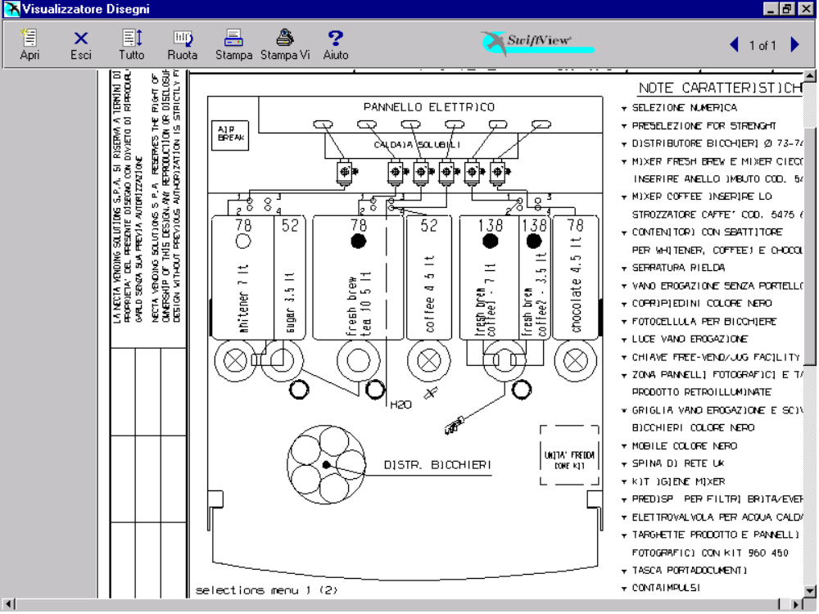

TABELLA PRODOTTI.

POSIZ. | PRODOTTO | N° DOSAT. | TARAT. DOS.  (grammi/sec.) | N° ELETTR. | TAR. EV  (cc/sec.)
1 | Whitener / Milk | 1 | 1,5 | 1 | 9
2 | Sugar | 2 | 2,3 | 1 | 9
3 | Fresh Brew 1 | 3 | 1,7 | 2 | 16
4 | Fresh Brew 1
5 | Coffee Ins. / Soup * | 4 | 0,6 / 2,5 * | 4 | 10 / 15 *
6 | Fresh Brew 2 | 6 | 1,7 | 5 | 14
7 | Fresh Brew 2 (C2) | 8 | 1,7 | 5 | 14
8 | Chocolate | 7 | 3,0 | 6 | 9
/ | Hot Water | / | / | 3 | 20
/ | Carbonated Water | / | / | 7 | 17
/ | Still Water | / | / | 8 | 16
DISPOSIZIONE TASTIERA L15.

Strength - | ¤ | Strength + | ¤

SELEZIONE | SUGAR  N. | EX. SUGAR  N. | NO SUGAR  N.
Coffee Fresh Brew Black | 17 | 18 | 19
Coffee Fresh Brew White | 21 | 22 | 23
Coffee Fresh Brew Ex. White | 24 | 25 | 26
Chocolate | -- | -- | 27
Soup * | -- | -- | 28 *
Hot Water | -- | -- | 29
Coffee2 Fresh Brew White | 31 | 32 | 33
Coffee2 Fresh Brew Ex. White | 34 | 35 | 36
Coffee Instant Black | 37 | 38 | 39
Coffee Instant White | 41 | 42 | 43
Coffee Instant Extra White | 44 | 45 | 46
Coffee2 Fresh Brew Black | 47 | 48 | 49
FB Tea White | 51 | 52 | 53
FB Tea Extra White | 54 | 55 | 56
Fresh Brew Tea Black | 57 | 58 | 59
Coffee Fresh Brew Cappuccino | 61 | -- | 62
Coffee Fresh Brew Espresso | 63 | -- | 64
Coffee Fresh Brew EspressoChoc | 65 | -- | 66
ChocoMilk | -- | -- | 67
Instant Cappuccino | 71 | -- | 72
Instant EspressoChoc | 73 | -- | 74
 | STILL |  | CARBONATED
Chilled Water | 81 |  | 84
Orange ( Syrop 1 ) | 82 |  | 85
Lemon (Syrop 2 ) | 83 |  | 86

* Quando si sostituisce il Coffee Instant con il Soup, e viceversa, e’ necessario disabilitare le selezioni della polvere da sostituire ed abilitare quelle della nuova, quindi modificare del valori di taratura del dosatore ed elettrov. corrispondente come indicato nella tabella prodotti.

PRESELEZIONI L15.

PRESELEZIONE  (N.) | VARIAZ. DOSE | DESCRIZIONE
Strength - | -10 % | Riduce la polvere di Coffee/Tea (3 step).
Strength + | +10 % | Aumenta la polvere di Coffee/Tea (3 step).
Extra Sugar | + 66% | Aumenta la dose di zucchero del 66%
No Sugar | - 100% | Azzera la dose di zucchero della selezione

SELEZIONI L15.

SELEZIONE  (N.) | DOSI ACQUA | ZUCCH.  (a porta) | DOSI POLVERI
Fresh Brew Black  ( 17 – 18 – 19 ) | Coffee FB  110 cc |  | Coff. FB  9,0 gr.
 | Sugar  60 cc (tot. 170 cc) |  | Sugar  5,3 gr.
Fresh Brew White  ( 21 – 22 – 23 ) | Coffee FB  110 cc |  | Coff. FB  9,0 gr.
 | Milk  60 cc (tot. 170 cc) |  | Milk  1,5 gr. | Sugar  5,3 gr.
Fr. Br. Ex.White  ( 24 – 25 – 26 ) | Coffee FB  110 cc |  | Coff. FB  9,0 gr.
 | Milk  60 cc (tot. 170 cc) |  | Milk  2,1 gr. | Sugar  5,3 gr.
Chocolate  ( 27 ) | Chocolate  80 cc |  | Chocolate  19,0 gr.
Hot Water
60 cc (tot. 140 cc)
Soup *  ( 28 ) | Soup  150 cc |  | Soup  8,0 gr.
Hot Water  ( 29 ) | Hot Water  150 cc
Fresh Brew White  ( 31 – 32 – 33 ) | Coffee2 FB  110 cc |  | Coff.2 FB  9,0 gr.
 | Milk  60 cc (tot. 170 cc) |  | Milk  1,5 gr. | Sugar  5,3 gr.
Fr. Br. Ex.White  ( 34 – 35 – 36 ) | Coffee2 FB  110 cc |  | Coff.2 FB  9,0 gr.
 | Milk  60 cc (tot. 170 cc) |  | Milk  2,1 gr. | Sugar  5,3 gr.
Coffee Black  ( 37 – 38 – 39 ) | Coffee Instant  40 cc |  | Coffee  1,4 gr.
 | Sugar  45 cc |  | Sugar  5,3 gr.
Hot Water
55 cc (tot. 140 cc)

SELEZIONE  (N.) | DOSI ACQUA | ZUCCH.  (a porta) | DOSI POLVERI
Coffee White  ( 41 – 42 – 43 ) | Coffee Instant  40 cc |  | Coffee  1,4 gr.
 | Milk  60 cc |  | Milk  1,8 gr. | Sugar  5,3 gr.
Hot Water
50 cc (tot. 150 cc)
Coffee Ex. White  ( 44 – 45 – 46 ) | Coffee Instant  40 cc |  | Coffee  1,4 gr.
 | Milk  60 cc |  | Milk  3,0 gr. | Sugar  5,3 gr.
Hot Water
50 cc (tot. 150 cc)
Fresh Brew Black  ( 47 – 48 – 49 ) | Coffee2 FB  110 cc |  | Coff.2 FB  9,0 gr.
 | Sugar  60 cc (tot. 170 cc) |  | Sugar  5,3 gr.
Fresh Brew White  ( 51 – 52 – 53 ) | Tea FB  110 cc |  | Tea FB  3,0 gr.
 | Milk  60 cc (tot. 170 cc) |  | Milk  1,5 gr. | Sugar  5,3 gr.
Fr. Br. Ex.White  ( 54 – 55 – 56 ) | Tea FB  110 cc |  | Tea FB  3,0 gr.
 | Milk  60 cc (tot. 170 cc) |  | Milk  2,1 gr. | Sugar  5,3 gr.
Fresh Brew Black  ( 57 – 58 – 59 ) | Tea FB  110 cc |  | Tea FB  3,0 gr.
 | Sugar  60 cc (tot. 170 cc) |  | Sugar  5,3 gr.
FB Cappuccino  ( 61 – 62 ) | Coffee FB  80 cc |  | Coff. FB  6,5 gr.
 | Milk  55 cc |  | Milk  8,0 gr. | Sugar  5,3 gr.
 | Chocolate  30 cc (tot. 165 cc) |  | Chocolate  3,5 gr.

SELEZIONE  (N.) | DOSI ACQUA | ZUCCH.  (a porta) | DOSI POLVERI
FB Espresso  ( 63 – 64 ) | Coffee FB  50 cc |  | Coff. FB  3,3 gr.
 | Sugar  60 cc (tot. 110 cc) |  | Sugar  5,3 gr.
EspressoChoc  ( 65 – 66 ) | Coffee FB  55 cc |  | Coff. FB  3,8 gr.
 | Milk  35 cc |  | Milk  1,8 gr. | Sugar  5,3 gr.
 | Chocolate  50 cc (tot. 140 cc) |  | Chocolate  13,0 gr.
Chocomilk  ( 67 ) | Chocolate  70 cc |  | Chocolate  16,0 gr.
 | Milk  60 cc (tot. 130 cc) |  | Milk  1,4 gr.
Inst. Cappuccino  ( 71 – 72 ) | Coffee Instant  40 cc |  | Coffee  1,6 gr.
 | Milk  60 cc |  | Milk  8,0 gr. | Sugar  5,3 gr.
 | Chocolate  40 cc (tot. 140 cc) |  | Chocolate  9,6 gr.
Ins.EspressoChoc  ( 73 – 74 ) | Coffee Instant  40 cc |  | Coffee  1,4 gr.
 | Milk  35 cc |  | Milk  1,8 gr. | Sugar  5,3 gr.
 | Chocolate  50 cc (tot. 125 cc) |  | Chocolate  13 gr.
Chilled Water  ( 81 ) | Still  160 cc
Chilled Water  ( 84 ) | Carbonated  140 cc
Still
20 cc (tot. 160)
SELEZIONE  (N.) | DOSI ACQUA | ZUCCH.  (a porta) | DOSI POLVERI
Orange  ( 82 ) | Still  150 cc |  | Syrop 1  32 ds
Orange  ( 85 ) | Still  35 cc |  | Syrop 1  0 ds
 | Carbonated  95 cc |  | Syrop 1  32 ds
Still
20 cc (tot. 150)
Lemon  ( 83 ) | Still  150 cc |  | Syrop 2  32 ds
Lemon  ( 86 ) | Still  35 cc |  | Syrop 2  0 ds
 | Carbonated  95 cc |  | Syrop 2  32 ds
Still
20 cc (tot. 150)

DISPOSIZIONE INFORMAZIONI GENERALI.

TABELLA PESI VALIDATORE:
Linea | A | B | C | D | E | F
Peso | 1 | 2 | 10 | 20 | 50 | 5

PREZZO SELEZIONI: Tutte le selezioni a 10.00.
NPREZZO SELEZIONI: Tutte le selezioni puntano al prezzo 1.

POSIZIONE PUNTO DECIMALE: 2.
TEMPERATURA CALDAIA EXP: ---- °C.
TEMPERATURA CALDAIA SOLUBILI: 86.0 °C.

RITARDI ACQUE / POLVERI: Ritardo polvere rispetto all’acqua 0.6 sec.

TIPO DI TASTIERA: Tastiera numerica.

LINGUE: Italiano, Francaise, Espanol, English, Deutsch, Danska, Norge, Svenska, Ungaria, Nederlands e Czech

MODIFICHE.
SW CPU / SCHEDA ATTUAZIONI REV. 1.1:
Modifica alla struttura del database (l’upgrade necessita l’inizializzazione del d.a.).

