LAYOUT L02/L06.

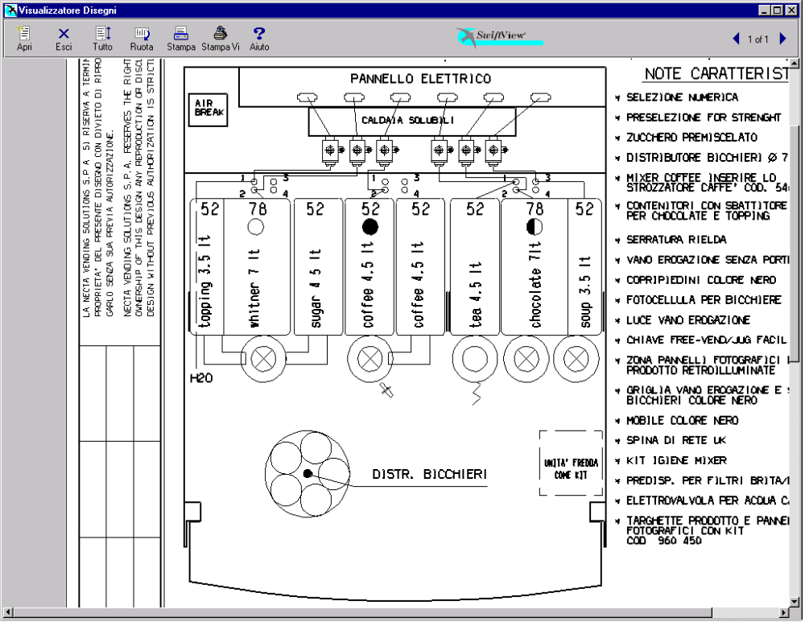

TABELLA PRODOTTI.

POSIZ. | PRODOTTO | N° DOSAT. | TARAT. DOS.  (grammi/sec.) | N° ELETTR. | TAR. EV  (cc/sec.)
1 | Topping | 1 | 1,5 | 2 | 9
2 | Milk / Whitner | 2 | 1,5 | 2 | 9
3 | Sugar | 3 | 2,3 | 2 | 9
4 | Coffee Instant Dec | 4 | 0,6 | 3 | 10
5 | Coffee Instant | 5 | 0,6 | 3 | 10
6 | Tea | 6 | 2,5 | 4 | 15
7 | Chocolate | 7 | 3,0 | 5 | 9
8 | Soup | 8 | 2,5 | 6 | 15
/ | / | / | / | 1 | 16
DISPOSIZIONE TASTIERA L02.

Strength - | ¤ | Strength + | ¤

SELEZIONE | SUGAR  N. | EX. SUGAR  N. | NO SUGAR  N.
Coffee Instant Black | 17 | 18 | 19
Coffee Instant White | 21 | 22 | 23
Coffee Instant Ex. White | 24 | 25 | 26
Chocolate | -- | -- | 27
Soup | -- | -- | 28
Hot Water | -- | -- | 29
Coffee Instant Black Decaffeinated | 37 | 38 | 39
Coffee Instant White Decaffeinated | 41 | 42 | 43
Coffee Inst. Ex. White Decaffeinated | 44 | 45 | 46
Tea Instant White | 51 | 52 | 53
Tea Instant Extra White | 54 | 55 | 56
Tea Instant Black | 57 | 58 | 59
Cappuccino Instant | 61 | -- | 62
Espresso Instant | 63 | -- | 64
EspressoChoc Instant | 65 | -- | 66
ChocoMilk | -- | -- | 67
Instant Cappuccino Decaffeinated | 75 | -- | 76
Instant EspressoChoc Decaffeinated | 77 | -- | 78
 | STILL |  | CARBONATED
Chilled Water | 81 |  | 84
Orange ( Syrop 1 ) | 82 |  | 85
Lemon (Syrop 2 ) | 83 |  | 86

PRESELEZIONI L02.

PRESELEZIONE  (N.) | VARIAZ. DOSE | DESCRIZIONE
Strength - | -10 % | Riduce la polvere di Coffee/Tea (3 step).
Strength + | +10 % | Aumenta la polvere di Coffee/Tea (3 step).
Extra Sugar | + 66% | Aumenta la dose di zucchero del 66%
No Sugar | - 100% | Azzera la dose di zucchero della selezione
SELEZIONI L02.

SELEZIONE  (N.) | DOSI ACQUA | ZUCCH.  (a porta) | DOSI POLVERI
Coffee Black  ( 17 – 18 – 19 ) | Coffee Instant  40 cc |  | Coffee  1,4 gr.
 | Sugar  50 cc (tot. 90 cc) |  | Sugar  5,3 gr.
Coffee White  ( 21 – 22 – 23 ) | Coffee Instant  40 cc |  | Coffee  1,4 gr.
 | Milk  60 cc |  | Milk  1,8 gr. | Sugar  5,3 gr.
Hot Water
50 cc (tot. 150 cc)
Coffe Extra White  ( 24 – 25 – 26 ) | Coffee Instant  40 cc |  | Coffee  1,4 gr.
 | Milk  60 cc |  | Milk  3,0 gr. | Sugar  5,3 gr.
Hot Water
50 cc (tot. 150 cc)
Chocolate  ( 27 ) | Chocolate  80 cc |  | Chocolate  19,0 gr.
Hot Water
60 cc (tot. 140 cc)
Soup  ( 28 ) | Soup  150 cc |  | Soup  8,0 gr.
Hot Water  ( 29 ) | Hot Water  150 cc
Coffee Black Dec.  ( 37 – 38 – 39 ) | Coffee Instant Dec.  40 cc |  | Coffee  1,4 gr.
 | Sugar  50 cc (tot. 90 cc) |  | Sugar  5,3 gr.
Coffee White Dec  ( 41 – 42 – 43 ) | Coffee Instant Dec.  40 cc |  | Coffee  1,4 gr.
 | Milk  60 cc |  | Milk  1,8 gr. | Sugar  5,3 gr.
Hot Water
50 cc (tot. 150 cc)
SELEZIONE  (N.) | DOSI ACQUA | ZUCCH.  (a porta) | DOSI POLVERI
Dec. Extra White  ( 44 – 45 – 46 ) | Coffee Instant Dec.  40 cc |  | Coffee  1,4 gr.
 | Milk  60 cc |  | Milk  3,0 gr. | Sugar  5,3 gr.
Hot Water
50 cc (tot. 150 cc)
Tea Instant White  ( 51 – 52 – 53 ) | Tea  50 cc |  | Tea  0,9 gr.
 | Milk  60 cc |  | Milk  0,7 gr. | Sugar  5,3 gr.
Hot Water
50 cc (tot. 160 cc)
Tea Inst.Ex.White  ( 54 – 55 – 56 ) | Tea  50 cc |  | Tea  0,9 gr.
 | Milk  60 cc |  | Milk  1,1 gr. | Sugar  5,3 gr.
Hot Water
50 cc (tot. 160 cc)
Tea Instant Black  ( 57 – 58 – 59 ) | Tea  50 cc |  | Tea  0,9 gr.
 | Sugar  60 cc |  | Sugar  5,3 gr.
Hot Water
50 cc (tot. 160 cc)
Inst. Cappuccino  ( 61 – 62 ) | Coffee Instant  40 cc |  | Coffee  1,6 gr.
 | Topping  60 cc |  | Topping  8,0 gr. | Sugar  5,3 gr.
 | Chocolate  40 cc (tot. 140 cc) |  | Chocolate  9,6 gr.
Espresso  ( 63 – 64 ) | Coffee Instant  35 cc |  | Coffee  1,4 gr.
 | Sugar  30 cc (tot. 65 cc) |  | Sugar  5,3 gr.

SELEZIONE  (N.) | DOSI ACQUA | ZUCCH.  (a porta) | DOSI POLVERI
Ins.EspressoChoc  ( 65 – 66 ) | Milk  35 cc |  | Milk  1,8 gr. | Sugar  5,3 gr.
 | Coffee Instant  40 cc |  | Coffee  1,4 gr.
 | Chocolate  50 cc (tot. 125 cc) |  | Chocolate  13 gr.
Chocomilk  ( 67 ) | Chocolate  80 cc |  | Chocolate  16,0 gr.
 | Milk  60 cc (tot. 140 cc) |  | Milk  1,4 gr.
Dec. Cappuccino  ( 75 – 76 ) | Coffee Instant Dec.  40 cc |  | Coffee  1,6 gr.
 | Topping  60 cc |  | Topping  8,0 gr. | Sugar  5,3 gr.
 | Chocolate  40 cc (tot. 140 cc) |  | Chocolate  9,6 gr.
Dec. Espr. Choc  ( 77 – 78 ) | Milk  35 cc |  | Milk  1,8 gr. | Sugar  5,3 gr.
 | Coffee Instant  40 cc |  | Coffee  1,4 gr.
 | Chocolate  50 cc (tot. 125 cc) |  | Chocolate  13 gr.
Chilled Water  ( 81 ) | Still  100 cc
Chilled Water  ( 84 ) | Carbonated  100 cc
Orange  ( 82 ) | Still  84 cc |  | Syrop 1  32 cc
Orange  ( 85 ) | Carbonated  84 cc |  | Syrop 1  32 cc
Lemon  ( 83 ) | Still  84 cc |  | Syrop 2  32 cc
Lemon  ( 86 ) | Carbonated  84 cc |  | Syrop 2  32 cc

LAYOUT L06.

N.B. Il layout 6 viene ottenuto dal layout 2 con la sola modifica di sostituire la
pipetta numero 3 per buttare lo zucchero nel mixer del caffè invece che nel
mixer del whitner.

TABELLA PRODOTTI.

POSIZ. | PRODOTTO | N° DOSAT. | TARAT. DOS.  (grammi/sec.) | N° ELETTR. | TAR. EV  (cc/sec.)
1 | Topping | 1 | 1,5 | 2 | 9
2 | Milk / Whitner | 2 | 1,5 | 2 | 9
3 | Sugar | 3 | 2,3 | 3 | 10
4 | Coffee Instant Dec | 4 | 0,6 | 3 | 10
5 | Coffee Instant | 5 | 0,6 | 3 | 10
6 | Tea | 6 | 2,5 | 4 | 15
7 | Chocolate | 7 | 3,0 | 5 | 9
8 | Soup | 8 | 2,5 | 6 | 15
/ | / | / | / | 1 | 16
DISPOSIZIONE TASTIERA L06.

Strength - | ¤ | Strength + | ¤

SELEZIONE | SUGAR  N. | EX. SUGAR  N. | NO SUGAR  N.
Coffee Instant Black | 17 | 18 | 19
Coffee Instant White | 21 | 22 | 23
Coffee Instant Ex. White | 24 | 25 | 26
Chocolate | -- | -- | 27
Soup | -- | -- | 28
Hot Water | -- | -- | 29
Coffee Instant Black Decaffeinated | 37 | 38 | 39
Coffee Instant White Decaffeinated | 41 | 42 | 43
Coffee Inst. Ex. White Decaffeinated | 44 | 45 | 46
Tea Instant White | 51 | 52 | 53
Tea Instant Extra White | 54 | 55 | 56
Tea Instant Black | 57 | 58 | 59
Cappuccino Instant | 61 | -- | 62
Espresso Instant | 63 | -- | 64
EspressoChoc Instant | 65 | -- | 66
ChocoMilk | -- | -- | 67
Instant Cappuccino Decaffeinated | 75 | -- | 76
Instant EspressoChoc Decaffeinated | 77 | -- | 78
 | STILL |  | CARBONATED
Chilled Water | 81 |  | 84
Orange ( Syrop 1 ) | 82 |  | 85
Lemon (Syrop 2 ) | 83 |  | 86

PRESELEZIONI L06.

PRESELEZIONE  (N.) | VARIAZ. DOSE | DESCRIZIONE
Strength - | -10 % | Riduce la polvere di Coffee/Tea (3 step).
Strength + | +10 % | Aumenta la polvere di Coffee/Tea (3 step).
Extra Sugar | + 66% | Aumenta la dose di zucchero del 66%
No Sugar | - 100% | Azzera la dose di zucchero della selezione
SELEZIONI L06.

SELEZIONE  (N.) | DOSI ACQUA | ZUCCH.  (a porta) | DOSI POLVERI
Coffee Black  ( 17 – 18 – 19 ) | Coffee Instant  40 cc |  | Coffee  1,4 gr. | Sugar  5,3 gr.
Hot Water
50 cc (tot. 90 cc)
Coffee White  ( 21 – 22 – 23 ) | Coffee Instant  40 cc |  | Coffee  1,4 gr. | Sugar  5,3 gr.
 | Milk  60 cc |  | Milk  1,8 gr.
Hot Water
50 cc (tot. 150 cc)
Coffe Extra White  ( 24 – 25 – 26 ) | Coffee Instant  40 cc |  | Coffee  1,4 gr. | Sugar  5,3 gr.
 | Milk  60 cc |  | Milk  3,0 gr.
Hot Water
50 cc (tot. 150 cc)
Chocolate  ( 27 ) | Chocolate  80 cc |  | Chocolate  19,0 gr.
Hot Water
60 cc (tot. 140 cc)
Soup  ( 28 ) | Soup  150 cc |  | Soup  8,0 gr.
Hot Water  ( 29 ) | Hot Water  150 cc
Coffee Black Dec.  ( 37 – 38 – 39 ) | Coffee Instant Dec.  40 cc |  | Coffee  1,4 gr. | Sugar  5,3 gr.
Hot Water
50 cc (tot. 90 cc)
Coffee White Dec  ( 41 – 42 – 43 ) | Coffee Instant Dec.  40 cc |  | Coffee  1,4 gr. | Sugar  5,3 gr.
 | Milk  60 cc |  | Milk  1,8 gr.
Hot Water
50 cc (tot. 150 cc)
SELEZIONE  (N.) | DOSI ACQUA | ZUCCH.  (a porta) | DOSI POLVERI
Dec. Extra White  ( 44 – 45 – 46 ) | Coffee Instant Dec.  40 cc |  | Coffee  1,4 gr. | Sugar  5,3 gr.
 | Milk  60 cc |  | Milk  3,0 gr.
Hot Water
50 cc (tot. 150 cc)
Tea Instant White  ( 51 – 52 – 53 ) | Tea  50 cc |  | Tea  0,9 gr.
 | Milk  60 cc |  | Milk  0,7 gr.
 | Sugar  50 cc (tot. 160 cc) |  | Sugar  5,3 gr.
Tea Inst.Ex.White  ( 54 – 55 – 56 ) | Tea  50 cc |  | Tea  0,9 gr.
 | Milk  60 cc |  | Milk  1,1 gr.
 | Sugar  50 cc (tot. 160 cc) |  | Sugar  5,3 gr.
Tea Instant Black  ( 57 – 58 – 59 ) | Tea  50 cc |  | Tea  0,9 gr.
 | Sugar  60 cc |  | Sugar  5,3 gr.
Hot Water
50 cc (tot. 160 cc)
Inst. Cappuccino  ( 61 – 62 ) | Coffee Instant  40 cc |  | Coffee  1,6 gr. | Sugar  5,3 gr.
 | Topping  60 cc |  | Topping  8,0 gr.
 | Chocolate  40 cc (tot. 140 cc) |  | Chocolate  9,6 gr.
Espresso  ( 63 – 64 ) | Coffee Instant  65 cc |  | Coffee  1,4 gr. | Sugar  5,3 gr.

SELEZIONE  (N.) | DOSI ACQUA | ZUCCH.  (a porta) | DOSI POLVERI
Ins.EspressoChoc  ( 65 – 66 ) | Milk  35 cc |  | Milk  1,8 gr.
 | Coffee Instant  40 cc |  | Coffee  1,4 gr. | Sugar  5,3 gr.
 | Chocolate  50 cc (tot. 125 cc) |  | Chocolate  13 gr.
Chocomilk  ( 67 ) | Chocolate  80 cc |  | Chocolate  16,0 gr.
 | Milk  60 cc (tot. 140 cc) |  | Milk  1,4 gr.
Dec. Cappuccino  ( 75 – 76 ) | Coffee Instant Dec.  40 cc |  | Coffee  1,6 gr. | Sugar  5,3 gr.
 | Topping  60 cc |  | Topping  8,0 gr.
 | Chocolate  40 cc (tot. 140 cc) |  | Chocolate  9,6 gr.
Dec. Espr. Choc  ( 77 – 78 ) | Milk  35 cc |  | Milk  1,8 gr.
 | Coffee Instant  40 cc |  | Coffee  1,4 gr. | Sugar  5,3 gr.
 | Chocolate  50 cc (tot. 125 cc) |  | Chocolate  13 gr.
Chilled Water  ( 81 ) | Still  100 cc
Chilled Water  ( 84 ) | Carbonated  100 cc
Orange  ( 82 ) | Still  84 cc |  | Syrop 1  32 cc
Orange  ( 85 ) | Carbonated  84 cc |  | Syrop 1  32 cc
Lemon  ( 83 ) | Still  84 cc |  | Syrop 2  32 cc
Lemon  ( 86 ) | Carbonated  84 cc |  | Syrop 2  32 cc

DISPOSIZIONE INFORMAZIONI GENERALI.

TABELLA PESI VALIDATORE:
Linea | A | B | C | D | E | F
Peso | 1 | 2 | 10 | 20 | 50 | 5

PREZZO SELEZIONI: Tutte le selezioni a 10.00.
NPREZZO SELEZIONI: Tutte le selezioni puntano al prezzo 1.

POSIZIONE PUNTO DECIMALE: 2.
TEMPERATURA CALDAIA EXP: ---- °C.
TEMPERATURA CALDAIA SOLUBILI: 86.0 °C.

RITARDI ACQUE / POLVERI: Ritardo polvere rispetto all’acqua 0.6 sec.

MODIFICHE.
SW CPU / SCHEDA ATTUAZIONI REV. 0.5:
Implementazione gestioni sportelli e taniche per autoalimentazione.
Aggiornamento dosi.
SW CPU / SCHEDA ATTUAZIONI REV. 0.7:
Pulsante lavaggi in programmazione come nella rev. 0.5.
Gestione funzionamento ventola sulla mensola del FB montata in posizione centrale.

